Supplementary Material

Supplemental Appendix S1: Full Search Strategy...……………………………………………………….……2

Supplemental Appendix S2: PRISMA Checklist ………………………………………………………………4

Supplemental Table S1: Assessment of bias using quality scores…...…….……………………………..….....7

Supplemental Table S2: Randomized Controlled Trials of AF Ablation from 2007-2021 with a Control Arm of Solely Pulmonary Vein Isolation or Pulmonary Vein Antrum Isolation……………………………………...10

Supplemental Table S3: Geographic Location and Antiarrhythmic Use in Randomized Controlled Trials of Catheter-based Pulmonary Vein Isolation AF Ablation……………….………………………….…………….12

Supplemental Figure S1: PRISMA Flow Diagram…………………………………………………………....13

Supplemental Figure S2: Rates of atrial arrhythmia recurrence in pulmonary vein isolation arms of randomized controlled trials of AF ablation from 2007-2021………………………………………………………………...14

Supplemental Figure S3: Intermittent Vs. Continuous Rhythm Monitoring Meta-Regression Analyses……...15

Supplemental Figure S4: Duration of intermittent rhythm monitoring and atrial arrhythmia recurrence rate in pulmonary vein isolation arms of randomized controlled trials of AF Ablation from 2007-2021, excluding Iskandar et al. 2017…………………………………………………………………………….………………..16

Supplemental Figure S5: Forest Plots of Random and Fixed-Effects Cumulative Metanalysis of Atrial Arrhythmia Recurrence Rate by Days…………………………………………………………………………..17

Supplemental References……...…………………………………………….…….…………………..……....20

Supplemental Appendix S1: Search Strategy
The following search strategy was generated with the help of a librarian experienced in literature searches in the cardiovascular field.

Medline Search Strategy (MEDLINE(R) ALL 1946-; via Ovid)
# | Searches
1 | AFib.tw.
2 | ((atrial or atrium) adj2 fibril?at$3).tw.
3 | Atrial Fibrillation/
4 | or/1-3
5 | Catheter Ablation/
6 | ablat$3.tw.
7 | or/5-6
8 | Follow-Up Studies/
9 | ((long term or days or month? or year?) and follow-up).tw.
10 | holter.tw.
11 | loop record*.tw.
12 | transtelephonic.tw.
13 | trans-telephonic.tw.
14 | monitor*.tw.
15 | exp Echocardiography/
16 | echocardiography.tw.
17 | ECG?.tw.
18 | transmi*.tw.
19 | or/8-18
20 | 4 and 7 and 19
21 | Animals/
22 | Humans/
23 | 21 not 22
24 | 20 not 23
25 | limit 24 to yr=“2007-2019”

Embase Search (Embase Classic+Embase 1947 -; via Ovid)
# | Searches
1 | AFib.tw.
2 | ((atrial or atrium) adj2 fibril?at$3).tw.
3 | exp atrial fibrillation/
4 | 1 or 2 or 3
5 | catheter ablation/
6 | ablat$3.tw.
7 | 5 or 6
8 | follow up/
9 | ((long term or days or month? or year?) and follow-up).tw.
10 | holter.tw.
11 | loop record*.tw.
12 | transtelephonic.tw.
13 | trans-telephonic.tw.
14 | monitor*.tw.
15 | exp echocardiography/
16 | echocardiography.tw.
17 | ECG?.tw.
18 | transmi*.tw.
19 | or/8-18
20 | 4 and 7 and 19
21 | exp animal/
22 | human/
23 | 21 not 22
24 | 20 not 23
25 | limit 24 to yr=“2007-2019”

Cochrane Central Register of Controlled Trials (via Ovid)
# | Searches
1 | AFib.tw.
2 | ((atrial or atrium) adj2 fibril?at$3).tw.
3 | Atrial Fibrillation/
4 | or/1-3
5 | Catheter Ablation/
6 | ablat$3.tw.
7 | or/5-6
8 | Follow-Up Studies/
9 | ((long term or days or month? or year?) and follow-up).tw.
10 | holter.tw.
11 | loop record*.tw.
12 | transtelephonic.tw.
13 | trans-telephonic.tw.
14 | monitor*.tw.
15 | exp Echocardiography/
16 | echocardiography.tw.
17 | ECG?.tw.
18 | transmi*.tw.
19 | or/8-18
20 | 4 and 7 and 19
21 | Animals/
22 | Humans/
23 | 21 not 22
24 | 20 not 23
25 | limit 24 to yr="2007-2019"

For Studies published between January 1st 2020 and September 22nd 2021:
The same search strategy was employed as above with changes to the date filter (line 25) to reflect the updated search time period (January 1st 2020 to September 22nd 2021). An “RCT” filter was used to narrow the search results to randomized controlled studies.

Supplemental Appendix S2: PRISMA Checklist
Section and Topic | Item # | Checklist item | Performed- Yes/No
TITLE
Title | 1 | Identify the report as a systematic review. | Yes
ABSTRACT
Abstract | 2 | See the PRISMA 2020 for Abstracts checklist. | Yes
INTRODUCTION
Rationale | 3 | Describe the rationale for the review in the context of existing knowledge. | Yes
Objectives | 4 | Provide an explicit statement of the objective(s) or question(s) the review addresses. | Yes
METHODS
Eligibility criteria | 5 | Specify the inclusion and exclusion criteria for the review and how studies were grouped for the syntheses. | Yes
Information sources | 6 | Specify all databases, registers, websites, organisations, reference lists and other sources searched or consulted to identify studies. Specify the date when each source was last searched or consulted. | Yes
Search strategy | 7 | Present the full search strategies for all databases, registers and websites, including any filters and limits used. | Yes
Selection process | 8 | Specify the methods used to decide whether a study met the inclusion criteria of the review, including how many reviewers screened each record and each report retrieved, whether they worked independently, and if applicable, details of automation tools used in the process. | Yes
Data collection process | 9 | Specify the methods used to collect data from reports, including how many reviewers collected data from each report, whether they worked independently, any processes for obtaining or confirming data from study investigators, and if applicable, details of automation tools used in the process. | Yes
Data items | 10a | List and define all outcomes for which data were sought. Specify whether all results that were compatible with each outcome domain in each study were sought (e.g. for all measures, time points, analyses), and if not, the methods used to decide which results to collect. | Yes
Data items | 10b | List and define all other variables for which data were sought (e.g. participant and intervention characteristics, funding sources). Describe any assumptions made about any missing or unclear information. | Yes
Study risk of bias assessment | 11 | Specify the methods used to assess risk of bias in the included studies, including details of the tool(s) used, how many reviewers assessed each study and whether they worked independently, and if applicable, details of automation tools used in the process. | Yes
Effect measures | 12 | Specify for each outcome the effect measure(s) (e.g. risk ratio, mean difference) used in the synthesis or presentation of results. | Yes
Synthesis methods | 13a | Describe the processes used to decide which studies were eligible for each synthesis (e.g. tabulating the study intervention characteristics and comparing against the planned groups for each synthesis (item #5)). | Yes
Synthesis methods | 13b | Describe any methods required to prepare the data for presentation or synthesis, such as handling of missing summary statistics, or data conversions. | Yes
Synthesis methods | 13c | Describe any methods used to tabulate or visually display results of individual studies and syntheses. | Yes
Synthesis methods | 13d | Describe any methods used to synthesize results and provide a rationale for the choice(s). If meta-analysis was performed, describe the model(s), method(s) to identify the presence and extent of statistical heterogeneity, and software package(s) used. | Yes
Synthesis methods | 13e | Describe any methods used to explore possible causes of heterogeneity among study results (e.g. subgroup analysis, meta-regression). | Yes
Synthesis methods | 13f | Describe any sensitivity analyses conducted to assess robustness of the synthesized results. | Yes
Reporting bias assessment | 14 | Describe any methods used to assess risk of bias due to missing results in a synthesis (arising from reporting biases). | Yes
Certainty assessment | 15 | Describe any methods used to assess certainty (or confidence) in the body of evidence for an outcome. | Yes
RESULTS
Study selection | 16a | Describe the results of the search and selection process, from the number of records identified in the search to the number of studies included in the review, ideally using a flow diagram. | Yes
Study selection | 16b | Cite studies that might appear to meet the inclusion criteria, but which were excluded, and explain why they were excluded. | Yes
Study characteristics | 17 | Cite each included study and present its characteristics. | Yes
Risk of bias in studies | 18 | Present assessments of risk of bias for each included study. | Yes
Results of individual studies | 19 | For all outcomes, present, for each study: (a) summary statistics for each group (where appropriate) and (b) an effect estimate and its precision (e.g. confidence/credible interval), ideally using structured tables or plots. | Yes
Results of syntheses | 20a | For each synthesis, briefly summarise the characteristics and risk of bias among contributing studies. | Yes
Results of syntheses | 20b | Present results of all statistical syntheses conducted. If meta-analysis was done, present for each the summary estimate and its precision (e.g. confidence/credible interval) and measures of statistical heterogeneity. If comparing groups, describe the direction of the effect. | Yes
Results of syntheses | 20c | Present results of all investigations of possible causes of heterogeneity among study results. | Yes
Results of syntheses | 20d | Present results of all sensitivity analyses conducted to assess the robustness of the synthesized results. | Yes
Reporting biases | 21 | Present assessments of risk of bias due to missing results (arising from reporting biases) for each synthesis assessed. | Yes
Certainty of evidence | 22 | Present assessments of certainty (or confidence) in the body of evidence for each outcome assessed. | Yes
DISCUSSION
Discussion | 23a | Provide a general interpretation of the results in the context of other evidence. | Yes
Discussion | 23b | Discuss any limitations of the evidence included in the review. | Yes
Discussion | 23c | Discuss any limitations of the review processes used. | Yes
Discussion | 23d | Discuss implications of the results for practice, policy, and future research. | Yes
OTHER INFORMATION
Registration and protocol | 24a | Provide registration information for the review, including register name and registration number, or state that the review was not registered. | Yes
Registration and protocol | 24b | Indicate where the review protocol can be accessed, or state that a protocol was not prepared. | Yes
Registration and protocol | 24c | Describe and explain any amendments to information provided at registration or in the protocol. | Yes
Support | 25 | Describe sources of financial or non-financial support for the review, and the role of the funders or sponsors in the review. | Yes
Competing interests | 26 | Declare any competing interests of review authors. | Yes
Availability of data, code and other materials | 27 | Report which of the following are publicly available and where they can be found: template data collection forms; data extracted from included studies; data used for all analyses; analytic code; any other materials used in the review. | Yes

Supplemental Table S1: Assessment of bias using quality scores

Name-Year of Trial | Randomized | Study Question stated | Multicentre trial | Structured Abstract | Inclusion criteria | Randomization Strategy | Allocation Concealment | Patient/Caregiver Blinding | Outcome assessor blinding | Data analysts blinded | Intention to treat analysis | Valid statistical methods | Dropouts | Total Quality Score (Max score= 13)
Andrade et al. 2019 | 1 | 1 | 1 | 1 | 1 | 1 | 0 | 1 | 1 | 1 | 1 | 1 | 1 | 12
Andrade et al. 2021 | 1 | 1 | 1 | 1 | 1 | 1 | 1 | 1 | 1 | 1 | 1 | 1 | 1 | 13
Arbelo et al. 2014 | 1 | 1 | 1 | 1 | 1 | 1 | 0 | 1 | 1 | 1 | 1 | 1 | 1 | 12
Atienza et al. 2014 | 1 | 1 | 1 | 1 | 1 | 1 | 0 | 1 | 1 | 1 | 1 | 1 | 1 | 12
Boersma et al. 2016 | 1 | 1 | 1 | 1 | 1 | 1 | 0 | 1 | 1 | 1 | 1 | 1 | 1 | 12
Chen et al. 2011 | 1 | 1 | 1 | 1 | 1 | 1 | 0 | 1 | 1 | 1 | 1 | 1 | 1 | 12
Cosedis Nielsen et al. 2012 | 1 | 1 | 1 | 1 | 1 | 1 | 0 | 1 | 1 | 1 | 1 | 1 | 1 | 12
Di Biase et al. 2009 | 1 | 1 | 1 | 1 | 1 | 1 | 0 | 1 | 1 | 1 | 1 | 1 | 1 | 12
Duytschaever et al. 2018 | 1 | 1 | 1 | 1 | 1 | 1 | 0 | 1 | 1 | 1 | 1 | 1 | 1 | 12
Ejima et al. 2019 | 1 | 1 | 1 | 1 | 1 | 1 | 0 | 1 | 1 | 1 | 1 | 1 | 1 | 12
Fiala et al. 2008 | 1 | 1 | 1 | 1 | 1 | 1 | 0 | 1 | 1 | 1 | 1 | 1 | 1 | 12
Fichtner et al. 2013 | 1 | 1 | 1 | 1 | 1 | 1 | 0 | 1 | 1 | 1 | 1 | 1 | 1 | 12
Gavin et al. 2012 | 1 | 1 | 1 | 1 | 1 | 1 | 0 | 1 | 1 | 1 | 1 | 1 | 1 | 12
Giannopoulos et al. 2014 | 1 | 1 | 1 | 1 | 1 | 1 | 0 | 1 | 1 | 1 | 1 | 1 | 1 | 12
Gula et al. 2016 | 1 | 1 | 1 | 1 | 1 | 1 | 0 | 1 | 1 | 1 | 1 | 1 | 1 | 12
Hunter et al. 2015 | 1 | 1 | 1 | 1 | 1 | 1 | 0 | 1 | 1 | 1 | 1 | 1 | 1 | 12
Iskandar et al. 2017 | 1 | 1 | 1 | 1 | 1 | 1 | 0 | 1 | 1 | 1 | 1 | 1 | 1 | 12
Kim et al. 2015 | 1 | 1 | 1 | 1 | 1 | 1 | 0 | 1 | 1 | 1 | 1 | 1 | 1 | 12
Kuck et al. 2016 | 1 | 1 | 1 | 1 | 1 | 1 | 0 | 1 | 1 | 1 | 1 | 1 | 1 | 12
Kuck et al. 2021 | 1 | 1 | 1 | 1 | 1 | 1 | 0 | 1 | 1 | 1 | 1 | 1 | 1 | 12
Kühne et al. 2010 | 1 | 1 | 1 | 1 | 1 | 1 | 0 | 1 | 1 | 1 | 1 | 1 | 1 | 12
Macle et al. 2015 | 1 | 1 | 1 | 1 | 1 | 1 | 0 | 1 | 1 | 1 | 1 | 1 | 1 | 12
McCready et al. 2014 | 1 | 1 | 1 | 1 | 1 | 1 | 0 | 1 | 1 | 1 | 1 | 1 | 1 | 12
McLellan et al 2015 | 1 | 1 | 1 | 1 | 1 | 1 | 0 | 1 | 1 | 1 | 1 | 1 | 1 | 12
Pedrote et al. 2016 | 1 | 1 | 1 | 1 | 1 | 1 | 0 | 1 | 1 | 1 | 1 | 1 | 1 | 12
Pérez-Castellano et al. 2014 | 1 | 1 | 1 | 1 | 1 | 1 | 0 | 1 | 1 | 1 | 1 | 1 | 1 | 12
Podd et al. 2012 | 1 | 1 | 1 | 1 | 1 | 1 | 0 | 1 | 1 | 1 | 1 | 1 | 1 | 12
Schaeffer et al. 2018 | 1 | 1 | 1 | 1 | 1 | 1 | 0 | 1 | 1 | 1 | 1 | 1 | 1 | 12
Skala et al. 2019 | 1 | 1 | 1 | 1 | 1 | 1 | 0 | 1 | 1 | 1 | 1 | 1 | 1 | 12
Steinberg et al. 2020 | 1 | 1 | 1 | 1 | 1 | 1 | 0 | 1 | 1 | 1 | 1 | 1 | 1 | 12
Ucer et al. 2020 | 1 | 1 | 1 | 1 | 1 | 1 | 0 | 1 | 1 | 1 | 1 | 1 | 1 | 12
Ullah et al. 2016 | 1 | 1 | 1 | 1 | 1 | 1 | 0 | 1 | 1 | 1 | 1 | 1 | 1 | 12
Wang et al. 2016 | 1 | 1 | 1 | 1 | 1 | 1 | 0 | 1 | 1 | 1 | 1 | 1 | 1 | 12
Wazni et al. 2021 | 1 | 1 | 1 | 1 | 1 | 1 | 0 | 1 | 1 | 1 | 1 | 1 | 1 | 12
Xu et al. 2020 | 1 | 1 | 1 | 1 | 1 | 1 | 0 | 1 | 1 | 1 | 1 | 1 | 1 | 12
Zhao et al. 2013 | 1 | 1 | 1 | 1 | 1 | 1 | 0 | 1 | 1 | 1 | 1 | 1 | 1 | 12
Atienza et al. 2014 | 1 | 1 | 1 | 1 | 1 | 1 | 0 | 1 | 1 | 1 | 1 | 1 | 1 | 12
Chauhan et al. 2020 | 1 | 1 | 1 | 1 | 1 | 1 | 0 | 1 | 1 | 1 | 1 | 1 | 1 | 12
Chun et al. 2021 | 1 | 1 | 1 | 1 | 1 | 1 | 0 | 1 | 1 | 1 | 1 | 1 | 1 | 12
Elayi et al. 2008 | 1 | 1 | 1 | 1 | 1 | 1 | 0 | 1 | 1 | 1 | 1 | 1 | 1 | 12
Fink et al. 2017 | 1 | 1 | 1 | 1 | 1 | 1 | 0 | 1 | 1 | 1 | 1 | 1 | 1 | 12
Lee et al. 2019 | 1 | 1 | 1 | 1 | 1 | 1 | 0 | 1 | 1 | 1 | 1 | 1 | 1 | 12
Pappone et al. 2018 | 1 | 1 | 1 | 1 | 1 | 1 | 0 | 1 | 1 | 1 | 1 | 1 | 1 | 12
Verma et al. 2015 | 1 | 1 | 1 | 1 | 1 | 1 | 0 | 1 | 1 | 1 | 1 | 1 | 1 | 12
Wang et al. 2017 | 1 | 1 | 1 | 1 | 1 | 1 | 0 | 1 | 1 | 1 | 1 | 1 | 1 | 12
Borregaard et al. 2017 | 1 | 1 | 1 | 1 | 1 | 1 | 0 | 1 | 1 | 1 | 1 | 1 | 1 | 12
Dixit et al. 2008 | 1 | 1 | 1 | 1 | 1 | 1 | 0 | 1 | 1 | 1 | 1 | 1 | 1 | 12
Gaita et al. 2008 | 1 | 1 | 1 | 1 | 1 | 1 | 0 | 1 | 1 | 1 | 1 | 1 | 1 | 12
Hu et al. 2021 | 1 | 1 | 1 | 1 | 1 | 1 | 0 | 1 | 1 | 1 | 1 | 1 | 1 | 12
Inoue et al. 2021 | 1 | 1 | 1 | 1 | 1 | 1 | 0 | 1 | 1 | 1 | 1 | 1 | 1 | 12
Kiuchi et al. 2016 | 1 | 1 | 1 | 1 | 1 | 1 | 0 | 1 | 1 | 1 | 1 | 1 | 1 | 12
Kobori et al. 2015 | 1 | 1 | 1 | 1 | 1 | 1 | 0 | 1 | 1 | 1 | 1 | 1 | 1 | 12
Pokushalov et al. 2012 | 1 | 1 | 1 | 1 | 1 | 1 | 0 | 1 | 1 | 1 | 1 | 1 | 1 | 12
Pontoppidan et al. 2009 | 1 | 1 | 1 | 1 | 1 | 1 | 0 | 1 | 1 | 1 | 1 | 1 | 1 | 12
Rillig et al. 2017 | 1 | 1 | 1 | 1 | 1 | 1 | 0 | 1 | 1 | 1 | 1 | 1 | 1 | 12
Verma et al. 2010 | 1 | 1 | 1 | 1 | 1 | 1 | 0 | 1 | 1 | 1 | 1 | 1 | 1 | 12
Yu et al. 2017 | 1 | 1 | 1 | 1 | 1 | 1 | 0 | 1 | 1 | 1 | 1 | 1 | 1 | 12

* In Cosedis Nelson et al. 2012, the intervention arm was included in the PVI-arm analysis.
+ In Atienza et al. 2014 (RADAR-AF) there were 2 different intervention protocols for patients with paroxysmal and non-paroxysmal AF, for a total of 4 arms. Both the PAF control arm and non-PAF control arms were included in this analysis.

Supplemental Table S2: Randomized Controlled Trials of AF Ablation from 2007-2021 with a Control Arm of Solely Pulmonary Vein Isolation or Pulmonary Vein Antrum Isolation
Study Arm | Rhythm Monitoring Device(s) Used | N | N with arrhythmia recurrence (%) | Duration of Rhythm Monitoring After 3-month Blanking Period (days) | Trial Length (months) | Recurrence Endpoint
PAF
Andrade et al. 2019¹ | Continuous ILR + Holter (1D) | 115 | 53 (46.1%) | 274 | 12 | AF + AT>30s
Andrade et al. 2021² | Continuous ILR | 154 | 66 (42.9%) | 274 | 12 | AF + AA >30s
Arbelo et al. 2014³ | 2D (48 Hour) Holter | 61 | 27 (44.3%) | 7 | 15 | AF + AA >30s
Atienza et al. 2014⁴⁺ | 2D (48 Hour) Holter | 59 | 24 (40.7%) | 6 | 12 | AF + AA >30s
Boersma et al. 2016⁵ | 2D (48 Hour) Holter | 59 | 11 (18.6%) | 6 | 12 | AF + AT>30s
Chen et al. 2011⁶ | 1D (24 Hour) Holter | 35 | 8 (22.9%) | 3 | 22.6 | AF + AA >30s
Cosedis Nielsen et al. 2012⁷* | 7D (168 hours) Holter | 146 | 22 (15.1%) | 35 | 24 | AF + AA >30s
Di Biase et al. 2009⁸ | 2D (48 Hour) Holter | 35 | 9 (25.7%) | 10 | 13.7 | AF + AA >60s
Duytschaever et al. 2018⁹ | 1D (24 Hour) Holter + Holter (7D) | 76 | 16 (21.1%) | 9 | 12 | AF + AA >30s
Ejima et al. 2019¹⁰ | 1D (24 Hour) Holter | 67 | 10 (14.9%) | 4 | 12 | AF>60s
Fiala et al. 2008¹¹ | 1D (24 Hour) Holter | 54 | 11 (20.4%) | 10 | 48 | AF + AA >30s
Fichtner et al. 2013¹² | 7D (168 hours) Holter | 102 | 42 (41.2%) | 21 | 12 | AF + AA >30s
Gavin et al. 2012¹³ | 1D (24 Hour) Holter | 22 | 5 (22.7%) | 4 | 18 | AF>60s
Giannopoulos et al. 2014¹⁴ | 2D (48 Hour) Holter | 147 | 68 (46.3%) | 21.4 | 13.7 | AF + AA >30s
Gula et al. 2016¹⁵ | 1D (24 Hour) Holter + loop recorder (2 weeks) | 59 | 21 (35.6%) | 16 | 12 | AF >30s
Hunter et al. 2015¹⁶ | 7D (168 hours) Holter | 79 | 41 (51.9%) | 21 | 12 | AF + AA >30s
Iskandar et al. 2017¹⁷ | 30 Day event Holter | 30 | 9 (30.0%) | 90 | 12 | AF>60s
Kim et al. 2015¹⁸ | 1D (24 Hour) Holter | 50 | 6 (12.0%) | 3.7 | 16.3 | AF (no other qualifiers)
Kuck et al. 2016¹⁹ | 1D (24 Hour) Holter | 376 | 87 (23.1%) | 4 | 18 | AF >30s
Kuck et al. 2021²⁰ | Transtelephonic monitoring | 128 | 63 (49.2%) | 1 | 36 | AF + AT>30s
Kühne et al. 2010²¹ | 1D (24 Hour) Holter + Event (7D) | 25 | 9 (36.0%) | 24 | 12 | AF + AA >30s
Macle et al. 2015²² | 1D (24 Hour) Holter + Transtelephonic monitoring | 137 | 79 (57.7%) | 3 | 12 | AF >30s
McCready et al. 2014²³ | 3D (72 Hour) Holter | 94 | 40 (42.6%) | 9 | 12 | AF + AA >30s
McLellan et al 2015²⁴ | 7D (168 hours) Holter | 117 | 35 (29.9%) | 19.8 | 17 | AF + AT>30s
Pedrote et al. 2016²⁵ | 1D (24 Hour) Holter | 25 | 6 (24.0%) | 4 | 12 | 0% AF Burden/Any AF
Pérez-Castellano et al. 2014²⁶ | Continuous ILR | 25 | 8 (32.0%) | 274 | 12 | AF + AA >30s
Podd et al. 2012²⁷ | Continuous ILR | 25 | 12 (48.0%) | 274 | 12 | AF + AA >30s
Schaeffer et al. 2018²⁸ | 1D (24 Hour) Holter | 35 | 10 (28.6%) | 3 | 12 | AF + AA >30s
Skala et al. 2019²⁹ | 7D (168 hours) Holter | 31 | 7 (22.6%) | 28 | 12 | AF >30s
Steinberg et al. 2020³⁰ | 7D (168 hours) Holter | 148 | 84 (56.8%) | 28 | 12 | AF + AA >30s
Ucer et al. 2020³¹ | 3D (72 Hour) Holter | 25 | 9 (36%) | 9 | 12 | AF + AA >30s
Ullah et al. 2016³² | 7D (168 hours) Holter | 58 | 29 (50.0%) | 14 | 12 | AF > 2 minutes
Wang et al. 2016³³ | 2D (48 Hour) Holter | 137 | 36 (26.3%) | 10 | 12 | AF + AA >30s
Wazni et al. 2021³⁴ | 1D (24 Hour) Holter | 104 | 21 (20.1%) | 2 | 12 | AF + AA >30s
Xu et al. 2020³⁵ | 1D (24 Hour) + 7D (168 Hours) | 60 | 12 (20.0%) | 10 | 18 | AF + AA >30s
Zhao et al. 2013³⁶ | 3D (72 Hour) event + Holter (1D) | 44 | 22 (50.0%) | 16 | 14 | AF + AA>30s or AAD Prescription or Repeat Ablation
PeAF
Atienza et al. 2014⁴ | 2D (48 Hour) Holter | 58 | 37 (63.8%) | 6 | 12 | AF + AA >30s
Chauhan et al. 2020³⁷ | 2D (48 Hour) Holter | 41 | 19 (46.3%) | 8 | 12 | AF + AA >30s
Chun et al. 2021³⁸ | 3D (72 Hour) Holter | 100 | 20 (20.0%) | 9 | 12 | AF + AT>30s
Elayi et al. 2008³⁹ | 2D (48 Hour) Holter + event monitor (4x/week) | 47 | 42 (89.4%) | 10 | 16 | AF + AA >60s
Fink et al. 2017⁴⁰ | 1D (24 Hour) Holter | 61 | 28 (45.9%) | 3 | 12 | AF + AA >30s
Lee et al. 2019⁴¹ | 1D (24 Hour) Holter | 107 | 25 (23.4%) | 3.7 | 16.2 | Arrhythmia (no other qualifiers)
Pappone et al. 2018⁴² | 1D (24 Hour) Holter | 40 | 20 (50.0%) | 3 | 12 | AF + AA >30s
Verma et al. 2015⁴³ | 1D (24 Hour) Holter + Transtelephonic monitoring | 67 | 31 (46.3%) | 5 | 18 | AF >30s
Wang et al. 2017⁴⁴ | 1D (24 Hour) Holter | 48 | 21 (43.8%) | 9 | 12 | AF >30s
PAF and PeAF
Borregaard et al. 2017⁴⁵ | Continuous ILR | 25 | 13 (52.0%) | 274 | 12 | AF + AA >30s
Dixit et al. 2008⁴⁶ | Transtelephonic monitoring | 53 | 21 (39.6%) | 1 | 12 | 0% AF Burden/Any AF
Gaita et al. 2008⁴⁷ | 1D (24 Hour) Holter | 67 | 41 (61.2%) | 3 | 12 | AF + AA >30s
Hu et al. 2021⁴⁸ | 2D (48 Hour) Holter | 62 | 22 (35.5%) | 9.6 | 16.9 | AF + AA >30s
Inoue et al. 2021⁴⁹ | 1D (24 Hour) Holter | 254 | 73 (28.7%) | 2 | 12 | AF + AA >30s
Kiuchi et al. 2016⁵⁰ | Continuous Non-ILR Implantable Device (ICD or CRT-D) | 24 | 18 (75.0%) | 274 | 12 | AF + AT>30s
Kobori et al. 2015⁵¹ | 1D (24 Hour) Holter + Transtelephonic monitoring | 1001 | 327 (32.7%) | 2 | 12.6 | Palpitations/AF/AFl>30s
Pokushalov et al. 2012⁵² | 1D (24 Hour) Holter | 14 | 10 (71.4%) | 4 | 12 | AF + AA >30s
Pontoppidan et al. 2009⁵³ | 7D (168 hours) Holter | 76 | 53 (69.7%) | 21 | 12 | AF + AA >30s
Rillig et al. 2017⁵⁴ | 3D (72 Hour) Holter | 131 | 25 (19.1%) | 9 | 12 | AF + AA >30s
Verma et al. 2010⁵⁵ | 1D (24 Hour) Holter | 33 | 17 (51.5%) | 3 | 12 | AF + AA >30s
Yu et al. 2017⁵⁶ | 1D (24 Hour) Holter | 59 | 11 (18.6%) | 4.1 | 18.6 | AF >30s

Abbreviations: AF, atrial fibrillation; AT, atrial tachycardia; AA, atrial tachyarrhythmia; AFl, atrial flutter; PAF, paroxysmal AF; PeAF, Persistent AF; RF, radio frequency; PVI, pulmonary vein isolation; PVAI, pulmonary vein antrum isolation, CVPI, circumferential pulmonary vein isolation; ILR, implantable loop recorder; CF, contact force; WACA, wide area circumferential ablation; CFAE, complex fractionated atrial electrograms; CRYO, cryo-energy ablation

* In Cosedis Nelson et al. 2012, the intervention arm was included in the PVI-arm analysis.
+ In Atienza et al. 2014 (RADAR-AF) there were 2 different intervention protocols for patients with paroxysmal and non-paroxysmal AF, for a total of 4 arms. Both the PAF control arm and non-PAF control arms were included in this analysis.

Supplemental Table S3: Geographic Location and Antiarrhythmic Use in Randomized Controlled Trials of Catheter-based Pulmonary Vein Isolation AF Ablation

 | All Studies | Paroxysmal AF | Persistent AF | Paroxysmal and Persistent AF
Regions of Enrolled Patients
International (multi-country) | 11 (19.3%) | 5 (13.9%) | 3 (33.3%) | 3 (25.0%)
North America | 7 (12.3%) | 5 (13.9%) |  | 2 (16.7%)
South America | 1 (1.8%) |  |  | 1 (8.3%)
United Kingdom | 4 (7.0%) | 4 (11.1%)
Germany | 4 (7.0%) | 3 (8.3%) |  | 1 (8.3%)
Other Europe | 18 (31.6%) | 12 (33.3%) | 3 (33.3%) | 3 (25.0%)
Asia | 11 (19.3%) | 6 (16.7%) | 3 (33.3%) | 2 (16.7%)
Australia | 1 (1.8%) | 1 (2.8%)
Pre-ablation AAD Use, No.
AAD given within 2 weeks of procedure | 1 (1.8%) | 1 (2.8%)
AAD Stopped ≥5 have-lives or ≥3-months prior | 17 (29.8%) | 9 (25.0%) | 5 (55.6%) | 3 (25.0%)
AAD stopped 2 weeks to 3 months prior to ablation | 5 (8.8%) | 3 (8.3%) | 1 (11.1%) | 1 (8.3%)
Ablation done on AAD | 1 (1.8%) |  |  | 1 (8.3%)
No AAD exposure pre-ablation | 3 (5.3%) | 3 (8.3%)
Not specified | 30 (52.6%) | 20 (55.6%) | 3 (33.3%) | 7 (58.3%)
Post-ablation AAD Use, No.
No AAD post-procedure | 11 (19.3%) | 11 (30.6%)
Continued during blanking period and/or some of follow-up | 38 (66.7%) | 22 (61.1%) | 8 (89%) | 8 (66.7%)
Not specified | 8 (14.0%) | 3 (8.3%) | 1 (11%) | 4 (33.3%)

Abbreviations: AF, atrial fibrillation; AAD, antiarrhythmic drug use.

Supplemental Figure S1: PRISMA Flow Diagram. Diagram of number of records at screening, full text-review, and inclusion of PVI-arm only analysis. Abbreviations: PVI, pulmonary vein isolation
Between January 1st 2020 and September 22nd 2021, 2105 records were removed via database RCT filters, 286 reorders were removed after title and abstract screening, and 26 records were removed after full-text screening.

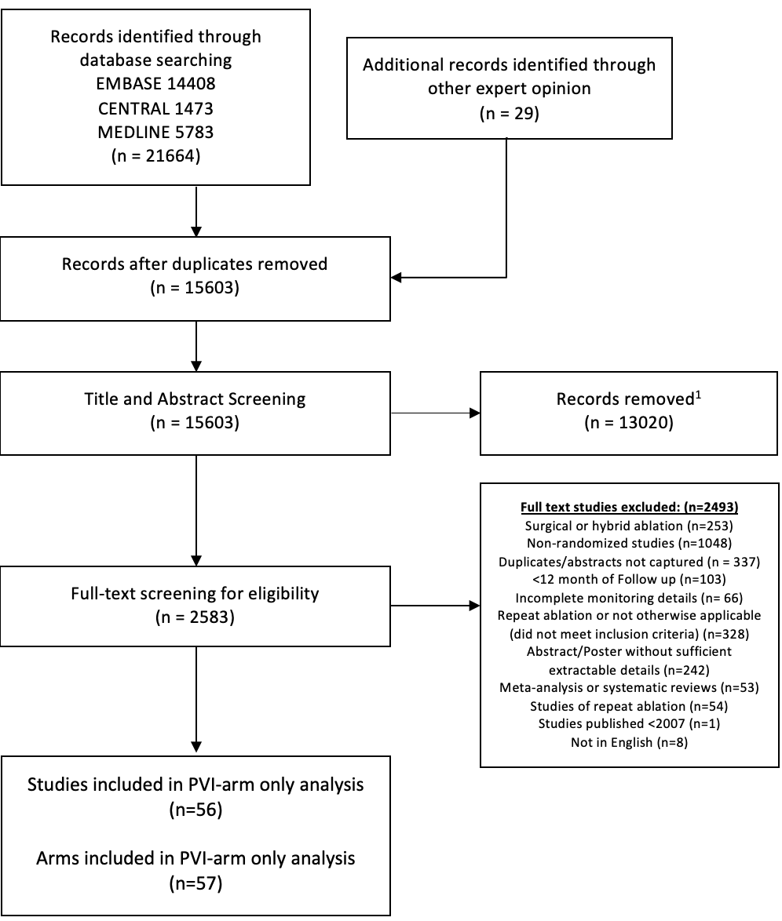

Supplemental Figure S2: Rates of atrial arrhythmia recurrence in pulmonary vein isolation arms of randomized controlled trials of AF ablation from 2007-2021, by type of AF and duration of trial follow-up. Square markers indicate the point estimate of AF recurrence. The size of each square is proportional to the corresponding weight of the given study. Horizontal lines indicate 95% CIs. Solid diamonds represent the estimated 95% CI for recurrence rate of all pooled trial arms.

Supplemental Figure S3: Intermittent Vs. Continuous Rhythm Monitoring Meta-Regression Analyses

PAF:
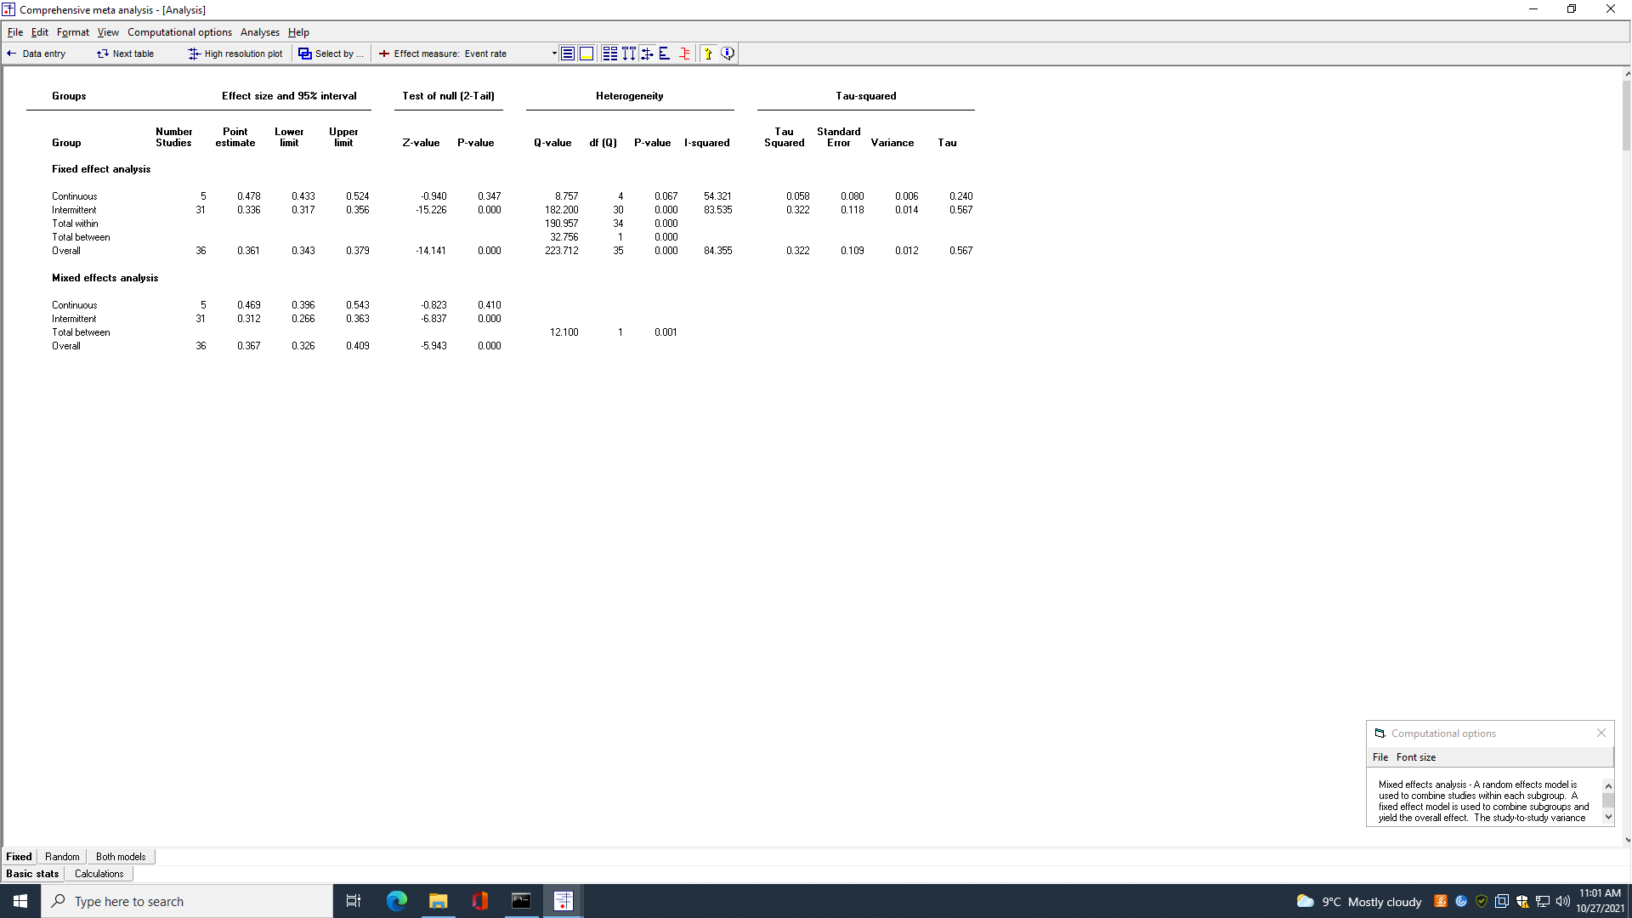

PeAF:
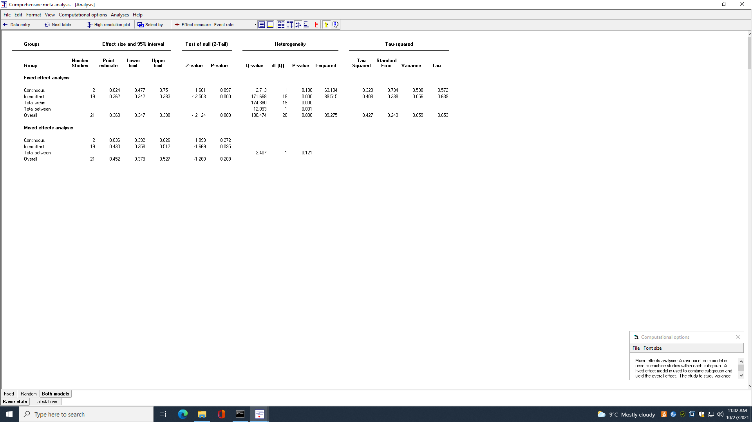

Supplemental Figure S4: Duration of intermittent rhythm monitoring and atrial arrhythmia recurrence rate in pulmonary vein isolation arms of randomized controlled trials of AF Ablation from 2007-2021, excluding Iskandar et al. 2017. The solid lines show mixed effects logistic regressions of duration of rhythm monitoring and logit event rate for A) PAF arms, and B) PeAF/combined arms. Abbreviations: PAF, paroxysmal AF; PeAF, persistent AF.

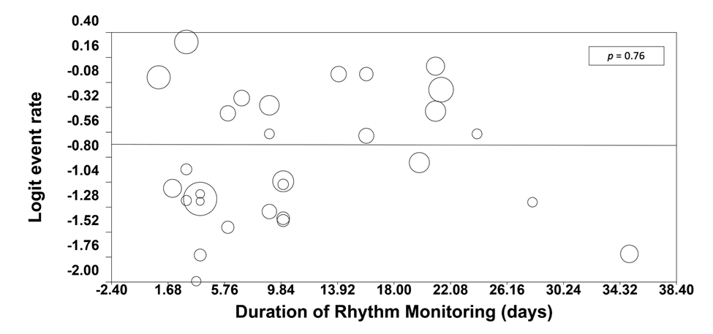

Supplemental Figure S5: Forest Plots of Random and Fixed-Effects Cumulative Metanalysis of Atrial Arrhythmia Recurrence Rate by Days

(Analysis 1.1) All PAF by Total Duration of Rhythm Monitoring (days)-Fixed Effects.
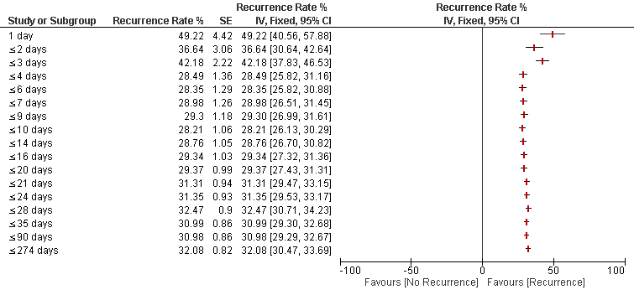
(Analysis 1.2) All PAF by Total Duration of Rhythm Monitoring (days)-Random Effects.
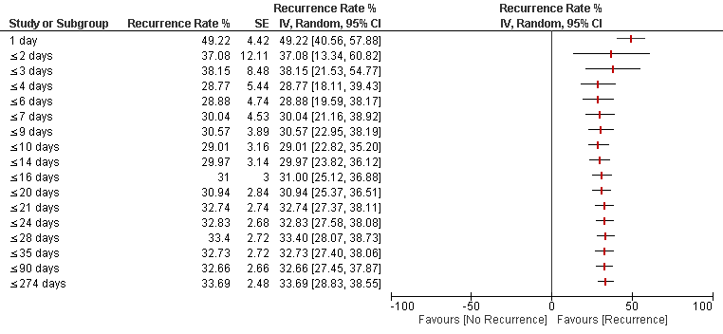
(Analysis 1.3) PAF Intermittent Monitoring by Total Duration of Rhythm Monitoring (days)-Fixed Effects.
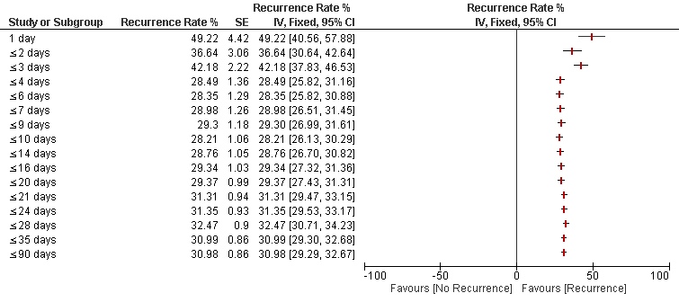
(Analysis 1.4) PAF Intermittent Monitoring by Total Duration of Rhythm Monitoring (days)-Random Effects.
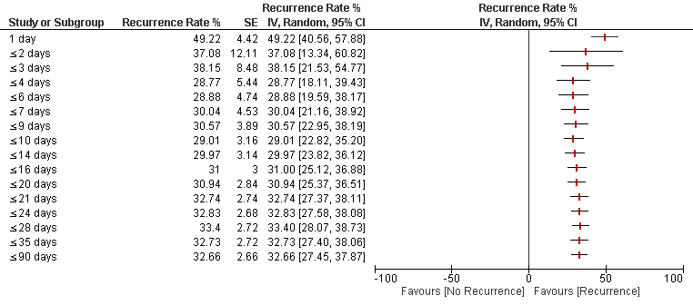

(Analysis 1.5) All PeAF/Combined by Total Duration of Rhythm Monitoring (days)-Fixed Effects.
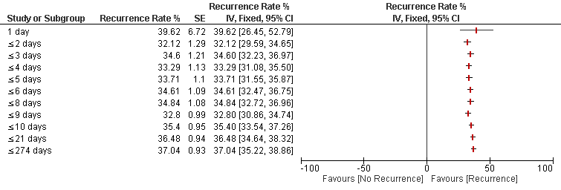

(Analysis 1.6) All PeAF/Combined by Total Duration of Rhythm Monitoring (days)-Random Effects.
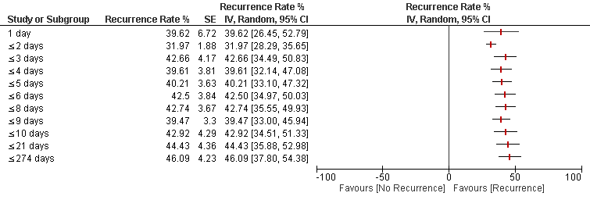
(Analysis 1.7) PeAF/Combined, 12-month, Intermittent by Total Duration of Rhythm Monitoring (days)-Fixed Effects.
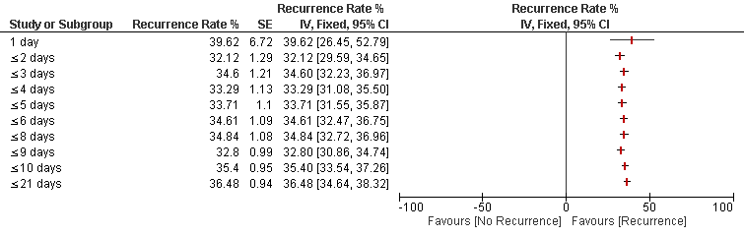

(Analysis 1.8) PeAF/Combined, 12-month Intermittent by Total Duration of Rhythm Monitoring (days)-Random Effects.
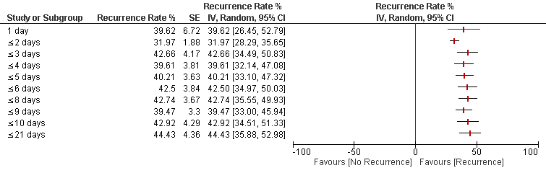

Supplemental Materials References:

1. Andrade JG, Champagne J, Dubuc M, et al. Cryoballoon or Radiofrequency Ablation for Atrial Fibrillation Assessed by Continuous Monitoring: A Randomized Clinical Trial. Circulation. 2019;140:1779-1788.
2. Andrade JG, Wells GA, Deyell MW, et al. Cryoablation or Drug Therapy for Initial Treatment of Atrial Fibrillation. N Engl J Med. 2021;384:305-315.
3. Arbelo E, Guiu E, Ramos P, et al. Benefit of left atrial roof linear ablation in paroxysmal atrial fibrillation: a prospective, randomized study. J Am Heart Assoc. 2014;3:e000877.
4. Atienza F, Almendral J, Ormaetxe JM, et al. Comparison of radiofrequency catheter ablation of drivers and circumferential pulmonary vein isolation in atrial fibrillation: a noninferiority randomized multicenter RADAR-AF trial. J Am Coll Cardiol. 2014;64:2455-2467.
5. Boersma LV, van der Voort P, Debruyne P, et al. Multielectrode Pulmonary Vein Isolation Versus Single Tip Wide Area Catheter Ablation for Paroxysmal Atrial Fibrillation: A Multinational Multicenter Randomized Clinical Trial. Circ Arrhythm Electrophysiol. 2016;9:e003151.
6. Chen M, Yang B, Chen H, et al. Randomized comparison between pulmonary vein antral isolation versus complex fractionated electrogram ablation for paroxysmal atrial fibrillation. J Cardiovasc Electrophysiol. 2011;22:973-981.
7. Cosedis Nielsen J, Johannessen A, Raatikainen P, et al. Radiofrequency ablation as initial therapy in paroxysmal atrial fibrillation. N Engl J Med. 2012;367:1587-1595.
8. Elayi CS, Fahmy TS, Martin DO, et al. Atrial fibrillation ablation strategies for paroxysmal patients randomized comparison between different techniques. Circ Arrhythm Electrophysiol. 2009;2:113-119.
9. Duytschaever M DA, Phlips T, Sarkozy A, El Haddad M, Taghji P, Knecht S, Tavernier R, Vandekerckhove Y, De Potter T,. PulmOnary vein isolation With vs. without continued antiarrhythmic Drug trEatment in subjects with Recurrent Atrial Fibrillation (POWDER AF): results from a multicentre randomized trial. Eur Heart J. 2018;39:1429.
10. Ejima K, Kato K, Okada A, et al. Comparison Between Contact Force Monitoring and Unipolar Signal Modification as a Guide for Catheter Ablation of Atrial Fibrillation. Circ Arrhythm Electrophysiol. 2019;12:e007311.
11. Fiala M, Chovancik J, Nevralova R, et al. Pulmonary vein isolation using segmental versus electroanatomical circumferential ablation for paroxysmal atrial fibrillation: over 3-year results of a prospective randomized study. J Interv Card Electrophysiol. 2008;22:13-21.
12. Fichtner S, Hessling G, Ammar S, et al. A prospective randomized study comparing isolation of the arrhythmogenic vein versus all veins in paroxysmal atrial fibrillation. Clin Cardiol. 2013;36:422-426.
13. Gavin AR, Singleton CB, Bowyer J, McGavigan AD. Pulmonary venous isolation versus additional substrate modification as treatment for paroxysmal atrial fibrillation. J Interv Card Electrophysiol. 2012;33:101-107.
14. Giannopoulos G, Kossyvakis C, Efremidis M, et al. Central sympathetic inhibition to reduce postablation atrial fibrillation recurrences in hypertensive patients: a randomized, controlled study. Circulation. 2014;130:1346-1352.
15. Gula LJ, Leong-Sit P, Manlucu J, et al. Pulmonary Vein Isolation With Incomplete Antral Ablation Lines: Is More Ablation Necessary? Results of a Randomized Trial. J Cardiovasc Electrophysiol. 2016;27:298-302.
16. Hunter RJ, Baker V, Finlay MC, et al. Point-by-Point Radiofrequency Ablation Versus the Cryoballoon or a Novel Combined Approach: A Randomized Trial Comparing 3 Methods of Pulmonary Vein Isolation for Paroxysmal Atrial Fibrillation (The Cryo Versus RF Trial). J Cardiovasc Electrophysiol. 2015;26:1307-1314.
17. Iskandar S, Reddy M, Afzal MR, et al. Use of Oral Steroid and its Effects on Atrial Fibrillation Recurrence and Inflammatory Cytokines Post Ablation - The Steroid AF Study. J Atr Fibrillation. 2017;9:1604.
18. Kim TH, Park J, Park JK, et al. Linear ablation in addition to circumferential pulmonary vein isolation (Dallas lesion set) does not improve clinical outcome in patients with paroxysmal atrial fibrillation: a prospective randomized study. Europace : European pacing, arrhythmias, and cardiac electrophysiology : journal of the working groups on cardiac pacing, arrhythmias, and cardiac cellular electrophysiology of the European Society of Cardiology. 2015;17:388-395.
19. Kuck KH, Brugada J, Furnkranz A, et al. Cryoballoon or Radiofrequency Ablation for Paroxysmal Atrial Fibrillation. N Engl J Med. 2016;374:2235-2245.
20. Kuck KH, Lebedev DS, Mikhaylov EN, et al. Catheter ablation or medical therapy to delay progression of atrial fibrillation: the randomized controlled atrial fibrillation progression trial (ATTEST). Europace. 2021;23:362-369.
21. Kuhne M, Suter Y, Altmann D, et al. Cryoballoon versus radiofrequency catheter ablation of paroxysmal atrial fibrillation: biomarkers of myocardial injury, recurrence rates, and pulmonary vein reconnection patterns. Heart rhythm. 2010;7:1770-1776.
22. Macle L, Khairy P, Weerasooriya R, et al. Adenosine-guided pulmonary vein isolation for the treatment of paroxysmal atrial fibrillation: an international, multicentre, randomised superiority trial. Lancet. 2015;386:672-679.
23. McCready J, Chow AW, Lowe MD, et al. Safety and efficacy of multipolar pulmonary vein ablation catheter vs. irrigated radiofrequency ablation for paroxysmal atrial fibrillation: a randomized multicentre trial. Europace. 2014;16:1145-1153.
24. McLellan A, Ling L, Azzopardi S, et al. A minimal or maximal ablation strategy to achieve pulmonary vein isolation for paroxysmal atrial fibrillation: A prospective multi-centre randomised controlled trial (the Minimax Study). Heart Lung Circ. 2015;24:S235.
25. Pedrote A, Arana-Rueda E, Arce-Leon A, et al. Impact of Contact Force Monitoring in Acute Pulmonary Vein Isolation Using an Anatomic Approach. A Randomized Study. Pacing Clin Electrophysiol. 2016;39:361-369.
26. Perez-Castellano N, Fernandez-Cavazos R, Moreno J, et al. The COR trial: a randomized study with continuous rhythm monitoring to compare the efficacy of cryoenergy and radiofrequency for pulmonary vein isolation. Heart rhythm. 2014;11:8-14.
27. Podd SJ, Sulke N, Caulfield D, Kirubakaran S, Furniss SS. Phased multipolar radiofrequency (RF) pulmonary vein ablation catheter (pvacTM) pulmonary vein isolation (PVI) is as effective and safe as conventional lasso guided irrigated RF point to point ablation-a prospective randomised 1 year device holter follow-up trial in patients with paroxysmal atrial fibrillation. Heart rhythm. 2012;9:S28.
28. Schaeffer B, Willems S, Meyer C, et al. Contact force facilitates the achievement of an unexcitable ablation line during pulmonary vein isolation. Clin Res Cardiol. 2018;107:632-641.
29. Skala T, Tudos Z, Moravec O, et al. Atrial fibrillation inducibility after pulmonary vein isolation under general anaesthesia. Biomed Pap Med Fac Univ Palacky Olomouc Czech Repub. 2019.
30. Steinberg JS, Shabanov V, Ponomarev D, et al. Effect of Renal Denervation and Catheter Ablation vs Catheter Ablation Alone on Atrial Fibrillation Recurrence Among Patients With Paroxysmal Atrial Fibrillation and Hypertension: The ERADICATE-AF Randomized Clinical Trial. JAMA. 2020;323:248-255.
31. Ucer E, Fredersdorf S, Seegers J, et al. High Predictive Value of Adenosine Provocation in Predicting Atrial Fibrillation Recurrence After Pulmonary Vein Isolation With Visually Guided Laser Balloon Compared With Radiofrequency Ablation. Circ J. 2020;84:404-410.
32. Ullah W, McLean A, Tayebjee MH, et al. Randomized trial comparing pulmonary vein isolation using the SmartTouch catheter with or without real-time contact force data. Heart rhythm. 2016.
33. Qiqi W, Yunpeng S, Zhen W, et al. Perindopril for the prevention of atrial fibrillation recurrence after radiofrequency catheter ablation: One-year experience. Heart rhythm. 2016;13:2040-2047.
34. Wazni OM, Dandamudi G, Sood N, et al. Cryoballoon Ablation as Initial Therapy for Atrial Fibrillation. N Engl J Med. 2021;384:316-324.
35. Xu Q, Ju W, Xiao F, et al. Circumferential pulmonary vein antrum ablation for the treatment of paroxysmal atrial fibrillation: A randomized controlled trial. Pacing Clin Electrophysiol. 2020;43:280-288.
36. Zhao X, Zhang J, Hu J, et al. Pulmonary antrum radial-linear ablation for paroxysmal atrial fibrillation: Interim analysis of a multicenter trial. Eur Heart J. 2013;34:1095.
37. Chauhan VS, Verma A, Nayyar S, et al. Focal source and trigger mapping in atrial fibrillation: Randomized controlled trial evaluating a novel adjunctive ablation strategy. Heart rhythm. 2020;17:683-691.
38. Chun JKR, Bordignon S, Last J, et al. Cryoballoon Versus Laserballoon: Insights From the First Prospective Randomized Balloon Trial in Catheter Ablation of Atrial Fibrillation. Circ Arrhythm Electrophysiol. 2021;14:e009294.
39. Elayi CS, Verma A, Di Biase L, et al. Ablation for longstanding permanent atrial fibrillation: results from a randomized study comparing three different strategies. Heart rhythm. 2008;5:1658-1664.
40. Fink T, Schluter M, Heeger C-H, et al. Stand-Alone Pulmonary Vein Isolation Versus Pulmonary Vein Isolation With Additional Substrate Modification as Index Ablation Procedures in Patients With Persistent and Long-Standing Persistent Atrial Fibrillation: The Randomized Alster-Lost-AF Trial (Ablation at St. Georg Hospital for Long-Standing Persistent Atrial Fibrillation). Circ Arrhythm Electrophysiol. 2017;10.
41. Lee JM, Shim J, Park J, et al. The Electrical Isolation of the Left Atrial Posterior Wall in Catheter Ablation of Persistent Atrial Fibrillation. JACC Clin Electrophysiol. 2019;5:1253-1261.
42. Pappone C, Ciconte G, Vicedomini G, et al. Clinical Outcome of Electrophysiologically Guided Ablation for Nonparoxysmal Atrial Fibrillation Using a Novel Real-Time 3-Dimensional Mapping Technique: Results From a Prospective Randomized Trial. Circ Arrhythm Electrophysiol. 2018;11:e005904.
43. Verma A, Jiang C-y, Betts TR, et al. Approaches to catheter ablation for persistent atrial fibrillation. N Engl J Med. 2015;372:1812-1822.
44. Wang M, Zhao Q, Ding W, Cai S. Comparison of Direct Current Synchronized Cardioversion to Ibutilide-Guided Catheter Ablation for Long-Term Sinus Rhythm Maintenance After Isolated Pulmonary Vein Isolation of Persistent Atrial Fibrillation. Am J Cardiol. 2017;119:1997-2002.
45. Borregaard R, Jensen HK, Tofig BJ, et al. Is the knowledge of contact force beneficial in pulmonary vein antrum isolation? Scand Cardiovasc J. 2017;51:129-137.
46. Dixit S, Gerstenfeld EP, Ratcliffe SJ, et al. Single procedure efficacy of isolating all versus arrhythmogenic pulmonary veins on long-term control of atrial fibrillation: a prospective randomized study. Heart rhythm. 2008;5:174-181.
47. Gaita F, Caponi D, Scaglione M, et al. Long-term clinical results of 2 different ablation strategies in patients with paroxysmal and persistent atrial fibrillation. Circ Arrhythm Electrophysiol. 2008;1:269-275.
48. Hu X, Jiang W, Wu S, et al. Extra-pulmonary vein driver mapping and ablation for persistent atrial fibrillation in obese patients. Europace. 2021;23:701-709.
49. Inoue K, Hikoso S, Masuda M, et al. Pulmonary vein isolation alone vs. more extensive ablation with defragmentation and linear ablation of persistent atrial fibrillation: the EARNEST-PVI trial. Europace. 2021;23:565-574.
50. Kiuchi MG, Chen S, E Silva GR, et al. Pulmonary vein isolation alone and combined with renal sympathetic denervation in chronic kidney disease patients with refractory atrial fibrillation. Kidney Res Clin Pract. 2016;35:237-244.
51. Kobori A, Shizuta S, Inoue K, et al. Adenosine triphosphate-guided pulmonary vein isolation for atrial fibrillation: the UNmasking Dormant Electrical Reconduction by Adenosine TriPhosphate (UNDER-ATP) trial. Eur Heart J. 2015;36:3276-3287.
52. Pokushalov E, Romanov A, Corbucci G, et al. A randomized comparison of pulmonary vein isolation with versus without concomitant renal artery denervation in patients with refractory symptomatic atrial fibrillation and resistant hypertension. J Am Coll Cardiol. 2012;60:1163-1170.
53. Pontoppidan J, Nielsen JC, Poulsen SH, et al. Prophylactic cavotricuspid isthmus block during atrial fibrillation ablation in patients without atrial flutter: a randomised controlled trial. Heart. 2009;95:994-999.
54. Rillig A, Schmidt B, Biase LD, et al. Manual Versus Robotic Catheter Ablation for the Treatment of Atrial Fibrillation. The Man and Machine Trial. JACC Clin Electrophysiol. 2017.
55. Verma A, Mantovan R, Macle L, et al. Substrate and Trigger Ablation for Reduction of Atrial Fibrillation (STAR AF): a randomized, multicentre, international trial. Eur Heart J. 2010;31:1344-1356.
56. Yu HT, Shim J, Park J, et al. Pulmonary Vein Isolation Alone Versus Additional Linear Ablation in Patients With Persistent Atrial Fibrillation Converted to Paroxysmal Type With Antiarrhythmic Drug Therapy: A Multicenter, Prospective, Randomized Study. Circ Arrhythm Electrophysiol. 2017;10.

