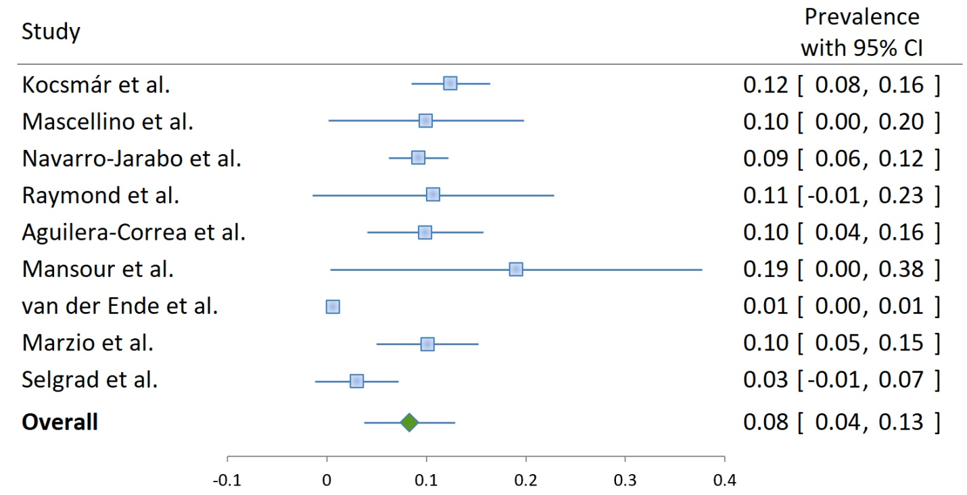
Figure S1: Clarithromycin resistance in Helicobacter pylori-positive samples/isolates in Europe.

