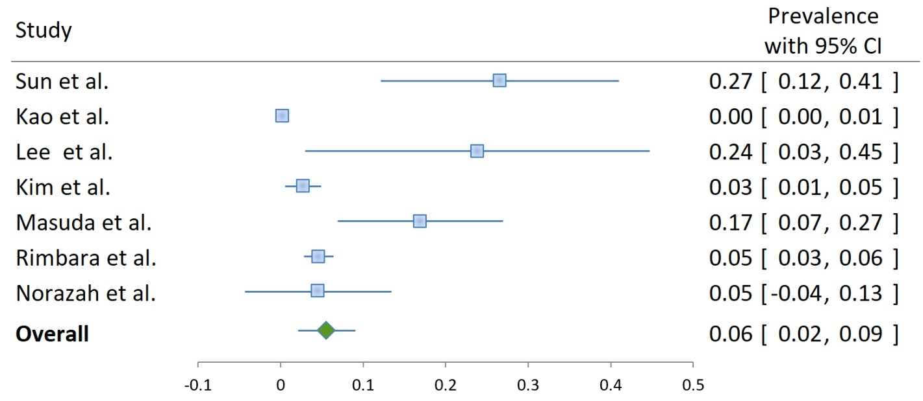
Figure S2 Clarithromycin resistance in Helicobacter pylori-positive samples or isolates in Asia.

