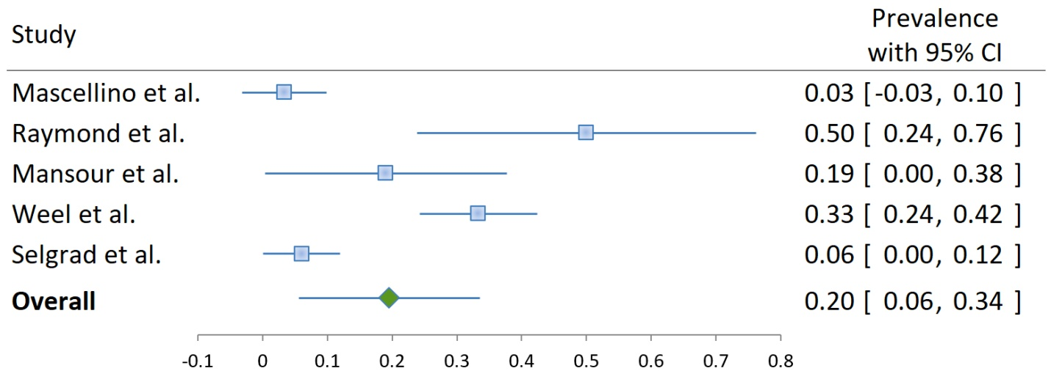
Figure S3: Metronidazole resistance in Helicobacter pylori-positive samples or isolates in Europe.

