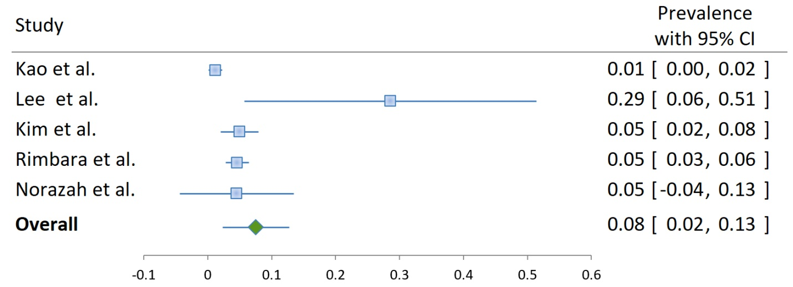
Figure S4: Metronidazole resistance in Helicobacter pylori-positive samples or isolates in Asia

