Additional file 5_doc1_extrafigures
Funnel plots and leave-one-meta-analysis figures

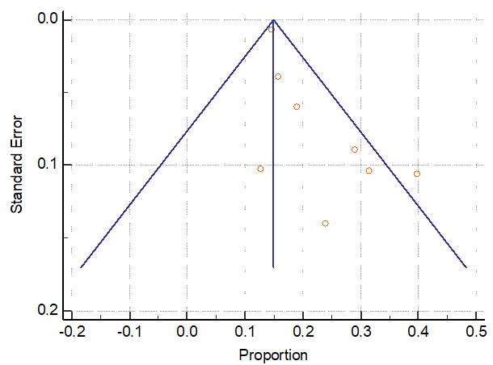
Figure 4: Funnel plot for studies included in the meta-analysis of the proportion of acute kidney injury among older adults prescribed glycopeptides before sensitivity analysis.

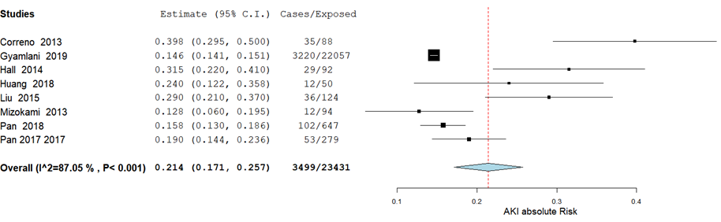
Figure 5: Meta-analysis of the proportion of acute kidney injury among older adults prescribed glycopeptides before sensitivity analysis
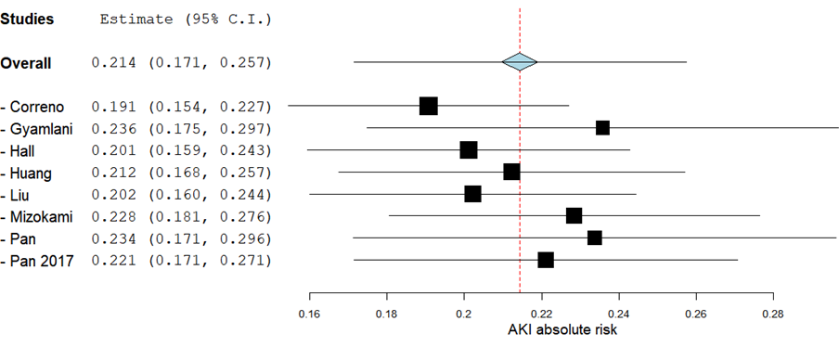
Figure 6: Sensitivity analysis for the studies included in the metal analysis of AKI due to glycopeptides (Leave one out approach)
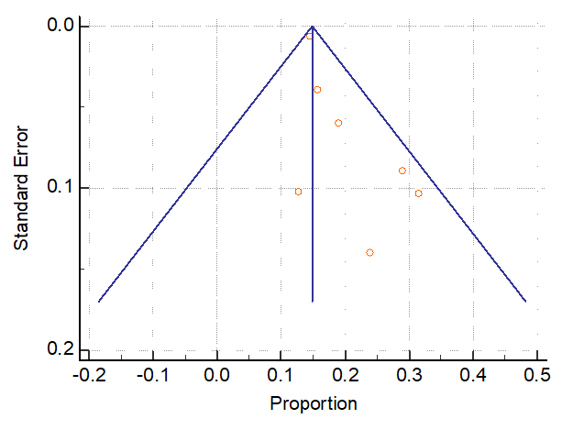
Figure 7: Funnel plot for studies included in the meta-analysis of the proportion of acute kidney injury among older adults prescribed glycopeptides after removing the outlier.

