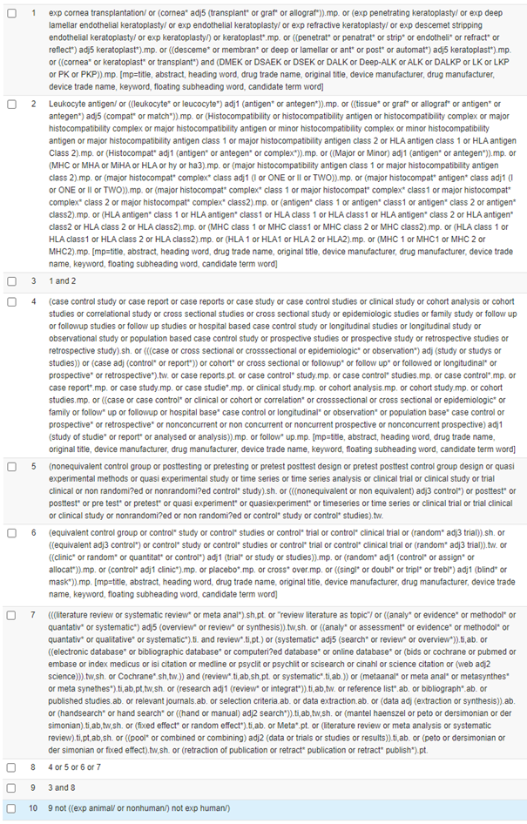
Ovid Embase sample search strategy

