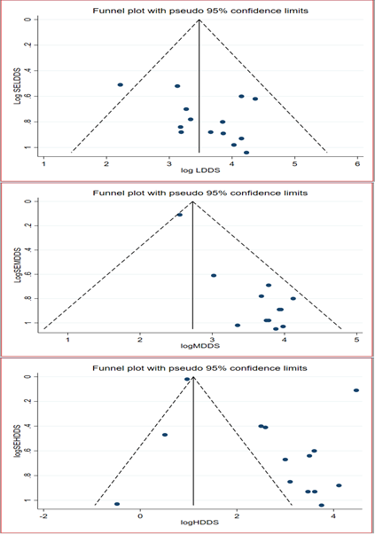
Supplementary Figure: Funnel plots of LDDS, MDDS and HDDS of pregnant and lactating women in Ethiopia.

