Jie Yang et al: COVID-19 Pandemic and Population-level Pregnancy and Neonatal Outcomes: A Systematic Review and Meta-analysis
Supporting Information Tables and Figures
Appendix Element | Page
Appendix S1. Search Strategies | 2
Appendix S2. Excluded Studies and Reasons for Exclusion | 5
Appendix S3. Forest Plot for Odds of Preterm Birth <34 Weeks’ Gestation | 7
Appendix S4. Forest Plot for Odds of Preterm Birth <32 Weeks’ Gestation | 8
Appendix S5. Forest Plot for Odds of Preterm Birth <28 Weeks’ Gestation | 9
Appendix S6. Forest Plot for Odds of Spontaneous Preterm Birth | 10
Appendix S7. Forest Plot for Odds of Induced Preterm Birth | 11
Appendix S8. Forest plot of adjusted odds of stillbirth | 12
Appendix S9. Forest Plot for Mean Birth weight | 13
Appendix S10. Forest Plot for Odds of Low Birth Weight | 14
Appendix S11. Forest Plot for Odds of Very Low Birth Weight | 15
Appendix S12. Forest Plot for Odds of Extremely Low Birth Weight | 16
Appendix S13. Forest Plot for Odds of Neonatal Mortality | 17
Appendix S14. Funnel Plot for Preterm Birth <37 Weeks’ Gestation | 18
Appendix S15. Funnel Plot for Stillbirth | 19

Appendix S1. Search Strategies
MEDLINE search strategy (until August 14, 2021)
1 | exp Coronavirus/
2 | exp Coronavirus Infections/
3 | (coronavirus* or corona virus* or corona virinae* or coronavirinae* or OC43 or NL63 or 229E or HKU1 or HCoV* or covid* or ncov* or coV or sars-cov* or sarscov* or Sars-coronavirus* or Severe Acute Respiratory Syndrome Coronavirus* or 2019-ncov or 2019-novel CoV or SARS-like coronavirus*).mp.
4 | ((novel or new or nouveau) adj2 pandemi*).mp.
5 | ((pneumonia or sars*).mp. or exp pneumonia/) and Wuhan.mp.
6 | (COVID-19 or severe acute respiratory syndrome coronavirus 2).os,ps,rs,ox,px,rx,nm.
7 | or/1-6
8 | exp Pregnancy/
9 | exp Pregnancy Complications/
10 | exp Pregnancy Outcome/
11 | exp Obstetrics/
12 | exp Maternal Health Services/
13 | exp Fetus/
14 | exp Infant, Newborn/
15 | Pregnant Women/
16 | (pregnan* or gestation* or parturition or neonatal* or neo natal* or neonate* or ante natal* or antenatal* or pre natal* or prenatal* or puerper* or postnatal* or postpartum or post partum or post natal* or peripartum or peri partum or intrapartum or intra partum or prepregnancy or pre pregnancy or preconception* or pre conception* or periconception* or peri conception* or preterm or premature or labo?r or newborn* or new born* or fetal or foetal or fetus or foetus or miscarriage* or obstetric*).tw,kf,kw.
17 | Infant, Premature/
18 | Infant, Extremely Premature/
19 | Infant, Low Birth Weight/
20 | Infant, Small for Gestational Age/
21 | Infant, Very Low Birth Weight/
22 | Infant, Extremely Low Birth Weight/
23 | ((Prematur* or Pre-matur* or Preterm* or Pre-term*) adj1 (Infan* or Newborn* or Neonat* or baby* or babies)).tw,kf,kw.
24 | (Low adj1 (Birth Weight or Birth Size)).tw,kf,kw.
25 | (Low-Birth-Weight or LBW).tw,kf,kw.
26 | or/8-25
27 | 7 and 26
28 | 27
29 | limit 28 to english language and human

Embase and Embase Plus search strategy (until August 14, 2021)
1 | exp Coronavirus/
2 | exp Coronavirus Infections/
3 | (coronavirus* or corona virus* or corona virinae* or coronavirinae* or OC43 or NL63 or 229E or HKU1 or HCoV* or covid* or ncov* or coV or sars-cov* or sarscov* or Sars-coronavirus* or Severe Acute Respiratory Syndrome Coronavirus* or 2019-ncov or 2019-novel CoV or SARS-like coronavirus*).mp.
4 | ((novel or new or nouveau) adj2 pandemi*).mp.
5 | ((pneumonia or sars*).mp. or exp pneumonia/) and Wuhan.mp.
6 | (COVID-19 or severe acute respiratory syndrome coronavirus 2).os,ps,rs,ox,px,rx,nm.
7 | or/1-6
8 | exp Pregnancy/
9 | exp Pregnancy Complications/
10 | exp Pregnancy Outcome/
11 | exp Obstetrics/
12 | exp Maternal Health Services/
13 | exp Fetus/
14 | exp Infant, Newborn/
15 | Pregnant Women/
16 | (pregnan* or gestation* or parturition or neonatal* or neo natal* or neonate* or ante natal* or antenatal* or pre natal* or prenatal* or puerper* or postnatal* or postpartum or post partum or post natal* or peripartum or peri partum or intrapartum or intra partum or prepregnancy or pre pregnancy or preconception* or pre conception* or periconception* or peri conception* or preterm or premature or labo?r or newborn* or new born* or fetal or foetal or fetus or foetus or miscarriage* or obstetric*).tw,kf,kw.
17 | Infant, Premature/
18 | Infant, Extremely Premature/
19 | Infant, Low Birth Weight/
20 | Infant, Small for Gestational Age/
21 | Infant, Very Low Birth Weight/
22 | Infant, Extremely Low Birth Weight/
23 | ((Prematur* or Pre-matur* or Preterm* or Pre-term*) adj1 (Infan* or Newborn* or Neonat* or baby* or babies)).tw,kf,kw.
24 | (Low adj1 (Birth Weight or Birth Size)).tw,kf,kw.
25 | (Low-Birth-Weight or LBW).tw,kf,kw.
26 | or/8-25
27 | 7 and 26
28 | 27
29 | limit 28 to english language
30 | limit 29 to humans

Appendix S2. Excluded Studies and Reasons for Exclusion
Author | Reasons for Exclusion
Arun¹ | Different outcome reported
Feldman² | Awaiting assessment
Ghesquiere³ | Different outcome reported
Goldenberg⁴ | Different outcome reported
Homer⁵ | Different to study objective
Kaempf⁶ | No comparison between pandemic and pre-pandemic periods; irrelevant outcome
Kugelman⁷ | Different outcome reported
Liao⁸ | Outcomes of maternal infections with COVID-19
Maeda⁹ | Details of outcome not available
Malhotra¹⁰ | Outcomes of maternal infections with COVID-19; no comparison
Mulji¹¹ | Awaiting assessment
Muhaidat¹² | No comparison between pandemic and pre-pandemic periods; irrelevant outcome
Nafees¹³ | Different to study objective
Naurin¹⁴ | Different outcome reported
Newnham¹⁵ | Awaiting assessment
Osanan¹⁶ | Editorial
Overbeck¹⁷ | Different study objective, no comparison between pandemic and pre-pandemic periods
Ozimek¹⁸ | Awaiting assessment
Shikuku¹⁹ | Awaiting assessment – Preprint only
Simpson²⁰ | Updated by latest study
Spurlin²¹ | Different to study objective
Tadesse²² | No comparison between pandemic and pre-pandemic periods; different outcome
Ucyigit²³ | Awaiting assessment
Vazquez-Vazquez²⁴ | Different to study objective
Viswanatha²⁵ | Awaiting assessment
Watson²⁶ | Awaiting assessment
Yaliwal²⁷ | No comparison between pandemic and pre-pandemic periods; different outcome

References
1. Arun Babu T, Sharmila V, Vishnu Bhat B. Curious scenario of changes in incidence of preterm births during COVID-19 pandemic. Pointers for future research? Eur J Obstet Gynecol Reprod Biol. 2020;253:333-334.
2. Feldman KM, Jagannatham S, Hussain FN, et al. 12 Observations from an inner city hospital during COVID-19: preterm birth rate and mode of delivery. American Journal of Obstetrics and Gynecology. 2021;224 (2 Supplement):S8.
3. Ghesquière L, Garabedian C, Drumez E, et al. Effects of COVID-19 pandemic lockdown on gestational diabetes mellitus: A retrospective study. Diabetes Metab. 2020;101201.
4. Goldenberg RL, McClure EM. Have Coronavirus Disease 2019 (COVID-19) Community Lockdowns Reduced Preterm Birth Rates? Obstet Gynecol. 2021;137:399-402.
5. Homer CSE, Leisher SH, Aggarwal N, et al. Counting stillbirths and COVID 19-there has never been a more urgent time. Lancet Glob Health. 2021;9:e10-e11.
6. Kaempf JW, Dirksen KM, Kockler NJ. Extremely premature infants, scarcity and the COVID-19 pandemic. Acta Paediatr. 2020;
7. Kugelman N, Lavie O, Assaf W, et al. Changes in the obstetrical emergency department profile during the COVID-19 pandemic. J Matern Fetal Neonatal Med. 2020;1-7.
8. Liao J, He X, Gong Q, Yang L, Zhou C, Li J. Analysis of vaginal delivery outcomes among pregnant women in Wuhan, China during the COVID-19 pandemic. Int J Gynaecol Obstet. 2020;150:53-57.
9. Maeda Y, Nakamura M, Ninomiya H, Ogawa K, Sago H, Miyawaki A. Trends in intensive neonatal care during the COVID-19 outbreak in Japan. Arch Dis Child Fetal Neonatal Ed. 2020;
10. Malhotra Y, Miller R, Bajaj K, Sloma A, Wieland D, Wilcox W. No change in cesarean section rate during COVID-19 pandemic in New York City. Eur J Obstet Gynecol Reprod Biol. 2020;253:328-329.
11. Mulji Y, Bishop C, Letchworth P. A review comparing in-utero death and placental abruption in 2020 to 2019. BJOG: An International Journal of Obstetrics and Gynaecology. 2021;128 (SUPPL 2):193.
12. Muhaidat N, Fram K, Thekrallah F, Qatawneh A, Al-Btoush A. Pregnancy During COVID-19 Outbreak: The Impact of Lockdown in a Middle-Income Country on Antenatal Healthcare and Wellbeing. Int J Womens Health. 2020;12:1065-1073.
13. M. Nafees FK. Pakistan's response to COVID-19 pandemic and efficacy of quarantine and partial lockdown: a review. Electron J Gen Med. 2020;17:
14. Naurin E, Markstedt E, Stolle D, et al. Pregnant under the pressure of a pandemic: a large-scale longitudinal survey before and during the COVID-19 outbreak. Eur J Public Health. 2021;31:7-13.
15. Newnham J. COVID-19: Preterm and stillbirth rates. Australian and New Zealand Journal of Obstetrics and Gynaecology. 2021;61 (SUPPL 1):140.
16. Osanan GC, Vidarte MFE, Ludmir J. Do not forget our pregnant women during the COVID-19 pandemic. Women Health. 2020;60:959-962.
17. Overbeck G, Graungaard AH, Rasmussen IS, et al. Pregnant women's concerns and antenatal care during COVID-19 lock-down of the Danish society. Dan Med J. 2020;67:
18. Ozimek JA, Greene N, Kilpatrick S, Naqvi M. 1114 Fetal demise during the COVID-19 pandemic: are rates increasing? American Journal of Obstetrics and Gynecology. 2021;224 (2 Supplement):S686-S687.
19. Shikuku D, Nyaoke I, Gichuru S, et al. Early indirect impact of COVID-19 pandemic on utilization and outcomes of reproductive, maternal, newborn, child and adolescent health services in Kenya. medRxiv. 2020;2020.2009.2009.20191247.
20. Simpson AN, Snelgrove JW, Sutradhar R, Everett K, Liu N, Baxter NN. Perinatal Outcomes During the COVID-19 Pandemic in Ontario, Canada. JAMA Netw Open. 2021;4:e2110104.
21. Spurlin EE, Han ES, Silver ER, et al. Where Have All the Emergencies Gone? The Impact of the COVID-19 Pandemic on Obstetric and Gynecologic Procedures and Consults at a New York City Hospital. J Minim Invasive Gynecol. 2020;
22. Tadesse E. Antenatal Care Service Utilization of Pregnant Women Attending Antenatal Care in Public Hospitals During the COVID-19 Pandemic Period. Int J Womens Health. 2020;12:1181-1188.
23. Ucyigit A, Burnie R, Martin H, Hassan M. Maternity outcomes during the Covid-19 pandemic: A single-site controlled retrospective observational study. BJOG: An International Journal of Obstetrics and Gynaecology. 2021;128 (SUPPL 2):195-196.
24. Vazquez-Vazquez A, Dib S, Rougeaux E, Wells JC, Fewtrell MS. The impact of the Covid-19 lockdown on the experiences and feeding practices of new mothers in the UK: Preliminary data from the COVID-19 New Mum Study. Appetite. 2021;156:104985.
25. Viswanatha DT, Viswanatha R, Shehata H, Ganapathy R. Covid-19 pandemic is not associated with an increased risk of perinatal mortality. BJOG: An International Journal of Obstetrics and Gynaecology. 2021;128:90.
26. Watson H, Adeluwoye T, Mehta M. A cross-sectional study of the impact of the COVID-19 pandemic on preterm birth rates on an innercity population. BJOG: An International Journal of Obstetrics and Gynaecology. 2021;128 (SUPPL 1):129.
27. Ostacoli L, Cosma S, Bevilacqua F, et al. Psychosocial factors associated with postpartum psychological distress during the Covid-19 pandemic: a cross-sectional study. BMC Pregnancy Childbirth. 2020;20:703.

Appendix S3. Forest Plot for Odds of Preterm Birth <34 Weeks’ Gestation in Pandemic vs Pre-pandemic Periods
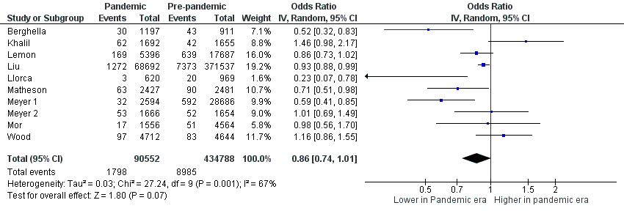
Abbreviations: CI, confidence interval; IV, inverse variance.
Appendix S4. Forest Plot for Odds of Preterm Birth <32 Weeks’ Gestation in Pandemic vs Pre-pandemic Periods
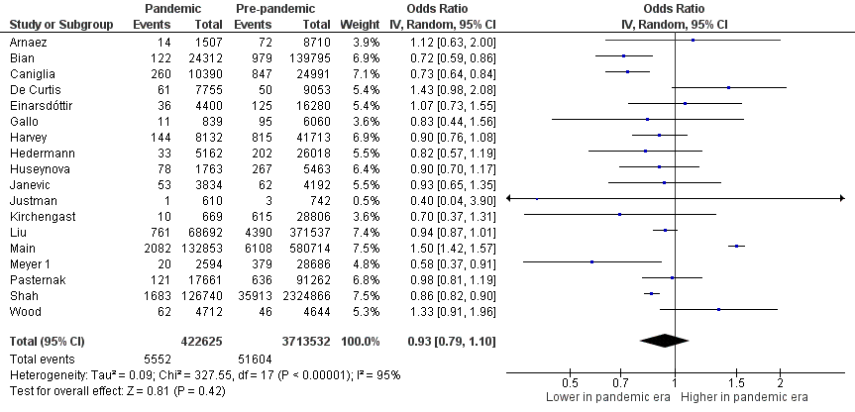
Abbreviations: CI, confidence interval; IV, inverse variance.
Appendix S5. Forest Plot for Odds of Preterm Birth <28 Weeks’ Gestation in Pandemic vs Pre-pandemic Periods
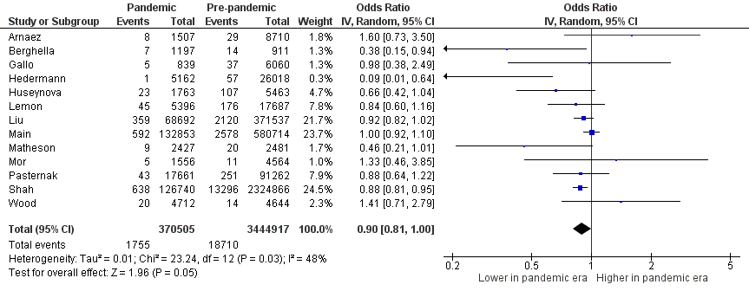
Abbreviations: CI, confidence interval; IV, inverse variance.
Appendix S6. Forest Plot for Odds of Spontaneous Preterm Birth in Pandemic vs Pre-pandemic Periods 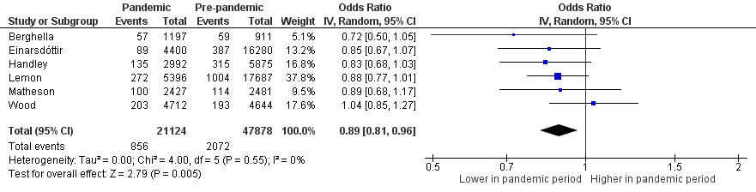

Abbreviations: CI, confidence interval; IV, inverse variance.
Appendix S7. Forest Plot for Odds of Induced Preterm Birth in Pandemic vs Pre-pandemic Periods
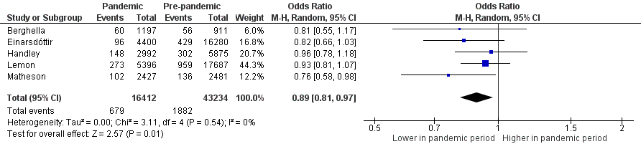
Abbreviations: CI, confidence interval; IV, inverse variance.
Appendix S8. Forest Plot for Adjusted Odds of Stillbirth
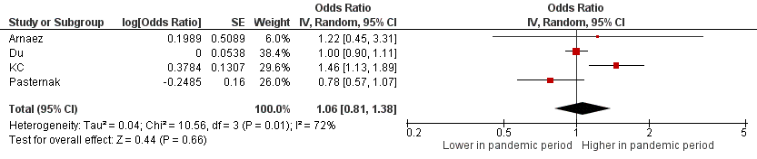
Abbreviations: CI, confidence interval; IV, inverse variance.
Appendix S9. Forest Plot for Mean Difference in Birth Weight in Pandemic vs Pre-pandemic Periods
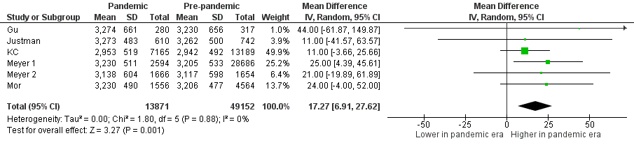
Abbreviations: CI, confidence interval; IV, inverse variance; SD, standard deviation.

Appendix S10. Forest Plot for Odds of Low Birth Weight in Pandemic vs Pre-pandemic Periods
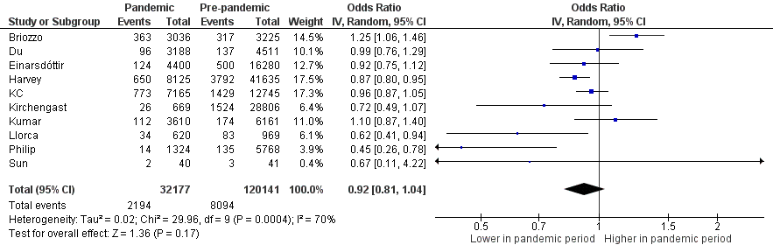
Abbreviations: CI, confidence interval; IV, inverse variance.
Appendix S11. Forest Plot for Odds of Very Low Birth Weight in Pandemic vs Pre-pandemic Periods
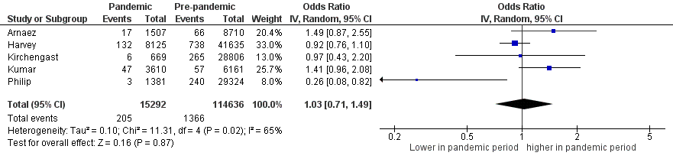
Abbreviations: CI, confidence interval; IV, inverse variance.
Appendix S12. Forest Plot for Odds of Extremely Low Birth Weight in Pandemic vs Pre-pandemic Periods
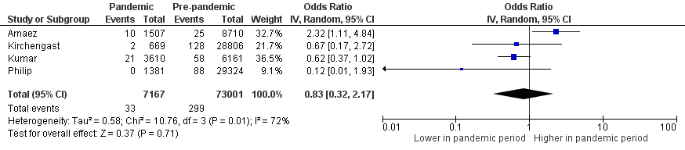
Abbreviations: CI, confidence interval; IV, inverse variance.

Appendix S13. Forest Plot for Odds of Neonatal Mortality in Pandemic vs Pre-pandemic Periods
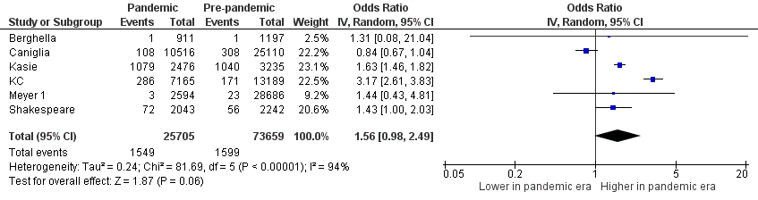
Abbreviations: CI, confidence interval; IV, inverse variance.

Appendix S14. Funnel Plot for Preterm Birth <37 Weeks’ Gestation

Appendix S15. Funnel Plot for Stillbirth

