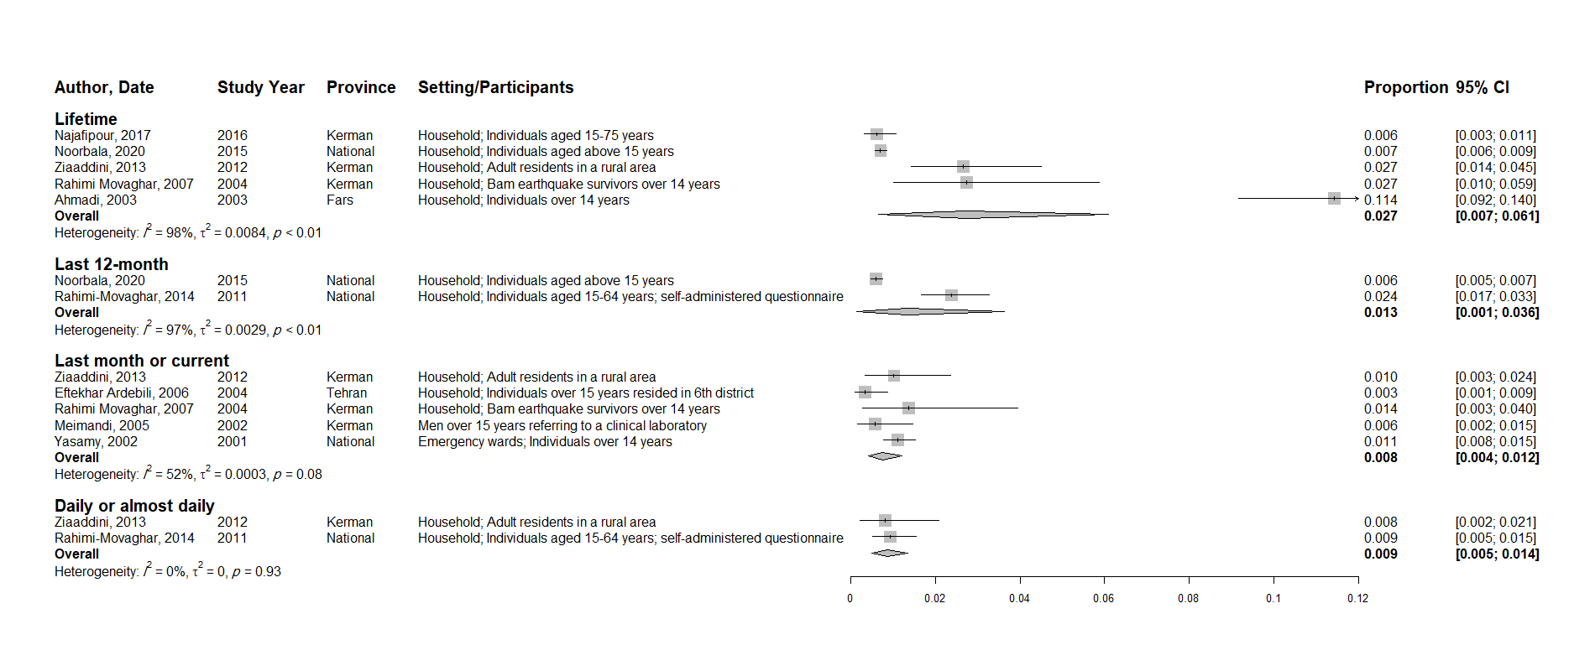
S1 Fig - The pooled prevalence of cannabis use among the male general population

