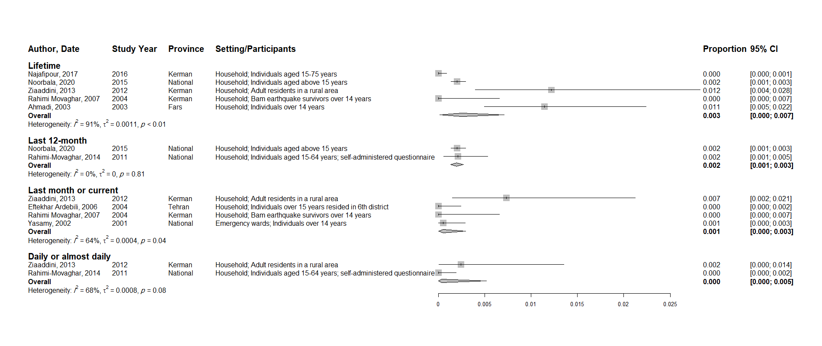
S2 Fig - The pooled prevalence of cannabis use among the female general population

