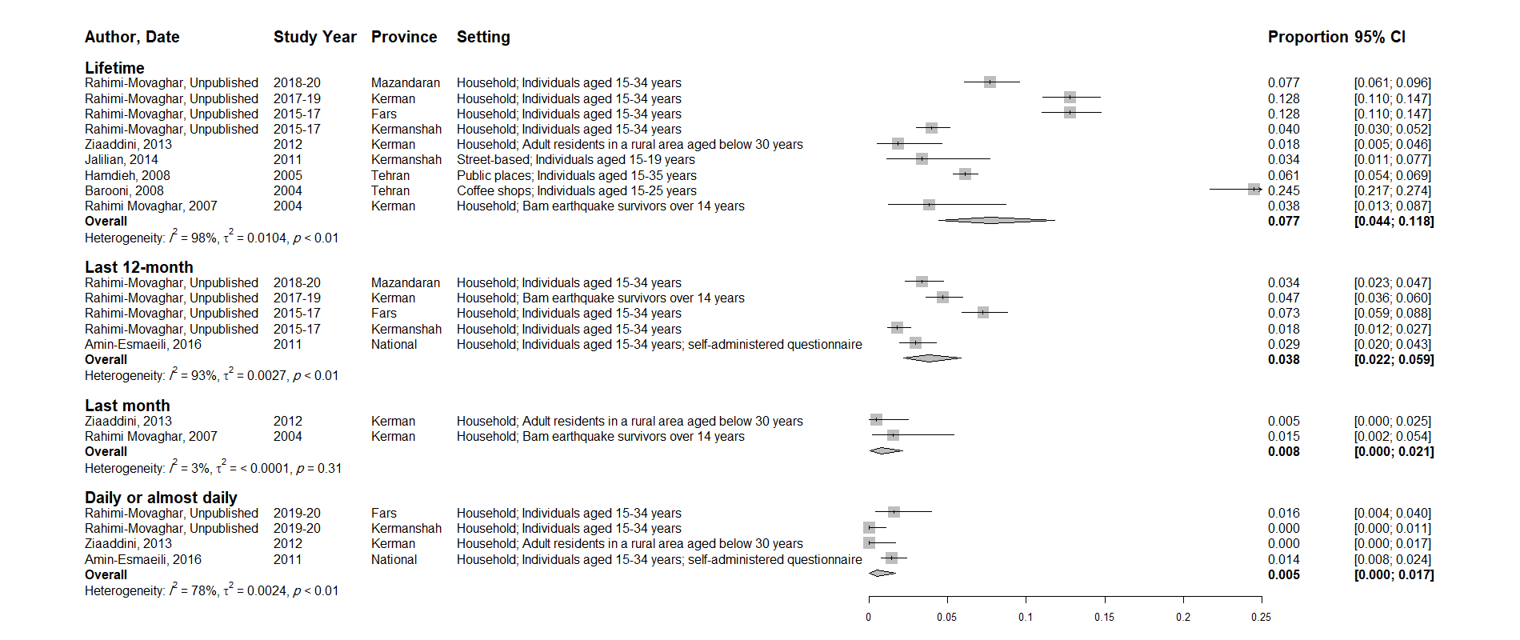
S3 Fig - The pooled prevalence of cannabis use among the male young general population

