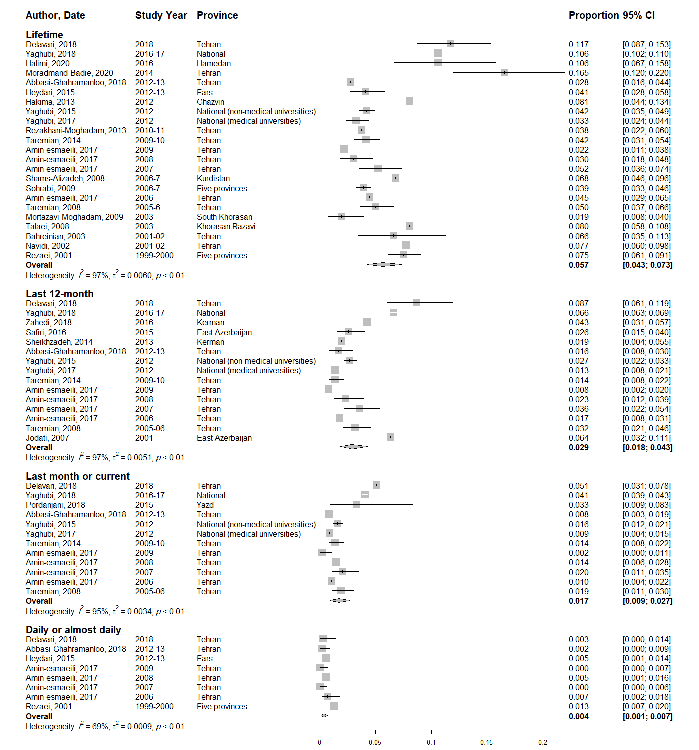
S5 Fig - The pooled prevalence of cannabis use among male university students

