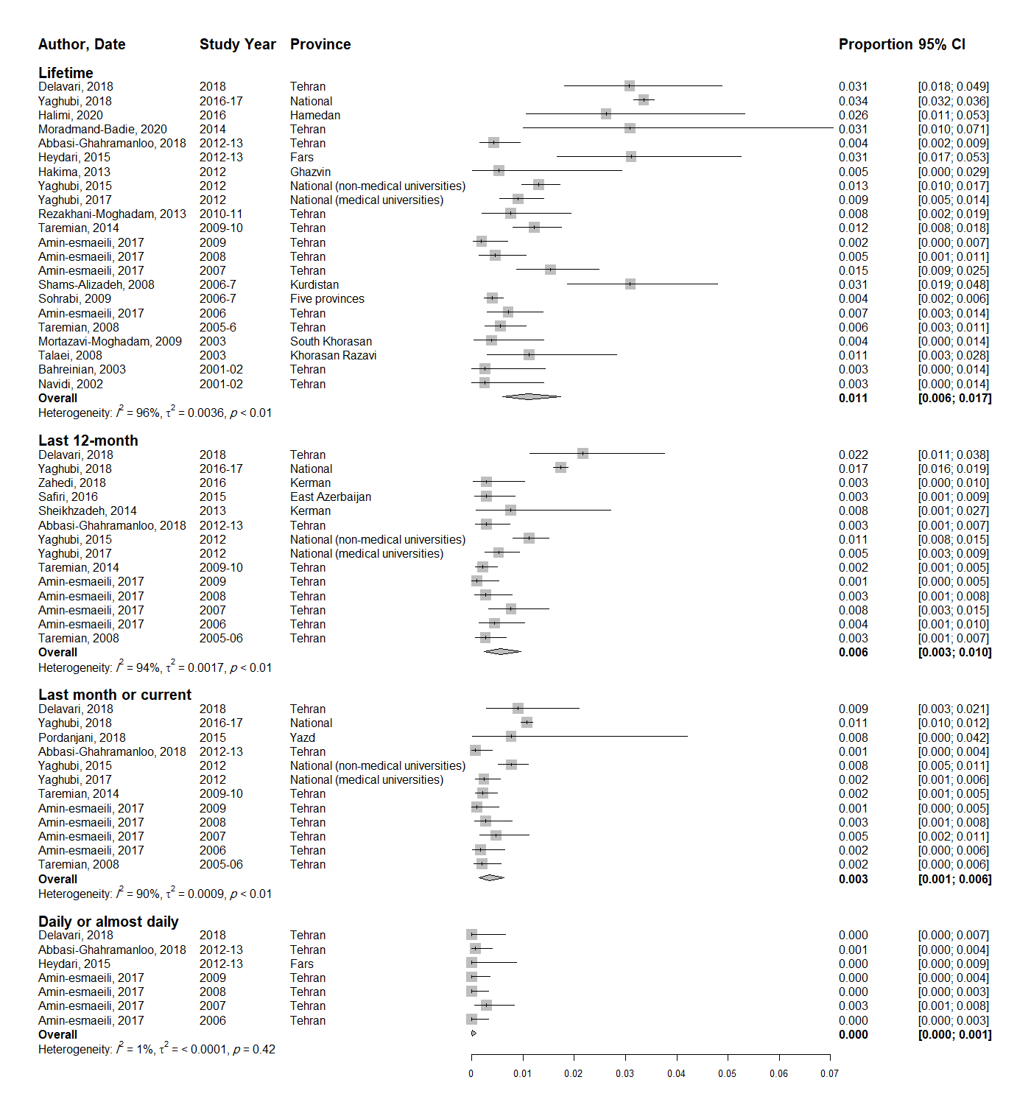
S6 Fig - The pooled prevalence of cannabis use among female university students

