S11 Fig– The pooled prevalence of last 12-month cannabis use among “combined youth groups” in different provinces; a) male subgroup b) female subgroup. The numbers on each province are the pooled estimates and the numbers in the parenthesis are the number of studies.

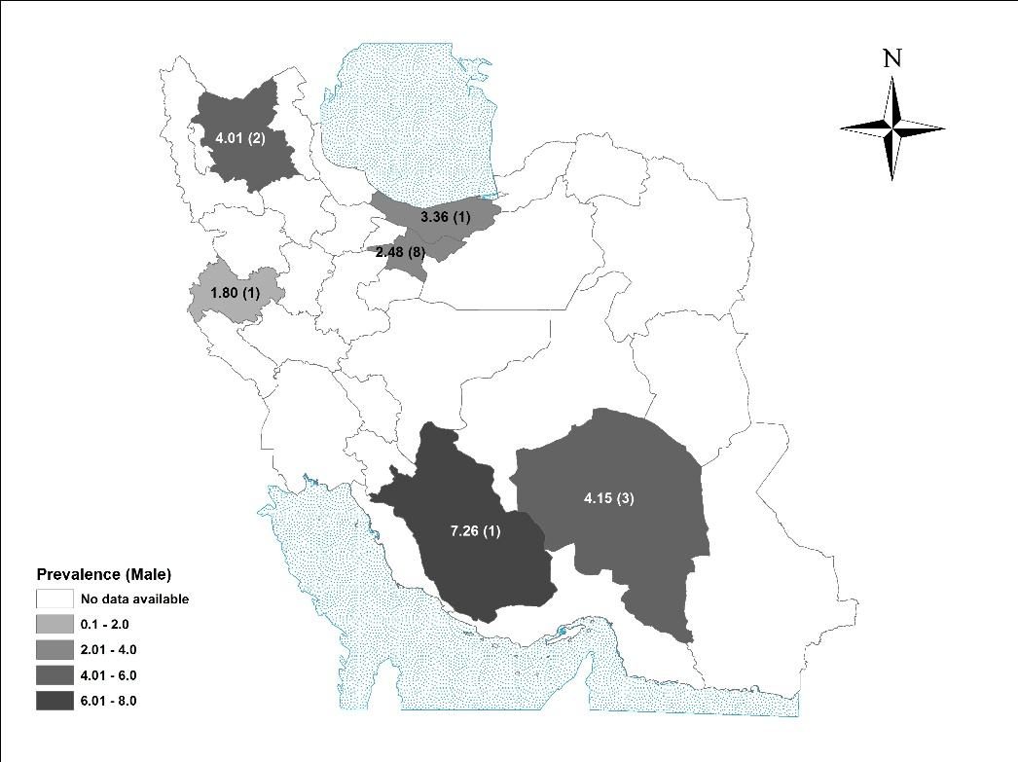
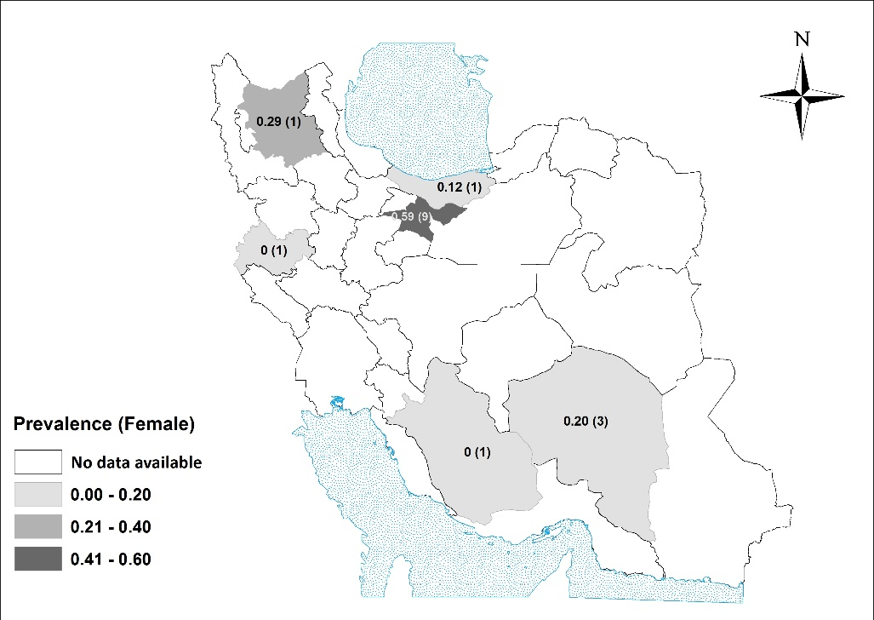
a
b

