Appendix.
A: Bystander CPR
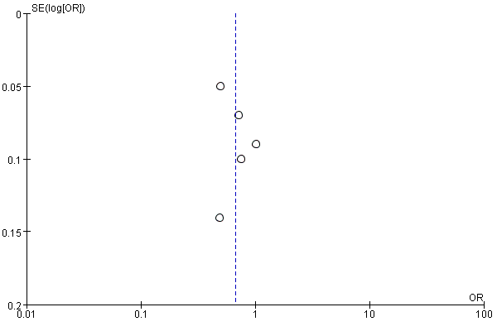
B: Survival to discharge
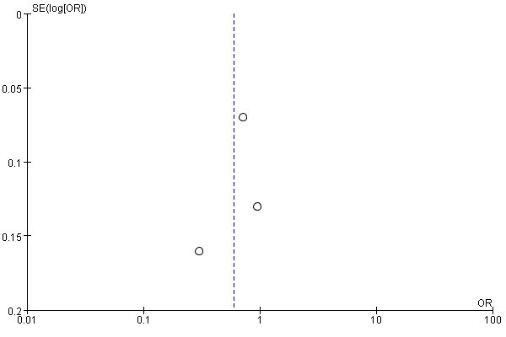
C: Neurologic recovery
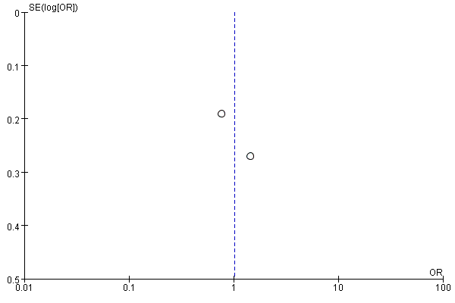
Figure 1. Funnel plots for outcomes with low SES communities compared with high SES communities of economic SES indicators. A: Bystander CPR; B: Survivals to discharge; C: Neurologic recovery.
A: Bystander CPR
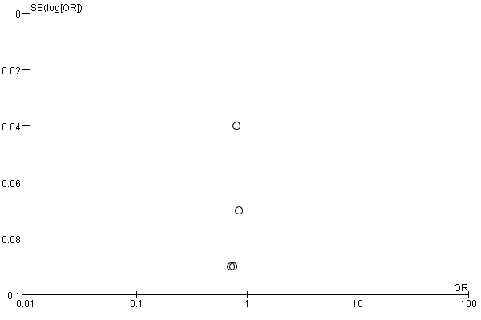
B: Survival to discharge
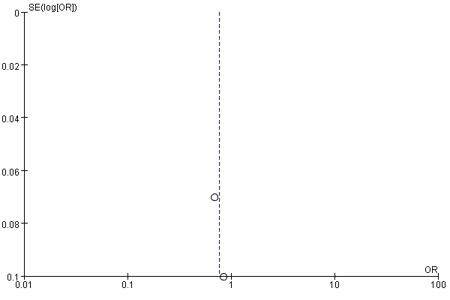
Figure 2. Funnel plots for outcomes with low SES communities compared with high SES communities of combined SES indicators. A: Bystander CPR; B: Survival to discharge.

