Dental plaque score reduction of the oscillating-rotating power toothbrush and the high frequency sonic power toothbrushes:

a systematic review and meta-analysis
of single brushing exercises

Online supplementary information

Online supporting information legends
Additional supporting information can be found in the online version of this article.

Appendix S1A. Overview of the included studies and characteristics processed for data extraction.
Appendix S1B. Study characteristics and heterogeneity assessments.

Appendix S2. Methodological, validity and quality scores and estimated risk of bias of the included studies.

Appendix S3. Overview of plaque index scores of the selected studies with various indices and their modifications. Baseline, end measurements and differences are presented as the (adjusted) means and standard deviations (SD) shown in parentheses. Statistically significant changes within groups are presented.

Appendix S4A. Forrest Plots of the performed meta-analysis for baseline-scores of the Modified Silness & Löe plaque index.
Appendix S4B. Forrest Plots of the performed meta-analysis for end-scores of the Modified Silness & Löe plaque index.
Appendix S4C. Trial Sequential Analysis (TSA) of the end scores of the Modified Silness & Löe plaque index (professional brushing). Plaque index for brushing with oscillating-rotating power toothbrush versus brushing with a high frequency sonic toothbrush.
Appendix S4D. Trial Sequential Analysis (TSA) of the end scores of Modified Silness & Löe plaque index (panellist brushing). Plaque index for brushing with oscillating-rotating power toothbrush versus brushing with a high frequency sonic toothbrush.

Appendix S5A. Forrest Plots of the performed meta-analysis for baseline-scores of the Modified Quigley & Hein plaque index.
Appendix S5B. Forrest Plots of the performed meta-analysis for end-scores of the

Modified Quigley & Hein plaque index.

Appendix S5C. Forrest Plots of the performed meta-analysis for difference-scores of the Modified Quigley & Hein plaque index.

Appendix S5D. Trial Sequential Analysis (TSA) of the end scores of the Modified Quigley & Hein plaque index. Plaque index for brushing with oscillating-rotating power toothbrush versus brushing with a high frequency sonic toothbrush.

Appendix S5E. Trial Sequential Analysis (TSA) of the difference scores of the Modified Quickly & Hein plaque index. Plaque index for brushing with oscillating-rotating power toothbrush versus brushing with a high frequency sonic toothbrush.

Appendix S6A. Forrest Plots of the performed meta-analysis for baseline-scores of the Rustogi Modified Navy plaque index.
Appendix S6B. Forrest Plots of the performed meta-analysis for end-scores of the
Rustogi Modified Navy plaque index.
Appendix S6C. Forrest Plots of the performed meta-analysis for difference-scores of the Rustogi Modified Navy plaque index.
Appendix S6D. Funnel Plots of the performed meta-analysis for difference-scores of the Rustogi Modified Navy plaque index.
Appendix S6E. Trial Sequential Analysis (TSA) of the end-scores of the Rustogi Modified Navy plaque index. Plaque index for brushing with oscillating-rotating power toothbrush versus brushing with a high frequency sonic toothbrush.
Appendix S6F. Trial Sequential Analysis (TSA) of the difference-scores of the Rustogi Modified Navy plaque index. Plaque index for brushing with oscillating-rotating power toothbrush versus brushing with a high frequency sonic toothbrush.

Appendix S7. Clinical relevance assessment of the plaque index scores using the variable plaque index.

Appendix S8. Overview of intra-oral safety assessments and their results.

Appendix S9. Overview of adverse events (AE) and their results.

Appendix S10. Overview of panellists questionnaire from the studies that included a questionnaire.

Appendix S11. Overview of the included studies, plaque score indexes and related companies.

Appendix S12. References used in the online appendices.

Appendix S1A. Overview of the included studies and characteristics processed for data extraction.

Authors  (year) | Study design, duration of experimental period  Blinding  Oral prophylaxis (OP) | # Participants baseline (end)  Gender  Mean age (SD)  Age range in years | Groups:  OR-PTB and/or HFS-PTB  Brush head  Mode  Brand  Dentifrice (DF) | Study procedures:  Regimen use & instruction  Professional/ participant  brushing | Indices  Conclusions of the original authors  Funding
Van der Weijden et al.  (1996-D1)¹ | RCT  Parallel  Split-mouth in 4 quadrants  Examiner-blind  Single use  OP  4 Experiments/ visits (4x pre-post)  3 comparisons | 24 (22)  Non-dental students  ♀: ?  ♂: ?  Age ?  Range ? | OR-PTB: Braun Plak Remover D7 with ? brush head Mode: ?/NA  OR-PTB: Braun Plak Remover D9 with EB9 brush head. Mode: ?/NA  HFS-PTB: Side to side PS-1  DF: none | 48 hours non-brushing  15, 30, 45, 60 seconds per quadrant,  Manufacture instructions  Professional brushing  Wash-out: NR | Modified Silness & Löe plaque index  No safety assessments  After professional brushing the OR-PTB D7 showed to have potential to be more effective than the HFS-PTB at 1, 2, 3 minutes brushing time, both the D7 and D9 were more effective than the HFS-PTB at 2 minute brushing time.  Funding: NR
Van der Weijden et al.  (1996-D2)¹ | RCT  Cross-over  Split-mouth in 4 quadrants  Examiner-blind  Single use  OP  4 Experiments/ visits (4x pre-post)  3 comparisons | 54 (49)  Non-dental students  ♀: ?  ♂: ?  Age ?  Range ? | OR-PTB: Braun Plak Remover D7 with ? brush head Mode: ?/NA  OR-PTB: Braun Plak Remover D9 with EB9 brush head. Mode: ?/NA  HFS-PTB: Side to side PS-1  DF: Zendium | 2 week familiarization period >2 minutes at least once daily  48 hours non-brushing  1, 2, 3, 4 minutes supervised brushing  Manufacture instructions  Professional brushing  Participant brushing  Wash-out: NR | Modified Silness & Löe plaque index  No safety assessments  After participants brushing the OR-PTB D7 showed to have potential to be more effective than the HFS-PTB at 1, 2, 3 minutes brushing time, in the hands of the participants, both the D7 and D9 were more effective than the HFS-PTB at 2 minute brushing time.  Funding: NR
Van der Weijden et al.  (1996-C1)² | RCT  Parallel  Contra-lateral split-mouth-model  Examiner-blind  Single use  1 Experiment/ visit (1x pre & post) | ? (35)  Non-dental students  ♀: 25  ♂: 10  Age ?  Range ? | OR-PTB: Braun/Oral-B Plak Control D7 with ? brush head. Mode: ?  HFS-PTB: Side to side with ? brush head. Mode: ?  DF: none | Approximately 2 week familiarization period  Brushing calendar  Manufacture instructions  24 hours non-brushing  Contra-lateral quadrants  30 Seconds per quadrant  Professional brushing | Modified Silness & Löe plaque index  No safety assessments  After professional brushing the OR-PTB is more effective in plaque removal than the HFS-PTB.  Funding: NR
Robinson et al. (1997)³ | RCT  Parallel  Examiner-blind  Single use and  6 months  OP  3 visits (2, 4, & 6 months pre-post) | 66 (54)  Adults with early-moderate periodontitis  ♀: 32◊  ♂: 22◊  Age ?  Range ?  Median age  42.5◊ | OR-PTB: Braun Oral-B D7 (Kronberg, Germany) with ? brush head  Mode: ?/NA?  HFS-PTB: Side to side Optiva Corporation, (Bellevue Washington) with ? brush head. Mode: ?/NA?  DF: Colgate Tartar Control Gel (Colgate, Palmolive, New York, NY) | 8-12 hours non-brushing (overnight)  Verbal and video instruction and need to demonstrate  Twice daily for 2 minutes with built-in timers  Regular flossers allowed  No other oral hygiene aids were allowed  Participant brushing  At 4 months replacement of brush head | Lobene modification of the Turesky modification of Quigley & Hein plaque index  Loesche Papillary Bleeding Score  Probing depths  Clinical attachment levels  No safety assessments  Both the OR-PTB and the HFS-PTB improved the mean overall plaque scores.  Funding: Optiva Corporation
Yankell & Emling (1997)⁴ | RCT  Parallel  Examiner-blind  Single use and  30 days  3 visits (baseline, day 15 & day 30 pre-post) | 128 (115◊)  Healthy participants  ♀: ?  ♂: ?  Age ?  Range 18-50 | OR-PTB: Braun Oral-B with ? brush head. Mode: ?  HFS-PTB: Side to side Optiva with ? brush head. Mode: ?  DF: single use Crest Regular (P&G Co, Cincinnati, OH, USA)  DF: 30 days own preferred DF | 10-16 hours non-brushing  Manufacture instructions  Twice daily 2 minutes for HFS-PTB and OR-PTB group  Rowena group: 2,5 minutes per brush head, in total 5 minutes  OR-PTB and HFS-PTB 2 minutes  Participants brushing | Turesky modification of Quigley & Hein plaque index of Ramfjord teeth  Eastman Bleeding index  Lobene Gingivitis score  Oral hard and soft tissue examination  Adverse events  The OR-PTB and the HFS-PTB removed statistically significant amounts of plaque after brushing.  Funding: NR
Sharma et al. (1998)⁵ | RCT  Parallel  Split-mouth-model  Examiner-blind  Single use  30 days/ 3 visits (only end-visit measured pre-post)  OP | 44 (44)  Population ?  ♀: 26  ♂: 18  36.6 (9.6)  22-60 | OR-PTB: Braun Oral-B 3D Plaque Remover D9 (Braun Oral-B, Kronenberg, Germany) with ? brush head. Mode: NA  HFS-PTB: Side to side Plus (Optiva Corp. Bellevue, WA, USA) with ? brush head. Mode: NA  DF: NR | 4 week training period twice daily brushing on alternative days  Individual visual aids, written instructions and models according to manufacturer’s instructions  Brushing calendar  48 hours non-brushing  Re-evaluation brushing technique Two minutes supervised brushing  Participants brushing | Rustogi Modified Navy plaque index  Oral soft tissue examination  Questionnaire  Adverse events  Significantly greater plaque reduction was achieved with a new electric toothbrush with a three-dimensional action (OR-PTB), when compared with the HFS-PTB. The OR-PTB was also greatly preferred by the participants, a fact which is likely to increase long-term compliance  Funding: NR
Hanato et al. (2005)⁶ | RCT  Cross-over  Examiner-blind  Single use  3 periods of 7 days  3 comparisons | 36 (35)  Healthy volunteers  ♀: 5  ♂: 31  32.7 (6.4)  23-50 | OR-PTB: Braun D3 with ? brush head. Mode: ? (Braun, Kronberg, Germany)  HFS-PTB: Doltz EW 1024  Twin motor (TST) with ? brush head. Mode: ? (Matsushita, Electric Works, Ltd, Osaka, Japan)  HFS-PTB: Doltz EW 1011 (CST)  with simple V-Shape brush head. Mode: ? (Matsushita, Electric Works, Ltd, Osaka, Japan)  DF: without effective ingredients provided upon request | 24 hours non-brushing  2 minutes brushing under supervision  Manufacturer's  instructions  Participants brushing  7 days wash-out period | Rustogi Modified Navy plaque index  No safety assessments  The new twin-motor HFS-PTB was more efficacious than the conventional HFS-PTB and the OR-PTB in terms of plaque removal from molars.  Funding: NR
Sharma et al. (2005)⁷ | RCT  Cross-over  Single-use and 30 days use for safety assessment  Examiner-blind  3 experiments/visits (3x pre-post)  3 comparisons | 79 (79)  Healthy adults from a large metropolitan area  ♀: 51  ♂: 28  36.3 (?)  18-53 | OR-PTB: Oral-B PC7000 with a round brush head. Mode: ?  OR-PTB: Oral-B 3D Excel 3DE with a round brush head. Mode: ?  HFS-PTB: Side to side Advance with ? brush head. Mode: NA  DF: Crest Cavity Protection, Procter & Gamble Company, Cincinnati, OH, USA) | 23-25 hours non-brushing  4 hours non-eating, drinking and smoking  Twice daily 2 minutes brushing in the absence of a mirror  Manufacturer instructions  Participants brushing  Wash-out period > 4 days  For the 30 days safety period participants were instructed to use the test brush at home twice daily and abstain from the use of interdental cleaning products, chewing gums and mouthrinses  Brushing calendar | Rustogi Modified Navy plaque index  Soft and hard tissue examination  Adverse events  Both OR-PTBs were more effective in plaque removal than the HFS-PTB.  Funding: NR
Strate et al. (2005)⁸ | RCT  Cross-over  Single use  Examiner-blind  2 experiments/ visits (2x pre-post) | 61 (61)  Healthy participants  ♀: 38  ♂: 23  37.8 (?)  19-64 | OR-PTB: Oral-B Professional Care Series with ? brush head. Mode: ? (Oral B Laboratories, Boston, MA, USA)  HFS-PTB: Side to side Elite, Philips with ? brush head. Mode: ? (Philips Oral Health Care Snoqualmie, WA, USA)  DF: Crest Cavity Protection (Procter & Gamble, Cincinnati, OH, USA) | 23-25 hours non-brushing  4 hours non-eating, drinking and smoking  Twice daily brushing for 2 minutes with timer  Manufacture instructions  Participants brushing under supervision without access to a mirror  > 4 days wash-out to their usual method of oral hygiene | Rustogi modified Navy plaque index  Hard and soft oral tissue examination  Adverse events  The OR-PTB is more effective at plaque removal than a HFS-PTB.  Funding: NR
Biesbrock et al. (2007-1)⁹ | RCT  Cross-over  Single use  Examiner-blind  2 experiments/ visits (2x pre-post) | 50 (50)  Participants in general good health  ♀: 36  ♂: 14  41.1 (?)  18-64 | OR-PTB: Oral-B Triumph with FlossAction brush head. Mode: ?  HFS-PTB: Side to side Elite 7300 in normal mode with a full-size, standard full-size brush head. Mode: normal setting (Philips Oral Healthcare, Inc, Snoqualmie, Washington, USA)  DF: Colgate Cavity Protection | +/- 7 days familiarization period  Twice daily brushing for 2 minutes  24 hours non-brushing  4 hours non-eating, drinking and smoking  Written manufacture instructions  Brushed for 2 minutes in absence of mirror  Participants brushing  Wash-out: NR | Rustogi modified Navy plaque index  Oral hard and soft tissue examination  Adverse events  The OR-PTB was significantly more effective in single-use plaque removal than the HFS-PTB with a standard brush head.  Funding: Procter & Gamble Company
Biesbrock et al. (2007-2)⁹ | RCT  Cross-over  Single use  Examiner-blind  4 experiments/ visits (4x pre-post) | 49 (48)  Participants in general good health  ♀: 34  ♂: 14  43.5 (?)  20-67 | OR-PTB: Oral-B Triumph with FlossAction brush head. Mode: ?  HFS-PTB: Side to side Elite 7300 with compact brush head. Mode: normal setting (Philips Oral Healthcare, Inc, Snoqualmie, Washington, USA)  DF: Crest Cavity Protection (Colgate-Palmolive, New York, USA) | 10 days familiarization period alternate use of toothbrush for two-days  Twice daily brushing for 2 minutes  24 hours non-brushing  4 hours non-eating, drinking and smoking  Written manufacture instructions  Brushed for 2 minutes in absence of mirror  3-4 days wash-out  Participants brushing | Rustogi Modified Navy plaque index  Oral hard and soft tissue examination  Adverse events  The OR-PTB was significantly more effective in single-use plaque removal than the HFS-PTB with a compact brush head.  Funding: Procter & Gamble Company
Biesbrock et al. (2008)¹⁰ | RCT  Cross-over  Single use  Examiner-blind  4 experiments/ visits (4x pre-post) | 48 (45)  Participants in good general health  ♀: 37  ♂: 8  41.2 (?)  27-55 | OR-PTB: Oral-B Triumph with FlossAction brushead. Mode: ?  HFS-PTB: Side to side FlexCare with ProResults brush head in Clean mode (Philips Oral Healthcare, Inc, Snoqualmie, Washington, USA)  DF: Crest Cavity Protection (Procter & Gamble, Cincinnati, OH, USA) | Familiarization period use both brushes 5-6 days switch after 2 times use  23-25 hours non-brushing  Twice daily: NR  Brushed for 2 minutes  Written and instructed according manufacture instructions  Supervised brushed with a small amount of dentifrice for 2 minutes  Participants brushing  2-5 days wash-out return to normal at home toothbrush and dentifrice | Rustogi Modified Navy plaque index  Oral hard and soft tissue examination  Adverse events  The OR-PTB was significantly more effective in plaque removal after single brushing than the HFS-PTB.  Funding: Procter & Gamble Company
Putt et al. (2008)¹¹ | RCT  Cross-over  Single use  Examiner-blind  2 experiments/ visits (2x pre-post) | 94 (93)  Population ?  ♀: 64  ♂: 30  38.1 (11.6)  18-60 | OR-PTB: Oral-B Triumph  Professional Care 9000 with the FlossAction brush head/ Mode: ? (Procter & Gamble, Cincinnati, OH, USA)  HFS-PTB: Philips Side to side Flexcare with the standard Proresults radial brush head/ Mode: ? (Philips Oral Healthcare, Inc, Snoqualmie, Washington, USA)  DF: Crest Cool mint Gel toothpaste (Procter & Gamble, Cincinnati, OH, USA) | For both visits:  +/- 7 days used assigned device  21-25 hours non-brushing  according instruction  2 minutes supervised brushing  Participants brushing  Brushing calendar  Wash-out: NR | Turesky Modified Quigley-Hein plaque index  Adverse events  Both the HFS-PTB and the OR-PTB were safe and effective. HFS-PTB reduced plaque scores significantly better than the OR- PTB  Funding: Philips Oral Healthcare, Inc, Snoqualmie, Washington, USA
Williams et al. (2008)¹² | RCT  Cross-over  Replicate single use  Examiner-blind  4 experiments/ visits (4x pre-post) | 48 (47)  Healthy adults  ♀: 41  ♂: 7  43.5 (12.1)  20-66 | OR-PTB: Oral-B Triumph  Professional Care 9000 with ? brush head. Mode: ? (Procter & Gamble, Mason, OH, USA)  HFS-PTB: Philips Side to side Flexcare with ? brush head. Mode: ? (Philips Oral Healthcare, Inc, Snoqualmie, Washington, USA)  DF: Crest Cavity Protection 0.243% Sodium fluoride (Procter & Gamble, Mason, OH, USA) | 10-14 days familiarization period used brushes alternate days every two days twice daily  23-25 hours non-brushing  4 hours non-eating, chewing gum, drinking and smoking  Manufacture instructions  Supervised brushing for 2 minutes  Participants brushing  >2 days wash-out return to normal at home toothbrush and dentifrice | Turesky Modified Quigley-Hein plaque index  Adverse events  The OR-PTB delivered superior plaque removal by reducing plaque scores more than the HFS-PTB.  Funding: Procter & Gamble Company
Goyal et al. (2009)¹³ | RCT  Parallel  Examiner-blind  Single use and 12 weeks (week 1, 6 & 12 pre-post) | 175 (171)  Participants in good general health  ♀: 120  ♂: 55  41 (10.77)  18-68 | OR-PTB: Oral-B Triumph Floss-Action brush head. Mode: ? (Procter & Gamble, Cincinnati, OH, USA)  HFS-PTB: Side to side FlexCare with ProResults brush head in clean mode (Philips Oral Healthcare, Inc, Snoqualmie, Washington, USA)  DF: Crest Cavity Protection with Sodium fluoride (Procter & Gamble, Cincinnati, OH, USA) | 12 hours non-brushing  4 hours non-eating, drinking, chewing gum and smoking  Twice daily brushing for 2 minutes  Supervised toothbrushing for 2 minutes with a standardized amount of dentifrice  Written manufacture instructions  Participants brushing | Rustogi Modified Navy plaque index  Gingival bleeding index (1989)  Modified gingival index  Oral hard and soft tissue examination  Adverse events  The OR-PTB was significantly more efficacious than the HFS-PTB in reducing plaque levels.  Funding: Procter & Gamble Company
Williams et al. 1(2009)¹⁴ | RCT  Parallel  Examiner-blind  Single use (3x) and 10 weeks (baseline, 4 & 10 weeks pre-post) | 179 (171 plaque index)  (165 bleeding index)  General population  ♀: 123  ♂: 56  42.3 (12.2)  19-67 | OR-PTB: Oral-B Triumph with FlossAction brush head. Mode: ? (Procter & Gamble, Cincinnati, OH, USA)  HFS-PTB: Side to side FlexCare with the ProResults brush head in clean mode (Philips Oral Healthcare, Inc, Snoqualmie, Washington, USA)  DF: yes, brand NR | 12 hours non-brushing  4 hours non-eating, drinking and smoking  Supervised pre-post measurement brushing  Twice daily brushing for 2 minutes  Written and verbal manufacture instructions  Participants brushing | Turesky Modification of the Quigley-Hein plaque index  Löe & Silness Gingival index (LSGI)  Bleeding score (calculated from LSGI)  Oral hard and soft safety assessment  Adverse events  The OR-PTB was significantly more effective than the HF-STB, both for whole mouth plaque scores and for gingival margin and interproximal scores.  Funding: Procter & Gamble Company
Ayad et al. (2012)¹⁵ | RCT  Parallel  Examiner-blind  Single use and  4 weeks (baseline & 4 weeks pre-post)  3 comparisons | 184 (184)  Participants in general good health  ♀: 138◊  ♂: 46◊  45◊ (?)  18-69◊ | OR-PTB: Oral-B Smart Series 5000 with Flossaction brush head in Daily Clean Mode (Procter & Gamble, Cincinnati, OH, USA)  HFS-PTB: Side to side Flexcare Contoured brush head in Clean Mode (Philips-Side to side, Co., Stamford CT, USA)  HFS-PTB: Colgate ProClinical A1500 Triple Clean brush head in Auto Mode (Colgate-Palmolive Company, New York, USA)  DF: Colgate Cavity Protection fluoride dentifrice | 24 hours non-brushing  Participants brushing  4 hours non-eating, drinking and smoking  Supervised brushing for 2 minutes according manufacture instruction with dentifrice  4 weeks= home use of the assigned toothbrush and dentifrice twice daily | Rustogi Modification of the Modified Navy plaque index  Löe and Silness Gingival index modified by Talbott and Gingivitis Severity index  Oral soft tissue assessment  Adverse events  The HFS-PTB Colgate ProClinical A1500Triple Clean Brush head provided statistically significantly greater reductions compared to the other two PTBs in whole mouth plaque index scores after a single tooth brushing.  Funding: Colgate-Palmolive Company

RCT: Randomized controlled trial
OR-PTB: Oscillating-rotating power toothbrush
HFS-PTB: High Frequency sonic power toothbrush
OP: Oral prophylaxis
DF: Dentifrice
◊: Calculated by the authors of this review based on the presented data in the selected paper
NR: Not reported
?: Unknown
Appendix S1B. Study characteristics and heterogeneity assessments.

The total number of participants per study that were analyzed ranged from 22-184, with a mean of number of 77 participants. Ten experiments included healthy participants^{4,6,7,8,9,10,12,13,15}. In the other experiments non-dental students^{1,2}, adults with early-moderate periodontitis³, general population¹⁴ participated in the clinical trials. In two studies the type of participants were not reported^{5,11}.

Study procedures
Four experiments^{1,3,5} started with an oral prophylaxis in order for all participants begin the study with equally clean teeth. The included studies differed in plaque accumulation time. Participants were instructed to stop brushing, 8-12 hours³, 10-16 hours⁴, 12 hours before the appointment^{13,14}, 24 hours before the appointment^{2,6,9,15}, 21-25 hours¹¹, 23-25 hours^{7,8,10,12} and 48 hours^{1,5}.

Two experiments^{2,5} allocated the two products contra-laterally and one study¹ split the mouth into four quadrants. Participants were brushed by a dental care professional in two experiments^{1,2} and in the other experiments the participants brushed themselves. Masking (blinding) of the examiner was described in all studies¹⁻¹⁵. In the experiments with a cross-over design the wash-out period ranged from 2-7 days. In three experiments the wash-out period was not described^{1,9,11}.

Power toothbrushes and study products
In the 16 of the 17 experiments^{1-3,5-15} that were identified an oscillating-rotating power toothbrush (OR-PTB) of Oral-B/Braun was compared to a high frequency power toothbrush (HFS-PTB) or a high frequency side to side power toothbrush (Optiva/Philips). Three experiments also involved a third group: another HFS-PTB group of Colgate-Palmolive Company or another OR-PTB group of Oral-B/Braun^{1,7}. Hanato et al. (2005)⁶ compared an OR-PTB group of Oral-B/Braun to two HFS-PTB of Doltz (Matsushita, Electric Works).
One study⁴ the data of the Rowenta-group was excluded from this review because this is not an OR-PTB or HFS-PTB.

Seven experiments described that the FlossAction brush head was used in combination with Oral-B Triumph⁹⁻¹⁴, and Oral-B Smart Series 5000¹⁵ OR-PTBs. For the side to side Elite HFS-PTB different brush heads were used: standard full-size⁹ and compact-size⁹. The side to side FlexCare was used in combination with the ProResults brush head^{10,11,13,14} and the Oral-B Smart Series 5000 HFS-PTB with a contoured brush head. Ayad et al. (2012)¹⁵ investigated the Colgate ProClinical in combination with the Triple Clean brush head. The action mode of the PTB was often not reported, only studies from the year 2007 reported a “normal setting” or “clean mode” for the high frequency sonic power toothbrush FlexCare.

During the brushing exercises no dentifrice was used in two experiments^{1,2}. In one study⁵ it was not reported if a dentifrice was used. In ten experiments^{1,4,7,8,9,10,12,13,15}, participants brushed with a dentifrice, and four experiments^{3,6,11,14} reported the use of a dentifrice, but it was unclear if it was used during the brushing exercise.

Indices and modifications
Different indices and their modifications were used. Three experiments^{1,2} used the
Silness & Löe (1964) plaque index^{16,17}, scored on a scale of 0-3 at six surfaces per teeth according the modification of Van Der Weijden et al. (1993)¹⁸ .

The Turesky et al. (1970)¹⁹ Modified Quigley & Hein (1962)^{20,21} plaque index was used in four experiments^{3,11,12,14.} This index has a scale of 0-5 and originally scored at two (buccal and lingual) sites of teeth as carried out^{12,14}. Two experiments^{3,11} scored six surfaces per tooth of which one experiments reported that this was according of the modification of Lobene (1982)²¹. One study⁴ evaluations were performed at the facial and lingual surfaces of the Ramfjord (1959)²² teeth.

In nine experiments^{5-9,10,13,15} the presence or absence of plaque at nine surfaces of each tooth was scored according to the Rustogi Modified Navy plaque index²³.

Funding and declaration of interest
In total nine studies reported funding. Five studies were funded by Procter & Gamble company^{9,10,12-14}. One study was funded by Philips Oral Healthcare, Inc., Snoqualmie, Washington, USA¹¹. Two studies were funded by Colgate-Palmolive Company^{3,15}. Frequently, a conflict of interest was reported as an acknowledgement. This was described in twelve studies⁵⁻¹⁵. One study declared specifically that the authors had no conflict of interest¹⁴.

Appendix S2. Methodological, validity and quality scores and estimated risk of bias of the included studies.
Study  Quality criteria |  | Vd Weijden  -D1 et al. 1996¹ | Vd Weijden  -D2 et al. 1996¹ | Vd Weijden  -C1 et al. 1996² | Robinson et al. 1997³ | Yankel & Emling 1997⁴ | Sharma et al.  1998⁵ | Hanato et al. 2005⁶ | Shama et al.  2005⁷ | Strate et al. 2005⁸ | Biesbrock et al.  2007-1⁹ | Biesbrock et al.  2007-2⁹ | Biesbrock et al.  2008¹⁰ | Putt et al.  2008¹¹ | William et al.  2008¹² | Goyal et al.  2009¹³ | William et al.  2009¹⁴ | Ayad et al. 2012¹⁵
 | Study design | CO | CO | PA | PA | PA | PA | CO | CO | CO | CO | CO | CO | CO | CO | PA | PA | PA
Internal validity | Random allocation* | + | + | + | + | + | + | + | + | + | + | + | + | + | + | + | + | +
Internal validity | Allocation concealment | ? | ? | ? | ? | ? | ? | ? | ? | ? | ? | ? | ? | + | ? | ? | ? | ?
Internal validity | Blinded to  product* | NA | NA | NA | NA | NA | NA | NA | NA | NA | NA | NA | NA | NA | NA | NA | NA | NA
Internal validity | Blinded to examiner* | + | + | + | + | + | + | + | + | + | + | + | + | + | + | + | + | +
Internal validity | Blinding during statistical analysis | ? | ? | ? | ? | ? | ? | ? | ? | ? | ? | ? | ? | - | ? | ? | ? | ?
Internal validity | Balanced experimental groups* | + | + | + | + | + | + | + | + | + | + | + | + | + | + | + | + | +
Internal validity | Reported loss to follow up* | + | + | - | + | + | + | + | + | + | + | + | + | + | + | + | + | +
Internal validity | # (%) of drop-outs | 2  (8,3%◊) | 5  (9,3%◊) | ? | 12  (18,2%◊) | 13◊  (10,2%◊) | 0  (0%◊) | 1  (2.8%◊) | 0  (0%◊) | 0  (0%◊) | 0  (0%◊) | 1  (2,0%◊) | 3  (6,3%◊) | 1  (1,5%◊) | 1  (2,1%◊) | 4  (2,3%◊) | 8  (4,5%◊) | 0  (0%◊)
Internal validity | Treatment identical, except for intervention* | + | + | + | + | + | + | + | + | + | + | + | + | + | + | + | + | +
Externl validity | Representative population group | + | + | + | + | + | ? | + | + | + | ? | ? | ? | ? | ? | ? | + | +
Externl validity | Eligibility criteria defined* | + | + | + | + | + | + | + | + | + | + | + | + | + | + | + | + | +

Statistical validity | Sample size calculation and power | - | - | - | - | - | - | - | + | + | - | - | - | + | - | + | + | -
Statistical validity | Point estimates presented for the primary outcome | + | + | + | + | + | + | + | + | + | + | + | + | + | + | + | + | +
Statistical validity | Measures of variability presented for the primary outcome | + | + | + | + | + | + | + | + | + | + | + | + | ? | + | + | + | +
Statistical validity | Unit of analysis | subject | subject | subject | subject | group | subject | subject | subject | subject | subject | subject | subject | subject | subject | subject | subject | ?
Statistical validity | Include an per protocol analysis | ? | ? | - | + | ? | ? | ? | ? | ? | ? | ? | ? | - | ? | ? | ? | ?
Statistical validity | Include an intention- to-treat analysis | ? | ? | ? | ? | ? | ? | ? | ? | ? | ? | ? | ? | + | ? | ? | ? | ?
Statistical validity | Correction for multiple comparisons | NA | NA | NA | NA | NA | NA | NA | NA | NA | NA | NA | NA | NA | NA | NA | NA | NA
Clinical aspects | Validated measurement | + | + | + | + | + | + | + | + | + | + | + | + | + | + | + | + | +
Clinical aspects | Calibration examiner | - | - | - | + | + | + | - | + | - | ? | - | - | + | + | + | + | +
Clinical aspects | Reproducibility data shown | - | - | - | - | + | - | - | - | - | - | - | - | + | - | - | - | -

Ethical aspects | Approval of Medical ethical Committee | - | - | - | - | - | - | - | + | +  GCP | + | + | + | +  GCP | + | + | + | +
Ethical aspects | Registration in Clinical Trail Registry | - | - | - | - | - | - | - | - | - | - | - | - | - | - | - | - | -
Ethical aspects | Informed consent | + | + | + | + | - | - | + | + | +  GCP | + | + | + | + | + | + | + | +
Ethical aspects | Conflict of Interest reported | - | - | - | - | - | + | + | + | + | + | + | + | + | + | + | + | +
Ethical aspects | Authors from the industry | - | - | - | +  DIFF  (Optiva Corporation) | - | +  P&G | +  DIFF  (Matsushita Electric Works, Ltd.) | +  P&G | +  P&G | +  P&G | +  P&G | +  P&G | +  Philips | +  P&G | +  P&G | +  P&G | +  DIFF  (ColgatePalmolive)
Ethical aspects | Funding reported | ? | ? | ? | + | ? | ? | ? | ? | ? | + | + | + | + | + | + | + | +
Authors estimated risk of bias |  | low | low | low | low | low | low | low | low | low | low | low | low | low | low | low | low | low

Each aspect of the score list was given a rating of ‘+’ for an informative description of the item concerned and a study design meeting the quality standard, ‘-’ for an informative description without a study design that met the quality standard, and ‘?’ for lacking or insufficient information. When random allocation, defined eligibility criteria, blinding of examiners and patients, balanced experimental groups, identical treatment between groups (except for intervention), and report of follow-up were present, the study was classified as having a low risk of bias. When one of these seven criteria was missing, the study was considered to have a moderate potential risk of bias. When two or more of these criteria were missing, the study was considered to have a high potential risk of bias. Items scored as reported by Sälzer et al. (2015) ²⁴.

?: Not specified/unclear
+: Yes
-: No
*: Reporting criteria for estimation the potential risk of bias
CO: Cross over
PA: Parallel
◊: Calculated by the authors of this review based on the presented data in the selected paper
GCP: Good Clinical Practice
P&G:` Procter Gamble
DIFF: Different
D1: Duration study part I
D2: Duration study part II
C1: Comparison study part I

Appendix S3. Overview of plaque index scores of the selected studies with various indices and their modifications. Baseline, end measurements and differences are presented as the (adjusted) means and standard deviations (SD) shown in parentheses. Statistically significant changes within groups are presented.

Authors (year) |  | Indices | Groups | Mean (SD) |  |  |  |  |  | Significant  within groups
 |  | Indices | Groups | Baseline |  | End |  | Difference |  | Significant  within groups
Van der Weijden et al.  (1996-D1)¹ |  | Modified Silness & Löe plaque index  1 minute brushing | OR-PTB D7  HFS-PTB | 1.78 (0.35)  1.86 (0.34) |  | 0.51 (0.32)  0.68 (0.39) |  | 1.27◊ (?)  1.18◊ (?) |  | ?  ?
 |  | Modified Silness & Löe plaque index  2 minutes brushing | OR-PTB D7  HFS-PTB | 1.86 (0.21)  1.87 (0.18) |  | 0.34 (0.30)  0.59 (0.40) |  | 1.52◊ (?)  1.28◊ (?) |  | ?  ?
 |  | Modified Silness & Löe plaque index  3 minutes brushing | OR-PTB D7  HFS-PTB | 1.83 (0.30)  1.82 (0.34) |  | 0.28 (0.30)  0.48 (0.34) |  | 1.55◊ (?)  1.34◊ (?) |  | ?  ?
 |  | Modified Silness & Löe plaque index  4 minutes brushing | OR-PTB D7  HFS-PTB | 1.89 (0.12)  1.87 (0.22) |  | 0.26 (0.32)  0.37 (0.37) |  | 1.63◊ (?)  1.50◊ (?) |  | ?  ?
 |  | Modified Silness & Löe plaque index  1 minute brushing | OR-PTB D9  HFS-PTB | 1.87 (0.24)  1.86 (0.34) |  | 0.51 (0.29)  0.68 (0.39) |  | 1.36◊ (?)  1.18◊ (?) |  | ?  ?
 |  | Modified Silness & Löe plaque index  2 minutes brushing | OR-PTB D9  HFS-PTB | 1.85 (0.32)  1.87 (0.18) |  | 0.30 (0.20)  0.59 (0.40) |  | 1.55◊ (?)  1.28◊ (?) |  | ?  ?
 |  | Modified Silness & Löe plaque index  3 minutes brushing | OR-PTB D9  HFS-PTB | 1.85 (0.33)  1.82 (0.34) |  | 0.25 (0.24)  0.48 (0.34) |  | 1.60◊ (?)  1.34◊ (?) |  | ?  ?
 | Modified Silness & Löe plaque index  4 minutes brushing |  | OR-PTB D9  HFS-PTB |  | 1.92 (0.11)  1.87 (0.22) | 0.21 (0.16)  0.37 (0.37) |  |  | 1.71◊ (?)  1.50◊ (?) | ?  ?
Van der Weijden et al.  (1996-D2)¹ |  | Modified Silness & Löe plaque index  1 minute brushing | OR-PTB D7  HFS-PTB | 1.90 (0.19)  1.94 (0.10) |  | 0.84 (0.45)  0.84 (0.47) |  | 1.06◊ (?)  1.10◊ (?) |  | ?  ?
 |  | Modified Silness & Löe plaque index  2 minutes brushing | OR-PTB D7  HFS-PTB | 1.91 (0.15)  1.93 (0.17) |  | 0.59 (0.37)  0.75 (0.45) |  | 1.32◊ (?)  1.18◊ (?) |  | ?  ?
 |  | Modified Silness & Löe plaque index  3 minutes brushing | OR-PTB D7  HFS-PTB | 1.91 (0.21)  1.93 (0.21) |  | 0.57 (0.38)  0.59 (0.42) |  | 1.34◊ (?)  1.34◊ (?) |  | ?  ?
 |  | Modified Silness & Löe plaque index  4 minutes brushing | OR-PTB D7  HFS-PTB | 1.93 (0.18)  1.94 (0.11) |  | 0.46 (0.35)  0.45 (0.37) |  | 1.47◊ (?)  1.49◊ (?) |  | ?  ?
 |  | Modified Silness & Löe plaque index  1 minute brushing | OR-PTB D9  HFS-PTB | 1.90 (0.12)  1.94 (0.10) |  | 0.80 (0.41)  0.84 (0.47) |  | 1.10◊ (?)  1.10◊ (?) |  | ?  ?
 |  | Modified Silness & Löe plaque index  2 minutes brushing | OR-PTB D9  HFS-PTB | 1.94 (0.12)  1.93 (0.17) |  | 0.61 (0.34)  0.75 (0.45) |  | 1.33◊ (?)  1.18◊ (?) |  | ?  ?
 |  | Modified Silness & Löe plaque index  3 minutes brushing | OR-PTB D9  HFS-PTB | 1.94 (0.11)  1.93 (0.21) |  | 0.52 (0.35)  0.59 (0.42) |  | 1.42◊ (?)  1.34◊ (?) |  | ?  ?
 |  | Modified Silness & Löe plaque index  4 minutes brushing | OR-PTB D9  HFS-PTB | 1.94 (0.12)  1.94 (0.11) |  | 0.39 (0.28)  0.45 (0.37) |  | 1.55◊ (?)  1.49◊ (?) |  | ?  ?
Van der Weijden et al.  (1996-C1)² |  | Modified Silness & Löe plaque index | OR-PTB  HFS-PTB | 1.82 (0.16)  1.81 (0.21) |  | 0.54 (0.24)  0.68 (0.32) |  | 1.28 (0.24)  1.12 (0.31) |  | ?  ?
Robinson et al. (1997)³ |  | Turesky Modified Quigley-Hein plaque index | OR-PTB  HFS-PTB | At 2 months:  1.84 (0.43)  1.99 (0.44) |  | 1.69 (0.38)  1.78 (0.39) |  | 0.15◊ (?)  0.21◊ (?) |  | ?  ?
 |  | Turesky Modified Quigley-Hein plaque index | OR-PTB  HFS-PTB | At 4 months:  1.72 (0.42)  1.82 (0.51) |  | 1.43 (0.36)  1.47 (0.35) |  | 0.29◊ (?)  0.35◊ (?) |  | ?  ?
 |  | Turesky Modified Quigley-Hein plaque index | OR-PTB  HFS-PTB | At 6 months:  1.65 (0.43)  1.69 (0.53) |  | 1.37 (0.39)  1.33 (0.44) |  | 0.28◊ (?)  0.36◊ (?) |  | ?  ?
Yankell & Emling (1997)⁴ |  | Turesky Modified Quigley-Hein plaque index | OR-PTB Oral-B  HFS-PTB | Baseline:  2.66 (0.45)  2.69 (0.46) |  | 2.23 (0.60)  2.22 (0.59) |  | 0.33◊ (?)  0.47◊ (?) |  | yes  yes
 |  | Turesky Modified Quigley-Hein plaque index | OR-PTB Oral-B  HFS-PTB | Day 15:  2.66 (0.39)  2.83 (0.45) |  | 2.23 (0.55)  2.34 (0.55) |  | 0.43◊ (?)  0.49◊ (?) |  | ?  ?
 |  | Turesky Modified Quigley-Hein plaque index | OR-PTB Oral-B  HFS-PTB | Day 30:  2.66 (0.39)  2.22 (0.58) |  | 2.72 (0.44)  2.33 (0.65) |  | +0.06◊ (?)  +0.11◊ (?) |  | ?  ?
Sharma et al. (1998)⁵ |  | Rustogi Modified Navy plaque index | OR-PTB  HFS-PTB | 0.67 (0.04)  0.68 (0.05) |  | 0.22 (0.08)  0.34 (0.08) |  | 0.45 (0.08)  0.34 (0.08) |  | yes  yes
Hanato et al. (2005)⁶ |  | Rustogi Modified Navy plaque index | OR-PTB  HFS-PTB TST | ? |  | ? |  | 36.7% (2.8%)  48.3% (3.3%) |  | ?  ?
 |  | Rustogi Modified Navy plaque index | OR-PTB  HFS-PTB CST | ? |  | ? |  | 36.7% (2.8%)  40.4% (2.4%) |  | ?
Sharma et al. (2005)⁷ |  | Rustogi Modified Navy plaque index | OR-PTB  (PC 7000)  HFS-PTB | 0.61 (0.03)  0.61 (0.03) |  | 0.26 (0.08)  0.31 (0.09) |  | 0.38 (0.06)  0.33 (0.07) |  | yes  yes
 |  | Rustogi Modified Navy plaque index | OR-PTB  (3DE)  HFS-PTB | 0.63 (0.03)  0.61 (0.03) |  | 0.26 (0.07)  0.31 (0.09) |  | 0.38 (0.06)  0.33 (0.07) |  | yes  yes
Strate et al. (2005)⁸ |  | Rustogi Modified Navy plaque index | OR-PTB  HFS-PTB | 0.63 (0.03)  0.63 (0.03) |  | 0.08 (0.05)  0.25 (0.10) |  | 0.55 (0.05)  0.38 (0.08) |  | yes  yes
Biesbrock et al. (2007-1)⁹ |  | Rustogi Modified Navy plaque index | OR-PTB  HFS-PTB  Standard brush | 0.62 (0.03)  0.63 (0.03) |  | 0.08◊ (?)  0.19◊ (?) |  | 0.54 (0.03)  0.44 (0.06) |  | yes  yes
Biesbrock et al. (2007-2)⁹ |  | Rustogi Modified Navy plaque index | OR-PTB  HFS-PTB  Compact brush | 0.62 (0.03)  0.62 (0.03) |  | 0.12◊ (?)  0.17◊ (?) |  | 0.50 (0.03◊)  0.45 (0.03◊) |  | yes  yes
Biesbrock et al. (2008)¹⁰ |  | Rustogi Modified Navy plaque index | OR-PTB  HFS-PTB | 0.62 (0.03)  0.62 (0.03) |  | 0.12◊ (?)  0.21◊ (?) |  | 0.50 (0.05◊)  0.41 (0.05◊) |  | yes  yes
Putt et al. (2008)¹¹ |  | Turesky Modified Quigley-Hein plaque index | OR-PTB  HFS-PTB | ? |  | ? |  | ? |  | ?  ?
Williams et al. (2008)¹² |  | Turesky Modified Quigley-Hein plaque index | OR-PTB  HFS-PTB | 2.85 (0.38)  2.87 (0.39) |  | 1.79◊ (?)  1.92◊ (?) |  | 1.06 (0.39◊)  0.95 (0.40◊) |  | ?  ?
Goyal et al. (2009)¹³ |  | Rustogi Modified Navy plaque index | OR-PTB  HFS-PTB | Baseline:  0.62♦ (0.04♦◊)  0.61♦ (0.04♦◊) |  | 0.11♦ (0.05♦◊)  0.18♦ (0.07♦◊) |  | 0.51♦ (0.05♦◊)  0.43♦ (0.07♦◊) |  | ?  ?
 |  | Rustogi Modified Navy plaque index | OR-PTB  HFS-PTB | Week 6:  0.61♦ (0.05♦◊)  0.60♦ (0.03♦◊) |  | 0.12♦ (0.05♦◊)  0.17♦ (0.06♦◊) |  | 0.49♦ (0.05♦◊)  0.43♦ (0.05♦◊) |  | ?  ?
 |  | Rustogi Modified Navy plaque index | OR-PTB  HFS-PTB | Week 12:  0.60♦ (0.05♦◊)  0.59♦ (0.04♦◊) |  | 0.11♦ (0.04♦◊)  0.16♦ (0.06♦◊) |  | 0.49♦ (0.05♦◊)  0.43♦ (0.05♦◊) |  | ?  ?
Williams et al. (2009)¹⁴ |  | Turesky Modified Quigley-Hein plaque index | OR-PTB  HFS-PTB | Baseline:  3.18♦ (0.49♦◊)  3.12♦ (0.42♦◊) |  | 2.31♦ (0.53♦◊)  2.32♦ (0.47♦◊) |  | 0.87♦ (0.35♦◊)  0.80♦ (0.33♦◊) |  | yes  yes
 |  | Turesky Modified Quigley-Hein plaque index | OR-PTB  HFS-PTB | Week 4:  2.75♦ (0.48♦◊)  2.76♦ (0.44♦◊) |  | 1.97♦ (0.52♦◊)  1.97♦ (0.51♦◊) |  | 0.79♦ (0.32♦◊)  0.79♦ (0.31♦◊) |  | ?  ?
 |  | Turesky Modified Quigley-Hein plaque index | OR-PTB  HFS-PTB | Week 10:  2.78♦ (0.53♦◊)  2.81♦ (0.50♦◊) |  | 2.06♦ (0.53♦◊)  2.07♦ (0.60♦◊) |  | 0.73♦ (0.33♦◊)  0.75♦ (0.36♦◊) |  | ?  ?
Ayad et al. (2012)¹⁵ |  | Rustogi Modified Navy plaque index | OR-PTB  HFS-PTB  Philips | 0.67 (0.05)  0.67 (0.04) |  | 0.35 (0.06)  0.36 (0.05) |  | 0.32 (0.06)  0.31 (0.06) |  | ?  ?
 |  | Rustogi Modified Navy plaque index | OR-PTB  HFS-PTB Colgate | 0.67 (0.05)  0.68 (0.05) |  | 0.35 (0.06)  0.29 (0.07) |  | 0.32 (0.06)  0.39 (0.08) |  | ?  ?

OR-PTB: Oscillating-rotating power toothbrush
HFS-PTB: High frequency sonic power toothbrush
D1: Duration study part I
D2: Duration study part II
C1: Comparison study part I
◊: Calculated by the authors of this review based on the presented data in the selected paper
♦: Additional data provided by the original authors
?: Unknown

Appendix S4A. Forest Plots of the performed meta-analysis for baseline-scores of the Modified Silness & Löe plaque index.
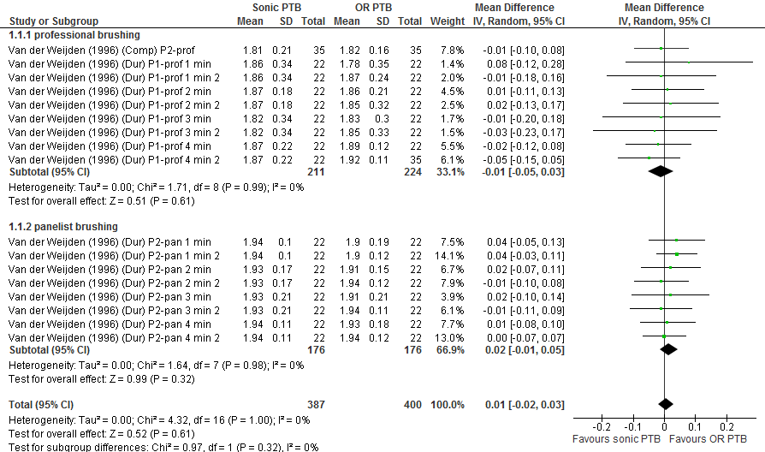

Appendix S4B. Forest Plots of the performed meta-analysis for end-scores of the Modified Silness & Löe plaque index.
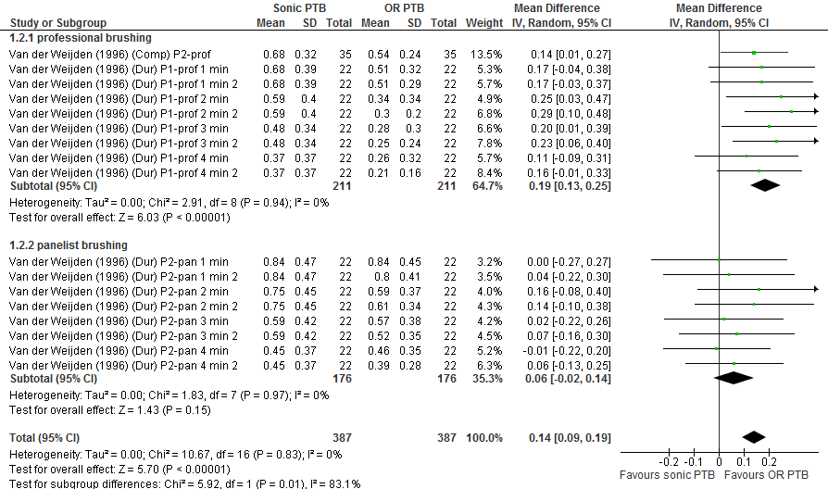

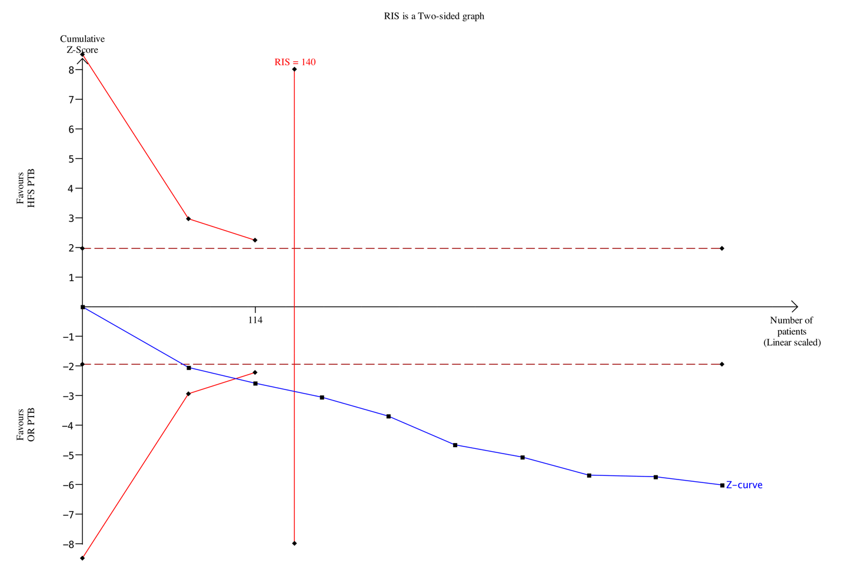
Appendix S4C. Trial Sequential Analysis (TSA) of the end scores of the Modified Silness & Löe plaque index (professional brushing). Plaque index for brushing with oscillating-rotating power toothbrush versus brushing with a high frequency sonic toothbrush.

The number of participants does reach the Required Information Size (RIS). The cumulative blue Z-curve does cross the brown dotted conventional boundary and the red trial sequential monitoring boundary. TSA shows that the evidence for this meta-analysis is firm.
The vertical red line represents the estimated heterogeneity-adjusted required information size, the number of participants for the meta-analysis sample size. The RIS was calculated based on a type Ι error risk of α = 5%, type ΙΙ error risk of β = 20%, power = 80% and δ² = 0.16.

Appendix S4D. Trial Sequential Analysis (TSA) of the end scores of the Modified Silness & Löe plaque index (panellist brushing). Plaque index for brushing with oscillating-rotating power toothbrush versus brushing with a high frequency sonic toothbrush.
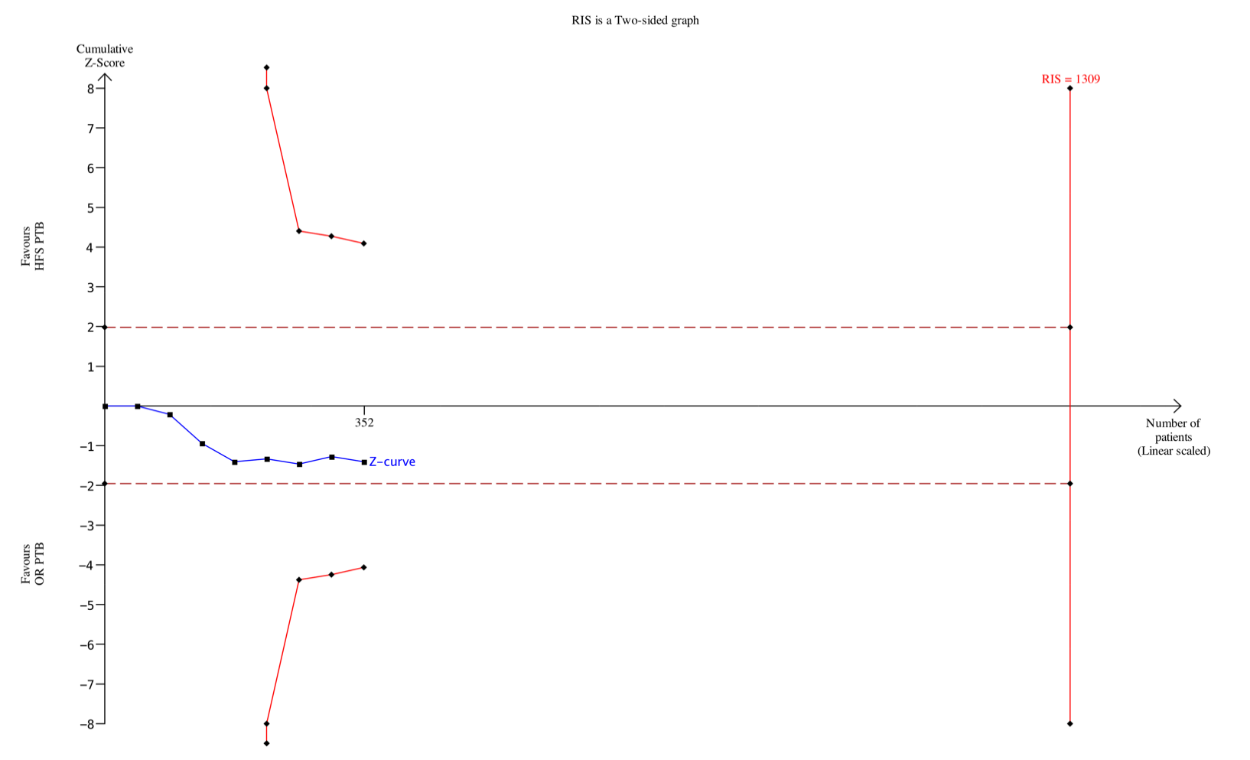
The number of participants does not reach the information size (RIS) and the cumulative blue Z-curve does not cross the brown dotted conventional boundary and the red trial sequential boundary monitoring. TSA shows that the evidence for this meta-analysis is inconclusive.
The vertical red line represents the estimated heterogeneity-adjusted required information size, the number of participants for the meta-analysis sample size. The RIS was calculated based on a type Ι error risk of α = 5%, type ΙΙ error risk of β = 20% and power = 80%.

Appendix S5A. Forest Plots of the performed meta-analysis for baseline-scores of the Modified Quigley & Hein plaque index.
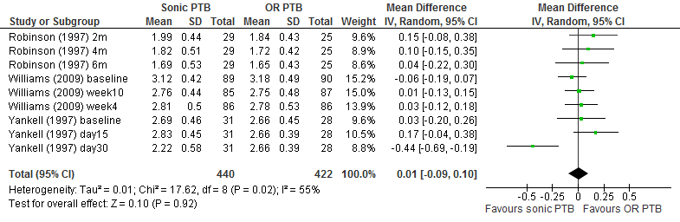

Appendix S5B. Forest Plots of the performed meta-analysis for end-scores of the

Modified Quigley & Hein plaque index.
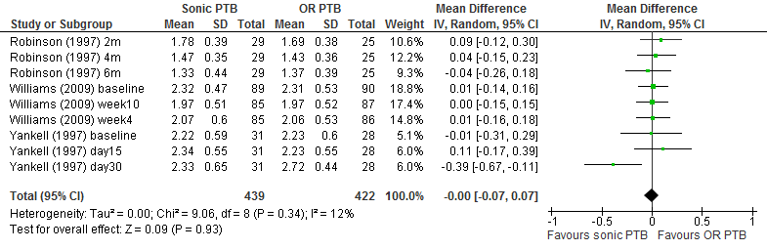

Appendix S5C. Forest Plots of the performed meta-analysis for difference-scores of the

Modified Quigley & Hein plaque index.
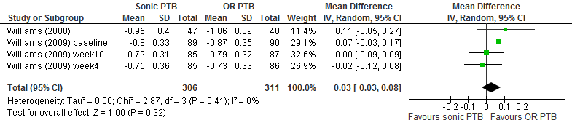

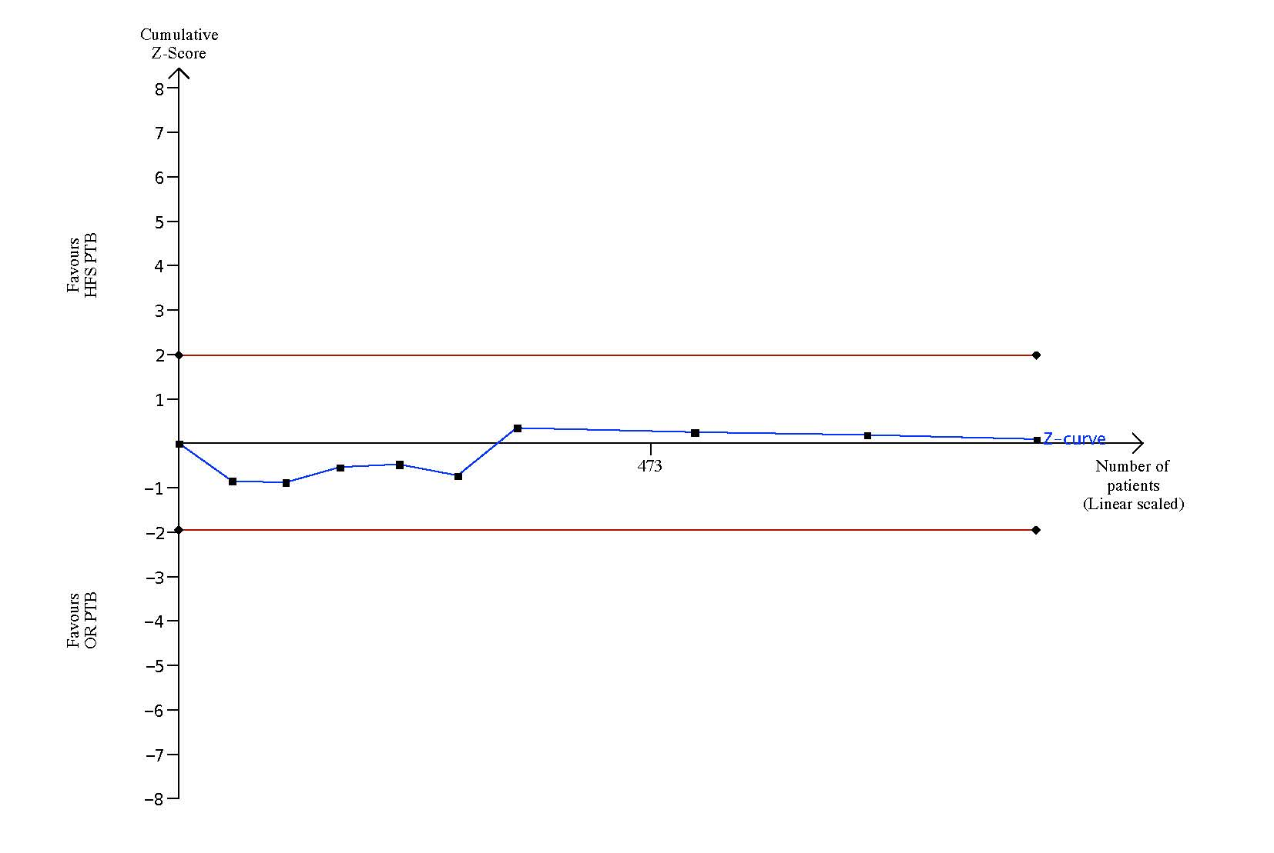
Appendix S5D. Trial Sequential Analysis (TSA) of the end scores of the Modified Quigley & Hein plaque index. Plaque index for brushing with oscillating-rotating power toothbrush versus brushing with a high frequency sonic toothbrush.
The estimated RIS is 865002 participants, far larger than the included 473 participants in this MA. Therefore, the boundary RIS is ignored due to too little information. It indicates further studies are unlikely to change the current conclusion.
The RIS was calculated based on a type Ι error risk of α = 5%, type ΙΙ error risk of β = 20% and power = 80%.

Appendix S5E. Trial Sequential Analysis (TSA) of the difference scores of the Modified Quigley & Hein plaque index. Plaque index for brushing with oscillating-rotating power toothbrush versus brushing with a high frequency sonic toothbrush.
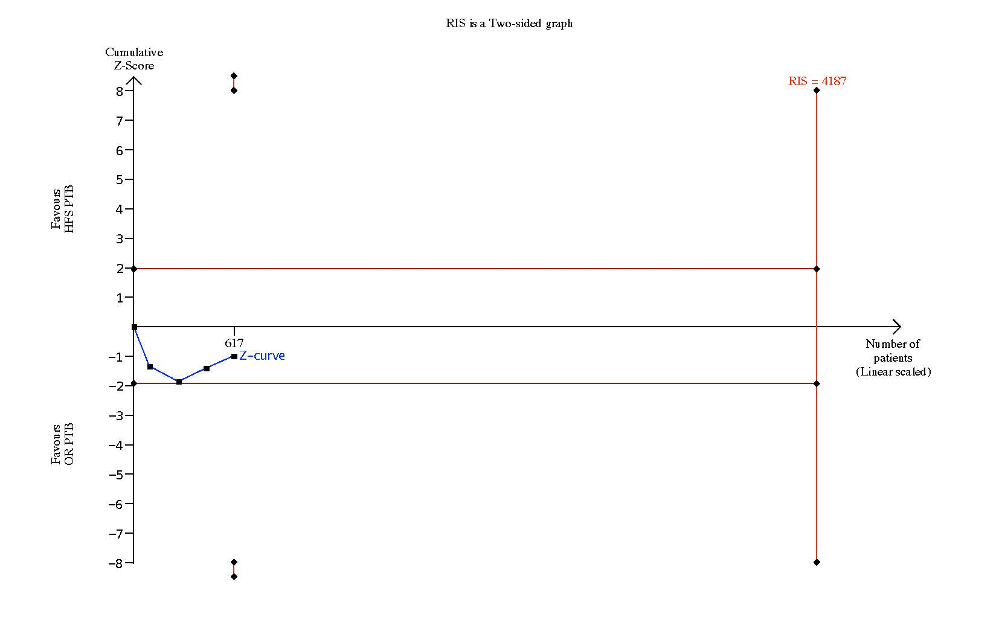
The number of participants does not reach the RIS and the cumulative Z-curve does not cross the trial sequential boundary monitoring or the brown conventional boundary. TSA suggest that the statistical evidence for meta-analysis is inconclusive.
The vertical red line represents the estimated heterogeneity-adjusted required information size, the number of participants for the meta-analysis sample size. The RIS was calculated based on a type Ι error risk of α = 5%, type ΙΙ error risk of β = 20% and power = 80%.

Appendix S6A. Forest Plots of the performed meta-analysis for baseline-scores of the Rustogi Modified Navy plaque index.
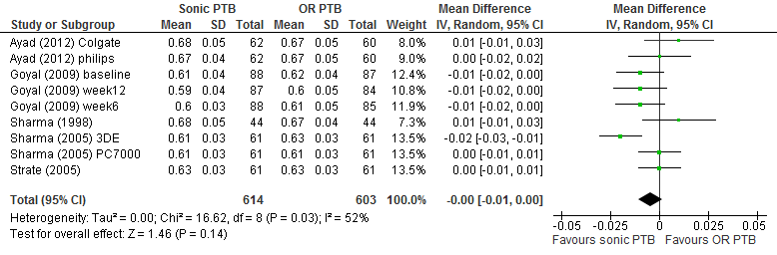

Appendix S6B. Forest Plots of the performed meta-analysis for end-scores of the
Rustogi Modified Navy plaque index.
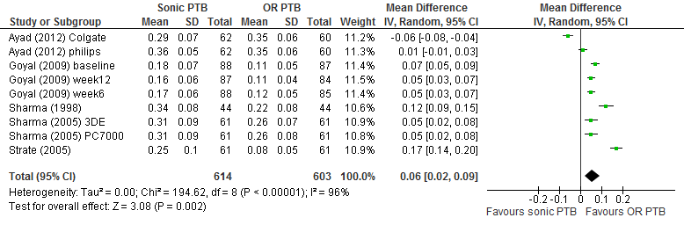

Appendix S6C. Forest Plots of the performed meta-analysis for difference-scores of the Rustogi Modified Navy plaque index.
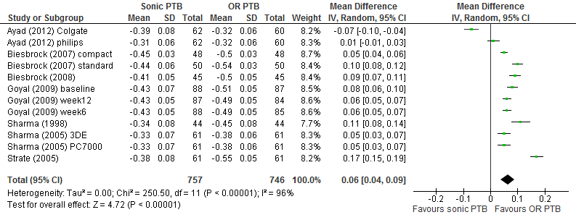

Appendix S6D. Funnel Plots of the performed meta-analysis for difference-scores of the Rustogi Modified Navy plaque index.
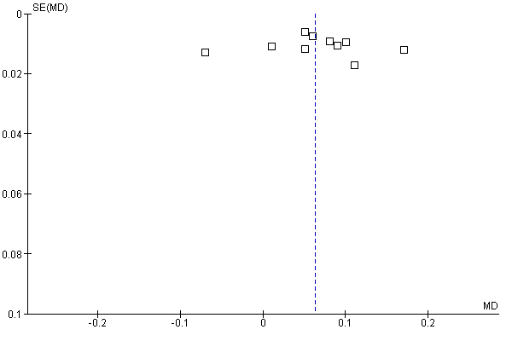

Appendix S6E. Trial Sequential Analysis (TSA) of the end scores of the Rustogi Modified Navy plaque index. Plaque index for brushing with oscillating-rotating power toothbrush versus brushing with a high frequency sonic toothbrush.
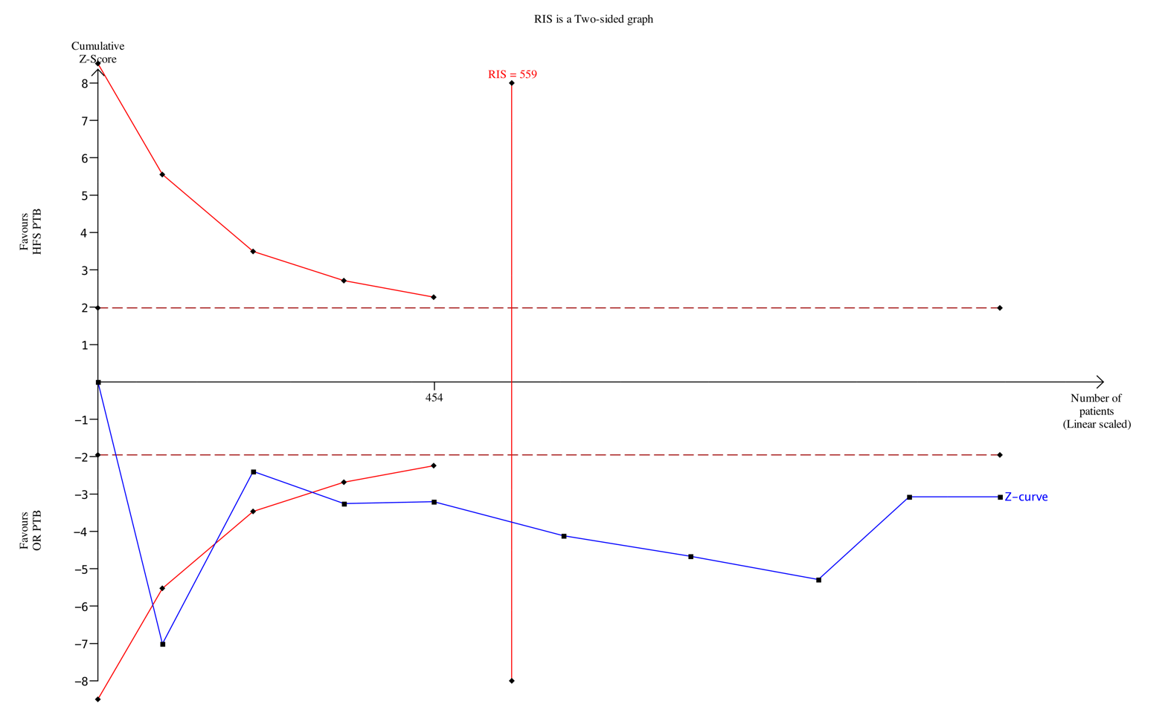
The number of participants does reach the information size and the cumulative blue Z-curve does cross the brown dotted conventional boundary and the red trial sequential boundary monitoring. The cumulative Z-curve reaches the monitoring boundary before reaching the RIS. TSA suggest that the statistical evidence for this meta-analysis is firm.
The vertical red line represents the estimated heterogeneity-adjusted required information size, the number of participants for the meta-analysis sample size. The RIS was calculated based on a type Ι error risk of α = 5%, type ΙΙ error risk of β = 20% and power = 80%.

Appendix S6F. Trial Sequential Analysis (TSA) of the difference scores of the Rustogi Modified Navy Plaque index. Plaque index scores for the oscillating-rotating power toothbrush versus brushing with a high frequency sonic toothbrush.

The number of participants does reach the Required Information Size (RIS). The cumulative blue Z-curve does cross the brown dotted conventional boundary and the red trial sequential monitoring boundary before reaching the RIS. TSA suggest that the evidence for this meta-analysis is firm.
The vertical red line represents the estimated heterogeneity-adjusted required information size, the number of participants for the meta-analysis sample size. The RIS was calculated based on a type Ι error risk of α = 5%, type ΙΙ error risk of β = 20%, power = 80% and δ² = 0.0064.

Appendix S7. Clinical relevance assessment of the plaque index scores using the variable plaque index.

Study | Outcome measure | Standard effect size |  | Interpretation effect size | MID (0.2) | MID (0.5) | Final decision
Study | Outcome measure | Effect size Cohens’d | Bias corrected (hedges)
Sharma et al. (1998)⁵ | RMN | 1.50 | 1.46 | LES | 0.01 | 0.02 | CR
Sharma et al. (2005)⁷ PC-7000 | RMN | 0.59 | 0.57 | MES | 0.01 | 0.02 | CR
Sharma et al. (2005) ⁷ 3DE | RMN | 0.62 | 0.60 | MES | 0.01 | 0.02 | CR
Strate et al. (2005)⁸ | RMN | 2.15 | 2.10 | LES | 0.01 | 0.02 | CR
Goyal et al. (2009) Baseline | RMN | 1.15 | 1.12 | LES | 0.01 | 0.02 | CR
Ayad et al. (2012) Philips¹⁵ | RMN | 0.18 | 0.18 | SES | 0.01 | 0.02 | NCR
Ayad et al. (2012) Colgate¹⁵ | RMN | -0.92 | -0.90 | LES | 0.01 | 0.03 | CR
Yankell et al. (1997) baseline⁴ | MQ&H | -0.02 | -0.02 | SES | 0.09 | 0.23 | NCR
Williams et al. (2009) baseline¹⁴ | MQ&H | 0.02 | 0.02 | SES | 0.09 | 0.23 | NCR
Van der Weijden et al. (1996)¹ (D1) prof 1min | MS&L | 0.48 | 0.46 | MES | 0.07 | 0.17 | PCR
Van der Weijden et al. (1996)¹ (D1) prof 2min | MS&L | 0.67 | 0.66 | MES | 0.04 | 0.10 | CR
Van der Weijden et al. (1996)¹ (D1) prof 3min | MS&L | 0.62 | 0.61 | MES | 0.06 | 0.16 | CR
Van der Weijden et al. (1996)¹ (D1) prof 4min | MS&L | 0.32 | 0.31 | SES | 0.04 | 0.09 | PCR
Van der Weijden et al. (1996)¹ ((D1) prof 1min | MS&L | 0.49 | 0.48 | MES | 0.06 | 0.15 | CR
Van der Weijden et al. (1996)¹ (D1) prof 2min | MS&L | 0.92 | 0.89 | LES | 0.05 | 0.13 | CR
Van der Weijden et al. (1996)¹ (D1) prof 3min | MS&L | 0.78 | 0.76 | MES | 0.07 | 0.17 | CR
Van der Weijden et al. (1996)¹ (D1) prof 4min | MS&L | 0.56 | 0.55 | MES | 0.03 | 0.09 | CR
Van der Weijden et al. (1996)¹ (D2) pann 1min | MS&L | 0.00 | 0.00 | SES | 0.03 | 0.08 | NCR
Van der Weijden et al. (1996)¹ (D2) pann 2min | MS&L | 0.39 | 0.38 | SES | 0.03 | 0.08 | PCR
Van der Weijden et al. (1996)¹ (D2) pann 3min | MS&L | 0.05 | 0.05 | SES | 0.04 | 0.11 | NCR
Van der Weijden et al. (1996)¹ (D2) pann 4min | MS&L | -0.03 | -0.03 | SES | 0.03 | 0.07 | NCR
Van der Weijden et al. (1996)¹ (D2) pann 1min | MS&L | 0.09 | 0.09 | SES | 0.02 | 0.06 | PCR
Van der Weijden et al. (1996)¹ (D2) pann 2min | MS&L | 0.35 | 0.34 | SES | 0.03 | 0.07 | PCR
Van der Weijden et al. (1996)¹ (D2) pann 3min | MS&L | 0.18 | 0.18 | SES | 0.03 | 0.08 | PCR
Van der Weijden et al. (1996)¹ (D2) pann 4min | MS&L | 0.18 | 0.18 | SES | 0.02 | 0.06 | PCR
Van der Weijden et al. (1996)² (C1) prof | MS&L | 0.49 | 0.48 | MES | 0.04 | 0.09 | CR
Summary of the clinical relevance and effect sizes | CR #13/26  PCR #7/26  NRC #6/26

RMNPI: Rustogi Modified Navy plaque index
MQ&HPI: Modified Silness and Löe plaque index
MS&LPI: Modified Quigley and Hein plaque index
D1: Duration study part I
D2: Duration study part II
C1: Comparison study part I

ES: Effect size
MID: Minimal important difference

Interpretation;
CR: Clinically relevant. When the calculated ES ≥ 0.40 and the mean differences between groups are higher than both MIDs
PCR: Potentially clinically relevant. If ES and MID cannot be established or the calculated ES <0.04 clinical criterion determines
NCR: Not clinically relevant

Overview and meaning;
SES: Small effect size (0.0-39)
MES: Moderate effect size (0.40-0.79)
LES: Large effect size (≥0.80)
Appendix S8. Overview of intra-oral safety assessments and their results.

Authors (year) | Assessment | Results
Yankell & Emling (1997)⁴ | Oral hard and soft tissue assessment | No unusual conditions were found at the safety examinations on any subjects at any measurement period during the study.
Sharma et al. (1998)⁵ | Oral soft tissue assessment | Both toothbrushes were found to be safe under the trial conditions.
Sharma et al. (2005)⁷ | Soft and hard tissue examination | No post-brushing changes in oral tissues or restorations were reported or observed with any toothbrush after single-use.
Strate et al. (2005)⁸ | Oral soft tissue assessment | No evidence of soft or hard tissue abrasion after single brushing with either brush.
Biesbrock et al. (2007-1)⁹ | Oral soft tissue assessment | All oral safety examination findings were normal.
Biesbrock et al. (2007-2)⁹ | Oral soft tissue assessment | All oral safety examination findings were normal.
Goyal et al. (2009)¹³ | Oral soft tissue assessment | Both power toothbrushes were well-tolerated.
Williams et al. (2009)¹⁴ | Oral hard and soft tissue assessment | NR.
Ayad et al. (2012)¹⁵ | Oral soft tissue assessment | No adverse events of the oral hard or soft tissues were observed by the examiner or reported by the participants.

NR: Not reported
Appendix S9. Overview of adverse events and their results.

Authors (year) | Adverse events/effects (AE)
Yankell & Emling (1997)⁴ | No attrition was not related to product use.
Sharma et al. (1998)⁵ | No AEs reported. Both toothbrushes were found to be safe under the trial conditions.
Sharma et al. (2005)⁷ | No AEs were reported during the study. One abnormality on the tongue was noted in one subject before brushing at each visit. No post-brushing changes in oral tissues or restorations were reported or observed with any toothbrush after single-use. Oral and hard tissue conditions revealed no changes.
Strate et al. (2005)⁸ | No AEs reported during the study.
Biesbrock et al. (2007-1)⁹ | There was no report of any treatment-related AEs.
Biesbrock et al. (2007-2) ⁹ | There was no report of any treatment-related AEs.
Biesbrock et al. (2008)¹⁰ | No AEs reported.
Putt et al. (2008)¹¹ | No serious AEs were associated with the use of either product. Six minor to moderate AEs were reported and were mostly related to soft-tissue irritation. No AEs needed dental/medical attention.
Williams et al. (2008)¹² | No AEs were reported during the conduct of the study.
Goyal et al. (2009)¹³ | No reported AEs in either group or subject withdrawals attributable to the test products.
Williams et al. (2009)¹⁴ | No product-related AEs were seen in either treatment-group.
Ayad et al. (2012)¹⁵ | No AEs of the oral hard or soft tissues were observed by the examiner or reported by the participants.

Appendix S10. Overview of panellists questionnaire from the studies that included a questionnaire.

Authors (year) | Participant questionnaire
Van der Weijden et al.  (1996-C1)² | A significant greater number of subjects thought that brushing with the OR-PTB was more enjoyable than the HFS-PTB. With regard to sound and vibration, the OR-PTB was judged to be preferable. When asked about how clean their teeth felt, the OR-PTB was considered better.
Sharma et al. (1998)⁵ | The three most frequent reasons for preferring the OR-PTB, given spontaneously, were: ‘smaller brushing area, easier to reach all areas of the mouth’, ‘feels - seems to clean better’, and ‘easier to control - use – maneuver’. They accounted for 50% (48/96) of all responses for the OR-PTB. The major reason given for preferring the HFS-PTB (4/8 responses) was: ‘seems to do a better job.’

OR-PTB: Oscillating-rotating power toothbrush
HFS-PTB: High frequency sonic power toothbrush

Appendix S11. Overview of the included studies, plaque score indexes and related companies.

Authors (Year) | Intervention | Comparison | Plaque index | Related company
Van der Weijden (1996-D1)¹ | HFS-PTB | OR-PTB | MS&LPI | NR
Van der Weijden (1996-D2)¹ | HFS-PTB | OR-PTB | MS&LPI | NR
Van der Weijden (1996-C1)² | HFS-PTB | OR-PTB | MS&LPI | NR
Robinson et al (1997)³ | HFS-PTB | OR-PTB | MQ&HPI | Optiva Corporation
Yankell & Emling (1997)⁴ | HFS-PTB | OR-PTB | MQ&HPI | NR
Sharma et al (1998)⁵ | HFS-PTB | OR-PTB | RMNPI | Procter & Gamble Company
Hanato et al (2005)⁶ | HFS-PTB | OR-PTB | RMNPI | Matsushita Electric Works, Ltd.
Sharma et al (2005)⁷ | HFS-PTB | OR-PTB | RMNPI | Procter & Gamble Company
Strate et al (2005)⁸ | HFS-PTB | OR-PTB | RMNPI | Procter & Gamble Company
Biesbrock et al (2007-1)⁹ | HFS-PTB | OR-PTB | RMNPI | Procter & Gamble Company
Biesbrock et al (2007-2)⁹ | HFS-PTB | OR-PTB | RMNPI | Procter & Gamble Company
Biesbrock et al (2008)¹⁰ | HFS-PTB | OR-PTB | RMNPI | Procter & Gamble Company
Putt et al (2008)¹¹ | HFS-PTB | OR-PTB | MQ&HPI | Philips Oral Healthcare, Inc, Snoqualmie, Washington, USA
Williams et al (2008)¹² | HFS-PTB | OR-PTB | MQ&HPI | Procter & Gamble Company
Goyal et al (2009)¹³ | HFS-PTB | OR-PTB | RMNPI | Procter & Gamble Company
Williams et al (2009)¹⁴ | HFS-PTB | OR-PTB | MQ&HPI | Procter & Gamble Company
Ayad et al (2012)¹⁵ | HFS-PTB Side to side | OR-PTB | RMNPI | Colgate-Palmolive Company
 | HFS-PTB Colgate | OR-PTB | RMNPI | Colgate-Palmolive Company
> : significant difference in favor of the comparison
< : significant difference in favor of the intervention
= : no significant difference
OR-PTB: Oscillating-rotating power toothbrush
HFS-PTB: High frequency sonic power toothbrush
D1: Duration study part I
D2: Duration study part II
C1: Comparison study part I
MS&LPI: Modified Silness & Löe plaque index
MQ&HPI: Turesky Modified Quigley-Hein plaque index
RMNPI: Rustogi Modified Navy plaque index

Appendix S12. References used in the online appendices.
* = included publications in this systematic review

¹ * Van der Weijden FA, Timmerman MF, Snoek IM, Reijerse E, Van der Velden U. Toothbrushing duration and plaque removing efficacy of electric toothbrushes. Am J Dent. 1996; 9 :S31-36.

² * Van der Weijden GA, Timmerman MF, Reijerse E, Snoek CM, Van der Velden U. Comparison of an oscillating/rotating electric toothbrush and a 'sonic' toothbrush in plaque-removing ability. A professional toothbrushing and supervised brushing study. J Clin Periodontol. 1996; 23: 407-411.

³ * Robinson PJ, Maddalozzo D, Breslin S. A six-month clinical comparison of the efficacy of the Sonicare and the Braun Oral-B electric toothbrushes on improving periodontal health in adult periodontitis patients. J Clin Dent. 1997; 8: 4-9.

⁴ * Yankell SL, Emling RC. A Thirty-Day Safety and Efficacy Evaluation of the Rowenta, Braun and Sonicare Powered Toothbrushes and a Manual Toothbrush. J Clin Dent. 1997; 8: 120-123.

⁵ * Sharma NC, Galustians J, Qaqish J, Cugini M. A comparison of two electric toothbrushes with respect to plaque removal and subject preference. Am J Dent. 1998; 11: S29-33.

⁶ * Hanato Y, Kishimoto T, Ojima M, Matsuo T, Kanesaki N, Ryu C, Hanioka T. Comparative study of plaque removal efficacy of twin-motor sonic toothbrush with floating bristles and conventional powered toothbrushes in posterior teeth. Am J Dent. 2005; 18: 237-240.

⁷ * Sharma NC, Goyal CR, Qaqish JG, Cugini MA, Thompson MC, Warren PR. Single-use plaque removal efficacy of three power toothbrushes. J Dent. 2005; 33: 11-15.

⁸ * Strate J, Cugini MA, Warren PR, Qaqish JG, Galustians HJ, Sharma NC. A comparison of the plaque removal efficacy of two power toothbrushes: Oral-b Professional Care Series versus Sonicare Elite. Int Dent J. 2005; 55: 151-156.

⁹ * Biesbrock AR, Bartizek RD, Walters PA, Warren PR, Cugini M, Goyal CR, Qaqish J. Clinical evaluations of plaque removal efficacy: an advanced rotating-oscillating power toothbrush versus a sonic toothbrush. J Clin Dent. 2007;18: 106-111.

¹⁰ * Biesbrock AR, Walters PA, Bartizek RD, Goyal CR, Qaqish JG. Plaque removal efficacy of an advanced rotation-oscillation power toothbrush versus a new sonic toothbrush. Am J Dent. 2008; 21: 185-188.

¹¹ * Putt MS, Milleman JL, Jenkins W, Schmitt P, Master AS, Strate J. A randomized crossover-design study to investigate the plaque removal efficacy of two power toothbrushes: Philips Sonicare Flexcare and Oral-B Triumph. Compend Contin Educ Dent. 2008; 29: 56, 58-64.

¹² * Williams K, Rapley K, Huan J, Walters P, He T, Grender J, Biesbrock AR. A study comparing the plaque removal efficacy of an advanced rotation-oscillation power toothbrush to a new sonic toothbrush. J Clin Dent. 2008; 19: 154-158.

¹³ * Goyal CR, Qaqish J, He T, Grender J, Walters P, Biesbrock AR. A randomized 12-week study to compare the gingivitis and plaque reduction benefits of a rotation-oscillation power toothbrush and a sonic power toothbrush. J Clin Dent. 2009; 20: 93-98.

¹⁴ * Williams K, Rapley K, Haun J, Walters P, He T, Grender J, Biesbrock AR. Comparison of rotation/oscillation and sonic power toothbrushes on plaque and gingivitis for 10 weeks. Am J Dent. 2009; 22: 345-349.

¹⁵ * Ayad F, Petrone DM, Wachs GN, Mateo LR, Chaknis P, Panagakos F. Comparative efficacy of a specially engineered sonic powered toothbrush with unique sensing and control technologies to two commercially available power toothbrushes on established plaque and gingivitis. J Clin Dent. 2012; 23: A5-10.

¹⁶ Danser MM, Timmerman MF, IJzerman Y, Piscaer M, van der Velden U, van der Weijden GA: Plaque removal with a novel manual toothbrush (X-Active) and the Braun Oral-B 3D Plaque Remover. J Clin Periodontol 2003; 30: 138–144.

¹⁷ Silness J and Löe H. Periodontal disease in pregnancy (II). Correlation between oral hygiene and periodontal condition. Acta odontol Scand 1964; 22: 121-135.
¹⁸ Van der Weijden GA, Danser MM, Nijboer A, Timmerman MF, Van der Velden U. The plaque-removing efficacy of an oscillating/rotating toothbrush. A short term study. J Clin Periodontol 1993; 273-278.
¹⁹ Turesky S, Gilmore ND, Glickman L. (1970) Reduced formation by chloromethyl analogue of vitamin C. Journal of Periodontology 41, 41-43.

²⁰ Quigley GA, Hein JW. (1962) Comparative cleansing efficiency of manual and power brushing. Journal of American Dental Association 65, 26-29.

²¹ Lobene RR, Soparker PM. & Newman B.S (1982). Use of Dental Floss. Effect of plaque and Gingivitis. Clinical Preventive Dentistry 4, 5-8.

²² Ramfjord SP. Indices for Prevalence and Incidence of Periodontal Disease. Journal of Periodontology. 1959;30(1):51-9.
²³ Rustogi KN, Curtis JP, Volpe AR, Kemp JH, McCool JJ, Korn LR. Refinement of the Modified Navy Plaque Index to increase plaque scoring efficiency in gumline and interproximal tooth areas. J Clin Dent. 1992; 3: C9-12.
²⁴ Sälzer S, Van der Weijden GA, Dorfer CE, Slot DE. Current Evidence on Prevention of Gingivitis: Oral Hygiene Devices and Dentifrices. Int J Evidence-Based Practice Dent Hygienist. 2017; 3: 118-127.

