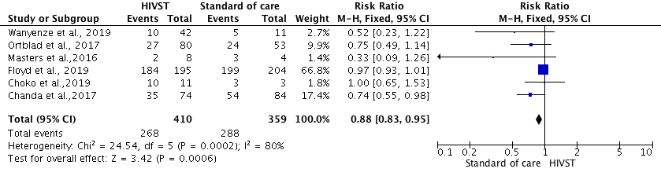
S8 Fig. Forest plot: Comparison of HIVST versus standard of HIV testing services; outcome: Linkage to HIV care and ART. The RR and horizontal lines represent the 95% CI in fixed-effect model.

