Supplementary Data
Table S1 List and characteristics of eligible studies included in the systematic review
References | Number of samples | Bacterial species isolated | Diagnostic method | Country | Sampled sites | Antibiotic susceptibility profile | Resistant gene
Boumama et al.,2010 | 600 | Acinetobacter lwoffi  Alcaligenes spp.  Citrobacter spp.  Enterobacter spp.  Escherichia coli  Klebsiella spp.  Leclercia adecarboxylata  Moellerella wisconsensis  Morganella morganii  Pasteurella spp.  Proteus spp.  Providencia spp.  Salmonella spp.  Serratia spp.  Shigella dysenteriae  Yersinia enterocolitica  Staphylococcus aureus  Staphylococcus coagulase-negative  Enterococcus spp. | Culture | Morocco | Residential areas | Ampicillin  Cefoxitin  Ceftazidime  Cefepime  Amikacin  Amoxicillin-clavulanate  Piperacillin-tazobactam  Imipenem  Ertapenem  Meropenem  Gentamicin  Ciprofloxacin  Cotrimoxazole  Vancomycin  Erythromycin  Clindamycin  Levofloxacin  Oxacillin  Penicillin  Gentamicin  Cotrimoxazole  Linezolid  Daptomycin | None
Mohammed et al., 2016 | 22 | Escherichia coli Enterobacter spp.  Klebsiella spp.  Staphylococcus aureus  Salmonella spp.  Shigella spp.  Proteus  CNS | Culture | Egypt | Livestock farm | Enrofloxacin  Cloxacillin  Gentamycin  Vancomycin  Cephalexin,  Penicillin G  Streptomycin  Colistin  Clindamycin  Tetracycline  Cefoxitin  Chloramphenicol | None
Nmorsi et al.,2007 | 737 | Escherichia coli  Serratia marcenscens  Proteus mirabilis  Proteus frundi  Streptococcus faecalis, Streptococcus pyogenes  Klebsiella pneumoniae,  Salmonella typhii,  Salmonella typhimurium  Staphylococcus aureus | Culture | Nigeria | Hospitals, Houses  Human habitation  Dairy farms  Stalls of food  Vendors Abattoir  Dairy farms | Chloramphenicol,  Cloxacillin  Tetracycline  Streptomycin  Oxacillin  Clindamycin  Ofloxacin | None
Songe et al.,2017 | 418 | Enteropathogenic Escherichia coli  Salmonella spp. | Culture  PCR | Zambia | Food markets | Ampicillin, Sulfamethoxazole/trimethoprim Streptomycin  Ciprofloxacin  Tetracycline  Gentamicin,  Nalidixic acid  Chloramphenicol  Ceftazidime  Norfloxacin  Cefotaxime  Ceftazidime  Cefotaxime | bla_{TEM}  bla_{SHV}  bla_{CTX-M}
Fouda et al.,2016 | None | Aerococcus viridans  Pseudomonas fluorescens  Kociuria rosea  Staphylococuus lentus  Micrococcus lentus/lylae  Escherichia coli  Enterobacter aerogenes  Staphylococcus sciuri  Staphylococcus lentus  Staphylococcus simulans  Leuconostoc pseudomesentroides  Lactobacillus delbrueckii  Pseudomonas veronii  Kocuria kristinae | Culture | Egypt | Garbage  Decaying organic matters  Manure  Carrions of different animals | None | None
Rahuma et al.,2005 | 150 | Escherichia coli  Salmonella sp.  Shigella sonnei  Yersinia enterocolitica  Edwardsiella tarda  Klebsiella spp.  Enterobacter spp.  Citrobacter spp.  Proteus spp.  Providencia spp.  Serratia spp.  Erwinia spp.  Aeromonas spp.  Flavobacterium spp.  Pseudomonas spp.  Xanthomonas spp.  Weeksella zoohlecum  Pasteurella spp.  Staphylococcus spp.  Streptococcus spp. | Culture | Libya | Hospital  City Streets  Abattoir | Amoxicillin  Amoxicillin–clavulanic acid Ceftriaxone  Cephaloridine  Chloramphenicol  Amikacin  Kanamycin  Nalidixic acid  Norfloxacin  Doxycycline  Trimethoprim–sulphamethoxazole  Methicillin  Fusidic acid | None
Mian et al.,2002 | 2506 | Salmonella enteritidis  Salmonella spp. | Culture |  | Food courts  Dumping ground  Food processing and  Poultry farm areas | None | None
Yalli et al., 2017 | 150 | Escherichia coli  Pseudomonas spp  Bacillus spp.  Enterobacter spp.  Staphylococcus spp.  Salmonella spp.  Proteus spp.  Klebsiella spp. | Culture | Nigeria | Kitchens  Toilet  Rooms | None | None
Ibrahim et al., 2018 | 27 | Escherichia coli  Salmonella spp.  Pseudomonas spp.  Shigella spp.  Klebsiella spp.  Staphylococcus spp.  Streptococcus spp.  Bacillus spp.  Proteus spp. | Culture | Nigeria | -Dumpsite  Canteen  Indoor premise | None | None
Nwankwo et al., 2020 | 150 | Escherichia coli  Klebsiella spp.  Staphylococcus aureus  Proteus vulgaris  Proteus mirabilis  Pseudomonas aeruginosa  Salmonella spp.  Enterococcus faecalis  Staphylococcus aureus  Staphylococcus epidermidis  Streptococcus spp. | Culture | Nigeria | Market  Refuse  Broken sewage  Restaurant  Clinic | Ofloxacin  Pefloxacin  Ceftriaxone  Amoxicillin  Clavulanate  Gentamicin  Streptomycin  Cephalexin,  Cotrimoxazole  Ampicillin | None
Awache & Forouk.,2016 | 1059 | Escherichia coli  Citrobacter freundii,  Bacillus megatarium,  Bacillus sphaericus  Bacillus alvei  Moganella morgana | Culture | Nigeria | Cafeteria  Food centers | None | None
Mawak &Olukose.,2006 | 200 | Escherichia coli  Staphylococcus spp.  Streptococcus spp.  Salmonella spp.  Klebsiella spp.  Pseudomonas spp.  Proteus spp. | Culture | Nigeria | Abattoir  Main market  Hospital | None | None
Khin-Nwe et al., 1989 | 186 | Escherichia coli  Vibrio cholerae  Salmonella spp.  Shigella spp. | Culture | Myanmar | Animal pens  Kitchen  Bazaar  Latrine  Refusal dumps  Food stalls | None | None
Nazni et al., 2005 | 20 | Bacillus spp.,  Coccobacillus spp.  Staphylococcus spp.  Microccus spp.  Streptococcus spp.  Acinetobacter spp.  Enterobacter spp.,  Proteus spp.  Escherichia spp.  Klebsiella spp. | Culture | Malaysia | Food courts  Dumping ground  Food processing  Poultry farm | None | None
Barro et al. 2007 | 1920 | Shigella spp.  Salmonella spp.  Streptococci spp.  Staphylococcus aureus | Culture | Burkina Faso | Fruit juice vending site  Meat/poultry vending site | None
Akoh et al., 2013 | 150 | Enterococci spp. | Culture | Nigeria | Poultry house | Ciprofloxacin  Streptomycin  Chloramphenicol  Ampiclox  Rifampicin  Norfloxacin  Levofloxacin
Brits et al., 2016 | 10 | Bacillus lentus  Bacillus pumilus.  Bacillus spp.  Bacillus subtilis  Kurthia gibsonii  Kurthia zopfii  Myroides profundi  Pantoea spp.  Proteus mirabilis  Pseudomonas spp.  Serratia spp.  Staphylococcus sciuri  Staphylococcus spp.  Williamsia spp. | Culture  PCR | South Africa | Municipal refuse | None
Deakpe et al., 2018 | 210 | Staphylococcus spp.  Bacillus spp.  Klebsiella spp.  Escherichia spp.  Proteus spp.  Salmonella spp.  Moraxella spp. | Culture | Nigeria | Wurukum Market  Modern Market  Railway Market  Kwararafa Quarters  High Level Market  North Bank Market  Wadata Market | None
Odetoyin et al.,2020 | 25 | Klebsiella pneumoniae  Escherichia coli  Staphylococcus aureus  Pseudomonas aeruginosa  Proteus spp  Salmonella spp | Culture | Nigeria | Slaughterhouse  Garbage Dump  Eatery  Hospital  Human House | Pefloxacin  Gentamycin  Amoxicillin  Ciprofloxacin  Streptomycin  Cotrimoxazole  Chloramphenicol  Sparfloxacin  Augmentin  Ofloxacin
CNS: Coagulase Negative Streptococci M-PCR: Multiplex-Polymerase chain reaction PCR: Polymerase chain reaction USA: United states of America, UK: United Kingdom

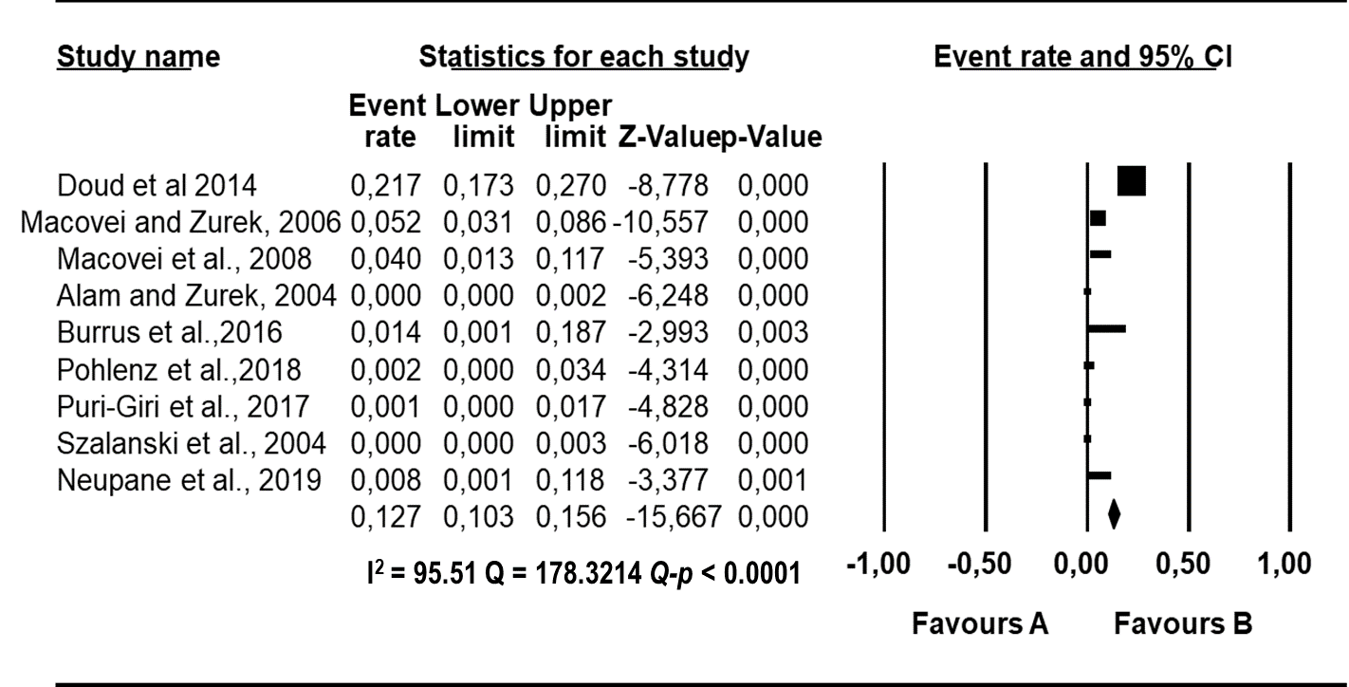
Figure S1 Forest plot of the point estimates owing to E. faecium from A. America. The squares demonstrate the individual point estimate. The diamond at the base indicate the pooled estimates from the total studies

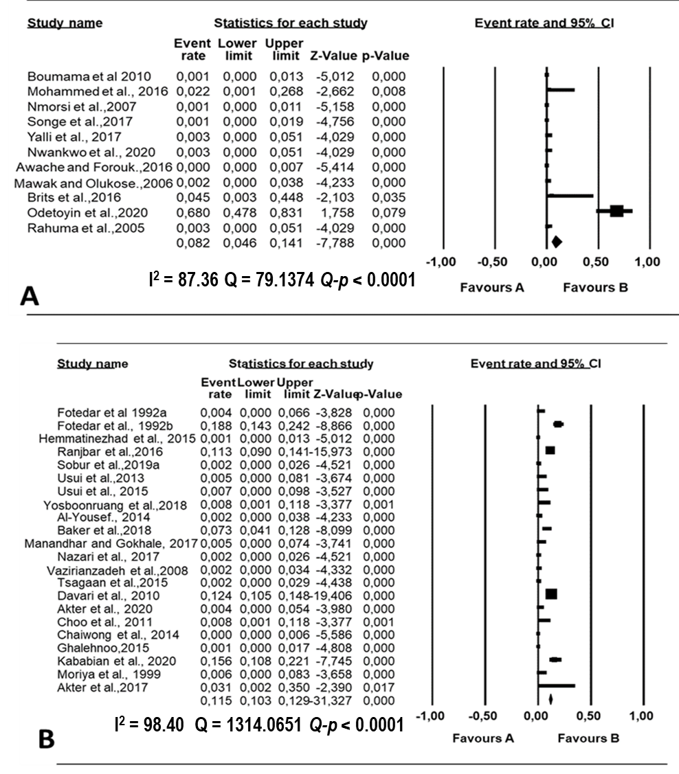
Figure S2 Forest plot of the point estimates owing to K. pneumoniae from (A) Africa and (B) Asia. The squares show the individual point estimate. The diamond at the base indicate the pooled estimates from the total studies
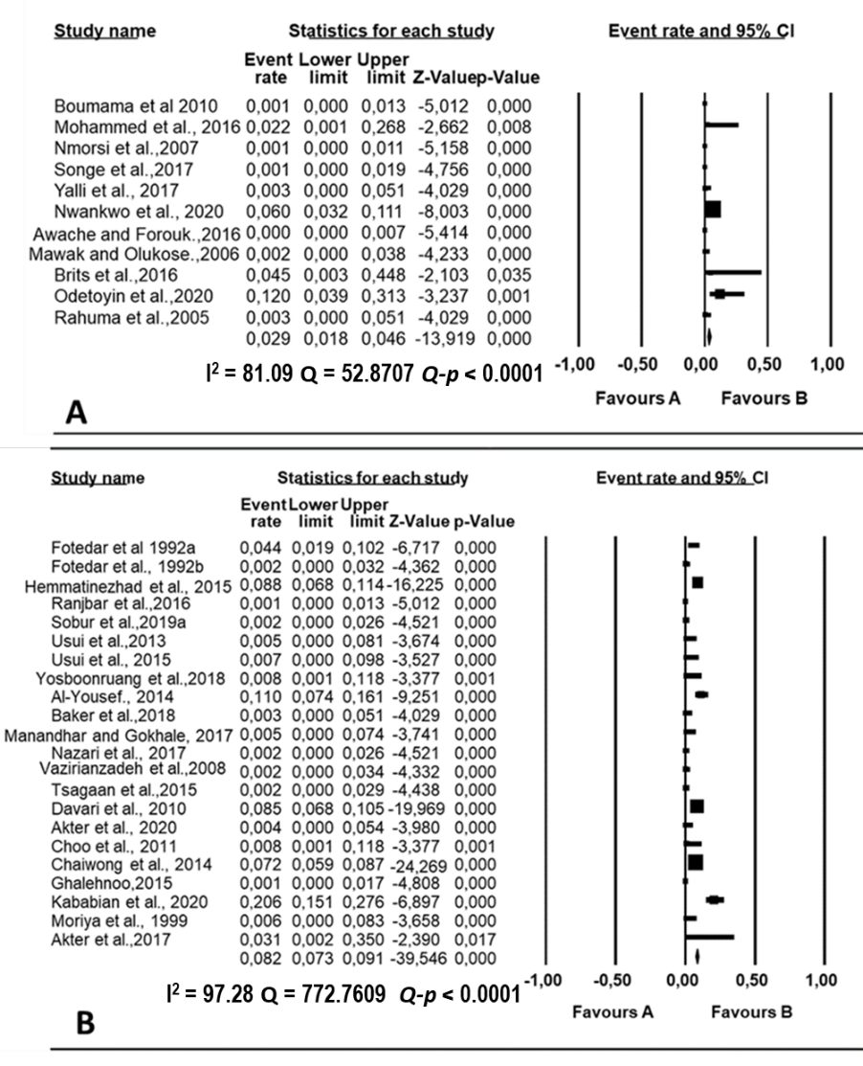
Figure S3 Forest plot of the point estimates owing to P. aeruginosa from (A) Africa and (B) Asia. The squares demonstrate the individual point estimate. The diamond at the base indicate the pooled estimates from the total studies

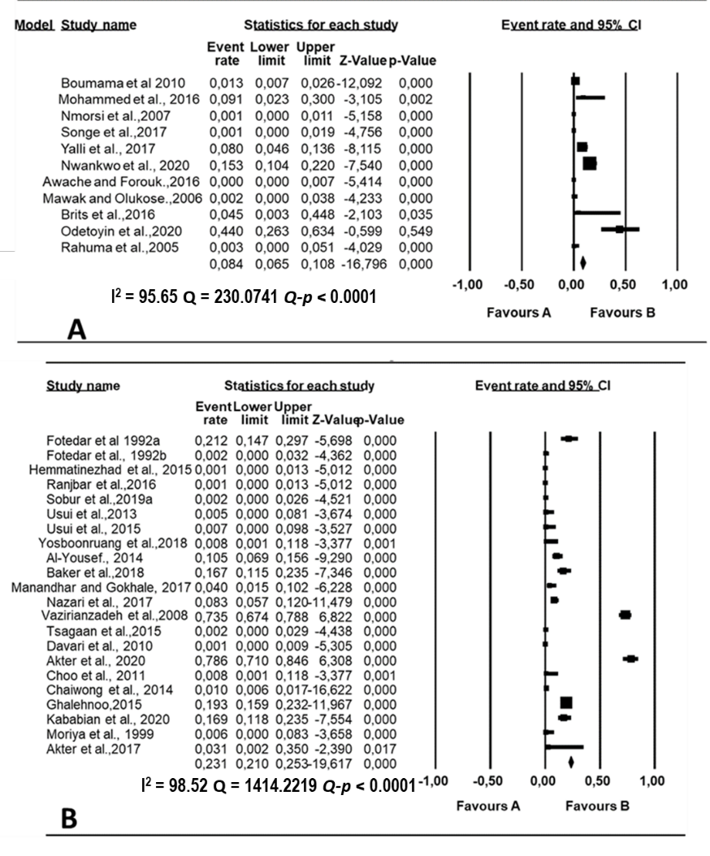
Figure S4 Forest plot of the point estimates owing to S aureus from (A) Africa and (B) Asia. The squares demonstrate the individual point estimate. The diamond at the base indicate the pooled estimates from the total studies.

REFERENCES
Ahmed, A. S., Ahmed, K. M., & Salih, S. S. (2013). Isolation and identification of bacterial isolates from houseflies in Sulaymaniyah city. Journal of Engineering and Technology, 31, 24-33.
Akoh, Q. P., Stephen, E., & Obi, S. K. C. (2013). Antibacterial susceptibility patterns of Enterococci isolated from house flies around poultry houses. Time Journal of Biological Sciences and Technology, 1(2), 12-16.
Akter, T., Ahmed, S. & Das, B. R. (2017). Carriage of multi-drug resistant gram-negative pathogenic bacteria by the house fly Musca domestica. Dhaka Univ. Journal of Biological Sciences, 26(1), 91-99.
Akter, S., Sabuj, A. A. M., Haque, Z. F., Rahman, M. T., Kafi, M. A., & Saha, S. (2020). Detection of antibiotic-resistant bacteria and their resistance genes from houseflies. Veterinary world, 13(2), 266-274.
Alam, M.J., & Zurek, L. (2014). Association of Escherichia coli 0157:H7 with houseflies on a Cattle Farm. Applied and Environmental Microbiology, 70(12), 7578-7580.
Al-Yousef, A. F. (2014). Detection of Enteric Pathogenic Bacteria Transmitted by Housefly (Musca domestica) in Riyadh. Egyptian Academic Journal of Biological Sciences, 7(2), 143 – 150.
Alves, T. S., Lara, G. H. B., Maluta, R. P, Ribeiro, M. G., & da Silva Leite, D. (2018). Carrier flies of multidrug-resistant Escherichia coli as potential dissemination agent in dairy farm environment. Science of the Total Environment, 633, 1345–1351.
Awache, I., & Farouk, A.A. Bacteria and fungi associated with houseflies collected from cafeteria and food Centres in Sokoto (2016). Fuw Trends in Science & Technology Journal, 1(1),123–125.
Baker, S. Z., Atiyae, Q. M., & Khairallah, M. S. (2018). Isolation and Identification of some Species of Bacterial Pathogens from Musca Domestica and Test their Susceptibility Against Antibiotics. Tikrit Journal of Pure Science, 23 (9) http://dx.doi.org/10.25130/tjps.23.2018.145.
Barro, N., Aly, S., Tidiane, O. C. A., & Sababenedjo., A. T. (2007). Carriage of Bacteria by Proboscises, Legs, and Feces of Two Species of Flies in Street Food Vending Sites in Ouagadougou, Burkina Faso. Journal of Food Protection, 69(8), 2007–2010.
Blaak, H., Hamidjaja, R. A., Van Hoek, A. H. A. M., De Heer, L., De Roda Husman, A. M., & Schets, F. M. (2014). Detection of extended-spectrum beta-lactamase (ESBL)-producing Escherichia coli on flies at poultry farms. Applied Environmental Microbiology, 80, 239–246.
Bouamama, L., Lebbadi, M., & Aarab, A. (2007). Bacteriological analysis of Periplaneta americana L. (Dictyoptera; Blattidae) and Musca domestica L. (Diptera; Muscidae) in ten districts of Tangier, Morocco. African Journal of Biotechnology, 6, 2038- 2042.
Brits, D., Brooks, M., & Villet, M. H. (2016). Diversity of bacteria isolated from the flies Musca domestica (Muscidae) and Chrysomya megacephala (Calliphoridae) with emphasis on vectored pathogens. African Entomology, 24(2), 365-375.
Buma, R., Maeda, T., Marutaka, Y., Kamei, M., Nagamune, H. & Kourai, H. (2004). Vectoral capacity of larvae, pupae and adult of housefly (Musca domestica) for Escherichia coli 0157:H7 and the possibility of transmission from source to human. Medical Entomology and Zoology, 55(2), 95-106.
Burrus, R. G., Hogsette, J. A., Kaufman, P. E., & Maruniak, J. E., Simonne, A. H., and Mai, V. (2017). Prevalence of Escherichia coli O157:H7 from house flies (Diptera: Muscidae) and dairy samples in North Central Florida. Journal of Medical Entomology, 54(3), 733–741.
Butler, J. F., Garcia-Maruniak, A., Meek, F. & Maruniak, J. E. (2010). Wild Florida houseflies (Musca domestica) as carriers of pathogenic bacteria. Florida Entomologist, 93(2), 218-223.
Cervelin, V., Fongaro, G., Pastore, J. B., Engel, F., Reimers, M.A. & Viancelli, A. (2018). Enterobacteria associated with houseflies (Musca domestica) as an infection risk indicator in swine production farms. Acta Tropica,185,13-17.
Chaiwong, T., Srivoramas, T., Sueabsamran, P., Sukontason, K., Sanford, M. R., & Sukontason, K.L. (2014). The blow fly, Chrysomya megacephala, and the house fly, Musca domestica, as mechanical vectors of pathogenic bacteria in Northeast Thailand. Tropical Biomedicine, 31(2), 336–346.
Choo, L. C., Saleha, A. A., Wai, S. S., & Fauziah, N. (2011). Isolation of Campylobacter and Salmonella from houseflies (Musca domestica) in a university campus and a poultry farm in Selangor, Malaysia. Tropical Biomedicine, 28(1), 16–20.
Cottone, C. B., Szalanski, A. L. McKay T., & Steelman C. D. (2014). Molecular detection of Campylobacter spp. and E. coli O157:H7 carried by filth flies (Diptera: Muscidae) associated with turkey production facilities. Midsouth Entomologist, 7, 1-7.
Davari, B., Kalantar, E., Zahirnia, A., & Moosa-Kazemi, S. H. (2010). Frequency of resistance and susceptible bacteria isolated from houseflies. Iran Journal of Arthropod-Borne disease,4, 50-55.
Davies M. P., Anderson, M. & Hilton, A. C. (2016). The housefly Musca domestica as a mechanical vector of Clostridium difficile. Journal of Hospital Infections, 94, 263-267.
Deakpe, T. E., Manyi, M. M. & Utume, L. N. (2018). Pathogenic parasites and bacteria associated with the housefly (Musca domestica) in Makurdi; a fly-infested area in central Nigeria. Nigerian Journal of Parasitology, 39, 111-115.
Doud, C. W., Scott, H. M., & Zurek, L. (2014). Role of house flies in the ecology of Enterococcus faecalis from wastewater treatment facilities. Microbial Ecology, 67(2), 380-391.
Förster, M., Klimpel, S., Mehlhorn, H., Sievert, K., Messler, S & Pfeffer, K. (2007). Pilot study on synanthropic flies (e.g. Musca, Sarcophaga, Calliphora, Fannia, Lucilia, Stomoxys) as vectors of pathogenic microorganisms. Parasitology Research, 101:243-246.
Forster, M., Sievert, K., Messler, S., Klimpel, S. & Pfeffer, K. (2009). Comprehensive study on the occurrence and distribution of pathogenic microorganisms carried by synanthropic flies caught at different rural locations in Germany. Journal of Medical Entomology, 46, 1164-1166.
Fotedar, R., Banerjee, U., Shriniwas, S. S., & Verma, A. (1992). The house fly (Musca domestica) as a carrier of pathogenic microorganisms in a hospital environment. Journal of Hospital Infections, 20, 209-215.
Fotedar, R., Banarjee, U., Samantray, J. C., & Shriniwas, S. S. (1992). Vector potential of the hospital house flies with special reference to Klebsiella species. Epidemiology and Infection, 109, 143- 147.
Fouda, A., Fouda, M. A., Aldally, A. G., Ismael, S. B. & Arvad, M. A. (2016). Isolation and identification of bacterial species associated with non-biting flies in Egypt. Egyptian academic Journal of Biological Sciences, 9(4), 37-45.
Galal, F. H., ElShammari, T., & Seufi, M. A. (2019). Isolation, Characterization and antagonistic activity of the external microflora of the house fly, Musca domestica (Diptera: Muscidae). Journal of Pure and Applied Microbiology, 13(3), doi 10.22207/JPAM.13.3.
Ghalehnoo, M. R. (2015). Housefly (Musca domestica) as harrier of enterotoxigenic Staphylococcus aureus in broiler farms in Iran: Is it important for public health? International Journal of Enteric Pathogens, 3(3) e25688. DOI: 10.17795/ijep25688
Hemmatinezhad, B., Ommi, D., Taktaz-Hafshejani, T., & Khamesipour, F. (2015). Molecular detection and antimicrobial resistance of Pseudomonas aeruginosa from houseflies (Musca domestica) in Iran. Journal of Venomous Animals Toxins, 21,18.
Ibrahim, A. W., Ajiboye, T. O., Akande, T. A., & Anibaba, O. O. (2018). Isolation and identification of pathogenic microorganisms from houseflies. Global journal of Science frontier research. 18(1), 57-64.
Iwasa, M., Makino, S., Asakura, H., Kobori, H & Morimoto, Y. (1999). Detection of Escherichia coli 0157-H7 from Musca domestica (Diptera: Muscidae) at a cattle farm in Japan. Journal of Medical Entomology, 36, 108-112.
Kababian, M., Mozaffari, E., Akbarzadeh, K., Kordshouli, R. S., Saghafipour, A., & Shams, S. (2020). Identification of bacteria contaminating Musca domestica (Diptera: Muscidae) collected from animal husbandries. Shiraz E-Med Journal, 21(4): e92018.
Kassiri, H., Akbarzadeh, K. & Ghaderi, A. (2012). Isolation of pathogenic Bacteria on the Housefly, Musca domestica L. (Diptera Muscidae) Body surface in Ahwaz Hospitals South Western Iran. Asian Pacific Journal of Tropical Biomedicine,12, 1116 – 1119.
Khalil., K., Lindblom, G. B., Mazhar, K., & Kaijser, B. (1994). Flies and water as reservoir for bacterial enteropathogens in urban and rural areas in and around Lahore, Pakistan. Epidemiology and Infections, 113, 435-444.
Khin-nwe, O. O., Sebastian, A.A. & Tin, A. (1989). Carriage of enteric bacterial pathogens by house flies in Yangon, Myanmar. Journal of Diarrheal Disease Research,7(3 and4), 81-84.
Li, S. & Stutzenberger, F. J. (2000). The house fly (Musca domestica) as a possible vector for Helicobacter pylori at agricultural sites. International Journal of Environmental Health Research, 10, 141-152.
Macovei, L. & Zurek, L. (2006) Ecology of antibiotic resistance genes: characterization of enterococci from houseflies collected in food settings. Applied Environmental Microbiology, 72, 4028-4035.
Macovei, L., Miles, B., & Zurek, L. (2008). The potential of house flies to contaminate ready to eat food with antibiotic resistant enterococci. Journal of Food Protection, 71, 432-439.
Manandhar, R. & Gokhale, S. (2017). Are Houseflies Still Important Vector of Gastrointestinal Infections? Journal of Bacteriology and Parasitology, 8:4 DOI:10.4172/2155-9597.1000318.
Mawak, J. D. & Olukose, O. J. (2006). Vector potential of houseflies (Musca domestica) for pathogenic organisms in Jos, Nigeria. Journal of Pest Disease and Vector Management, 7, 418–423.
Mian, L. S., Maag, H. & Tacal, J. V. (2002). Isolation of Salmonella from muscoid flies at commercial animal establishments in San Bernardino County, California. Journal of Vector Ecology,27(1), 82-85.

Mohammed, A. N., Gihan K. Abdel-Latef, G. H., Abdel-Azeem, N. M. & El-Dakhly, K. M. (2016). Ecological study on antimicrobial-resistant zoonotic bacteria transmitted by flies in cattle farms. Parasitology Research, 115, 3889–3896.
Moriya, K., Fujibayashi, T., Yoshihara, T., Matsuda, A., Sumi, N., Umezaki, N., Kurahashi, H., Agui, N., & Wada, A., (1999). Verotoxin-producing Escherichia coli O157: H7 carried by the housefly in Japan. Medical and Veterinary Entomology. 13, 214–216.
Nazni, W. A., Seleena, B., Lee, H. L., Jeffery, J. T., Rogayah, T. A. R. & Sofian, M.A. (2005). Bacteria fauna from the house fly, Musca domestica (L.). Tropical Biomedicine, 22(2), 225–231.
Nayduch, D., & Burrus, R. G., (2017). Flourishing in filth: House fly–microbe interactions across life history. Annals of the Entomological Society of America, 110, 6–18.
Nazari, M., Mahrabi, T., Hosseini, S. M., & Alikhani, M. Y. (2017). Bacterial contamination of adult houseflies (Musca domestica) and sensitivity of these bacteria to various antibiotics, captured from Hamadan City, Iran. Journal of Clinical Diagnostic Research, 11, DC04-DC07. doi:10.7860/JCDR/2017/23939.9720.
Neupane, S., Nayduch, D., & Zurek, L. (2019). House flies (Musca domestica) pose a risk of carriage and transmission of bacterial pathogens associated with bovine respiratory disease (BRD). Insects, 10, 1-7.
Nmorsi, O. P. G., Agbozele G., & Ukwandu, N. C. D. (2007). Some aspects of epidemiology of filth flies: Musca domestica, Musca domestica vicina, Drosophilia melanogaster and associated bacteria pathogens in Ekpoma, Nigeria. Vector Borne Zoonotic Disease, 7, 107–117.
Nwankwo, E. O., Ekemezie, C. L., & Adeyemo, S. (2020). Evaluation of microbial flora of the external surface of housefly (Musca domestica) in Umuahia Metropolis, Abia State, Southeast Nigeria. Calabar Journal of Health Sciences, 3(1), 9-15. DOI 10.25259/CJHS_5_2019.
Odentoyin, B., Adeola, B., & Olaniran, O. (2020). Frequency and antimicrobial resistance patterns of bacterial species isolated from the body surface of the house fly (Musca domestica) in Akure, Ondo State, Nigeria. Journal of Arthropod-Borne Disease, 14(1), 88–96.
Olsen, A., R., & Hammack, T. S., (2000). Isolation of Salmonella spp. from the housefly, Musca domestica L., and the dump fly, Hydrotaea aenescens (Wiedemann) (Diptera: Muscidae), at Cagedlaer house. Journal of Food Protocol,63, 958–960.
Ommi, D., Hashemian, S. M., Tajbakhsh, E., & Khamesipour, F. (2015). Molecular detection and antimicrobial resistance of Aeromonas from houseflies (Musca domestica) in Iran. Revista MVZ Cordoba, 20, 4929–4936.
Ommi, D., Hemmatinezhad, B., Hafshejani, T.T., & Khamispour, R. (2017). Incidence and antimicrobial resistance of Campylobacter and Salmonella from houseflies (Musca Domestica) in kitchens, farms, hospitals and slaughterhouses. Proceedings of the National Academy of Sciences, India Section B: Biological Sciences, 87(4):1285–1291.
Pohlenz, T.D., Zavadilova, K., Ghosh, A., & Zurek, L. (2018). Prevalence of Shiga-toxigenic Escherichia coli in house flies (Diptera: Muscidae) in an urban environment. Journal of Medical Entomology, 55(2), 436–439.
Poudel, A., Hathcock, T., Butaye, P., Kang, Y., Price, S., Macklin,K., Walz, P., Cattley, R., Kalalah, A., Adekanmbi, F. & Wang, C. (2019). Multidrug-resistant Escherichia coli, Klebsiella pneumoniae and Staphylococcus spp. in houseflies and blow flies from farms and their environmental settings. International Journal of Environmental Research and Public Health,16, 3583; doi:10.3390/ijerph16193583
Paulson, L., Pandya, P., Thakkar, B. & Parikh, P. (2018). Isolation of pathogenic bacteria from Musca domestica and the effect of antibiotics, captured from Vadodara city, Gujarat. Journal of Entomology and Zoology Studies, 2018; 6, 1369-1377.
Puri-Giri, R., Ghosh, A., Thomson, J. L. & Zurek, L. (2017). House flies in the confined cattle environment carry non-O157 Shiga toxin-producing Escherichia coli. Journal of Medical Entomology, 54, 726–732.

Ranjbar, R., Izadi, M., Hafshejani, T. T. & Khamesipour, F. (2016). Molecular detection and antimicrobial resistance of Klebsiella pneumoniae from house flies (Musca domestica) in kitchens, farms, hospitals and slaughterhouses. Journal of Infections and Public Health, 9, 499 –505. https://doi.org/10.1016/j.jiph.2015.12.
Rahuma, N., Ghenghesh, K. S., Ben-Aissa, R., & Elamaari, A. (2005). Carriage by the housefly (Musca domestica) of multiple antibiotic-resistant bacteria that are potentially pathogenic to humans, in hospital and other urban environments in Misurata, Libya. Annals of Tropical Medicine Parasitology, 99, 795-802.
Rosef, O., & Kapperud, G. (1983). House flies (Musca domestica) as possible vectors of Campylobacter fetus subsp. jejuni. Applied Environmental Microbiology, 45, 381–383.
Szalanski, A. L. Owens, C. B. Mckay T., & Steelman, C. D. (2004). Detection of Campylobacter and Escherichia coli O157:H7 from filth flies by polymerase chain reaction. Medical and Veterinary Entomology, 18, 241–246
Schaumburg, F., Onwugamba, F.C., Akulenko, R., Peters, G., Mellmann, A., Köck, R., & Becker, K. (2016). A geospatial analysis of flies and the spread of antimicrobial resistant bacteria. International Journal of Medical Microbiology, 306, 566–571. https://doi.org/10.1016/j.ijmm.2016.06.002.
Sobur, M. A., Levy, S., Haque, Z. F., Nahar, A., Zaman, S. B., & Rahman, M. T. (2019). Emergence of colistin-resistant Escherichia coli in poultry, house flies and pond water in Mymensingh, Bangladesh. Journal of Advanced Veterinary and Animal Research, 6(1), 50-53.
Sobur, A., Hasan, M., Haque, E., Mridul, A. I., Noreddin, A., El Zowalaty, M. E. & Rahman, T. (2019). Molecular Detection and Antibiotyping of Multidrug-Resistant Salmonella Isolated from Houseflies in a Fish Market. Pathogens, 8, 191; doi:10.3390/pathogens8040191.
Solà-Ginés, M., González-López, J. J., Cameron-Veas, K., Piedra-Carrasco, N., Cerdà-Cuéllar, M., & Migura-Garcia, L. (2015). Houseflies (Musca domestica) as vectors for extended spectrum β-lactamase-producing Escherichia coli on Spanish broiler farms. Applied Environmental Microbiology, 81:3604–3611. https://doi.org/10.1128/AEM.04252-14.
Songe, M., Hangombe, B., Knight-Jones, T., & Grace, D. (2016). Antimicrobial resistant enteropathogenic Escherichia coli and Salmonella spp. in houseflies infesting fish in food markets in Zambia. International Journal of Environmental Research. Public Health, 14, 21.
Tsangaan, A., Kanuka, H. & Okado, K. (2015). Study of pathogenic bacteria detected in fly samples using universal primer-multiplex PCR. Journal of Agricultural Sciences, 15(2), 27-32.
Usui, M., Iwasa, T., Fukuda, A., Sato, T., Okubo, T., & Tamura, Y. (2013). The role of flies in spreading the extended-Spectrum β-lactamase gene from cattle. Microbial Drug Resistance,19:415–420. https://doi.org/10.1089/mdr.2012.0251.
Usui, M., Shirakawa, T., Fukuda, A., Tamura, Y. (2015). The role of flies in disseminating plasmids with antimicrobial-resistance genes between farms. Microbial Drug Resistance 21, 562–569. https://doi.org/10.1089/mdr.2015.0033.
Vasan, T., Gilwax, I., & Pandian, S. (2008). Vector competence of Musca domestica Linn. With reference to the virulent strains of Salmonella typhi in bus stands and markets at Madurai, Tamil Nadu. Current Biotica, 2(2), 154-160.
Vaziriannzadeh, B., Solary, S. S., Radhar, M., Hajhassein, R., & Mendinejad, M. (2008). Identification of bacteria with possible transmitted by Musca domestica (Diptera: Muscidae) in the region of Ahvaz, SW Iran. Journal of Microbiology, 1(1), 28-31.
Wang, Y. C., Chang, Y. C., Chuang, H. L., Chiu, C. C., Yeh, K. S., Chang, C. C. Hsuan, S. L., Lin, W. H., & Chen, T. H. (2011). Transmission of Salmonella between swine farms by the housefly (Musca domestica). Journal of Food Protocol, 74, 1012–1016.
Yalli, A. A., Sambo S., Lawal H. M., & Tukur, U. (2017). Study of bacteria on the body surfaces of house flies (Musca Domestica) in some homes within Sokoto Metropolis. Journal of Advancement in Medical and Life Sciences, 5 (4) ISSN: 2348-294X.
Yosboonruang, A., Kiddee, A., Boonduang, C., & Pibalpakdee, P. (2019). Integron expression in multidrug-resistant Escherichia coli isolated from house flies within the hospital. Walailak Journal of Science and Technology, 16(5), 319-327.
Zhang, J., Wang, J., Chen, L., Yassin, A. K., Kelly, P., Butaye, P., Li, J., Gong, J., Cattley, R., Qi, K., & Wang, S. (2018). Housefly (Musca domestica) and blow fly (Protophormia terraenovae) as vectors of bacteria carrying colistin resistance genes. Applied and Environmental Microbiology, 84: e01736-17. https://doi.org/10.1128/AEM.01736-17.

