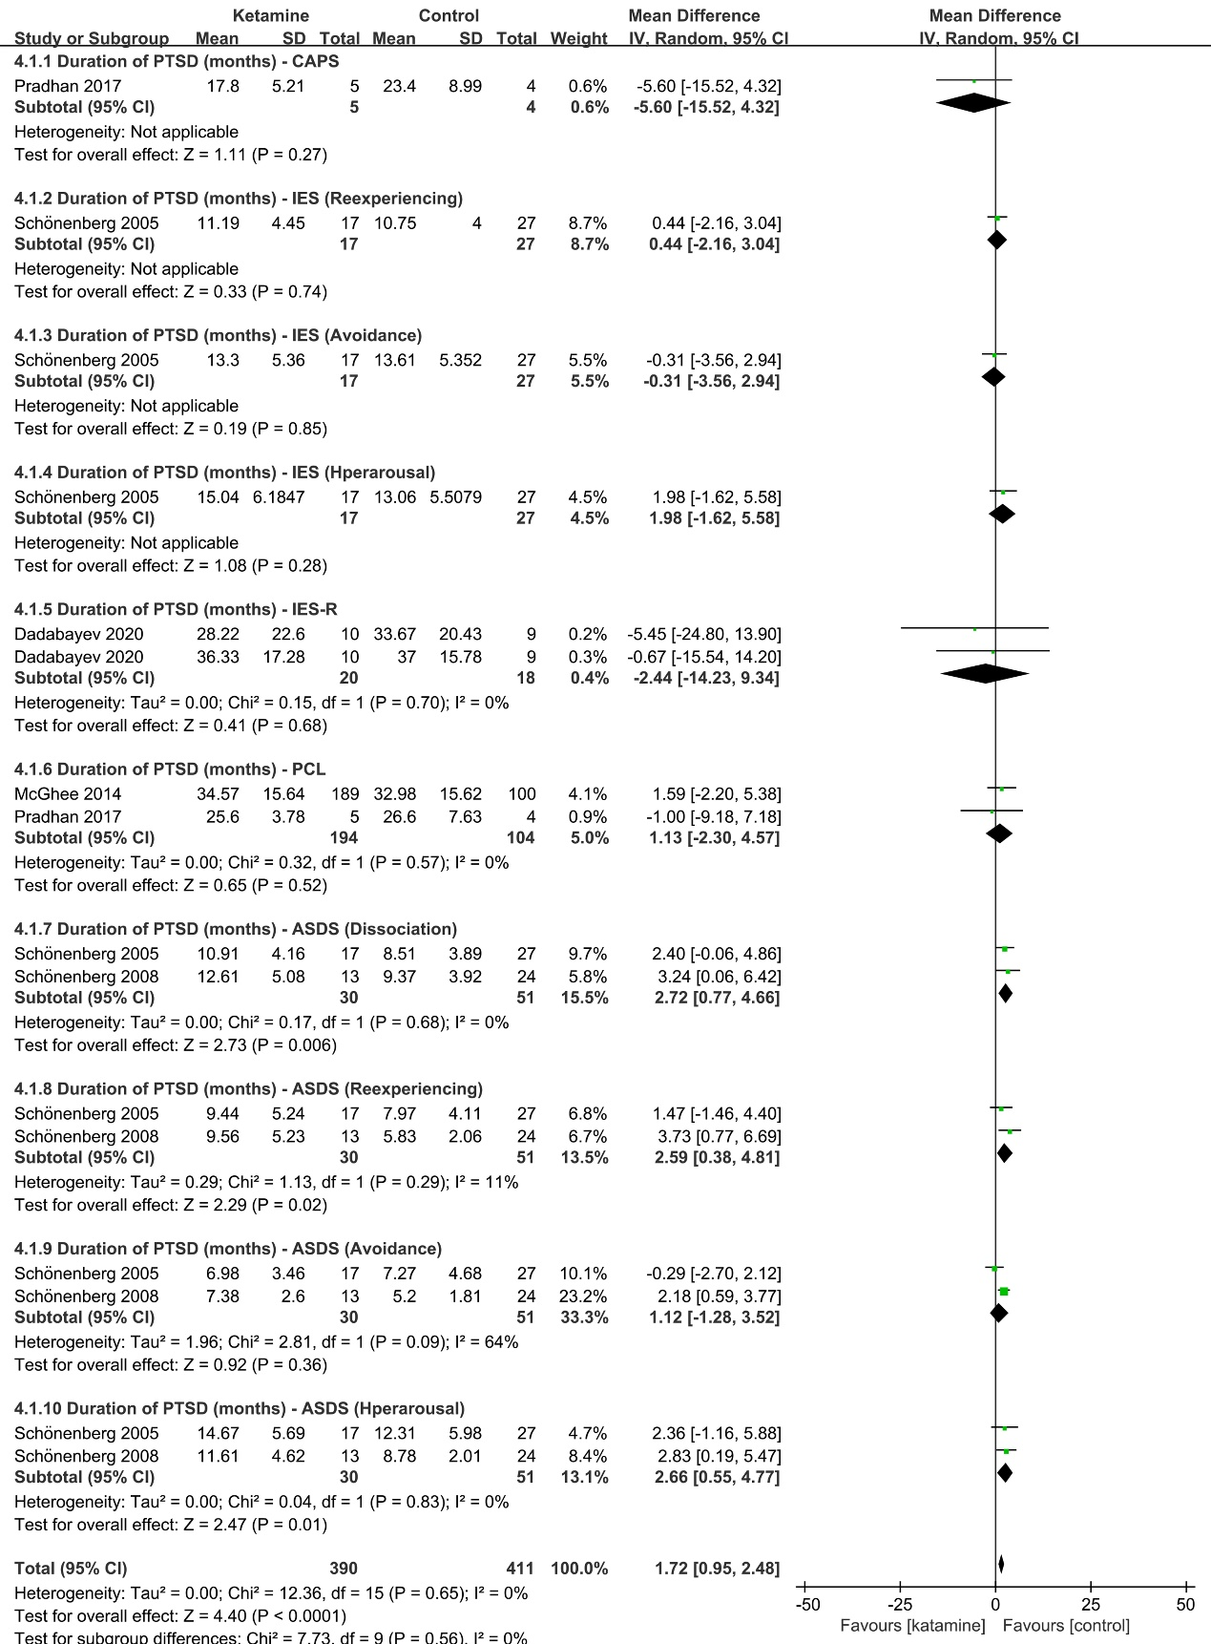
Fig. S1 PTSD-scale scores of short duration (months) by ketamine administration. (ketamine vs. control, full scales). IV, inverse variance; SD, standard deviation.

