SUPPLEMENTAL TABLE AND FIGURES
Red Flags, Prognostic Impact, and Management of Patients with Cardiac Amyloidosis and Aortic Valve Stenosis: A Systematic Review and Meta-analysis
Myasoedova VA¹, Conte M^{2.3}, Valerio V¹, Moschetta D^{1.4}, Massaiu I^{1.5}, Petraglia L², Leosco D², Poggio P¹ and Parisi V²
¹ Centro Cardiologico Monzino IRCCS,20138 Milan Italy
² Università degli Studi di Napoli Federico II, 80131, Napoli, Italy.
³ Casa di Cura San Michele, Maddaloni, Italy,
⁴ Università degli Studi di Milano, Milano, Italy,
⁵ Developmental Biology of the Immune System,Life and Medical Sciences Institute, University of Bonn, Bonn, Germany

Running title: Amyloidosis and Aortic Valve Stenosis

* These Authors equally contributed to the present work.
# To whom correspondence should be addressed:
Valentina Parisi, MD PhD
Dipartimento di Scienze Mediche Traslazionali
Università degli Studi di Napoli Federico II
80131, Napoli, Italy.
Email: parisi.valentina@tiscali.it

Supplemental Table S1. Quality assessment with Newcastle-Ottawa scale of the included studies.
Author, year | SELECTION |  |  |  | COMPARABILITY | OUTCOME
Author, year | Representativeness of the Exposed Cohort | Selection of the Non-Exposed Cohort | Ascertainment of Exposure | Demonstration That Outcome of Interest Was Not Present at Start of Study | COMPARABILITY | Assessment of Outcome | Enough Follow-Up Long for Outcomes to Occur | Adequacy of Follow Up of Cohorts | Quality
Castano et al., 2017 | * | * | * | - | * | * | - | - | 5
Cavalcante et al., 2017 | * | * | * | - | * | * | * | * | 7
Nitsche et al., 2020 | * | * | * | - | ** | * | * | * | 8
Scully et al., 2020 | * | * | * | - | ** | * | * | * | 8
Scully 2020_2 et al., | * | * | * | - | * | * | - | - | 5
Saito et al., 2020 | * | * | * | - | ** | * | - | - | 6
Rosenblum et al., 2021 | * | * | * | - | * | * | * | * | 7
Nitsche et al., 2021 | * | * | * | - | ** | * | * | * | 8
Ferreira et al., 2021 | * | * | * | - | * | * | * | * | 7
Singal et al., 2021 | * | * | * | - | ** | * | * | * | 8
Narotsky et al., 2015 | * | * | * | - | * | * | - |  | 5
Robin et al., 2021 | * | * | * | - | ** | * | - | - | 6
Treibel et al., 2016 | * | * | * | - | * | * | * | * | 7
Fukuzawa et al., 2020 | * | * | * | - | * | * | * | * | 7
Galat et al., 2016 | * | * | * | - | * | * | * | * | 7
Sperry et al., 2016 | * | * | * | - | * | * | * | * | 7
Java et al.,  2018 | * | * | * | - | * | * | * | * | 7
Ali Ambreen et al., 2020 | * | * | * | - | * | * | * | * | 7
Chacko et al., 2020 | * | * | * | - | * | * | * | * | 7

Supplemental Table S2. Statistical heterogeneity among studies
Variable | Q - Value | I - Squared | P - Value
Age, years | 14.4 | 37.3 | 0.110
Male, n (%) | 26.2 | 61.8 | 0.003
BMI, kg/m² | 6.7 | 25.3 | 0.244
Hypertension, n (%) | 14.9 | 33.1 | 0.134
Diabetes, n (%) | 11.3 | 29.5 | 0.183
Dyslipidemia, n (%) | 4.6 | 0 | 0.469
CAD, n (%) | 13.6 | 41.3 | 0.092
Stage D1 | 1.8 | 0 | 0.617
Stage D2 | 3.5 | 0 | 0.478
Stage D3 | 4.8 | 37.4 | 0.188
AV mean gradient, mmHg | 20.9 | 57.0 | 0.013
AV peak velocity, cm/s | 17.5 | 65.8 | 0.007
Aortic Valve Area, cm² | 36.7 | 75.5 | <0.001
E/A ratio | 82.5 | 95.2 | <0.001
E/è ratio | 6.1 | 1.4 | 0.414
LVEF, % | 19.6 | 49.1 | 0.033
IVS, mm | 19.2 | 47.8 | 0.038
SVi, mL/m² | 11.5 | 21.5 | 0.245
LV Mass index, g/m² | 31.1 | 74.3 | <0.001
Low voltage, n (%) | 5.2 | 0 | 0.741
Sokolow-Lyon Index, mV | 88.8 | 93.8 | <0.001
QRS duration, ms | 23.6 | 70.3 | 0.001
RBBB, n (%) | 6.6 | 9.0 | 0.360
NT-proBNP, ng/l | 16.7 | 70.1 | 0.005
HsTnT, ng/l | 1.8 | 0 | 0.776
AS: aortic stenosis; AV: aortic valve; BMI: body mass index; CA: cardiac amyloidosis; CAD coronary artery disease; D1: high gradient; D2: low-flow, low-gradient with reduced LVEF; D3: low-flow, low-gradient with normal LVEF; LV: left ventricular; IVS: intraventricular septum; LVEF: left ventricular ejection fraction; RBBB: right bundle branch block; SVi: stroke volume index

Supplementary Table S3. Publication bias Egger’s regression intercept test.
Variable | P - Value
Age, years | 0.023
Male, n (%) | 0.284
BMI, kg/m² | 0.227
Hypertension, n (%) | 0.357
Diabetes, n (%) | 0.794
Dyslipidemia, n (%) | 0.816
CAD, n (%) | 0.267
Stage D1 | 0.424
Stage D2 | 0.938
Stage D3 | 0.553
AV mean gradient, mmHg | 0.606
AV peak velocity, cm/s | 0.970
Aortic Valve Area, cm² | 0.924
E/A ratio | 0.019
E/è ratio | 0.399
LVEF, % | 0.071
IVS, mm | 0.116
SVi, mL/m² | 0.106
LV Mass index, g/m² | 0.045
Low voltage, n (%) | 0.775
Sokolow-Lyon Index, mV | 0.193
QRS duration, ms | 0.395
RBBB, n (%) | 0.080
NT-proBNP, ng/l | 0.954
HsTnT, ng/l | 0.912

AS: aortic stenosis; AV: aortic valve; BMI: body mass index; CA: cardiac amyloidosis; CAD coronary artery disease; D1: high gradient; D2: low-flow, low-gradient with reduced LVEF; D3: low-flow, low-gradient with normal LVEF; LV: left ventricular; IVS: intraventricular septum; LVEF: left ventricular ejection fraction; RBBB: right bundle branch block; SVi: stroke volume index

Supplementary Table S4. Meta-regressions

Variable | Z - Value | P - Value
Age, years | -3.0 | 0.003
Male, n (%) | -0.55 | 0.554
Hypertension, n (%) | -1.24 | 0.216
Diabetes, n (%) | 2.50 | 0.013
CAD, n (%) | -0.02 | 0.986
Stage D2 | 0.77 | 0.440
AV mean gradient, mmHg | 2.15 | 0.032
Aortic Valve Area, cm² | -1.20 | 0.230
E/è ratio | 0.09 | 0.929
LVEF, % | 0.86 | 0.390
IVS, mm | 1.12 | 0.263
SVi, mL/m² | -0.18 | 0.854
LV Mass index, g/m² | -0.38 | 0.705
Low voltage, n (%) | 0.37 | 0.711
QRS duration, ms | -1.25 | 0.213
RBBB, n (%) | -1.29 | 0.197
HsTnT, ng/l | -1.33 | 0.183
AS: aortic stenosis; AV: aortic valve; BMI: body mass index; CA: cardiac amyloidosis; CAD coronary artery disease; D1: high gradient; D2: low-flow, low-gradient with reduced LVEF; D3: low-flow, low-gradient with normal LVEF; LV: left ventricular; IVS: intraventricular septum; LVEF: left ventricular ejection fraction; RBBB: right bundle branch block; SVi: stroke volume index

Supplementary Table S5. Publication bias Egger’s regression intercept test.

Variable | P - Value
Medical/pharmacological treatment | 0.167
Aortic Valve Replacement | 0.898
Transcatheter Aortic Valve Implantation | 0.630

Supplementary Figure S1. Forrest plots of dichotomous variables
Supplementary Figure S2. Forest plots of continuous variables
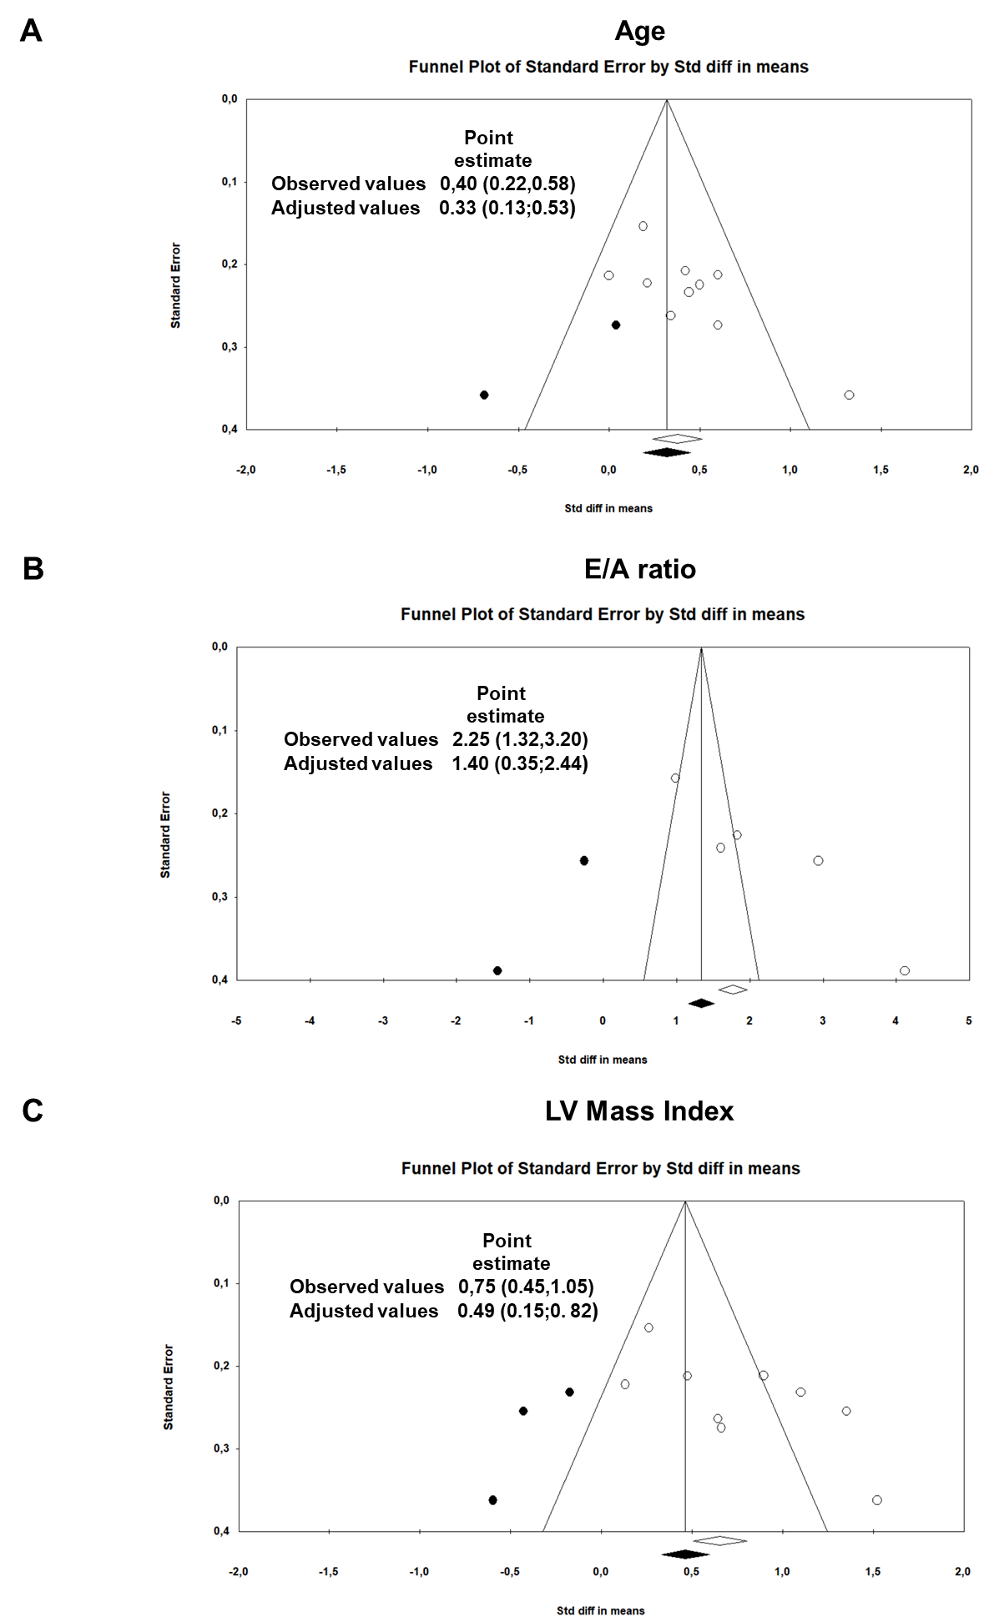
Supplementary Figure S3. Funnel plots of effect size versus standard error for the studies evaluating Age (A), E/A ratio (B), and left ventricular mass index (C) in AS patients with and without cardiac amyloidosis.

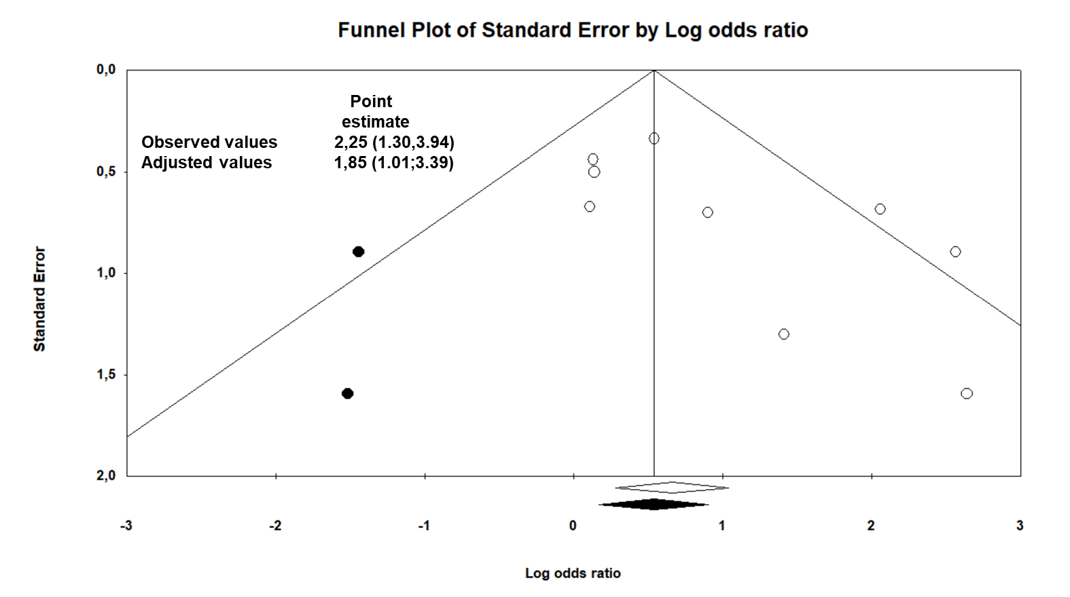
Supplementary Figure S4. Funnel plots of effect size versus standard error for the studies evaluating overall mortality in AS patients with and without cardiac amyloidosis.

