Pubmed
#1 (reintubation[Title/Abstract]) OR (re-intubation[Title/Abstract]) 2735
#2 (((factors[Title/Abstract]) OR (risk factor[Title/Abstract])) OR (influence factor[Title/Abstract])) OR (relevant factor[Title/Abstract]) 2470943
#3 ((Anesthesia[Title/Abstract]) OR (surgery[Title/Abstract])) OR (operative[Title/Abstract]) 1646586
#1 and #2 and #3 367

Web of science
#1 TS=(reintubation OR re-intubation) 2291
#2 TS=(factors OR risk factor OR influence factor OR relevant factor) 5607699
#3 TS=(Anesthesia OR surgery OR operative) 1412502
#1 and #2 and #3 442

Embase
#1 reintubation:ab,ti OR 're intubation':ab,ti 4799
#2 factors:ab,ti OR 'risk factor':ab,ti OR 'influence factor':ab,ti OR 'relevant factor':ab,ti 3224944
#3 anesthesia:ab,ti OR surgery:ab,ti OR operative:ab,ti 2188798
#1 and #2 and #3 651

Cochrane
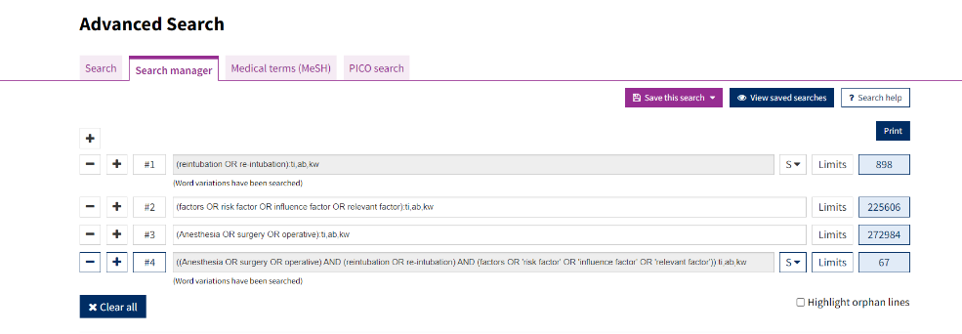
#1 898
#2 225606
#3 272984
#1 AND #2 AND #3 67

Total:367+442+651+67=1527

registration number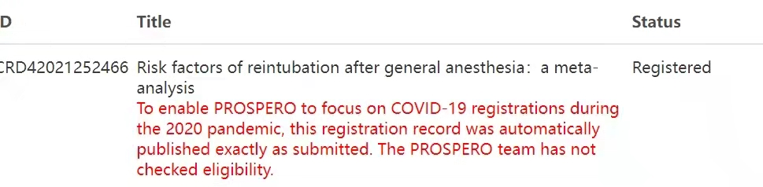

Quality assessment
Study | Selection | Comparability | Outcome | Total scores
Chen Si(1) | ☆☆☆☆ | ☆☆ | ☆☆☆ | 7
Ethan Y. Brovman(3) | ☆☆☆☆ | ☆☆ | ☆☆☆ | 6
Huan-Tang Lin(17) | ☆☆☆☆ | ☆☆ | ☆☆☆ | 7
Karla M. Greco(15) | ☆☆☆☆ | ☆☆ | ☆☆☆ | 8
Lauren A. Wilson(19) | ☆☆☆☆ | ☆☆ | ☆☆☆ | 7
Liu Jian(16) | ☆☆☆☆ | ☆☆ | ☆☆☆ | 7
Pei-Chi Ting（20） | ☆☆☆☆ | ☆☆ | ☆☆☆ | 6
Rafael De la Garza(4) | ☆☆☆☆ | ☆☆ | ☆☆☆ | 8
Rafael De la Garza(14) | ☆☆☆☆ | ☆☆ | ☆☆☆ | 7
Rujirojindakul, P.(18) | ☆☆☆☆ | ☆☆ | ☆☆☆ | 8
Note: A study can be awarded a maximum of one star for each numbered item within the Selection and Exposure categories. A maximum of two stars can be given for Comparability. A red star☆ indicates that the item is not eligible.

