Supplementary table 2
Sensitivity Analysis
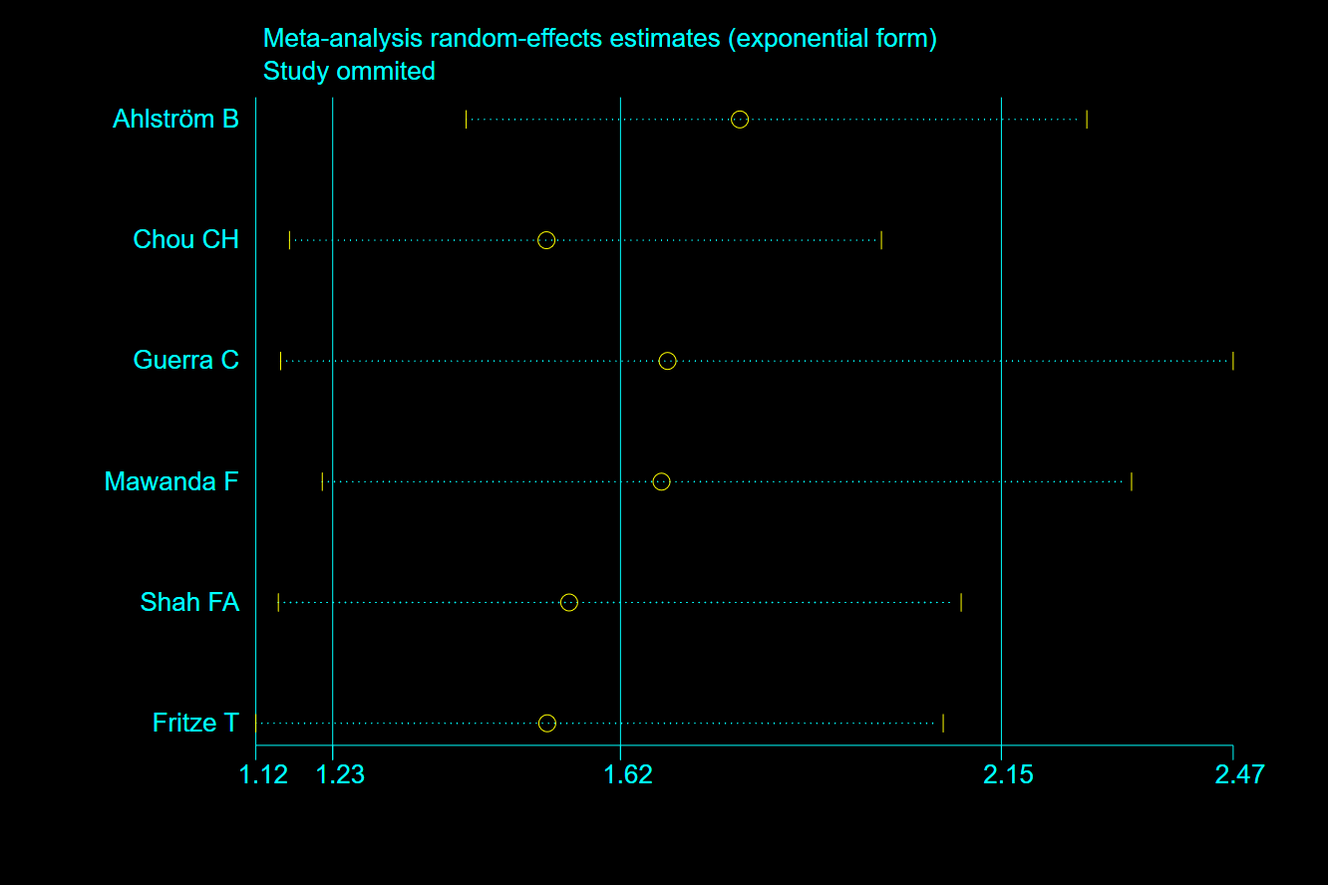
Figure 1 –Sensitivity analysis showing the effect of sepsis on all-cause dementia

Table 1 Sensitivity analysis showing the effect of sepsis on all-cause dementia
Deletion | Result
Ahlström B | OR=1.79, 95% CI [1.41, 2.26]
Chou CH | OR=1.52, 95% CI [1.17, 1.98]
Guerra C | OR=1.69, 95% CI [1.15, 2.47]
Mawanda F | OR=1.68, 95% CI [1.21, 2.33]
Shah FA | OR=1.55, 95% CI [1.15, 2.09]
Fritze T | OR=1.52, 95% CI [1.12, 2.07]

