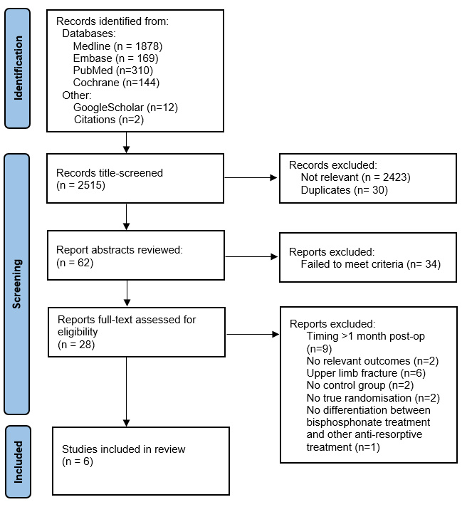

Supplementary Figure 1: PRISMA flow diagram

