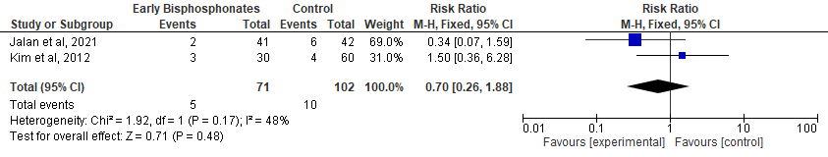

Supplementary Figure. Mortality

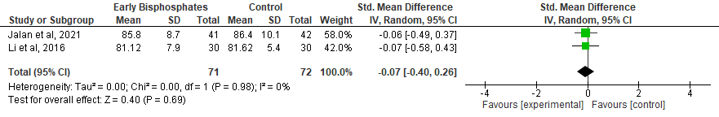

Supplementary Figure. Function

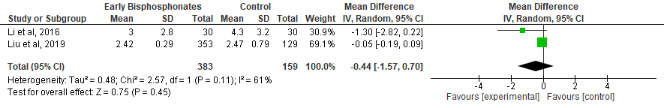

Supplementary Figure. Pain (VAS)

