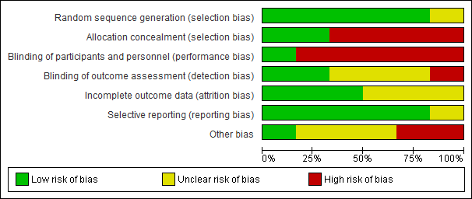

Supplementary Figure. Risk of Bias graph

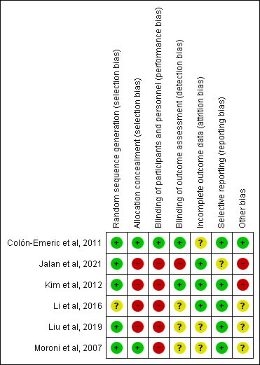

Supplementary Figure. Risk of Bias summary

