Supplementary Materials
Supplementary Table. 1 Search Strategies
The search included: PubMed, Embase, Cochrane Library, Web of Science, ClinicalTrial.gov, and medRxiv: The search date was from the inception through June 2021.
Supplementary Table. 2 Assessment of study quality using the Newcastle-Ottawa scale.

Supplementary Figure. 1 A meta-regression regarding touch-up ablation and sample size (P=0.129).
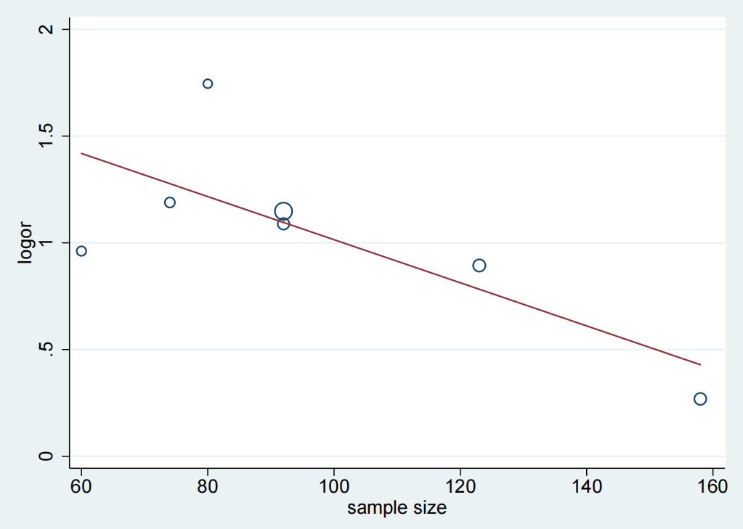

Supplementary Figure. 2 Meta analysis of (A) ablation lesion size (cm²) and (B) lesion area (%).
CBA, cryoballoon ablation; HBA, hot balloon ablation.

Supplementary Figure. 3 Sensitivity analysis of procedure time. Wakamatsu's study has been shown to affect the heterogeneity results significantly.
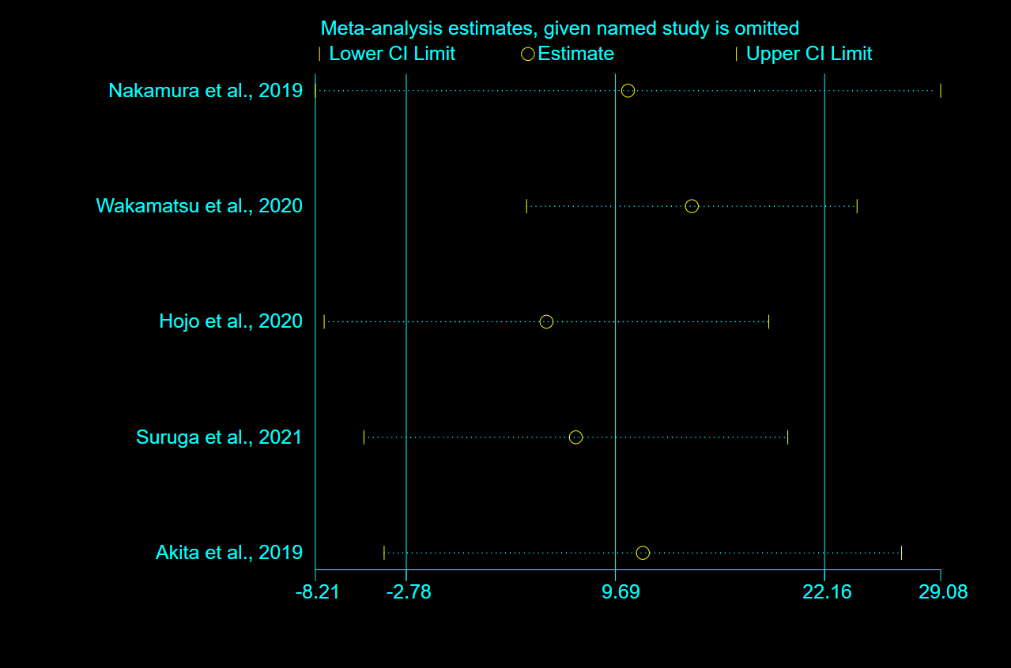

Supplementary Figure. 4 Subgroup analysis of AF recurrence regarding (A) paroxysmal or non-paroxysmal AF and (B) follow-up periods.
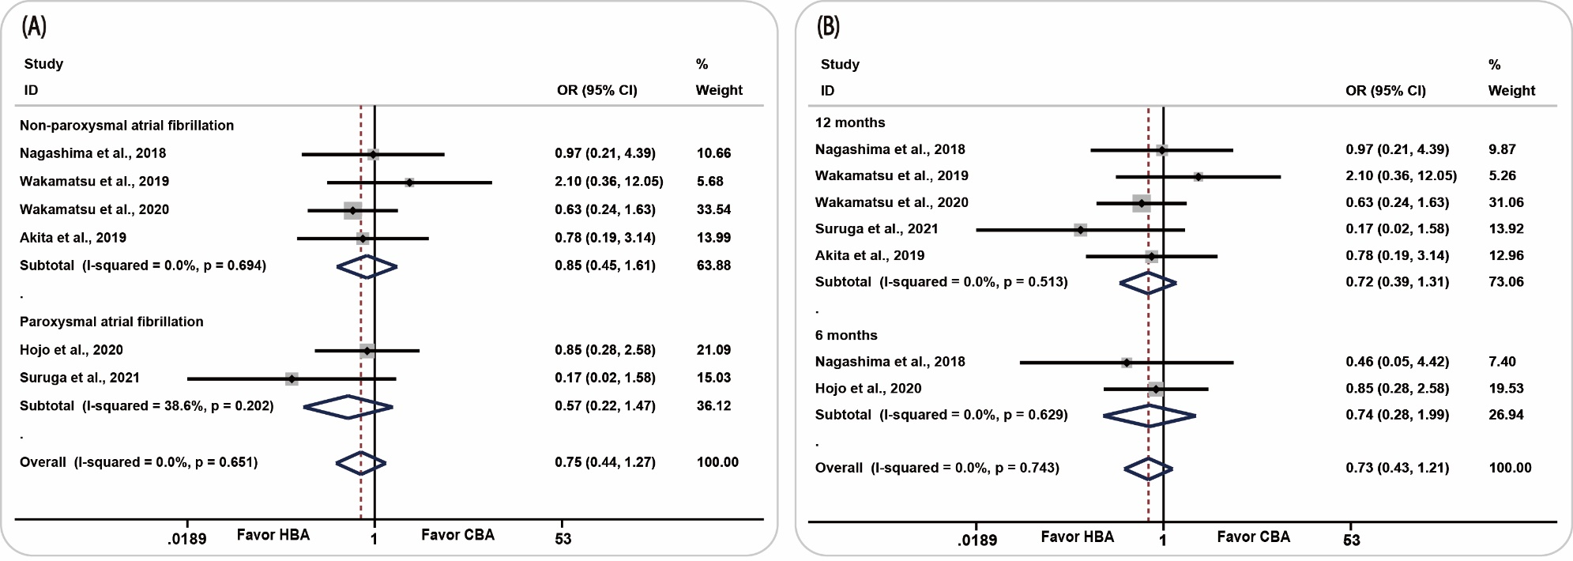
CBA, cryoballoon ablation; HBA, hot balloon ablation.

Supplementary Figure. 5 Publication Bias-Funnel plots for studies evaluating touch-up ablation.


