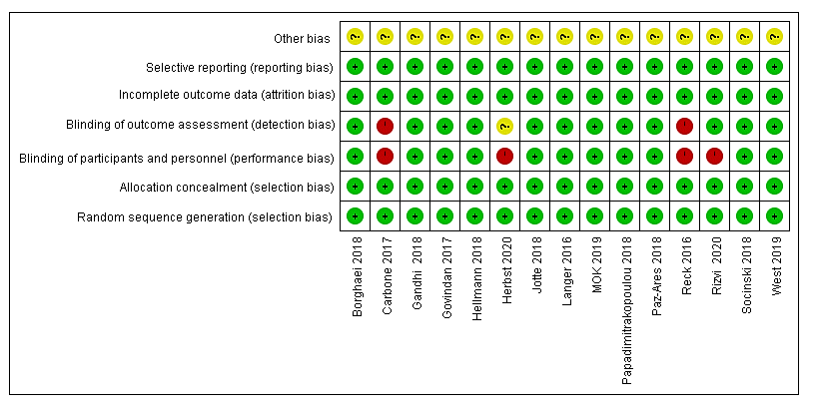
Supplementary Figure 1. Assessment of methodological quality of included trials

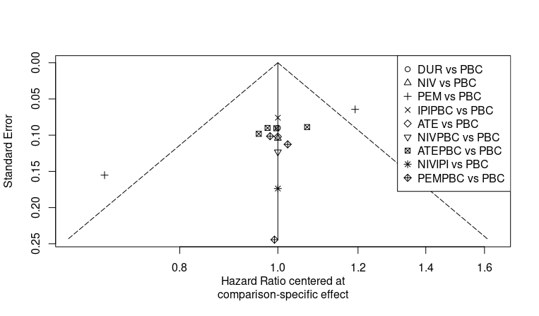

Supplementary Figure 2. Comparison-adjusted funnel plot for the selected studies. Abbreviation: ATE, Atezolizumab; ATEPBC, Atezolizumab & Platinum-based chemotherapy; DUR, Durvalumab; IPIPBC, Ipilimumab & Platinum-based chemotherapy; NIV, Nivolumab; NIVIPI, Nivolumab & Ipilimumab; NIVPBC, Nivolumab & Platinum-based chemotherapy; PEM, Pembrolizumab; PEMPBC, Pembrolizumab & Platinum-based chemotherapy; PBC, Platinum-based chemotherapy.

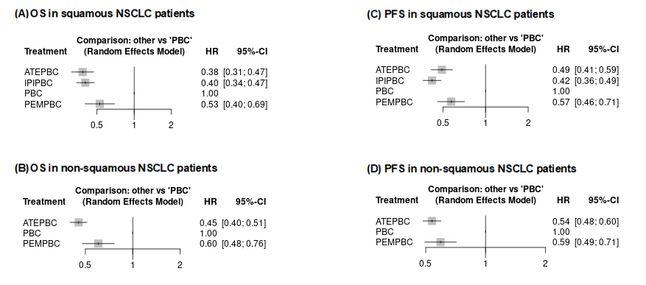
Supplementary Figure 3. Network Meta-Analysis in histology type subgroups. (A) Overall Survival in squamous NSCLC patients; (B) Overall Survival in non- squamous NSCLC patients; (C) Progression-Free Survival in squamous NSCLC patients; (D) Progression-Free Survival in non- squamous NSCLC patients. Abbreviation: ATE, Atezolizumab; ATEPBC, Atezolizumab & Platinum-based chemotherapy; DUR, Durvalumab; IPIPBC, Ipilimumab & Platinum-based chemotherapy; NIV, Nivolumab; NIVIPI, Nivolumab & Ipilimumab; NIVPBC, Nivolumab & Platinum-based chemotherapy; PEM, Pembrolizumab; PEMPBC, Pembrolizumab & Platinum-based chemotherapy; PBC, Platinum-based chemotherapy.

Supplementary Table 1. Rank probability of treatment for OS subgroup of the PD-L1 ≥ 50%.
Study and rank | PBC | ATE | ATEPBC | DUR | NIV | NIVIPI | PEM | PEMPBC
Best | 0.0% | 47.2% | 21.2% | 4.4% | 0.6% | 6.8% | 6.6% | 13.2%
2nd | 0.0% | 17.5% | 22.4% | 8.0% | 1.5% | 13.9% | 20.1% | 16.6%
3rd | 0.0% | 10.4% | 15.5% | 9.5% | 2.5% | 17.7% | 27.3% | 17.1%
4th | 0.0% | 8.3% | 13.4% | 13.4% | 4.4% | 19.2% | 24.8% | 16.5%
5th | 0.1% | 8.0% | 13.0% | 17.5% | 8.4% | 20.8% | 14.6% | 17.7%
6th | 1.9% | 5.9% | 10.2% | 27.7% | 18.1% | 16.5% | 5.9% | 13.8%
7th | 30.8% | 2.3% | 3.9% | 15.4% | 37.2% | 5.0% | 0.8% | 4.6%
Worst | 67.2% | 0.3% | 0.4% | 4.2% | 27.2% | 0.1% | 0.0% | 0.5%
Abbreviation: ATE, Atezolizumab; ATEPBC, Atezolizumab & Platinum-based chemotherapy; DUR, Durvalumab; IPIPBC, Ipilimumab & Platinum-based chemotherapy; NIV, Nivolumab; NIVIPI, Nivolumab & Ipilimumab; NIVPBC, Nivolumab & Platinum-based chemotherapy; PEM, Pembrolizumab; PEMPBC, Pembrolizumab & Platinum-based chemotherapy; PBC, Platinum-based chemotherapy.

Supplementary Table 2. Rank probability of treatment for OS subgroup of the PD-L1 1%-49%.
Study and rank | PBC | ATE | ATEPBC | PEM | PEMPBC
Best | 0.0% | 33.6% | 0.0% | 0.4% | 66.0%
2nd | 4.1% | 10.8% | 12.4% | 38.9% | 33.7%
3rd | 29.7% | 2.8% | 24.8% | 42.5% | 0.2%
4th | 45.8% | 2.5% | 38.1% | 13.5% | 0.0%
Worst | 20.4% | 50.3% | 24.7% | 4.6% | 0.0%
Abbreviation: ATE, Atezolizumab; ATEPBC, Atezolizumab & Platinum-based chemotherapy; DUR, Durvalumab; IPIPBC, Ipilimumab & Platinum-based chemotherapy; NIV, Nivolumab; NIVIPI, Nivolumab & Ipilimumab; NIVPBC, Nivolumab & Platinum-based chemotherapy; PEM, Pembrolizumab; PEMPBC, Pembrolizumab & Platinum-based chemotherapy; PBC, Platinum-based chemotherapy.

Supplementary Table 3. Rank probability of treatment for OS subgroup of the PD-L1 <1%.
Study and rank | PBC | ATEPBC | DUR | NIVIPI | NIVPBC | PEMPBC
Best | 0.0% | 1.6% | 0.0% | 55.4% | 5.1% | 37.8%
2nd | 0.0% | 9.3% | 0.2% | 31.5% | 16.3% | 42.7%
3rd | 0.0% | 38.1% | 0.7% | 9.8% | 37.0% | 14.3%
4th | 4.4% | 47.7% | 3.5% | 3.2% | 36.2% | 5.0%
5th | 78.8% | 3.0% | 13.6% | 0.1% | 4.4% | 0.2%
Worst | 16.8% | 0.3% | 82.0% | 0.0% | 1.0% | 0.0%
Abbreviation: ATE, Atezolizumab; ATEPBC, Atezolizumab & Platinum-based chemotherapy; DUR, Durvalumab; IPIPBC, Ipilimumab & Platinum-based chemotherapy; NIV, Nivolumab; NIVIPI, Nivolumab & Ipilimumab; NIVPBC, Nivolumab & Platinum-based chemotherapy; PEM, Pembrolizumab; PEMPBC, Pembrolizumab & Platinum-based chemotherapy; PBC, Platinum-based chemotherapy.

Supplementary Table 4. Rank probability of treatment for PFS subgroup of the PD-L1 ≥ 50%.
Study and rank | PBC | ATE | ATEPBC | IPIPBC | NIV | NIVIPI | PEM | PEMPBC
Best | 0.0% | 2.6% | 35.3% | 12.7% | 0.0% | 1.9% | 0.1% | 47.4%
2nd | 0.0% | 6.5% | 36.6% | 17.5% | 0.0% | 5.6% | 1.1% | 32.6%
3rd | 0.0% | 14.6% | 19.4% | 27.9% | 0.3% | 15.4% | 7.7% | 14.6%
4th | 0.0% | 22.6% | 6.3% | 18.9% | 1.2% | 25.4% | 21.5% | 4.1%
5th | 0.1% | 24.3% | 2.0% | 11.9% | 3.1% | 25.0% | 32.6% | 1.1%
6th | 3.4% | 22.4% | 0.4% | 9.1% | 9.6% | 22.2% | 32.7% | 0.2%
7th | 58.6% | 5.4% | 0.0% | 1.5% | 27.0% | 3.5% | 3.9% | 0.0%
Worst | 37.9% | 1.6% | 0.0% | 0.5% | 58.8% | 1.0% | 0.2% | 0.0%
Abbreviation: ATE, Atezolizumab; ATEPBC, Atezolizumab & Platinum-based chemotherapy; DUR, Durvalumab; IPIPBC, Ipilimumab & Platinum-based chemotherapy; NIV, Nivolumab; NIVIPI, Nivolumab & Ipilimumab; NIVPBC, Nivolumab & Platinum-based chemotherapy; PEM, Pembrolizumab; PEMPBC, Pembrolizumab & Platinum-based chemotherapy; PBC, Platinum-based chemotherapy.

Supplementary Table 5. Rank probability of treatment for PFS subgroup of the PD-L1 1%-49%.
Study and rank | PBC | ATE | ATEPBC | IPIPBC | PEM | PEMPBC
Best | 0.0% | 0.3% | 7.9% | 24.4% | 0.0% | 67.5%
2nd | 0.0% | 2.0% | 38.5% | 33.9% | 0.0% | 25.6%
3rd | 0.4% | 9.6% | 49.3% | 34.0% | 0.1% | 6.6%
4th | 27.9% | 58.3% | 4.3% | 6.8% | 2.3% | 0.3%
5th | 67.4% | 23.8% | 0.0% | 0.7% | 8.1% | 0.0%
Worst | 4.3% | 6.0% | 0.0% | 0.2% | 89.5% | 0.0%
Abbreviation: ATE, Atezolizumab; ATEPBC, Atezolizumab & Platinum-based chemotherapy; DUR, Durvalumab; IPIPBC, Ipilimumab & Platinum-based chemotherapy; NIV, Nivolumab; NIVIPI, Nivolumab & Ipilimumab; NIVPBC, Nivolumab & Platinum-based chemotherapy; PEM, Pembrolizumab; PEMPBC, Pembrolizumab & Platinum-based chemotherapy; PBC, Platinum-based chemotherapy.

Supplementary Table 6. Rank probability of treatment for PFS subgroup of the PD-L1 <1%.
Study and rank | PBC | ATE | ATEPBC | IPIPBC | NIVIPI | PEMPBC
Best | 0.0% | 18.9% | 17.7% | 18.8% | 15.3% | 29.3%
2nd | 0.0% | 16.3% | 26.4% | 16.9% | 14.9% | 25.5%
3rd | 0.2% | 17.3% | 26.8% | 18.5% | 16.9% | 20.4%
4th | 2.6% | 20.0% | 19.8% | 19.9% | 21.7% | 16.0%
5th | 23.2% | 19.6% | 9.0% | 18.7% | 21.2% | 8.3%
Worst | 74.0% | 7.9% | 0.4% | 7.2% | 10.0% | 0.6%
Abbreviation: ATE, Atezolizumab; ATEPBC, Atezolizumab & Platinum-based chemotherapy; DUR, Durvalumab; IPIPBC, Ipilimumab & Platinum-based chemotherapy; NIV, Nivolumab; NIVIPI, Nivolumab & Ipilimumab; NIVPBC, Nivolumab & Platinum-based chemotherapy; PEM, Pembrolizumab; PEMPBC, Pembrolizumab & Platinum-based chemotherapy; PBC, Platinum-based chemotherapy.

