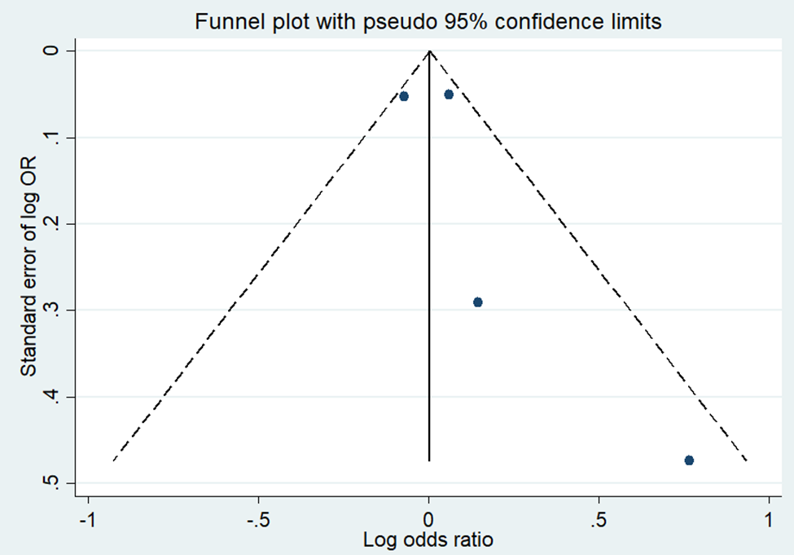
Supplementary figure 1. Funnel plots to assess publication bias of association between internet addiction and loneliness for studies with odds ratio measure

Supplementary figure 2. Funnel plots to assess publication bias of association between internet addiction and loneliness for studies with correlation coefficient measure

Supplementary figure 3. Funnel plots to assess publication bias of association between internet addiction and loneliness for studies with beta coefficient measure

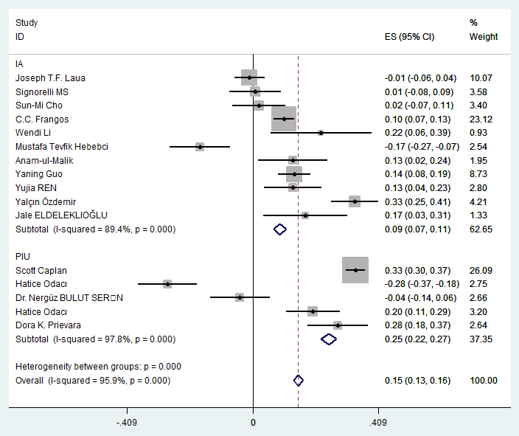
Supplementary figure 4. Forest plot of overall association stratified by definition of internet addiction (internet addiction and problematic internet use) for all studies included in meta-analysis.

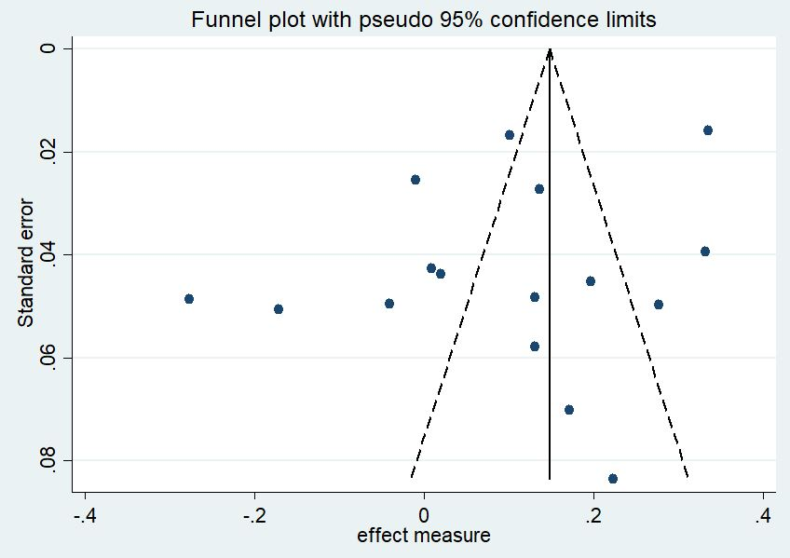

Supplementary figure 5. Funnel plots to assess publication bias of association between internet addiction and loneliness for all studies

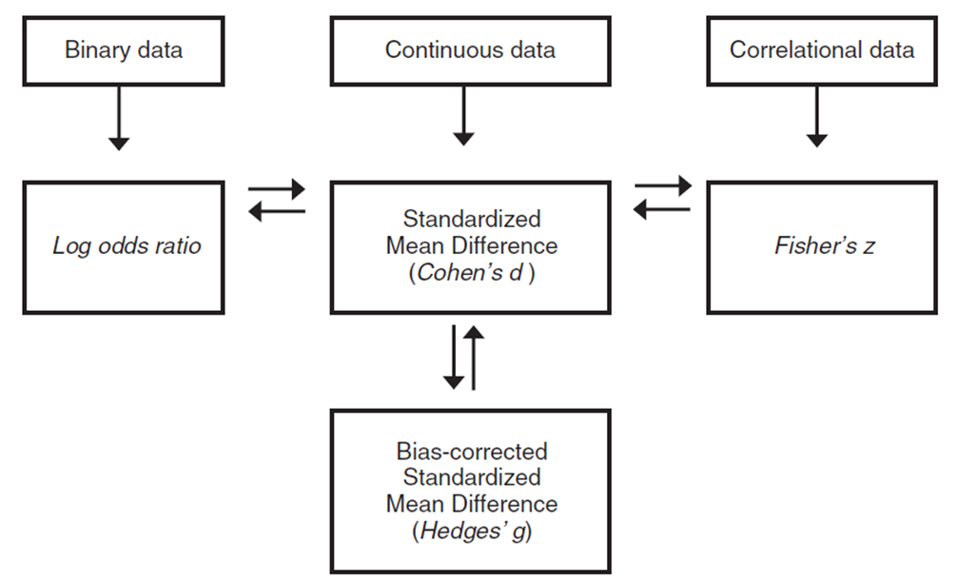

Supplementary figure 6. The mechanism of converting among effect sizes (Introduction to Meta-Analysis; Michael Borenstein)

Formulas; (Introduction to Meta-Analysis; Michael Borenstein)
Converting from the log odds ratio to d

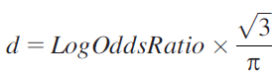

Converting from d to the log odds ratio

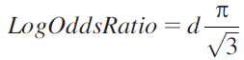
where π is the mathematical constant (approximately 3.14159).

Converting from r to d

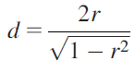

Converting from d to r

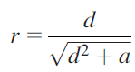
where a is a correction factor for cases where n1 ≠ n2



