SUPPLEMENTARY APPENDIX

Clinical Significance of Micronutrient Supplements in Patients with Coronavirus Disease 2019: A Comprehensive Systematic Review and Meta-Analysis

Azizullah Beran; MD, Mohammed Mhanna; MD, Omar Srour; MD, Hazem, Ayesh; MD, Waleed Khokher; MD, Asmaa S. Mhanna; MD, Dana Ghazaleh; MD, Yasmin Khader; MD, Wasef Sayeh; MD, Ahmed Elzanaty; MD, Ragheb Assaly; MD

Supplementary tables

Title | Page
Supplementary table 1: Search strategy used in each database searched. | 2-3
Supplementary table 2: Quality assessment of the studies that examined the effects of vitamin C on COVID-19. | 4
Supplementary table 3: Quality assessment of the studies that examined the effects of vitamin D on COVID-19. | 5-6
Supplementary table 4: Quality assessment of the studies that examined the effects of zinc on COVID-19. | 7

Supplementary figures

Title | Page
Supplementary figure 1: (A) Subgroup analysis of randomized controlled trials for vitamin C. (B) Subgroup analysis of intravenous vitamin C. | 8
Supplementary figure 2: Leave-one-out sensitivity analysis of studies that examined the effect of vitamin C on: A) mortality, B) intubation rate, C) length of hospital stay. | 9
Supplementary figure 3: Funnel plot showing publication bias analysis of studies that examined the effect of vitamin D supplementation on mortality in COVID-19. | 10

Supplementary table 1: Search strategy used in each database searched.

Database | Search Strategy | Articles retrieved
Medline/PubMed | ("covid 19"[All Fields] OR "covid 19"[MeSH Terms] OR "covid 19 vaccines"[All Fields] OR "covid 19 vaccines"[MeSH Terms] OR "covid 19 serotherapy"[All Fields] OR "covid 19 serotherapy"[Supplementary Concept] OR "covid 19 nucleic acid testing"[All Fields] OR "covid 19 nucleic acid testing"[MeSH Terms] OR "covid 19 serological testing"[All Fields] OR "covid 19 serological testing"[MeSH Terms] OR "covid 19 testing"[All Fields] OR "covid 19 testing"[MeSH Terms] OR "sars cov 2"[All Fields] OR "sars cov 2"[MeSH Terms] OR "severe acute respiratory syndrome coronavirus 2"[All Fields] OR "ncov"[All Fields] OR "2019 ncov"[All Fields] OR (("coronavirus"[MeSH Terms] OR "coronavirus"[All Fields] OR "cov"[All Fields]) AND 2019/11/01:3000/12/31[Date - Publication]) OR ("sars cov 2"[MeSH Terms] OR "sars cov 2"[All Fields] OR "sars cov 2"[All Fields])) AND ("micronutrients"[Pharmacological Action] OR "micronutrients"[MeSH Terms] OR "micronutrients"[All Fields] OR "micronutriments"[All Fields] OR "trace elements"[Pharmacological Action] OR "trace elements"[MeSH Terms] OR ("trace"[All Fields] AND "elements"[All Fields]) OR "trace elements"[All Fields] OR "micronutrient"[All Fields] OR ("nutrient s"[All Fields] OR "nutrients"[MeSH Terms] OR "nutrients"[All Fields] OR "nutrient"[All Fields]) OR ("vitamin a"[MeSH Terms] OR "vitamin a"[All Fields]) OR ("vitamin b 6"[MeSH Terms] OR "vitamin b 6"[All Fields] OR ("vitamin"[All Fields] AND "b6"[All Fields]) OR "vitamin b6"[All Fields]) OR ("vitamin b 12"[MeSH Terms] OR "vitamin b 12"[All Fields] OR ("vitamin"[All Fields] AND "b12"[All Fields]) OR "vitamin b12"[All Fields]) OR ("ascorbic acid"[MeSH Terms] OR ("ascorbic"[All Fields] AND "acid"[All Fields]) OR "ascorbic acid"[All Fields]) OR ("ascorbic acid"[MeSH Terms] OR ("ascorbic"[All Fields] AND "acid"[All Fields]) OR "ascorbic acid"[All Fields] OR "vitamin c"[All Fields]) OR ("vitamin d"[MeSH Terms] OR "vitamin d"[All Fields] OR "ergocalciferols"[MeSH Terms] OR "ergocalciferols"[All Fields]) OR ("vitamin e"[MeSH Terms] OR "vitamin e"[All Fields]) OR ("selenium"[MeSH Terms] OR "selenium"[All Fields] OR "selenium s"[All Fields] OR "seleniums"[All Fields]) OR ("zinc"[MeSH Terms] OR "zinc"[All Fields]) OR ("dietary supplements"[MeSH Terms] OR ("dietary"[All Fields] AND "supplements"[All Fields]) OR "dietary supplements"[All Fields] OR ("dietary"[All Fields] AND "supplement"[All Fields]) OR "dietary supplement"[All Fields])) | 1775
Embase | ('covid 19'/exp OR 'covid 19' OR 'sars cov 2'/exp OR 'sars cov 2') AND ('micronutrient'/exp OR micronutrient OR 'nutrient'/exp OR nutrient OR 'vitamin a'/exp OR 'vitamin a' OR (('vitamin'/exp OR vitamin) AND a) OR 'vitamin b6'/exp OR 'vitamin b6' OR (('vitamin'/exp OR vitamin) AND b6) OR 'vitamin b12'/exp OR 'vitamin b12' OR (('vitamin'/exp OR vitamin) AND ('b12'/exp OR b12)) OR 'ascorbic acid'/exp OR 'ascorbic acid' OR (ascorbic AND ('acid'/exp OR acid)) OR 'vitamin c'/exp OR 'vitamin c' OR (('vitamin'/exp OR vitamin) AND c) OR 'vitamin d'/exp OR 'vitamin d' OR (('vitamin'/exp OR vitamin) AND d) OR 'vitamin e'/exp OR 'vitamin e' OR (('vitamin'/exp OR vitamin) AND e) OR 'selenium'/exp OR selenium OR 'zinc'/exp OR zinc OR 'dietary supplement'/exp OR 'dietary supplement' OR (dietary AND supplement)) | 4346
Cochrane | ((COVID-19 OR SARS-CoV-2) AND (micronutrient OR nutrient OR vitamin A OR vitamin B6 OR vitamin B12 OR ascorbic acid OR vitamin C OR vitamin D OR vitamin E OR selenium OR zinc OR dietary supplement)):ti,ab,kw | 334

Supplementary table 2: Quality assessment of the studies that examined the effects of vitamin C in COVID-19.

Cohort studies | Selection |  |  |  | Comparability | Outcome |  |  |  | Quality score
Cohort studies | Representativeness of the exposed cohort | Selection of non-exposed cohort | Ascertainment of exposure | Demonstration that outcome of interest was not present at start of study | Comparability of the cohorts on the basis of design or analysis | Assessment of outcome | Was follow up long enough for outcomes to occur |  | Adequacy of follow up cohorts | Quality score
Al Sulaiman, 2021 (1) | 1 | 1 | 1 | 1 | 1 | 1 | 1 |  | 0 | 7
Gao, 2021 | 1 | 1 | 1 | 1 | 1 | 1 | 1 |  | 0 | 7
Li, 2021 | 1 | 1 | 1 | 1 | 1 | 1 | 0 |  | 0 | 6
Suna, 2021 | 1 | 1 | 1 | 1 | 1 | 1 | 0 |  | 0 | 6
Zheng, 2021 | 1 | 1 | 1 | 1 | 1 | 1 | 1 |  | 1 | 8
Randomized controlled studies | Randomization |  |  |  | Blinding |  |  | Withdrawals |  | Quality score
 | Was the study described as randomized? |  | Was the randomization appropriate? |  | Was the study described as double blind? | Was the double blinding appropriate? |  | Was there a description of withdrawals and dropouts?
JamaliMoghadam, 2021 | 1 |  | 1 |  | 0 | 0 |  | 0 |  | 2
Kumari, 2020 | 1 |  | 1 |  | 0 | 0 |  | 0 |  | 2
Thomas, 2021 | 1 |  | 1 |  | 0 | 0 |  | 1 |  | 3
Zhang, 2020 | 1 |  | 1 |  | 0 | 0 |  | 1 |  | 3

Supplementary table 3: Quality assessment of the studies that examined the effects of vitamin D on mortality in COVID-19.
Non-randomized studies | Selection |  |  |  | Comparability | Outcome |  |  |  | Quality score
Non-randomized studies | Representativeness of the exposed cohort | Selection of non-exposed cohort | Ascertainment of exposure | Demonstration that outcome of interest was not present at start of study | Comparability of the cohorts on the basis of design or analysis | Assessment of outcome | Was follow up long enough for outcomes to occur |  | Adequacy of follow up cohorts | Quality score
Alcala-Diaz, 2021 | 1 | 1 | 1 | 1 | 1 | 1 | 0 |  | 1 | 7
Arroyo-Diaz, 2021 | 1 | 1 | 1 | 1 | 0 | 1 | 0 |  | 1 | 6
Cangiano, 2021 | 1 | 1 | 1 | 1 | 1 | 1 | 1 |  | 1 | 8
C. Annweiler, 2020 | 1 | 1 | 1 | 1 | 1 | 1 | 1 |  | 0 | 7
Cereda, 2021 | 1 | 1 | 1 | 1 | 1 | 1 | 0 |  | 0 | 6
G. Annweiler, 2020 | 1 | 1 | 1 | 1 | 1 | 1 | 0 |  | 0 | 6
Guven, 2021 | 1 | 1 | 1 | 1 | 1 | 1 | 0 |  | 1 | 7
Hernandez, 2020 | 1 | 1 | 1 | 1 | 0 | 1 | 0 |  | 1 | 6
Jevalikar, 2021 | 1 | 1 | 1 | 1 | 1 | 1 | 0 |  | 0 | 6
Randomized controlled studies | Randomization |  |  |  | Blinding |  |  | Withdrawals |  | Quality score
 | Was the study described as randomized? |  | Was the randomization appropriate? |  | Was the study described as double blind? | Was the double blinding appropriate? |  | Was there a description of withdrawals and dropouts?
Castillo et al., 2020 | 1 |  | 1 |  | 0 | 0 |  | 1 |  | 3
Elamir, 2021 | 1 |  | 1 |  | 0 | 0 |  | 1 |  | 3
Lakkireddy, 2021 | 1 |  | 1 |  | 0 | 0 |  | 1 |  | 3
Murai, 2021 | 1 |  | 1 |  | 1 | 1 |  | 0 |  | 4

Supplementary table 4: Quality assessment of the studies that examined the effects of zinc on mortality in COVID-19.
Cohort studies | Selection |  |  |  | Comparability | Outcome |  |  |  | Quality score
Cohort studies | Representativeness of the exposed cohort | Selection of non-exposed cohort | Ascertainment of exposure | Demonstration that outcome of interest was not present at start of study | Comparability of the cohorts on the basis of design or analysis | Assessment of outcome | Was follow up long enough for outcomes to occur |  | Adequacy of follow up cohorts | Quality score
Al Sulaiman, 2021 (2) | 1 | 1 | 1 | 1 | 1 | 1 | 0 |  | 1 | 7
Yao, 2021 | 1 | 1 | 1 | 1 | 1 | 1 | 0 |  | 0 | 6
Randomized controlled studies | Randomization |  |  |  | Blinding |  |  | Withdrawals |  | Quality score
 | Was the study described as randomized? |  | Was the randomization appropriate? |  | Was the study described as double blind? | Was the double blinding appropriate? |  | Was there a description of withdrawals and dropouts?
Abd-Elsalam, 2020 | 1 |  | 1 |  | 0 | 0 |  | 0 |  | 2
Thomas et al., 2021 | 1 |  | 1 |  | 0 | 0 |  | 1 |  | 3
Zhang et al., 2020 | 1 |  | 1 |  | 0 | 0 |  | 1 |  | 3

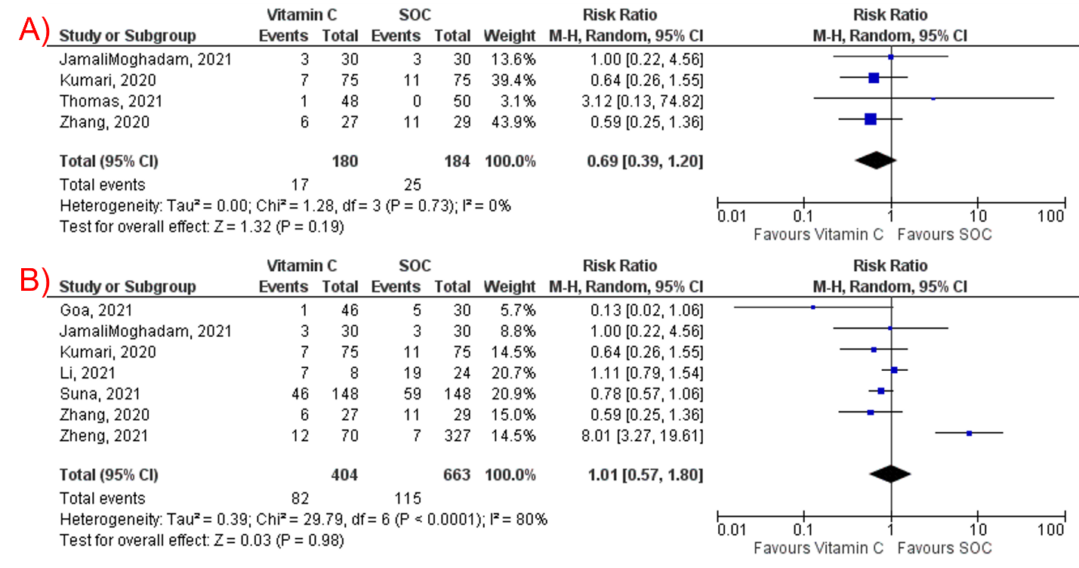
Supplementary figure 1: (A) Subgroup analysis of randomized controlled trials for vitamin C. (B) Subgroup analysis of intravenous vitamin C.

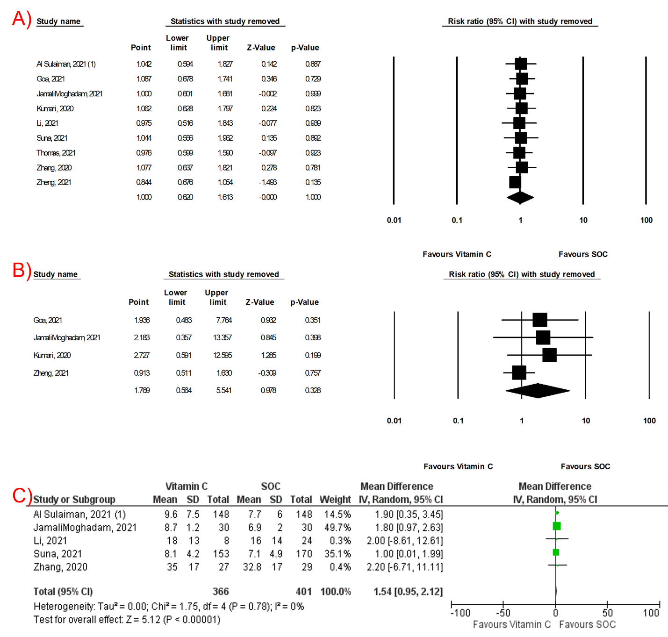

Supplementary figure 2: Leave-one-out sensitivity analysis of studies that examined the effect of vitamin C on: A) mortality, B) intubation rate, C) length of hospital stay.

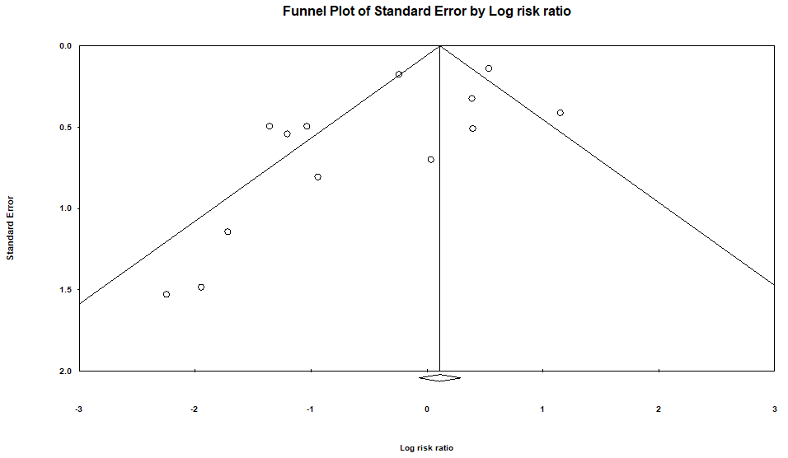
Supplementary figure 3: Funnel plot showing publication bias analysis of studies that examined the effect of vitamin D supplementation on mortality in COVID-19.

