Appendix 1:
The search of the databases was done by using the terms as follows:
(1) “Covid-19” [Mesh][tiab]
(2) “Coronavirus disease 2019” [tiab]
(3) “SARS-CoV-2” [tiab]
(4) or/1–3
(5) “Pulmonary Rehabilitation” [tiab]
(6) “Exercise” [tiab]
(7) “Physiotherapy” [tiab]
(8) “Respiratory therapy” [tiab]
(9) “Rehabilitation” [tiab]
(10) “Tele-rehabilitation” [tiab]
(11) “Fitness” [tiab]
(12) “Recovery” [tiab]
(13) or/6–12
(14) “Dyspnea” [tiab]
(15) “Exercise capacity” [tiab]
(16) “Pulmonary function” [tiab]
(17) “Lung functions” [tiab]
(18) “Fatigue” [tiab]
(19) “Health related quality of life” [tiab]
(20) “Quality of life” [tiab]
(21) or/14-20
(22) randomized controlled trial [pt]
(23) controlled clinical trial [pt]
(24) randomized controlled trials [mh]
(25) random allocation [mh]
(26) double-blind method [mh]
(27) single-blind method [mh]
(28) clinical trials [mh]
(29) “clinical trial” [tw]
(30) or/22–29
(31) and/ 4,13 and 21.
Figure 1-a: Risk of Bias Graph.
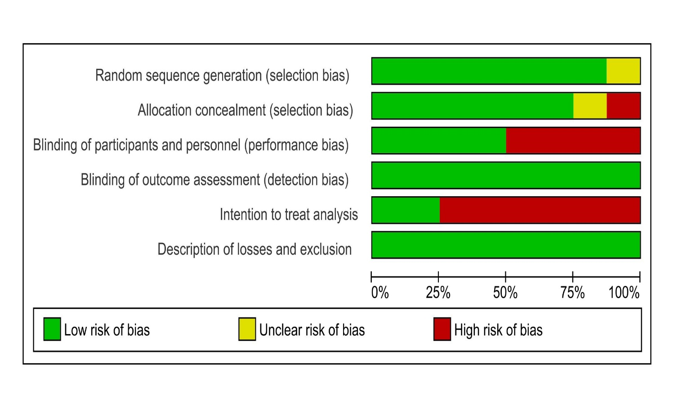

Figure 1-b: Risk of Bias Summary.


