Supplementary data

This document contains:

3 figures

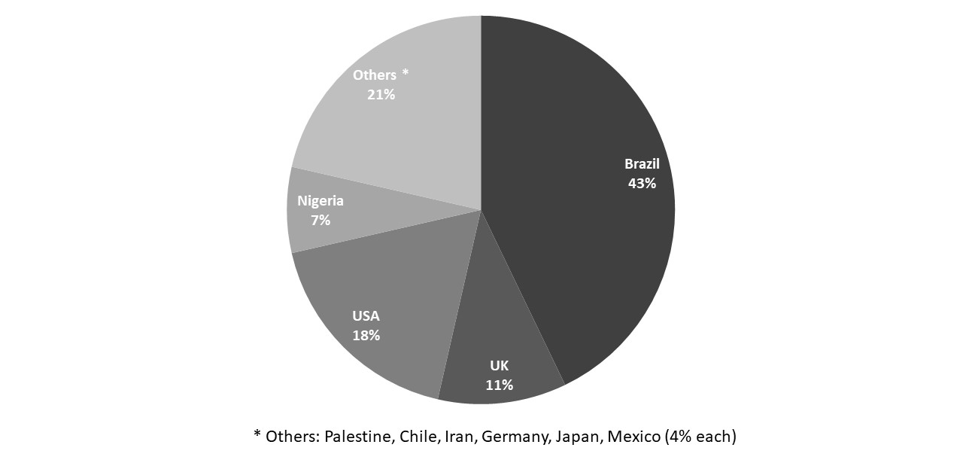
Figure S1. Mondial geographical repartition of the included studies.

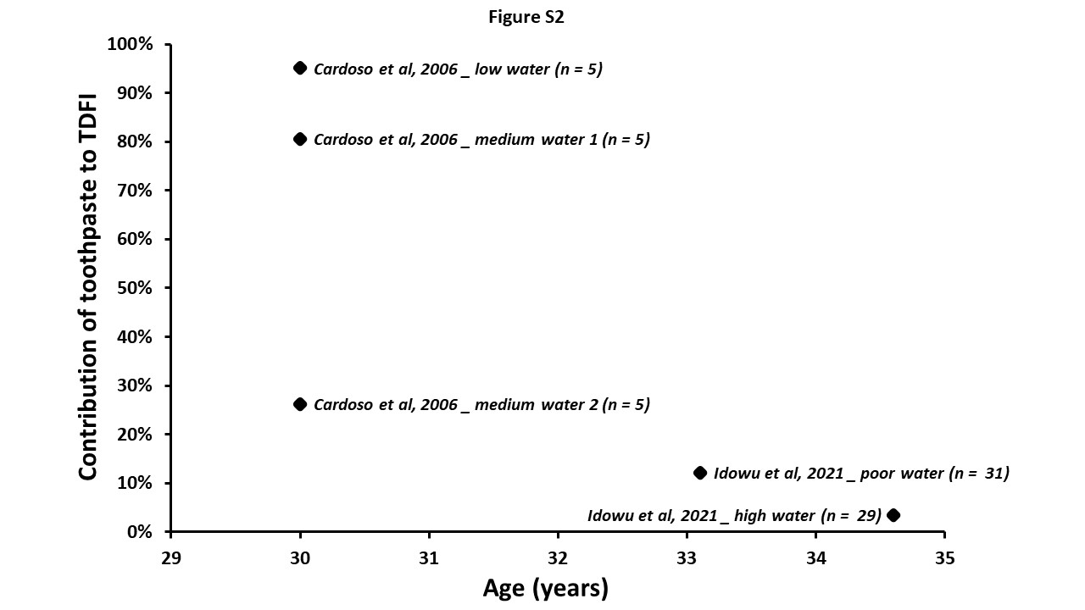
Figure S2. Contribution of toothpaste to the TDFI (%) in adults. Only 2 articles are related to adults in our PRISMA selection.

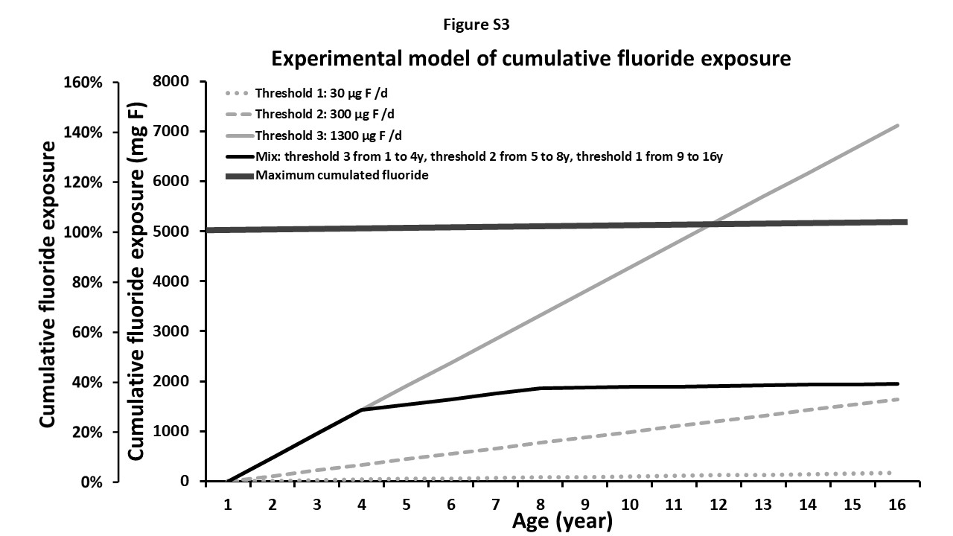
Figure S3. Experimental model of cumulative fluoride exposure following the age of the individuals. It considers 3 different thresholds of 30, 300 and 1300 µg F/d and a model of mixed exposures (1300 µg F/d until 4 years, then 300 µg F/d until 8 years and 30 µg F/d until 16 years). The maximum cumulated fluoride exposure (100 %) is reached at 5000 mg.

