Supplementary Material
Supplemental Tables:

Table S1. Characteristics of the included studies.
Table S2. Circulating lipid levels by the genotypes of SERPINE1 rs1799889 polymorphism.

Supplemental Figures:

Figure S1. Begg’s funnel plot of the association analysis between SERPINE1 rs1799889 polymorphism and circulating TG levels.
Figure S2. Begg’s funnel plot of the association analysis between SERPINE1 rs1799889 polymorphism and circulating TC levels.
Figure S3. Begg’s funnel plot of the association analysis between SERPINE1 rs1799889 polymorphism and circulating LDL-C levels.
Figure S4. Begg’s funnel plot of the association analysis between SERPINE1 rs1799889 polymorphism and circulating HDL-C levels.

Table S1. Characteristics of the included studies.
First author, reference | Year | Ethnicity | Gender | Study population | Outcomes
Panahloo A [R1] | 1995 | Other ethnic | M/F | Patients with T2DM | TC/HDL
Margaglione M [R2] | 1997 | Caucasian | M/F | Patients with high risk of CAD | HDL
Margaglione M [R3] | 1998 | Caucasian | M/F | Healthy subjects | TG/TC/LDL/HDL
Burzotta F [R4] | 1998 | Caucasian | M/F | Healthy subjects | TG/TC
Grancha S [R5] | 1999 | Caucasian | F | Patients with CAD | TG/TC
Song JH1 [R6] | 2000 | Asian | M/F | Patients with CAD | TG/TC/LDL/HDL
Song JH2 [R6] | 2000 | Asian | M/F | Control subjects | TG/TC/LDL/HDL
Wong TY [R7] | 2000 | Asian | M/F | Patients with T2DM | TG/TC
Seguí R [R8] | 2000 | Caucasian | M/F | Patients with deep vein thrombosis | TG/TC
van Harmelen V [R9] | 2000 | Caucasian | M/F | Healthy subjects | TG
Estellés A [R10] | 2001 | Caucasian | M/F | Patients with obesity | TG
Li CG [R11] | 2001 | Asian | M/F | Patients with T2DM | TG/TC
Hoekstra T [R12] | 2003 | Caucasian | M/F | Healthy subjects | TC/LDL/HDL
Jeng JR1 [R13] | 2003 | Asian | M | Patients with hypertension and healthy subjects | TG/TC
Jeng JR2 [R13] | 2003 | Asian | F | Patients with hypertension and healthy subjects | TG/TC
Lopes C [R14] | 2003 | Caucasian | M/F | Patients with T2DM | TG/HDL
Chen CH1 [R15] | 2003 | Asian | M/F | Patients with stroke | TG/TC/LDL/HDL
Chen CH2 [R15] | 2003 | Asian | M/F | Control subjects | TG/TC/LDL/HDL
Zhang AJ [R16] | 2003 | Asian | M/F | Patients with cerebral infarction | TG/TC/LDL/HDL
Kitamura Y [R17] | 2004 | Asian | M | Healthy subjects | TG/TC/LDL/HDL
Zhang AY [R18] | 2004 | Asian | M/F | Patients with CAD | TG/TC/LDL/HDL
Ruiz-Quezada S [R19] | 2004 | Other ethnic | M/F | Healthy subjects | TG/TC/LDL/HDL
Roncal C1 [R20] | 2004 | Caucasian | M/F | Patients with hypertension | TG/TC/HDL
Roncal C2 [R20] | 2004 | Caucasian | M/F | Control subjects | TG/TC/HDL
Liu SQ [R21] | 2004 | Asian | M/F | Patients with T2DM | TG/TC/LDL/HDL
Chen YL [R22] | 2005 | Asian | M/F | Patients with deep vein thrombosis | TG/TC/LDL/HDL
Meigs JB [R23] | 2006 | Caucasian | M/F | Healthy subjects | TG
Zietz B [R24] | 2006 | Caucasian | M/F | Patients with T2DM | TG/TC/LDL/HDL
Wang L [R25] | 2007 | Asian | M/F | Patients with T2DM and control subjects | TG/TC
Karadeniz M [R26] | 2007 | Turkish | F | Patients with PCOS | TG/TC/LDL/HDL
Corsetti JP [R27] | 2008 | Other ethnic | M/F | Patients with high risk of CAD | TG/TC/LDL/HDL
Kucukarabaci B1 [R28] | 2008 | Turkish | M/F | Patients with stroke | TC/HDL
Kucukarabaci B2 [R28] | 2008 | Turkish | M/F | Control subjects | TC/HDL
Wang HJ1 [R29] | 2011 | Caucasian | M/F | Patients with T1DM | TG/TC
Wang HJ2 [R29] | 2011 | Caucasian | M/F | Patients with T2DM | TG/TC
Katrancıoğlu N [R30] | 2011 | Turkish | M/F | Healthy subjects | TG/TC/LDL/HDL
Fernandes KS [R31] | 2012 | Other ethnic | F | Patients with obesity | TC/LDL/HDL
Sun SK1 [R32] | 2013 | Asian | F | Patients with metabolic syndrome | TG/TC/LDL/HDL
Sun SK2 [R32] | 2013 | Asian | F | Patients with non-metabolic syndrome | TG/TC/LDL/HDL
Sun SK3 [R32] | 2013 | Asian | F | Control subjects | TG/TC/LDL/HDL
Xu F [R33] | 2016 | Asian | M/F | Patients with T2DM | TG/TC/LDL/HDL
Karabouta Z1 [R34] | 2016 | Caucasian | M/F | Patients with obesity | TG/TC/LDL/HDL
Karabouta Z2 [R34] | 2016 | Caucasian | M/F | Control subjects | TG/TC/LDL/HDL
Sahana N1 [R35] | 2018 | Other ethnic | M/F | Patients with CAD | TG/TC/LDL/HDL
Sahana N2 [R35] | 2018 | Other ethnic | M/F | Control subjects | TG/TC/LDL/HDL
Chen TH [R36] | 2018 | Asian | M/F | Patients with adenoma | TG/TC/HDL
Borisova EP [R37] | 2018 | Caucasian | M/F | Patients with COPD | TG/TC/LDL/HDL
Khalaf FA1 [R38] | 2019 | Other ethnic | M/F | Patients with T2DM | TG/TC/LDL/HDL
Khalaf FA2 [R38] | 2019 | Other ethnic | M/F | Patients with T2DM and vascular complication | TG/TC/LDL/HDL
Oh J [R39] | 2020 | Asian | M/F | Patients with colorectal cancer | TG/TC/HDL
Bayramoglu A1 [R40] | 2020 | Turkish | M/F | Patients with CAD | TG/TC/LDL/HDL
Bayramoglu A2 [R40] | 2020 | Turkish | M/F | Control subjects | TG/TC/LDL/HDL
M: male; F: female; CAD: coronary artery disease; T1DM: type 1 diabetes mellitus; T2DM: type 2 diabetes mellitus; COPD: chronic obstructive pulmonary disease; PCOS: polycystic ovary syndrome; TG: triglycerides; TC: total cholesterol; LDL-C: low-density lipoprotein cholesterol; HDL-C: high-density lipoprotein cholesterol.
Table S2. Circulating lipid levels by the genotypes of SERPINE1 rs1799889 polymorphism.
First author, reference | Number |  |  | TG, mmol/L |  |  | TC, mmol/L |  |  | LDL-C, mmol/L |  |  | HDL-C, mmol/L
 | 4G/4G | 4G/5G+5G/5G |  | 4G/4G | 4G/5G+5G/5G |  | 4G/4G | 4G/5G+5G/5G |  | 4G/4G | 4G/5G+5G/5G |  | 4G/4G | 4G/5G+5G/5G
Panahloo A [R1] | 32 | 114 |  | 1.33±0.91 | 1.28±0.88 |  | 5.6±0.8 | 5.25±1.11 |  | - | - |  | 1.1±0.3 | 1.1±0.3
Margaglione M [R2] | 62 | 146 |  | 1.2±0.57 | 1.33±0.66 |  | - | - |  | - | - |  | 0.76±0.21 | 0.87±0.22
Margaglione M [R3] | 307 | 872 |  | 1.71±0.81 | 1.42±0.64 |  | 4.95±0.94 | 4.85±1.01 |  | - | - |  | - | -
Burzotta F [R4] | 72 | 146 |  | 1.5±0.75 | 1.54±0.86 |  | 5.15±1.03 | 5.11±1.07 |  | - | - |  | - | -
Grancha S [R5] | 6 | 35 |  | 1.26±0.48 | 1.26±0.57 |  | 6.31±1.47 | 5.5±0.98 |  | - | - |  | - | -
Song JH1 [R6] | 62 | 96 |  | 2.34±1.44 | 1.87±1.96 |  | 5.42±1.03 | 4.99±1.01 |  | 3.54±0.97 | 3.19±0.89 |  | 1.19±0.36 | 1.1±0.29
Song JH2 [R6] | 54 | 85 |  | 1.2±0.5 | 1.56±1 |  | 5.24±0.93 | 5.36±0.84 |  | 3.15±0.82 | 3.21±0.79 |  | 1.52±0.33 | 1.57±0.42
Wong TY [R7] | 47 | 94 |  | 1.8±0.2 | 1.54±0.14 |  | 5.8±1.0 | 5.54±1.2 |  | - | - |  | - | -
Seguí R [R8] | 40 | 150 |  | 0.86±0.59 | 0.88±0.42 |  | 5.4±1.1 | 5.08±1.07 |  | - | - |  | - | -
van Harmelen V [R9] | 24 | 65 |  | 1.79±0.7 | 1.86±0.78 |  | - | - |  | - | - |  | - | -
Estellés A [R10] | 29 | 73 |  | - | - |  | - | - |  | - | - |  | - | -
Li CG [R11] | 52 | 91 |  | 1.93±2.43 | 1.6±1.03 |  | 5.38±1.05 | 5.24±1.07 |  | - | - |  | - | -
Hoekstra T [R12] | 193 | 436 |  | 1.34±0.85 | 1.41±1.15 |  | 6.3±1.2 | 6.2±1.23 |  | 3.8±1.1 | 3.73±1.0 |  | 1.4±0.5 | 1.4±0.37
Jeng JR1 [R13] | 77 | 228 |  | 1.29±0.9 | 1.39±0.9 |  | 5.25±1.17 | 5.16±0.93 |  | - | - |  | - | -
Jeng JR2 [R13] | 69 | 191 |  | 1.98±1.5 | 1.94±1.1 |  | 5.38±0.82 | 5.42±1.1 |  | - | - |  | - | -
Lopes C [R14] | 288 | 779 |  | 1.69±0.99 | 1.45±0.83 |  | - | - |  | - | - |  | 1.49±0.4 | 1.45±0.4
Chen CH1 [R15] | 40 | 60 |  | 2.1±0.86 | 1.98±1.05 |  | 5.43±0.95 | 5.37±1.07 |  | 3.37±0.71 | 3.35±0.84 |  | 1.15±0.29 | 1.13±0.34
Chen CH2 [R15] | 58 | 92 |  | 1.56±1.09 | 1.84±1.85 |  | 5.49±1.23 | 5.28±1.07 |  | 3.4±1.11 | 3.11±1 |  | 1.32±0.31 | 1.51±0.41
Zhang AJ [R16] | 48 | 65 |  | 2.08±0.90 | 1.95±1.07 |  | 5.73±1.02 | 5.05±0.6 |  | 3.15±0.83 | 2.82±0.68 |  | 1.15±0.26 | 1.3±0.22
Kitamura Y [R17] | 77 | 79 |  | 1.46±0.89 | 1.52±0.97 |  | 5.15±0.90 | 5.14±0.99 |  | 3.09±0.84 | 3.15±0.97 |  | 1.42±0.37 | 1.33±0.29
Zhang AY [R18] | 33 | 53 |  | 1.21±0.35 | 1.62±0.87 |  | 5.63±1.09 | 4.98±0.68 |  | 3.14±0.88 | 2.8±0.7 |  | 1.16±0.29 | 1.31±0.24
Ruiz-Quezada S [R19] | 16 | 94 |  | 1.23±0.6 | 1.3±0.79 |  | 5.17±1.34 | 5.1±1.03 |  | 3.41±1.03 | 3.28±0.91 |  | 1.22±0.44 | 1.17±0.34
Roncal C1 [R20] | 12 | 34 |  | - | - |  | 6.21±0.69 | 6.59±1.1 |  | - | - |  | 1.35±0.34 | 1.29±0.28
Roncal C2 [R20] | 24 | 52 |  | 1.48±0.53 | 1.57±0.35 |  | 6.09±1.1 | 6.13±1 |  | - | - |  | 1.42±0.35 | 1.41±0.38
Liu SQ [R21] | 42 | 105 |  | 1.05±0.85 | 1.06±0.86 |  | 5.8±1.33 | 5.29±1.25 |  | - | - |  | - | -
Chen YL [R22] | 46 | 74 |  | 3.69±2.27 | 3.29±1.91 |  | 4.92±1.07 | 4.8±0.49 |  | - | - |  | - | -
Meigs JB [R23] | 594 | 1575 |  | 2.24±0.68 | 1.95±0.46 |  | - | - |  | - | - |  | - | -
Zietz B [R24] | 176 | 371 |  | 1.57±0.91 | 1.34±0.74 |  | 6.85±1.32 | 6.9±1.32 |  | 4.01±1.19 | 4.22±1.21 |  | 1.14±0.34 | 1.2±0.36
Wang L [R25] | 68 | 108 |  | 1.58±0.25 | 1.5±0.32 |  | 5.6±2.31 | 4.87±2.21 |  | - | - |  | - | -
Karadeniz M [R26] | 22 | 67 |  | - | - |  | 5.24±0.89 | 5.09±1.15 |  | 3±0.58 | 3.03±0.91 |  | 1.58±0.55 | 1.45±0.33
Corsetti JP [R27] | 35 | 126 |  | - | - |  | 4.13±0.59 | 4.04±0.51 |  | - | - |  | 0.94±0.22 | 0.94±0.21
Kucukarabaci B1 [R28] | 114 | 139 |  | 1.1±1.12 | 0.93±0.69 |  | 4.66±1.26 | 4.76±1.4 |  | - | - |  | 1.2±0.43 | 1.23±0.35
Kucukarabaci B2 [R28] | 29 | 51 |  | 1.8±1.31 | 1.95±1.83 |  | 5.33±1.17 | 4.9±1.11 |  | - | - |  | 1.34±0.25 | 1.3±1.15
Wang HJ1 [R29] | 62 | 138 |  | 2.1±0.57 | 1.75±0.42 |  | 5.02±1.18 | 5.07±1.31 |  | - | - |  | - | -
Wang HJ2 [R29] | 112 | 238 |  | - | - |  | 4.9±1.4 | 4.96±1.33 |  | - | - |  | - | -
Katrancıoğlu N [R30] | 50 | 59 |  | 2.56±1.68 | 2.17±1.31 |  | 4.77±1.17 | 4.27±0.98 |  | 3.42±0.82 | 3.04±0.73 |  | 0.8±0.08 | 0.89±0.11
Fernandes KS [R31] | 13 | 44 |  | 1.34±0.68 | 1.27±0.58 |  | 4.62±0.94 | 4.4±1.09 |  | 2.82±1.01 | 2.57±0.67 |  | 1.12±0.31 | 1.23±0.29
Sun SK1 [R32] | 88 | 184 |  | 0.89±0.31 | 0.91±0.31 |  | 5.5±1.2 | 5.6±0.92 |  | 3±0.8 | 2.88±0.73 |  | 1.32±0.24 | 1.47±0.44
Sun SK2 [R32] | 107 | 257 |  | 4.69±1.33 | 4.09±2.05 |  | 5.6±1 | 5.38±0.95 |  | 2.9±0.8 | 2.84±0.64 |  | 1.59±0.31 | 1.69±0.4
Sun SK3 [R32] | 20 | 72 |  | 1.12±0.61 | 1.04±0.58 |  | 5.5±0.8 | 5.45±0.83 |  | 2.9±0.3 | 2.9±0.52 |  | 1.63±0.28 | 1.77±0.29
Xu F [R33] | 40 | 67 |  | 0.85±0.47 | 0.76±0.32 |  | 4.69±1.33 | 4.54±1.41 |  | 3.06±0.85 | 2.93±0.95 |  | 1.13±0.49 | 1±0.29
Karabouta Z1 [R34] | 36 | 53 |  | 4.58±2.48 | 4.31±2.61 |  | 4.27±1.01 | 4.11±0.72 |  | 2.57±0.88 | 2.42±0.66 |  | 1.19±0.29 | 1.21±0.3
Karabouta Z2 [R34] | 22 | 66 |  | 4.83±2.25 | 4.34±1.31 |  | 4.3±0.67 | 4.52±0.93 |  | 2.45±0.57 | 2.55±0.87 |  | 1.46±0.34 | 1.11±0.62
Sahana N1 [R35] | 101 | 79 |  | 1.45±0.62 | 1.38±0.73 |  | 5.12±1.59 | 5.36±1.58 |  | 3.43±1.80 | 3.5±1.71 |  | 1.09±0.33 | 1.18±0.29
Sahana N2 [R35] | 70 | 44 |  | 1.6±0.11 | 1.38±0.09 |  | 5.69±3.44 | 5.27±2.68 |  | 3.74±1.15 | 3.49±1.34 |  | 1.02±0.24 | 0.98±0.31
Chen TH [R36] | 53 | 95 |  | 1.52±0.42 | 1.74±0.38 |  | 5.2±1.08 | 5.1±0.88 |  | - | - |  | 1.2±0.25 | 1.2±0.32
Borisova EP [R37] | 37 | 63 |  | 1.87±0.33 | 1.89±0.38 |  | 5.3±0.14 | 5.21±0.21 |  | 3.5±0.12 | 3.33±0.16 |  | 1.4±0.07 | 1.38±0.06
Khalaf FA1 [R38] | 40 | 77 |  | 1.49±0.96 | 1.55±0.92 |  | 5.03±0.65 | 5.03±0.57 |  | 3.33±0.46 | 3.26±0.45 |  | 0.85±0.15 | 0.85±0.22
Khalaf FA2 [R38] | 28 | 55 |  | 2.01±1.32 | 1.8±0.75 |  | 5.11±0.91 | 5.08±0.57 |  | 3.15±0.55 | 3.31±0.47 |  | 1.02±0.1 | 0.96±0.14
Oh J [R39] | 314 | 479 |  | 2.01±1.1 | 1.89±1.47 |  | 4.8±1.06 | 4.83±0.97 |  | - | - |  | 1.13±0.37 | 1.13±0.33
Bayramoglu A1 [R40] | 79 | 51 |  | 1.33±0.91 | 1.28±0.88 |  | 4.83±1.32 | 4.7±1.34 |  | 2.93±1 | 3.01±1.26 |  | 1.02±0.25 | 0.96±0.23
Bayramoglu A2 [R40] | 51 | 79 |  | 1.2±0.57 | 1.33±0.66 |  | 5.05±0.93 | 4.91±1.06 |  | 2.91±0.9 | 2.92±1.02 |  | 1.13±0.37 | 1.21±0.44
SERPINE1: plasminogen activator inhibitor-1; TG: triglycerides; TC: total cholesterol; LDL-C: low-density lipoprotein cholesterol; HDL-C: high-density lipoprotein cholesterol.

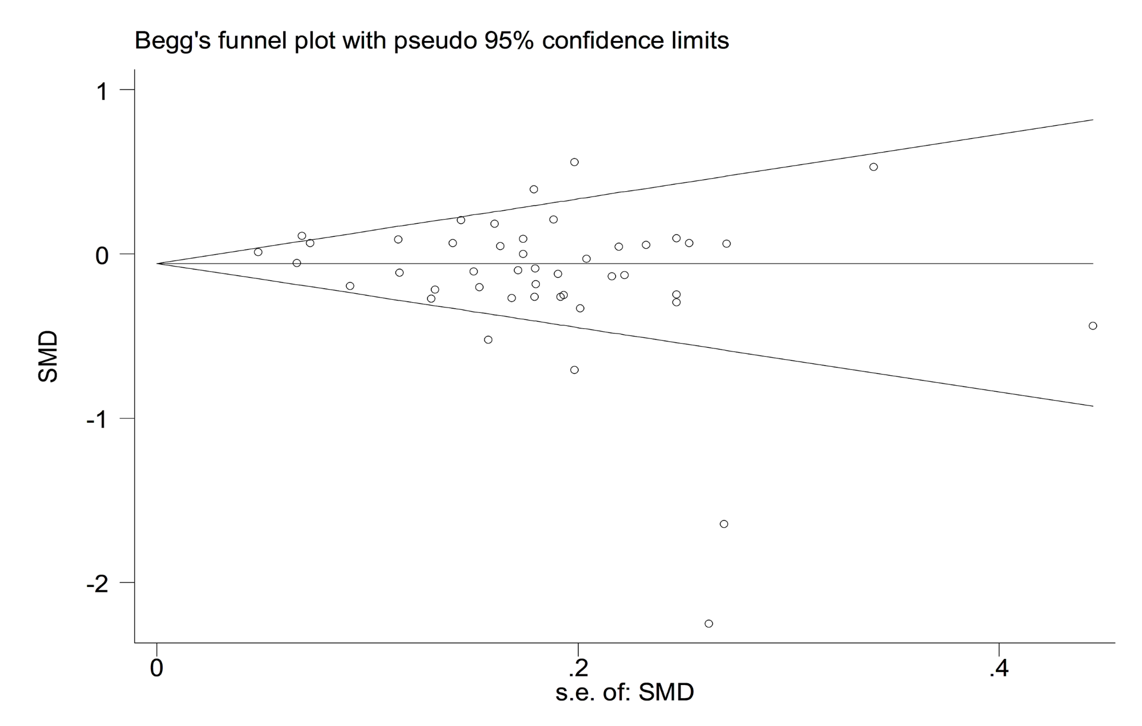
Figure S1. Begg’s funnel plot of the association analysis between SERPINE1 rs1799889 polymorphism and circulating TG levels (P = 0.26).

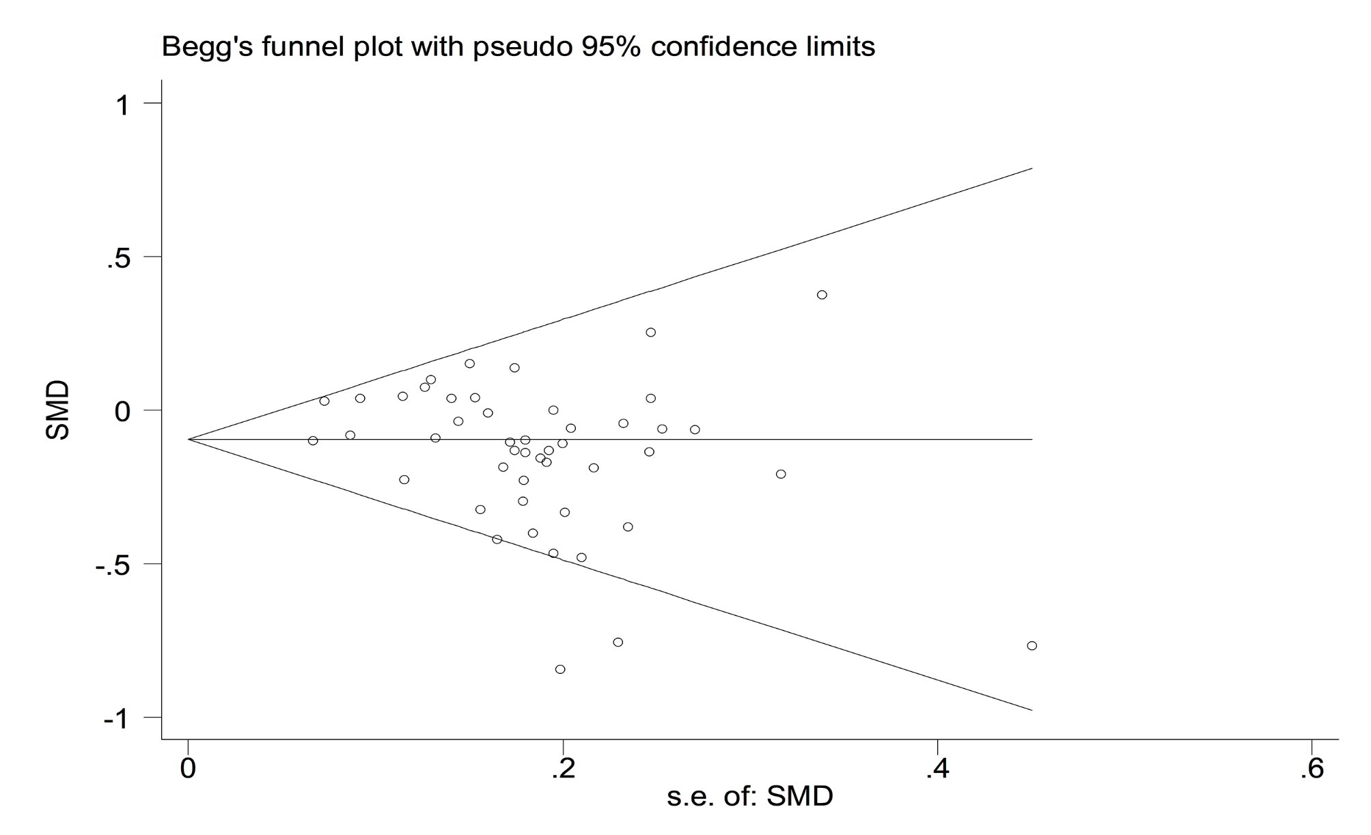
Figure S2. Begg’s funnel plot of the association analysis between SERPINE1 rs1799889 polymorphism and circulating TC levels (P = 0.41).

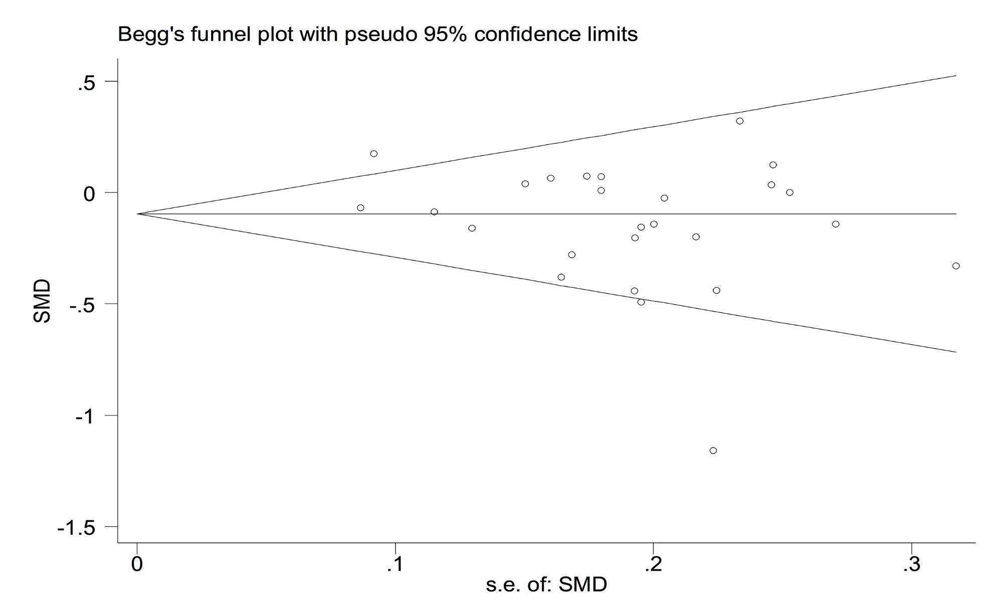
Figure S3. Begg’s funnel plot of the association analysis between SERPINE1 rs1799889 polymorphism and circulating LDL-C levels (P = 0.34).

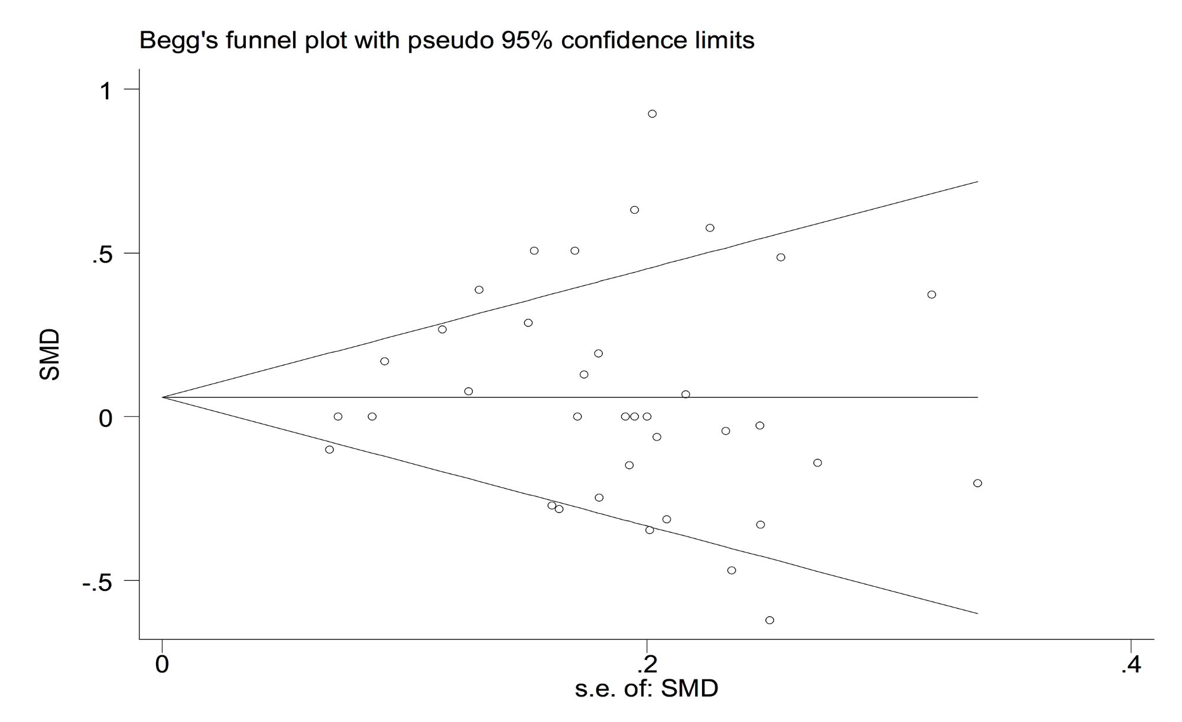
Figure S4. Begg’s funnel plot of the association analysis between SERPINE1 rs1799889 polymorphism and circulating HDL-C levels (P = 0.73).

References of included studies

R1. Panahloo A, Mohamed-Ali V, Lane A, Green F, Humphries SE, Yudkin JS. Determinants of plasminogen activator inhibitor 1 activity in treated NIDDM and its relation to a polymorphism in the plasminogen activator inhibitor 1 gene. Diabetes. 1995;44(1):37-42. doi: 10.2337/diab.44.1.37.
R2. Margaglione M, Grandone E, Vecchione G, Cappucci G, Giuliani N, Colaizzo D, Celentano E, Panico S, Di Minno G. Plasminogen activator inhibitor-1 (PAI-1) antigen plasma levels in subjects attending a metabolic ward: relation to polymorphisms of PAI-1 and angiontensin converting enzyme (ACE) genes. Arterioscler Thromb Vasc Biol. 1997;17(10):2082-7. doi: 10.1161/01.atv.17.10.2082.
R3. Margaglione M, Cappucci G, Colaizzo D, Giuliani N, Vecchione G, Grandone E, Pennelli O, Di Minno G. The PAI-1 gene locus 4G/5G polymorphism is associated with a family history of coronary artery disease. Arterioscler Thromb Vasc Biol. 1998;18(2):152-6. doi: 10.1161/01.atv.18.2.152.
R4. Burzotta F, Di Castelnuovo A, Amore C, D'Orazio A, Di Bitondo R, Donati MB, Iacoviello L. 4G/5G promoter PAI-1 gene polymorphism is associated with plasmatic PAI-1 activity in Italians: a model of gene-environment interaction. Thromb Haemost. 1998;79(2):354-8.
R5. Grancha S, Estellés A, Tormo G, Falco C, Gilabert J, España F, Cano A, Segui R, Aznar J. Plasminogen activator inhibitor-1 (PAI-1) promoter 4G/5G genotype and increased PAI-1 circulating levels in postmenopausal women with coronary artery disease. Thromb Haemost. 1999;81(4):516-21.
R6. Song J, Yoon YM, Jung HJ, Hong SH, Park H, Kim JQ. Plasminogen activator inhibitor-1 4G/5G promoter polymorphism and coagulation factor VII Arg353-->Gln polymorphism in Korean patients with coronary artery disease. J Korean Med Sci. 2000;15(2):146-52. doi: 10.3346/jkms.2000.15.2.146.
R7. Wong TY, Poon P, Szeto CC, Chan JC, Li PK. Association of plasminogen activator inhibitor-1 4G/4G genotype and type 2 diabetic nephropathy in Chinese patients. Kidney Int. 2000;57(2):632-8. doi: 10.1046/j.1523-1755.2000.00884.x.
R8. Seguí R, Estellés A, Mira Y, España F, Villa P, Falcó C, Vayá A, Grancha S, Ferrando F, Aznar J. PAI-1 promoter 4G/5G genotype as an additional risk factor for venous thrombosis in subjects with genetic thrombophilic defects. Br J Haematol. 2000;111(1):122-8. doi: 10.1046/j.1365-2141.2000.02321.x.
R9. van Harmelen V, Wahrenberg H, Eriksson P, Arner P. Role of gender and genetic variance in plasminogen activator inhibitor-1 secretion from human adipose tissue. Thromb Haemost. 2000;83(2):304-8.
R10. Estellés A, Dalmau J, Falcó C, Berbel O, Castelló R, España F, Aznar J. Plasma PAI-1 levels in obese children--effect of weight loss and influence of PAI-1 promoter 4G/5G genotype. Thromb Haemost. 2001;86(2):647-52.
R11. Li CG, Dong YH, Wang HY, Si YG, Lv WS, Zhai MX, Wang J, Liu L. Association of plasminogen activator inhibitor 4G/5G polymorphism and type 2 diabetes with nephropathy. Chinese Journal of Diabetes. 2001; 9(6): 333-340.
R12. Hoekstra T, Geleijnse JM, Kluft C, Giltay EJ, Kok FJ, Schouten EG. 4G/4G genotype of PAI-1 gene is associated with reduced risk of stroke in elderly. Stroke. 2003;34(12):2822-8. doi: 10.1161/01.STR.0000098004.26252.EB.
R13. Jeng JR. Association of PAI-1 gene promoter 4g/5g polymorphism with plasma PAI-1 activity in Chinese patients with and without hypertension. Am J Hypertens. 2003;16(4):290-6. doi: 10.1016/s0895-7061(03)00004-9.
R14. Lopes C, Dina C, Durand E, Froguel P. PAI-1 polymorphisms modulate phenotypes associated with the metabolic syndrome in obese and diabetic Caucasian population. Diabetologia. 2003;46(9):1284-90. doi: 10.1007/s00125-003-1170-0.
R15. Chen CH, Eng HL, Chang CJ, Tsai TT, Lai ML, Chen HY, Liu CJ, Lin TM. 4G/5G promoter polymorphism of plasminogen activator inhibitor-1, lipid profiles, and ischemic stroke. J Lab Clin Med. 2003;142(2):100-5. doi: 10.1016/S0022-2143(03)00063-5.
R16. Zhang AJ, Song BH, Wang JX, Feng YC. The association between PAI-1 4G/5G polymorphism and cerebral infarction. Shandong Medical Journal. 2003; 43(31): 42-43.
R17. Kitamura Y, Okumura K, Imamura A, Mizuno T, Tsuzuki M, Numaguchi Y, Matsui H, Murohara T. Association of plasminogen activator inhibitor-1 4G/5G gene polymorphism with variations in the LDL particle size in healthy Japanese men. Clin Chim Acta. 2004;347(1-2):209-16. doi: 10.1016/j.cccn.2004.04.014.
R18. Zhang AY, Ji XW, Guan LX, Wang JX, Zhao CH, Zhao LM, Zhang YZ. The relationship between 4G/5G polymorphism of PAI-1 gene and blood lipid and blood sugar in patients with coronary heart disease. 2004; 2(7): 538-539.
R19. Ruiz-Quezada S, Vázquez-Del Mercado M, Parra-Rojas I, Rangel-Villalobos H, Best-Aguilera C, Sánchez-Orozco LV, Muñoz-Valle JF. Genotype and allele frequency of PAI-1 promoter polymorphism in healthy subjects from the west of Mexico. Association with biochemical and hematological parameters. Ann Genet. 2004;47(2):155-62. doi: 10.1016/j.anngen.2003.12.001.
R20. Roncal C, Orbe J, Rodriguez JA, Belzunce M, Beloqui O, Diez J, Páramo JA. Influence of the 4G/5G PAI-1 genotype on angiotensin II-stimulated human endothelial cells and in patients with hypertension. Cardiovasc Res. 2004;63(1):176-85. doi: 10.1016/j.cardiores.2004.03.023.
R21. Liu SQ, Xue YM, Yang GC, He FY, Zhao XS. relationship between plasminogen activator inhibitor-1 gene 4G/5G polymorphism and type 2 diabetic nephropathy in Chinese Han patients in Guangdong Province. J First Mil Med Univ. 2004; 4(8): 904-906.
R22. Chen YL, Zhang JX, Wang PX, Cui BZ, Zhao FM, Mao YM, Li JY, Bi YY, Li H. Association of4G/5G polymorphism in PAI1 promoter with PAI1 level in deep vein thrombosis. Chin J Med Genet. 2005; 22 (6): 624-627.
Meigs JB, Dupuis J, Liu C, O'Donnell CJ, Fox CS, Kathiresan S, Gabriel SB, Larson MG, Yang Q, R23. Herbert AG, Wilson PW, Feng D, Tofler GH, Cupples LA. PAI-1 Gene 4G/5G polymorphism and risk of type 2 diabetes in a population-based sample. Obesity (Silver Spring). 2006;14(5):753-8. doi: 10.1038/oby.2006.85.
R24. Zietz B, Leonhardt K, Schäffler A. Kandidatengene des Diabetes mellitus Typ 2 Gibt es einen Gen-Dosiseffekt für Risikofaktoren sowie mikro-und makrovaskuläre Folgeerkrankungen? Med Klin (Munich). 2006;101(8):605-16.
R25. Wang L, Liu Y, Guo H. Associations of 4G/5G promoter polymorphism of PAI-1 with PAI-1 antigen content and type 2 diabetic nephropathy. Chinese Journal of Gerontology. 2007; 27: 1485-1487.
R26. Karadeniz M, Erdogan M, Berdeli A, Saygili F, Yilmaz C. 4G/5G polymorphism of PAI-1 gene and Alu-repeat I/D polymorphism of TPA gene in Turkish patients with polycystic ovary syndrome. J Assist Reprod Genet. 2007;24(9):412-8. doi: 10.1007/s10815-007-9160-7.
R27. Corsetti JP, Ryan D, Moss AJ, Rainwater DL, Zareba W, Sparks CE. Plasminogen activator inhibitor-1 polymorphism (4G/5G) predicts recurrence in nonhyperlipidemic postinfarction patients. Arterioscler Thromb Vasc Biol. 2008;28(3):548-54. doi: 10.1161/ATVBAHA.107.155556.
R28. Kucukarabaci B, Gunes HV, Ozdemir G, Cosan D, Ozbabalik D, Dikmen M, Degirmenci I. Investigation of association between plasminogen activator inhibitor type-1 (PAI-1) gene 4G/5G polymorphism frequency and plasma PAI-1 enzyme activity in patients with acute stroke. Genet Test. 2008;12(3):443-51. doi: 10.1089/gte.2008.0025.
R29. Wang H, Madhusudhan T, He T, Hummel B, Schmidt S, Vinnikov IA, Shahzad K, Kashif M, Muller-Krebs S, Schwenger V, Bierhaus A, Rudofsky G, Nawroth PP, Isermann B. Low but sustained coagulation activation ameliorates glucose-induced podocyte apoptosis: protective effect of factor V Leiden in diabetic nephropathy. Blood. 2011;117(19):5231-42. doi: 10.1182/blood-2010-10-314773.
R30. Katrancıoğlu N, Karahan O, Kurtulgan HK, Sanrı US, Kılıç AT. PAI-1 4G/4G gene polymorphism is associated with higher serum lipid level in Turkish population. Cumhuriyet Med J. 2011; 33: 307-311.
R31. Fernandes KS, Sandrim VC. 4G/5G polymorphism modulates PAI-1 circulating levels in obese women. Mol Cell Biochem. 2012;364(1-2):299-301. doi: 10.1007/s11010-012-1230-1.
R32. Sun SK, Qin Y, Tian QW, Tian YF, Zhai MX. Relationship between PAI-1 4G/5G polymorphism and metabolic syndrome in postmenopausal women. Int J Endocrinol Metab. 2013; 33(6): 361-365.
R33. Xu F, Liu H, Sun Y. Association of plasminogen activator inhibitor-1 gene polymorphism and type 2 diabetic nephropathy. Ren Fail. 2016;38(1):157-62. doi: 10.3109/0886022X.2015.1089464.
R34. Karabouta Z, Makedou A, Argiriou A, Xanthopoulou E, Papandreou D, Rousso I, Athanassiadou-Piperopoulou F. 4G polymorphism of plasminogen activator inhibitor-1 (PAI-1), PAI-1 plasma levels, and lipid profiles in overweight/obese children and adolescents. 55 th Annual ESPE Meeting. 2016.
R35. Sahana N, Vivekananda B, Abinaya M. Association of Plasminogen Activator Inhibitor-1 (PAI-1) 4G/5G and Apolipoprotein E polymorphisms with risk of Myocardial Infarction in Indian Tamil Population. Research Journal of Biotechnology. 2018; 13(1): 91-98.
R36. Chen TH, Hsu CM, Hsu HC, Chiu CT, Su MY, Chu YY, Chang ML. Plasminogen activator inhibitor-1 is associated with the metabolism and development of advanced colonic polyps. Transl Res. 2018;200:43-53. doi: 10.1016/j.trsl.2018.05.010.
R37. Borisova EP, Kylbanova ES, Asekritova AS. Polymorphisms of Genes Involved in Endothelial Dysfunction in the Yakuts with COPD and Metabolic Syndrome. International Journal of Biomedicine. 2018; 8(2): 134-138.
T38. Khalaf FA, Ibrahim HR, Bedair HM. Plasminogen activator inhibitor-1 gene polymorphism as a risk factor for vascular complications in type 2 diabetes mellitus. Egyptian Journal of Medical Human Genetics. 2019; 20: 18.
R39. Oh J, An HJ, Kim JO, Jun HH, Kim WR, Kim EJ, Oh D, Kim JW, Kim NK. Association between Five Common Plasminogen Activator Inhibitor-1 (PAI-1) Gene Polymorphisms and Colorectal Cancer Susceptibility. Int J Mol Sci. 2020;21(12):4334. doi: 10.3390/ijms21124334.
R40. Bayramoglu A, Bayramoglu G, Urhan Kucuk M, Guler HI, Arpaci A. Genetic variations of Renin-angiontensin and Fibrinolytic systems and susceptibility to coronary artery disease: a population genetics perspective. Minerva Cardioangiol. 2020. doi: 10.23736/S0026-4725.20.05212-3.

