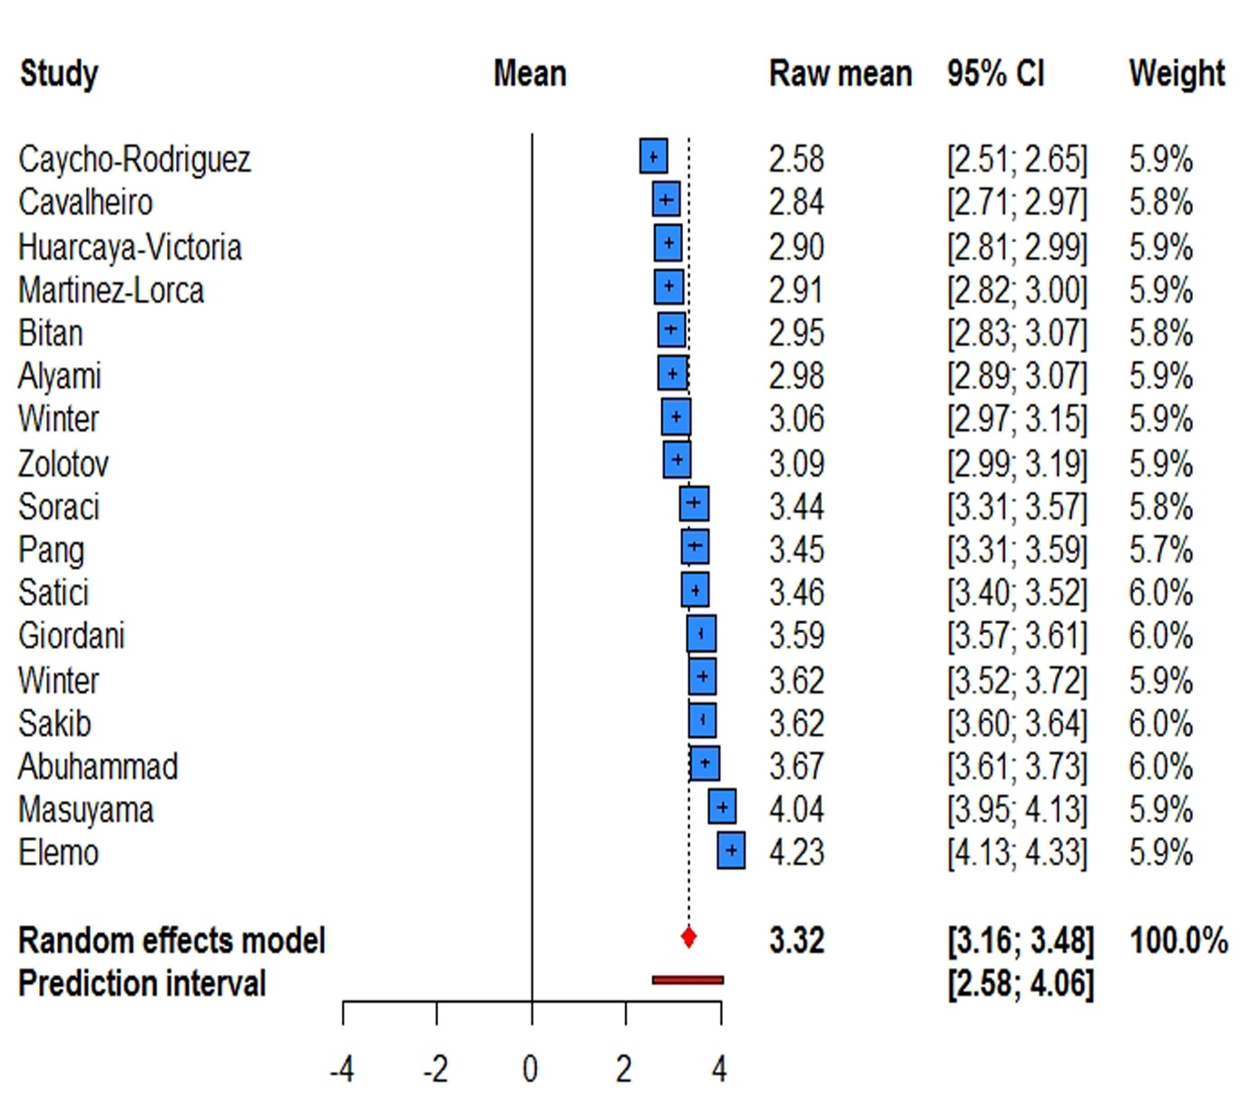
Supplementary figure 1: Forest plot of the fear Score mean of question 1
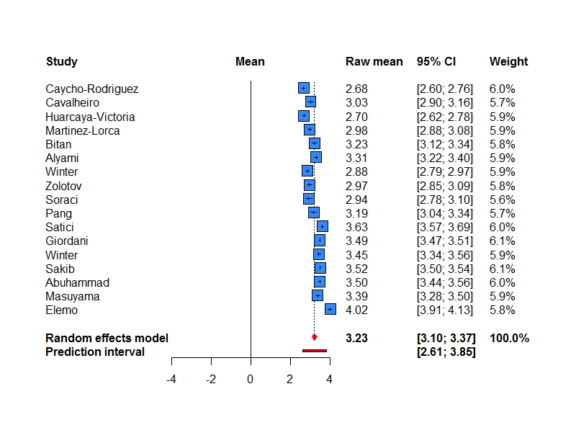
Supplementary figure 2: Forest plot of the fear Score mean of question 2

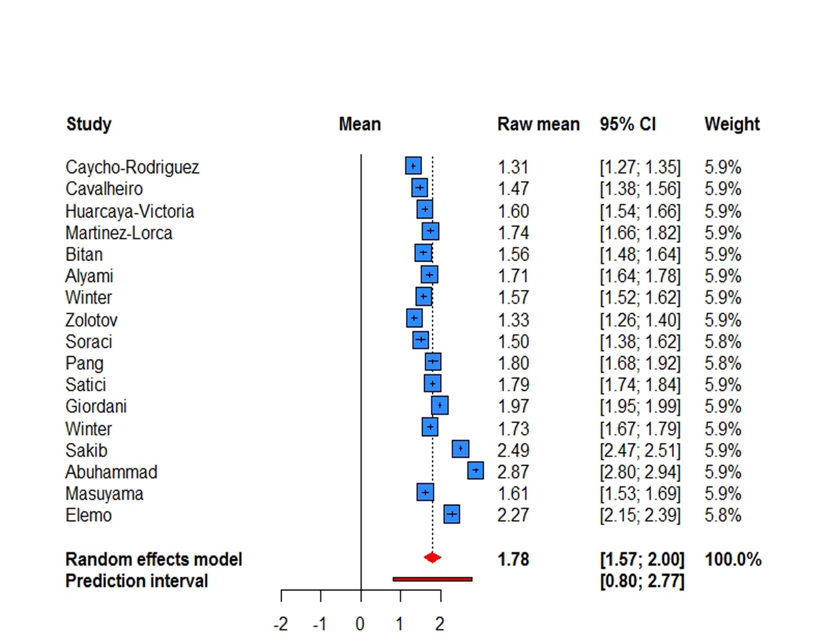
Supplementary figure 3: Forest plot of the fear Score mean of question 3
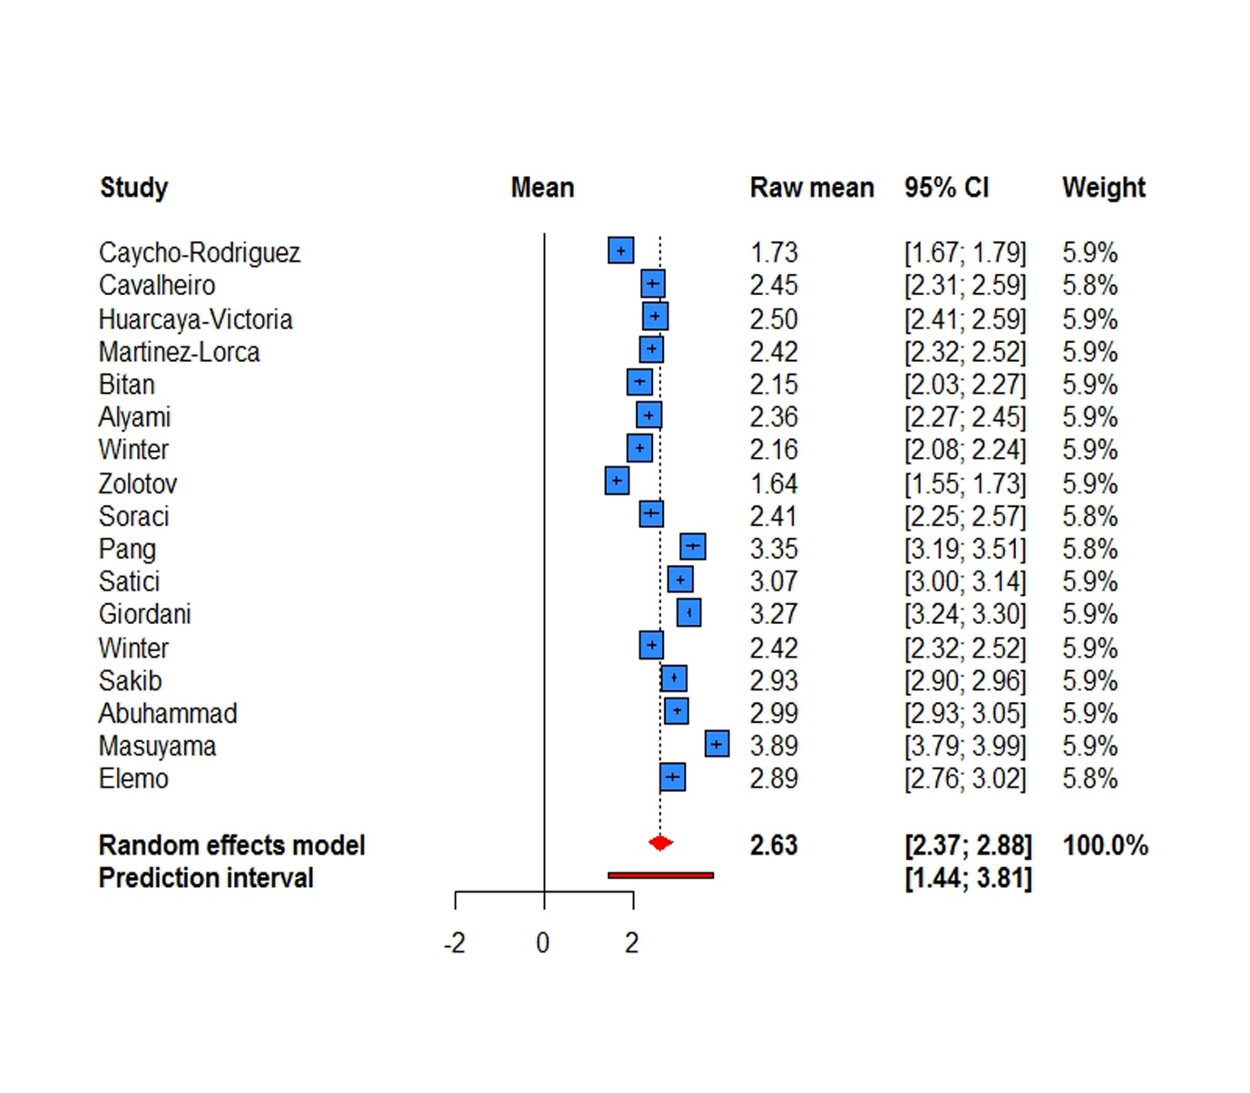
Supplementary figure 4: Forest plot of the fear Score mean of question 4
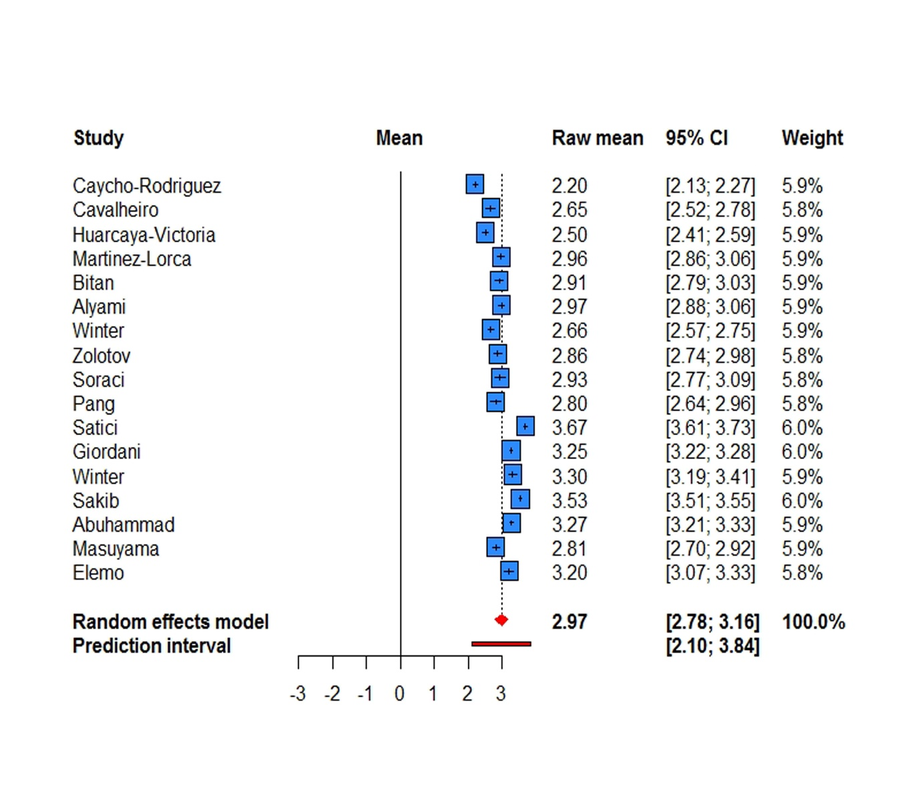
Supplementary figure 5: Forest plot of the fear Score mean of question 5
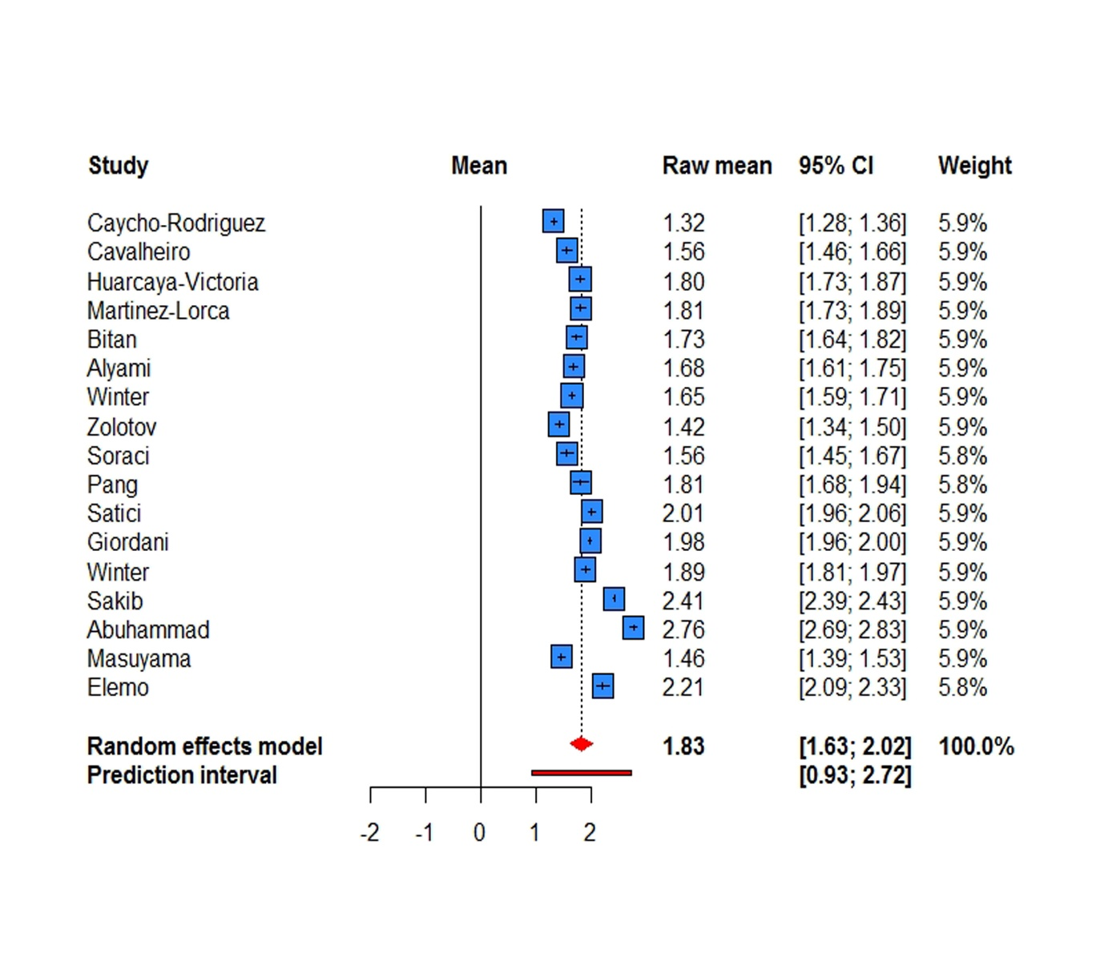
Supplementary figure 6: Forest plot of the fear Score mean of question 6
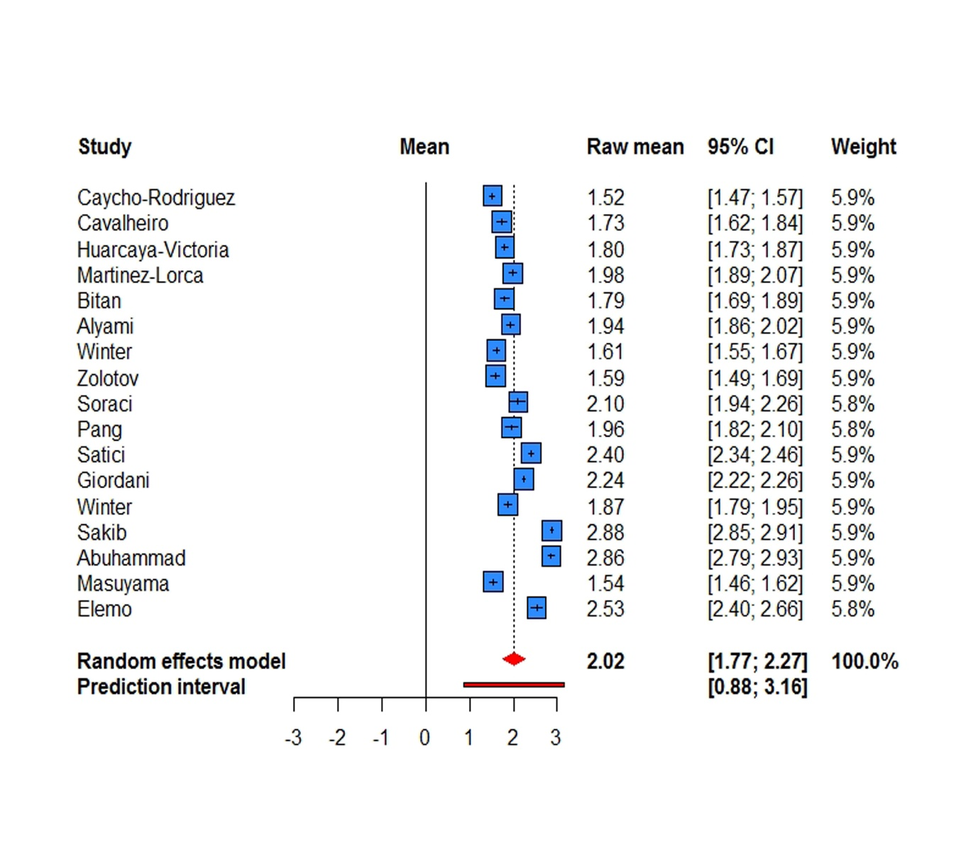
Supplementary figure 7: Forest plot of the fear Score mean of question 7

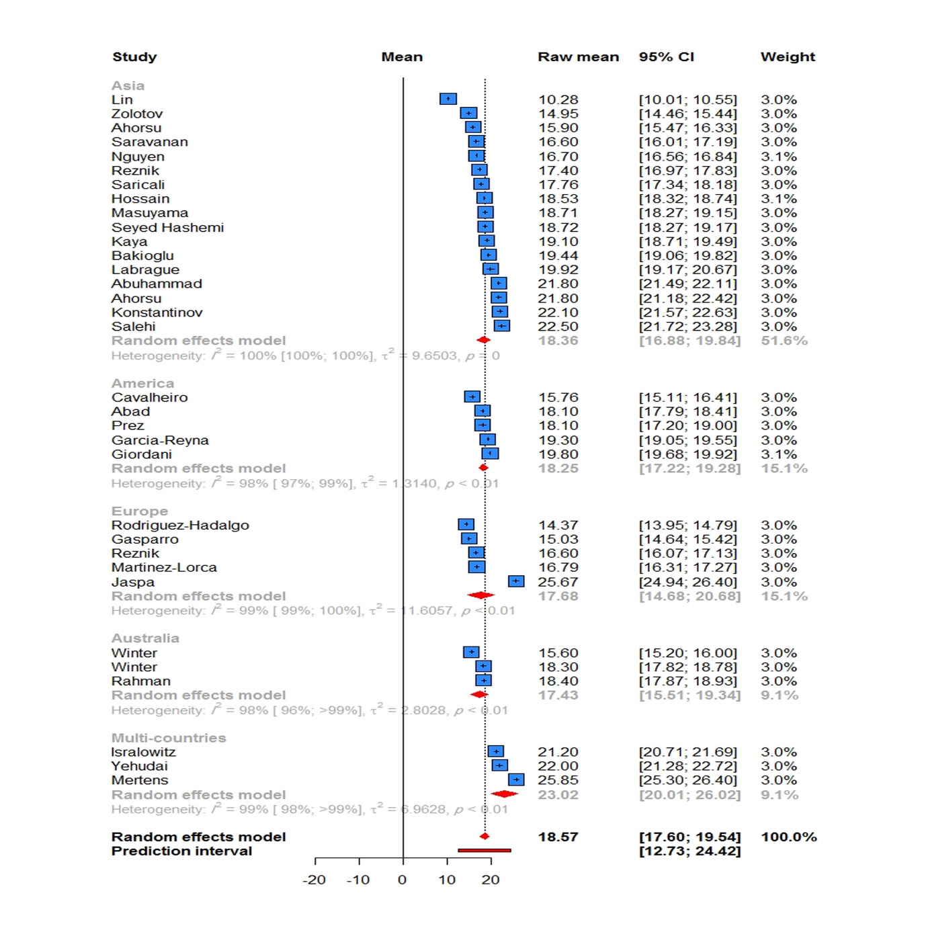
Supplementary figure 8: Forest plot of the total mean score of fear, according to continent
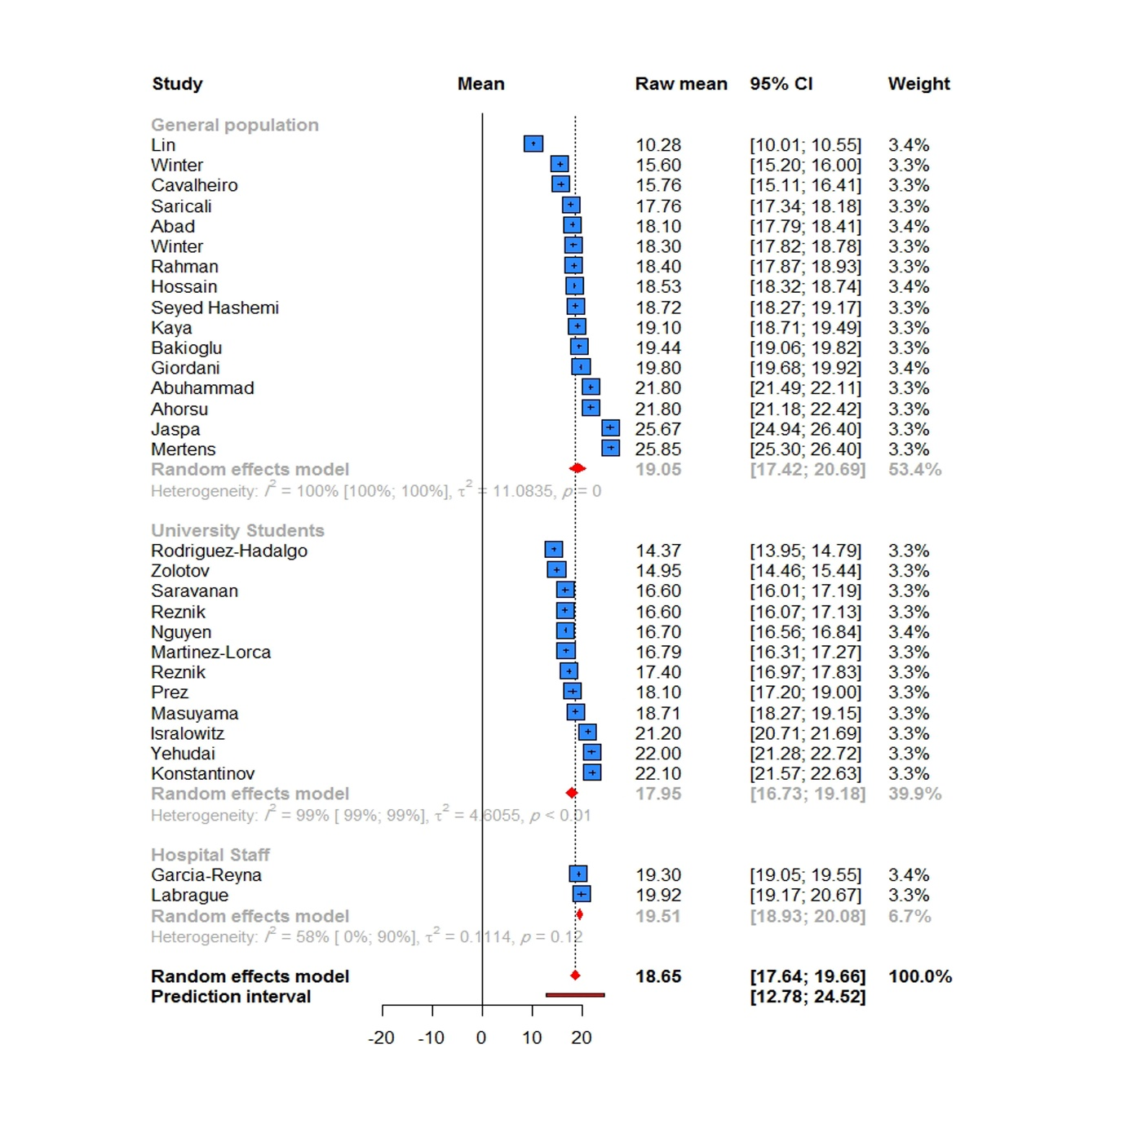

Supplementary figure 9: Forest plot of the total mean score of fear, according to target population
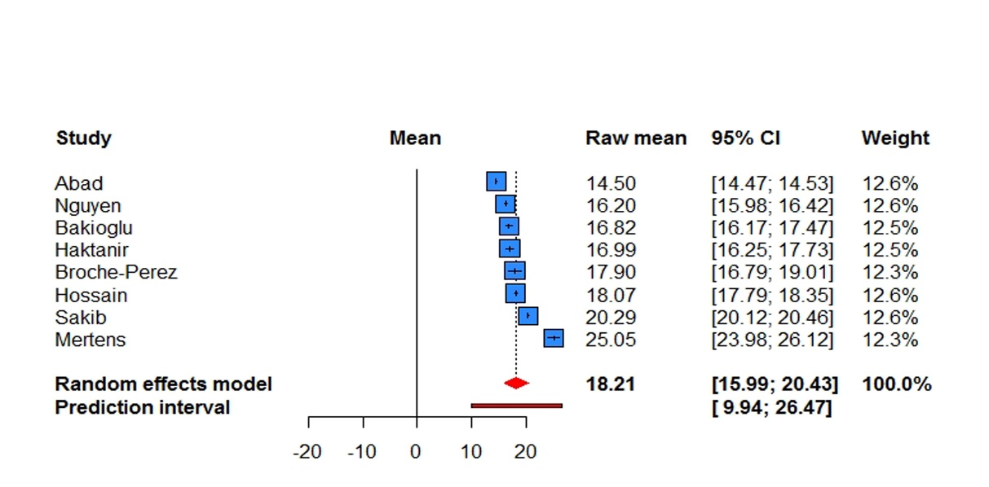
Supplementary figure 10: Forest plot of mean score of fear in men
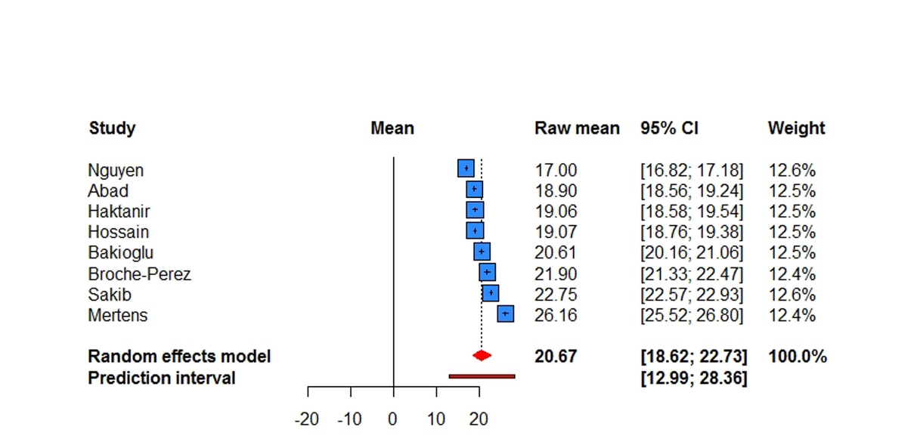

Supplementary figure 11: Forest plot of mean score of fear in women
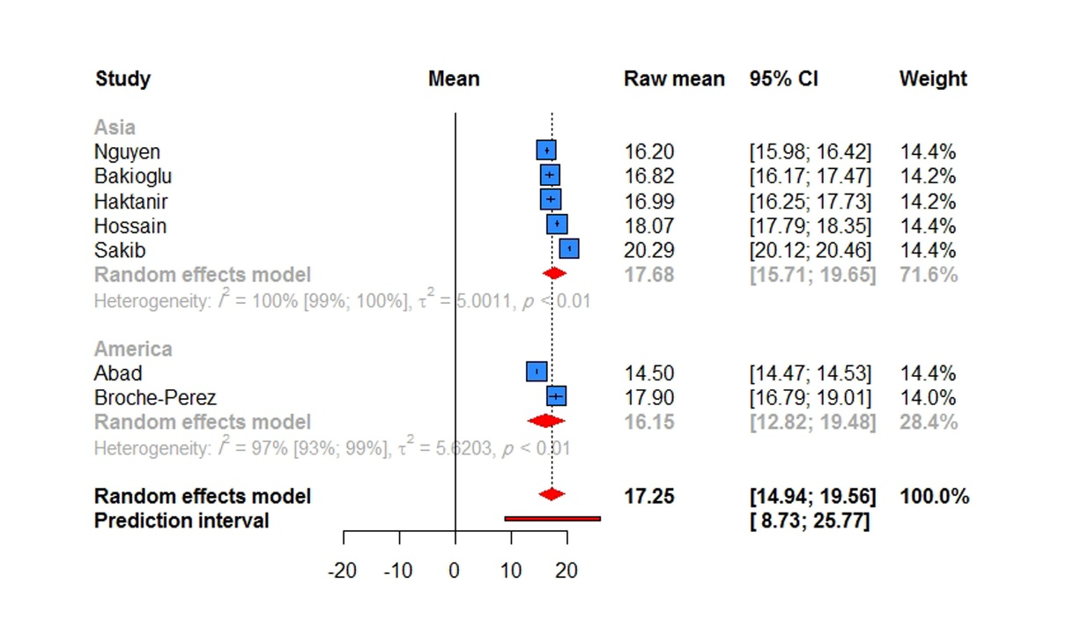
Supplementary figure 12: Forest plot of mean score of fear in men , according to continent
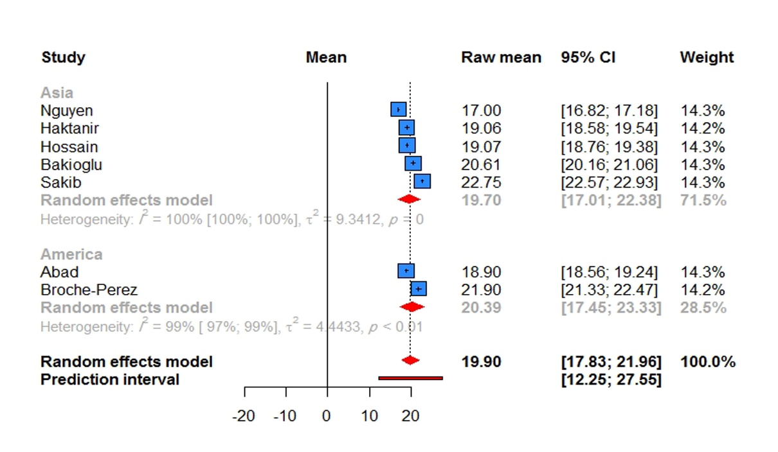

Supplementary figure 13: Forest plot of mean score of fear in women , according to continent
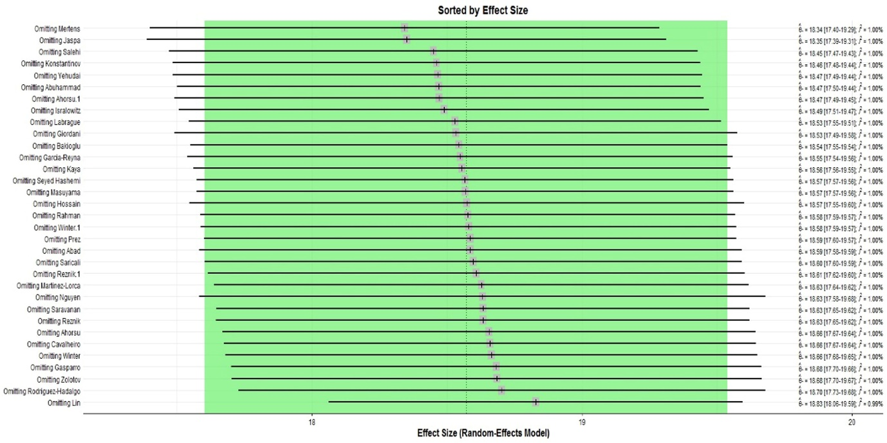
Supplementary figure 14: Plot of sensitivity analysis of total mean scores of fear based on leave-one-out method
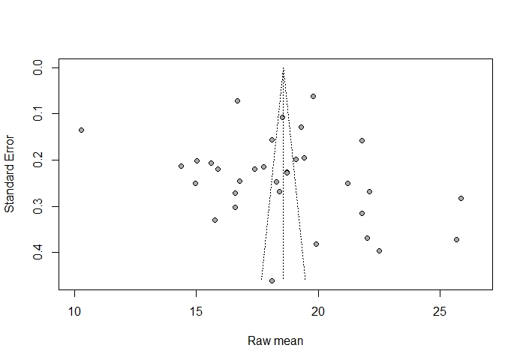
Supplementary figure 15: Funnel plot of publication bias based on Egger’s regression test

