Search strings MEDLINE (Pubmed), Cochrane Library, Lilacs, Web of Science (WoS) and PsycINFO

Pubmed
"Dementia"[Mesh] AND ("Social Cognition" OR "Theory of Mind"[Mesh] OR "Social Perception"[Mesh] OR "Emotional Intelligence"[Mesh] OR "Social Knowledge" OR "Attributional Style" OR "Attributional Bias") AND "last 10 years"[PDat])

Cochrane Library
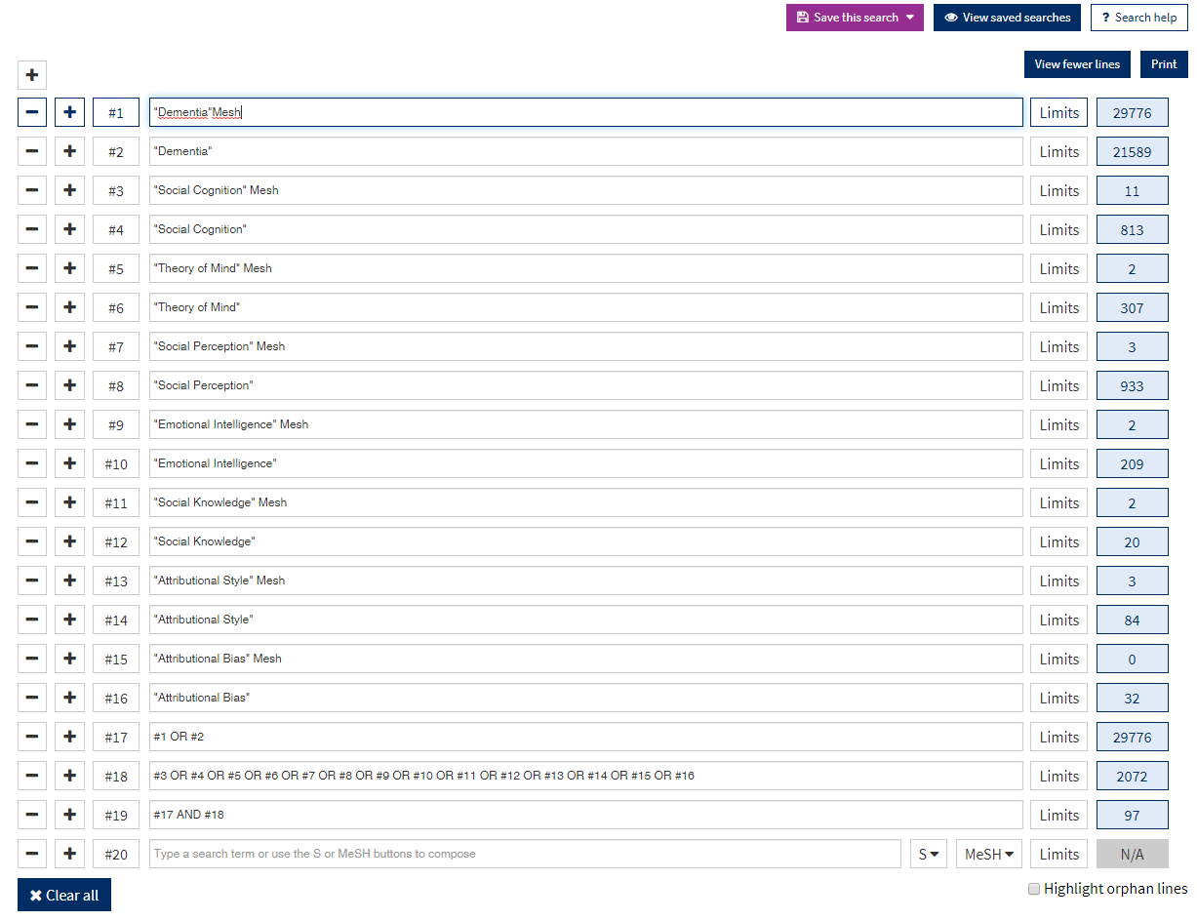

Lilacs
tw:"dementia" AND (tw:"Social Cognition" OR tw:"Theory of Mind" OR tw:"Social Perception" OR tw:"Emotional Intelligence" OR tw:"Social Knowledge" OR tw:"Attributional Style" OR tw:"Attributional Bias")

Web of Science (WoS)
TS="dementia" AND TS=("Social Cognition" OR "Theory of Mind" OR "Social Perception" OR "Emotional Intelligence" OR "Social Knowledge" OR "Attributional Style" OR "Attributional Bias")

PsycINFO:
(DE "Dementia") AND ((DE "Social Cognition") OR (DE "Theory of Mind") OR (DE "Social Perception") OR (DE "Emotional Intelligence") OR ("Social Knowledge") OR ("Attributional Style") OR (Attributional Bias")).

