Figure S1
Pooled hazard ratios of all-cause mortality per SD decrease in (a) BIA-, (b) DXA- and (c) CT-measurement.
- BIA
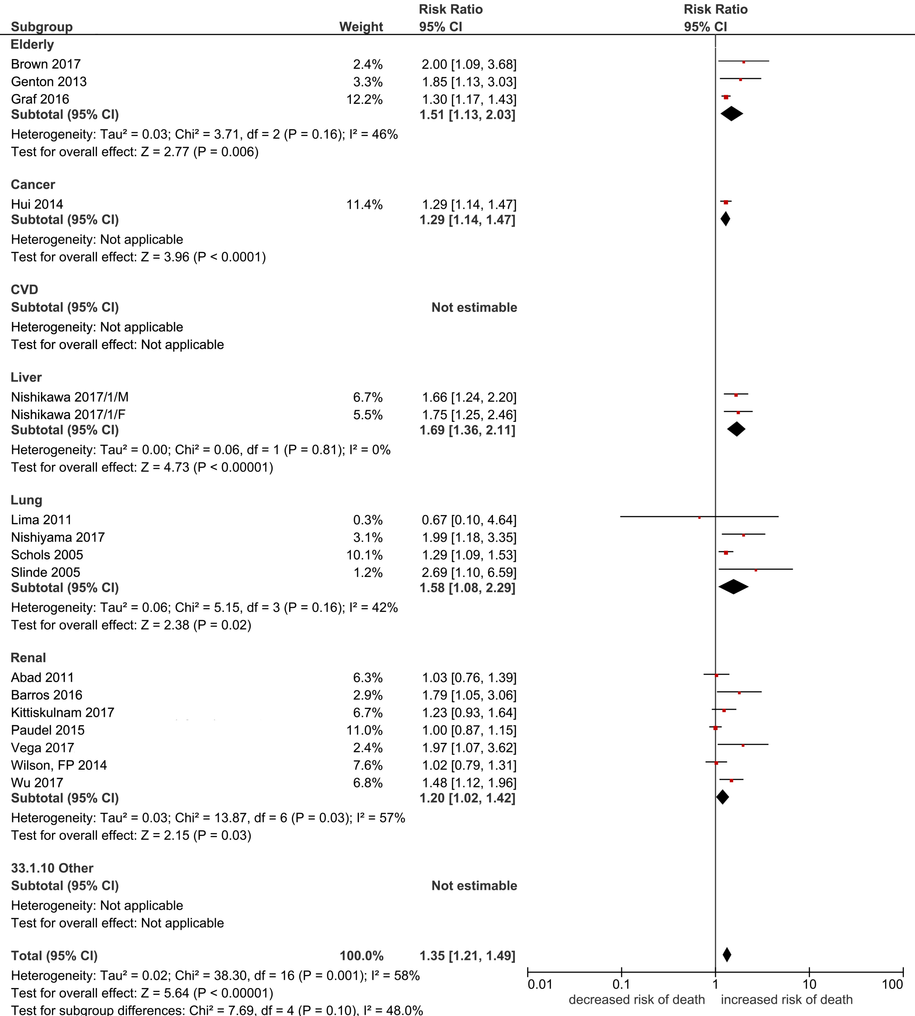

- DXA
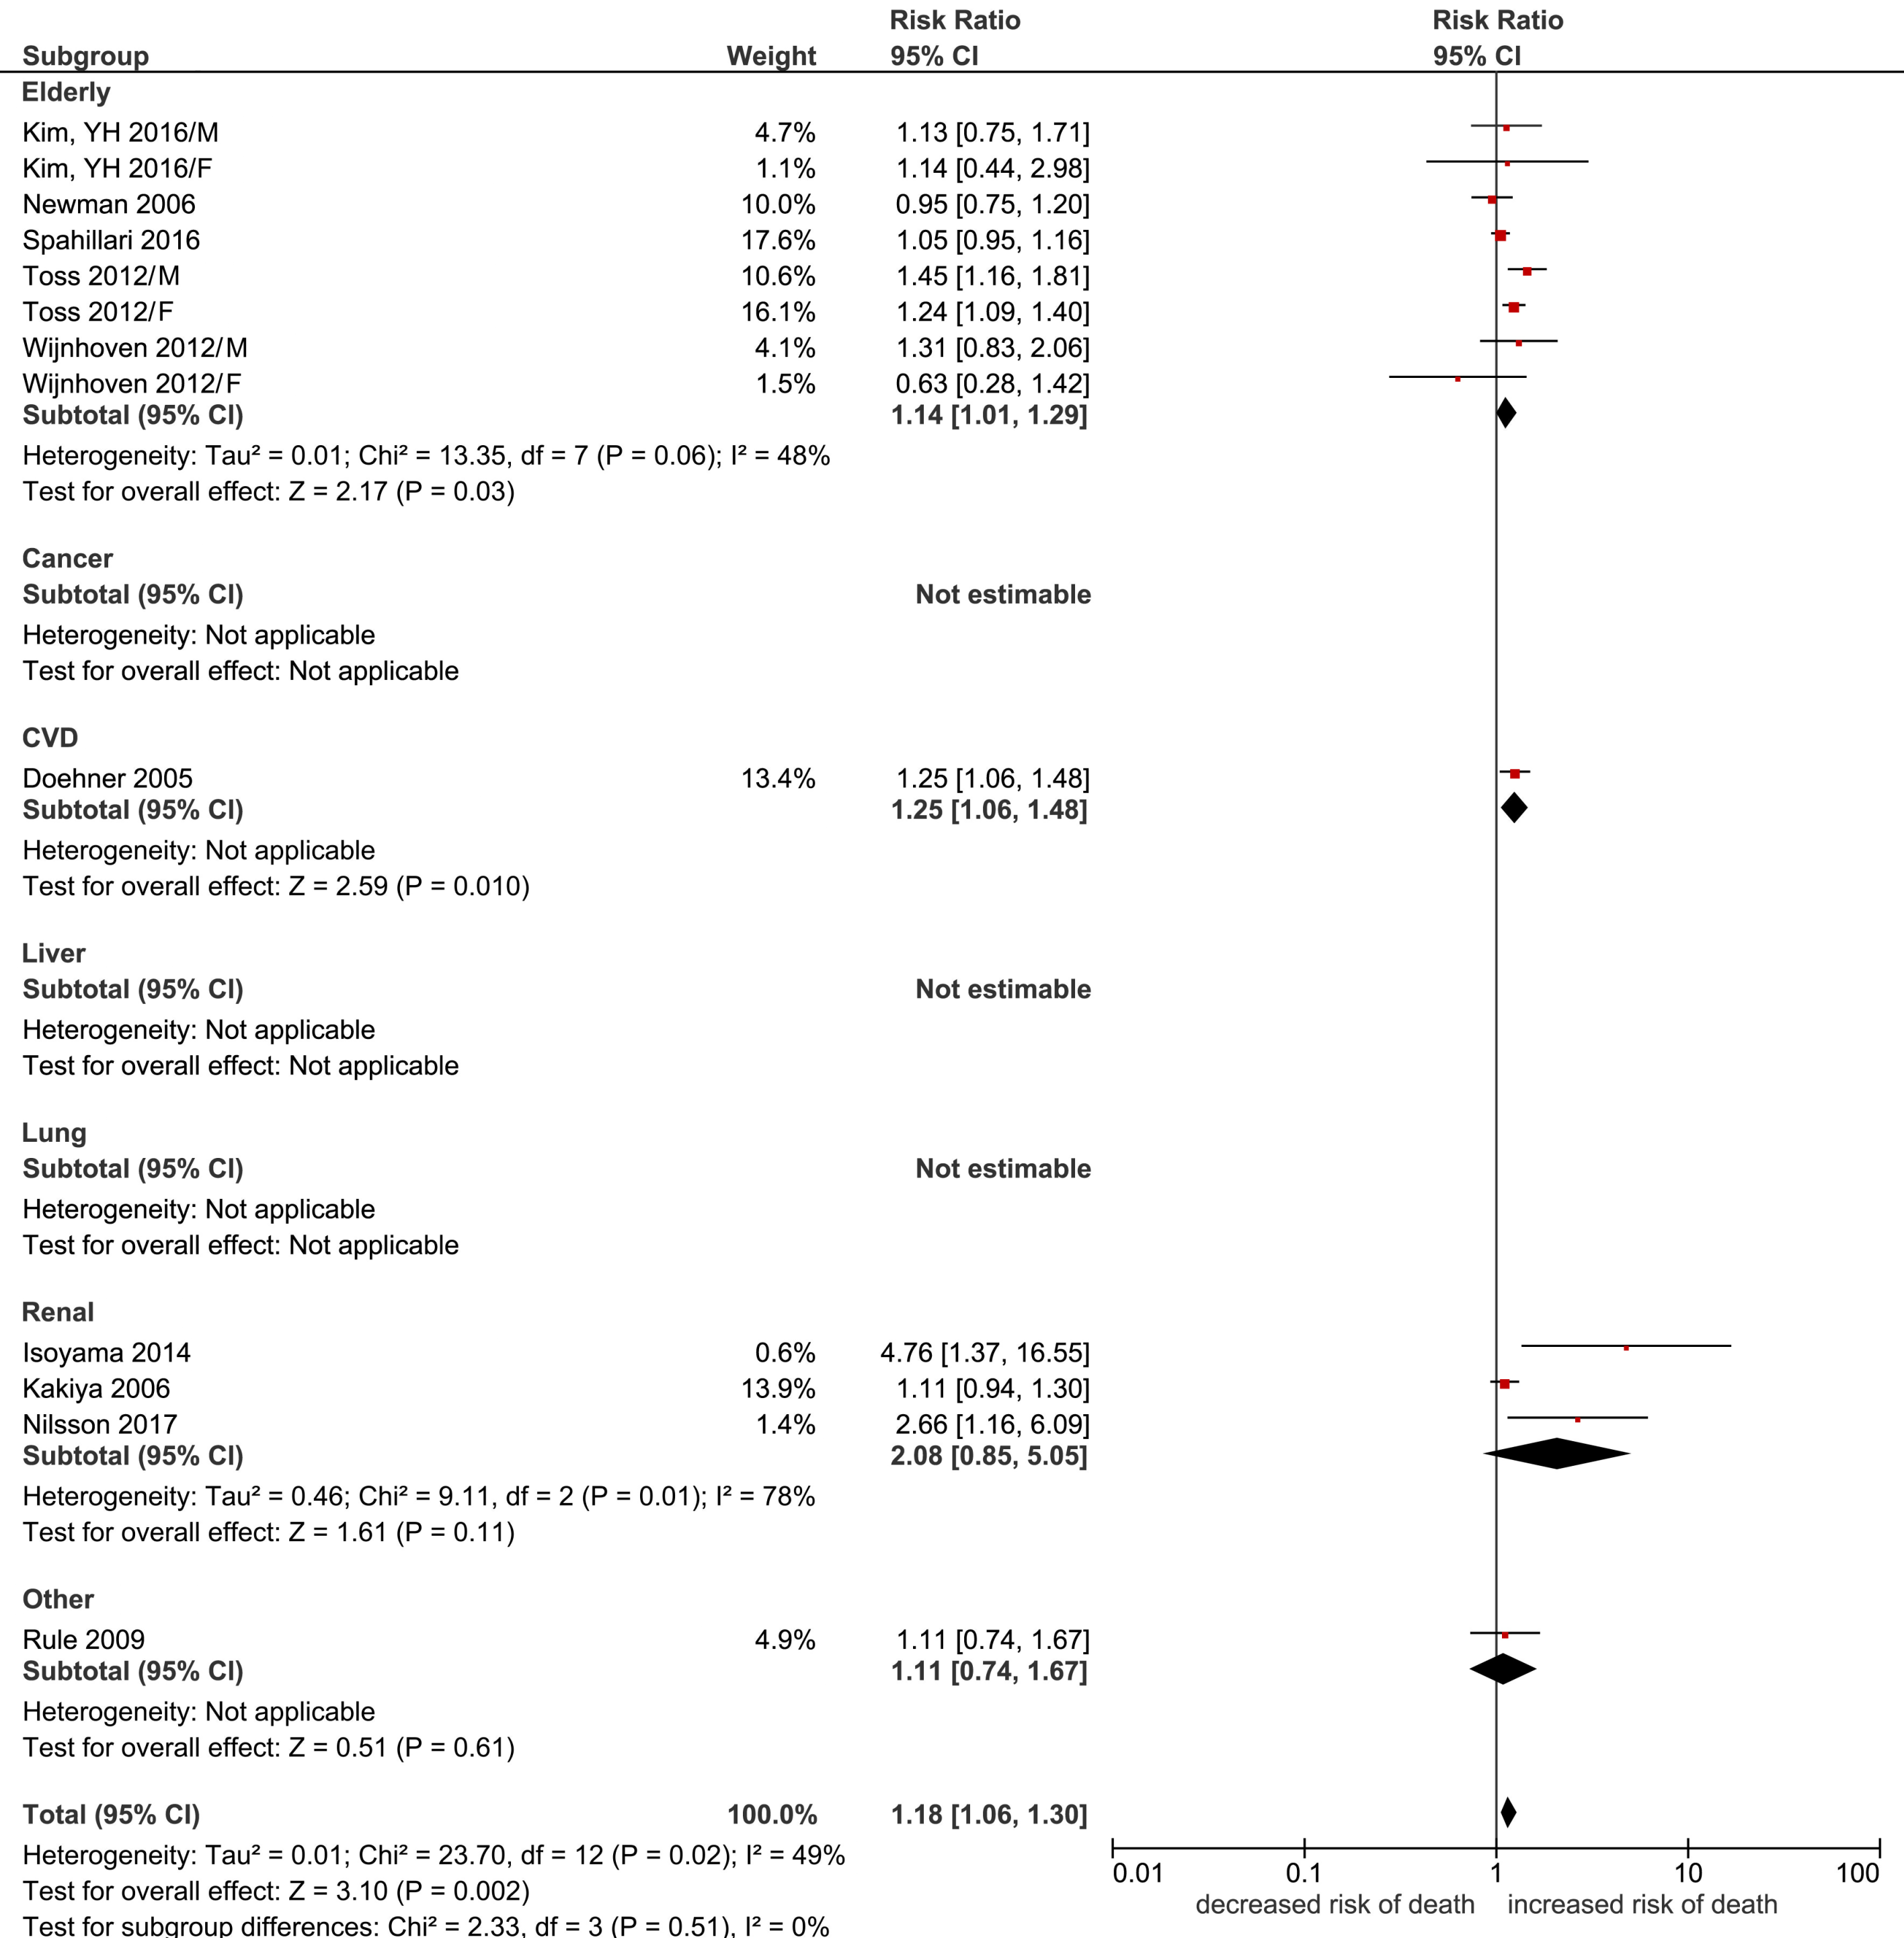

- CT
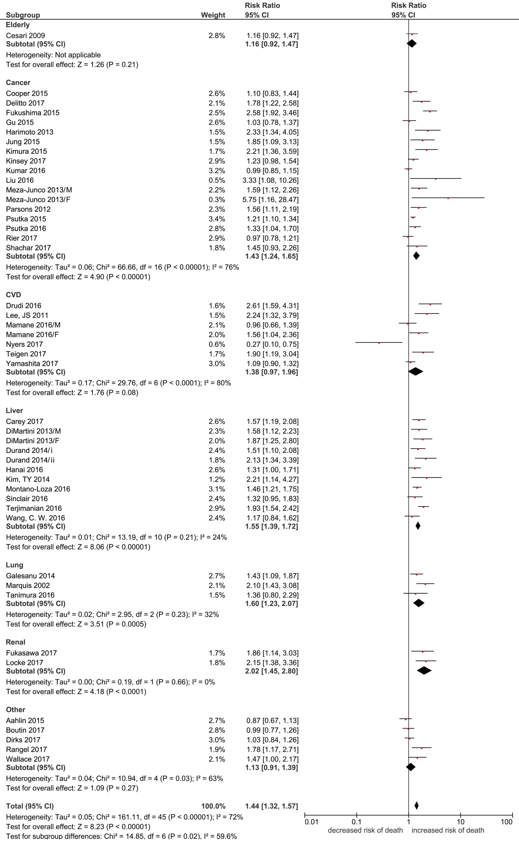
Keys: SD: standard deviation; BIA: bioelectrical impedance analysis; DXA: dual energy X-ray absorptiometry; CT: computed tomography; Random effects analysis; Author Year/A: Males; Author Year/B: Females; Nishikawa 2017/1: ref [119] Durand 2014/i: 2002-2007 cohort; Durand 2014/ii: 2007-2011 cohort
Figure S2
Pooled hazard ratios of all-cause mortality in people with low lean mass by (a) BIA-, (b) DXA- and (c) CT-measurement.
- BIA
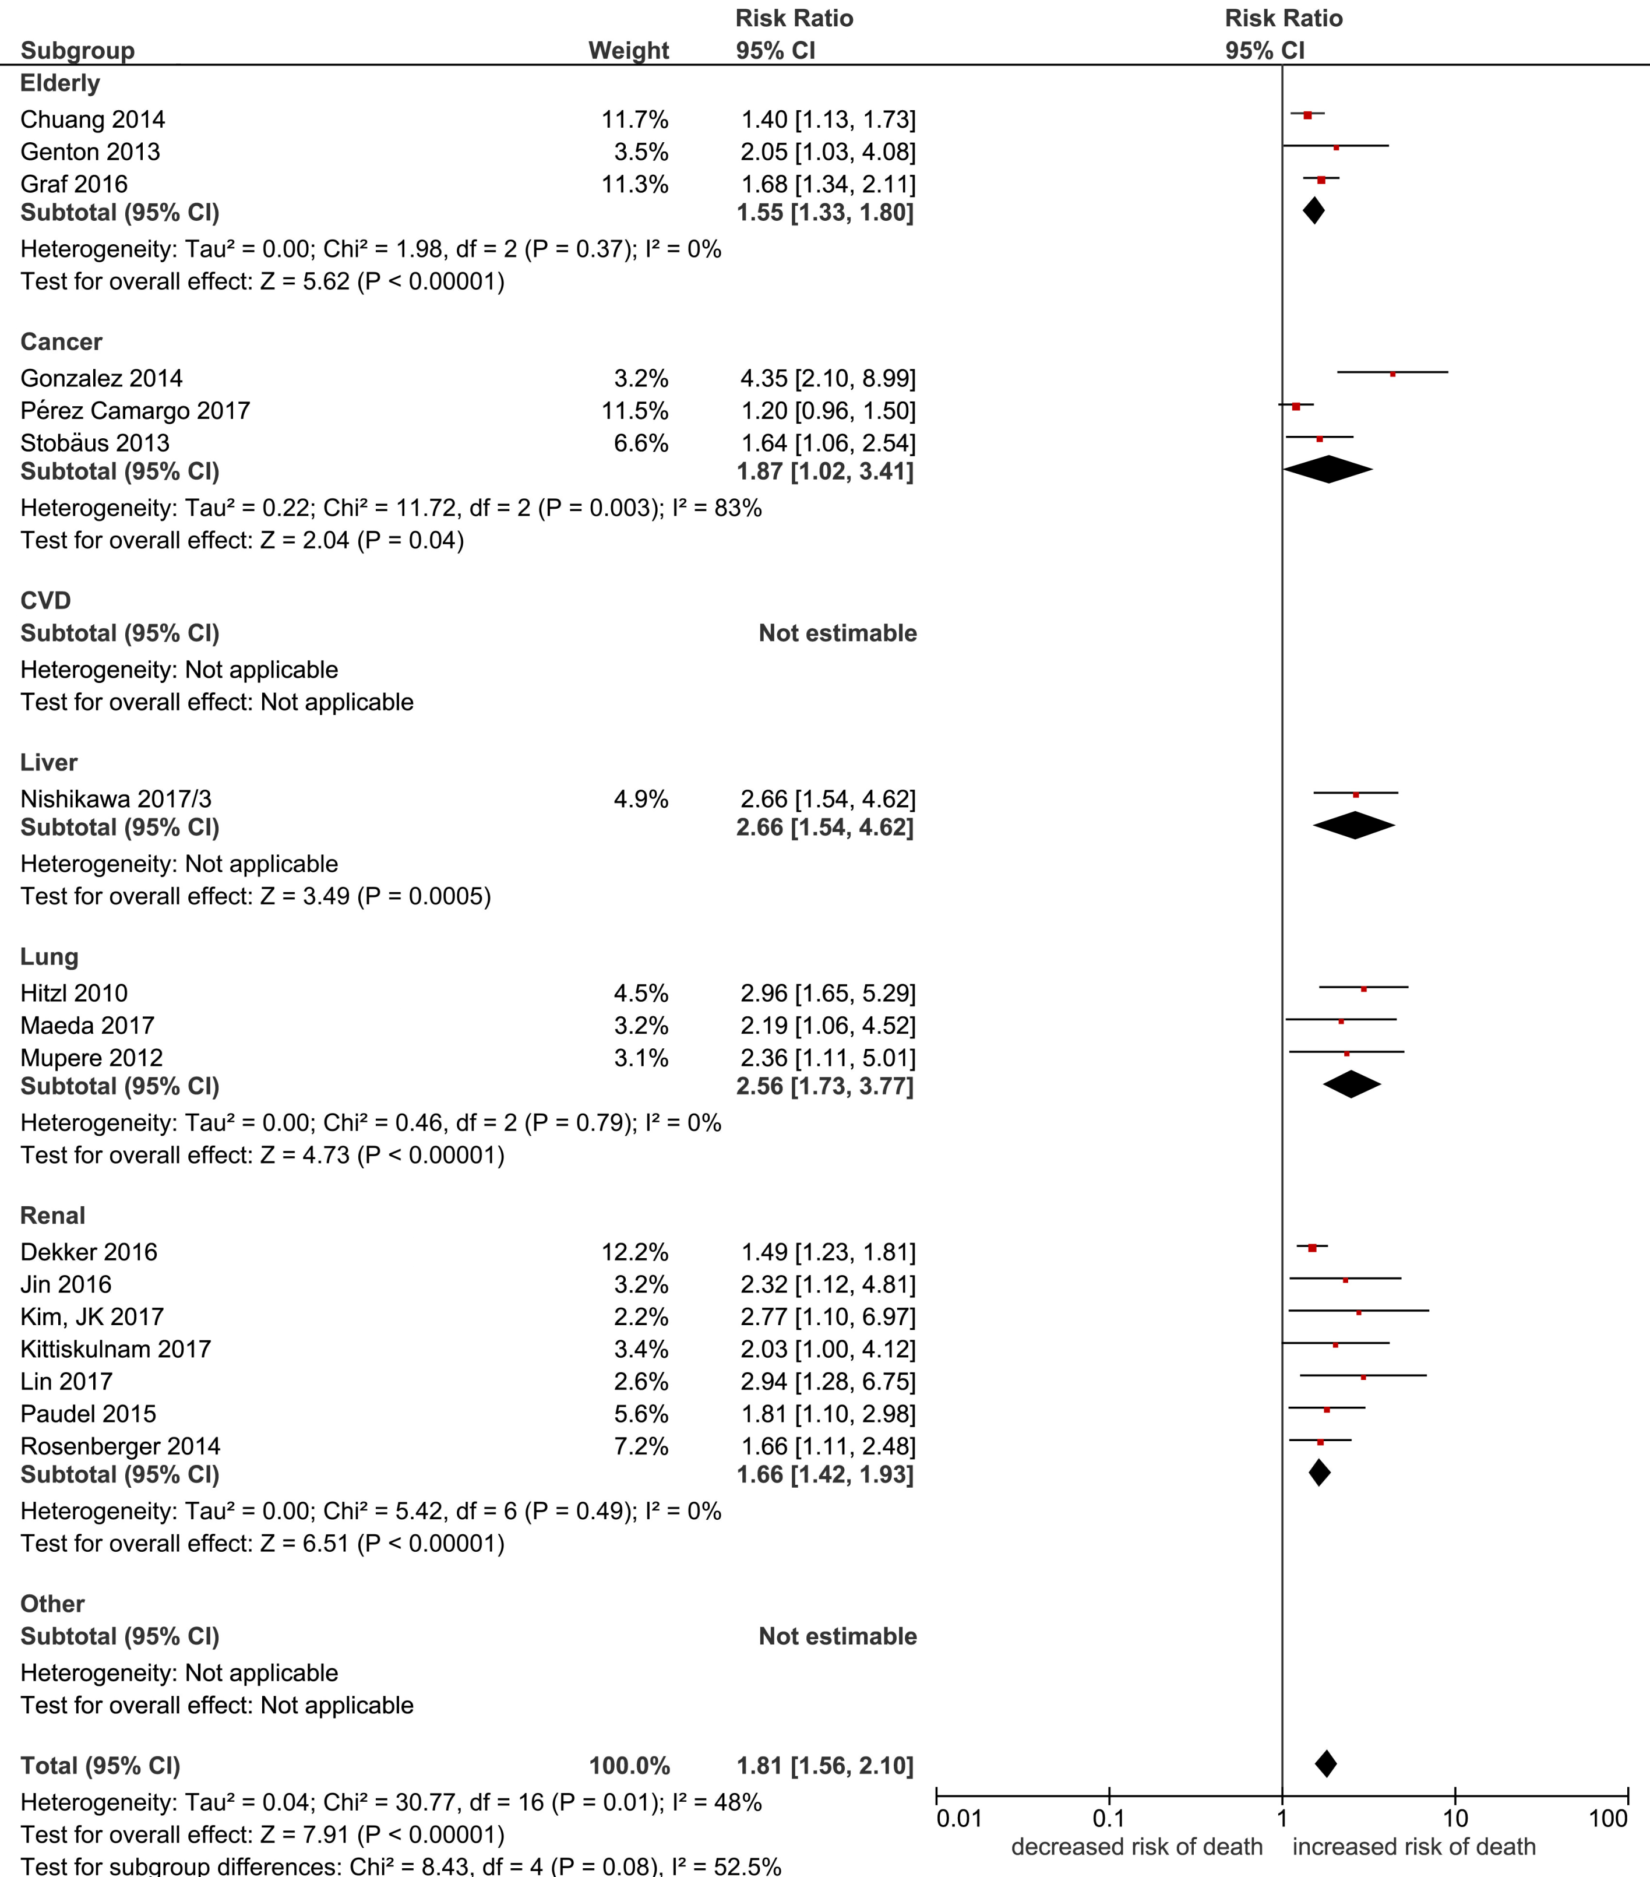

- DXA
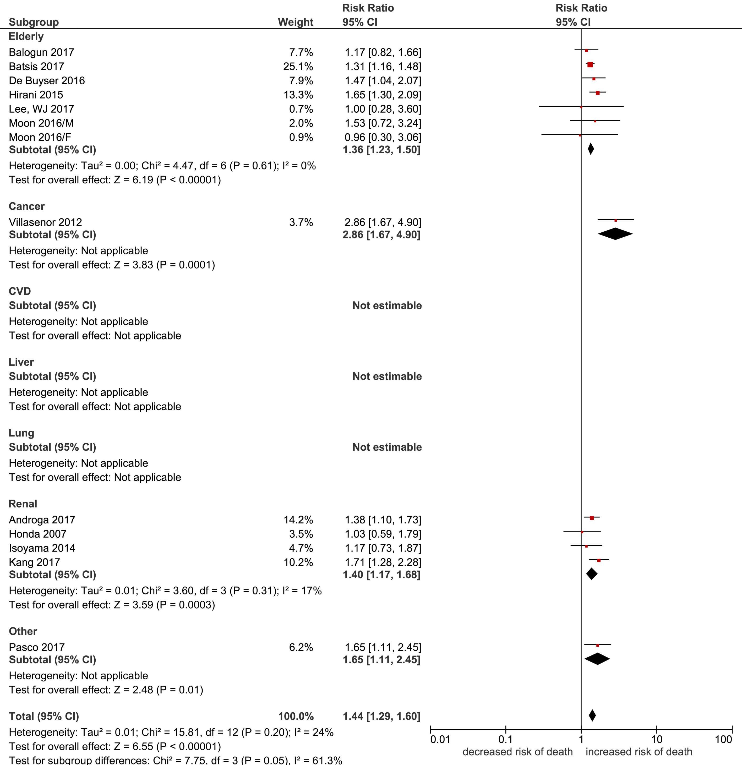

- CT
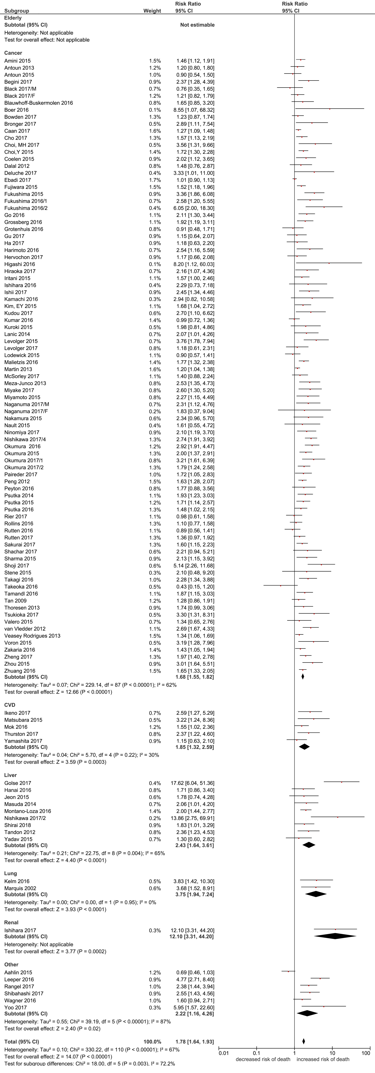
Keys: BIA: bioelectrical impedance analysis; DXA: dual energy X-ray absorptiometry; CT: computed tomography; Random effects analysis; Author Year/A: Males; Author Year/B: Females; Nishikawa 2017/2: ref [120] ; Nishikawa 2017/3: ref [121]; Nishikawa 2017/4: ref [122]; Fukushima 2016/1: ref [41]; Fukushima 2016/2: ref [42]; Okumura 2017/1: ref [126]; Okumura 2017/2: ref [127]

Figure S3
Funnel plots of all-cause mortality per SD decrease in (a) BIA-, (b) DXA- and (c) CT-measurement.
- BIA
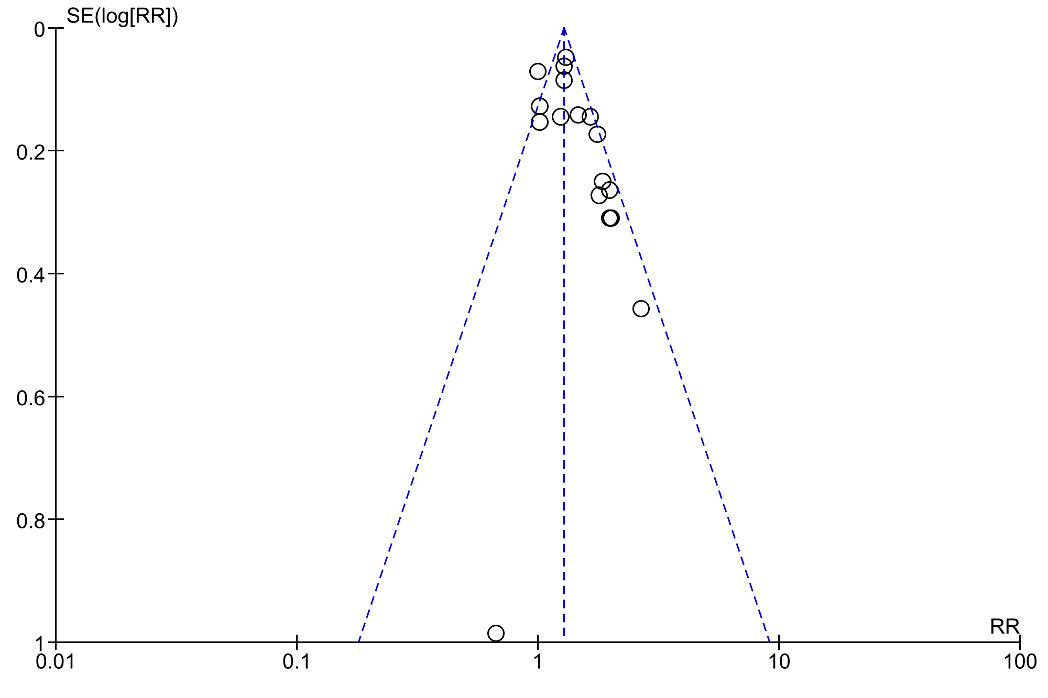
- DXA
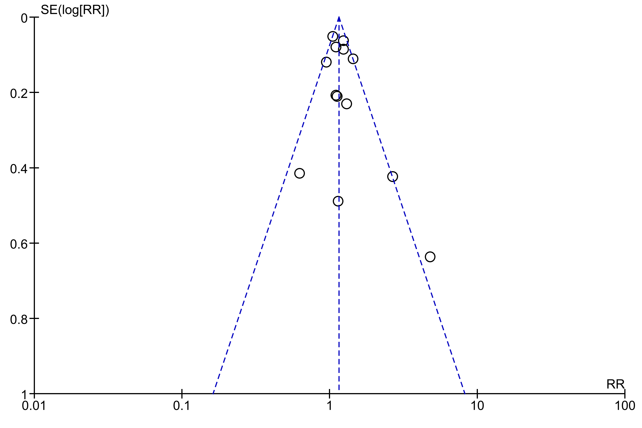
- CT
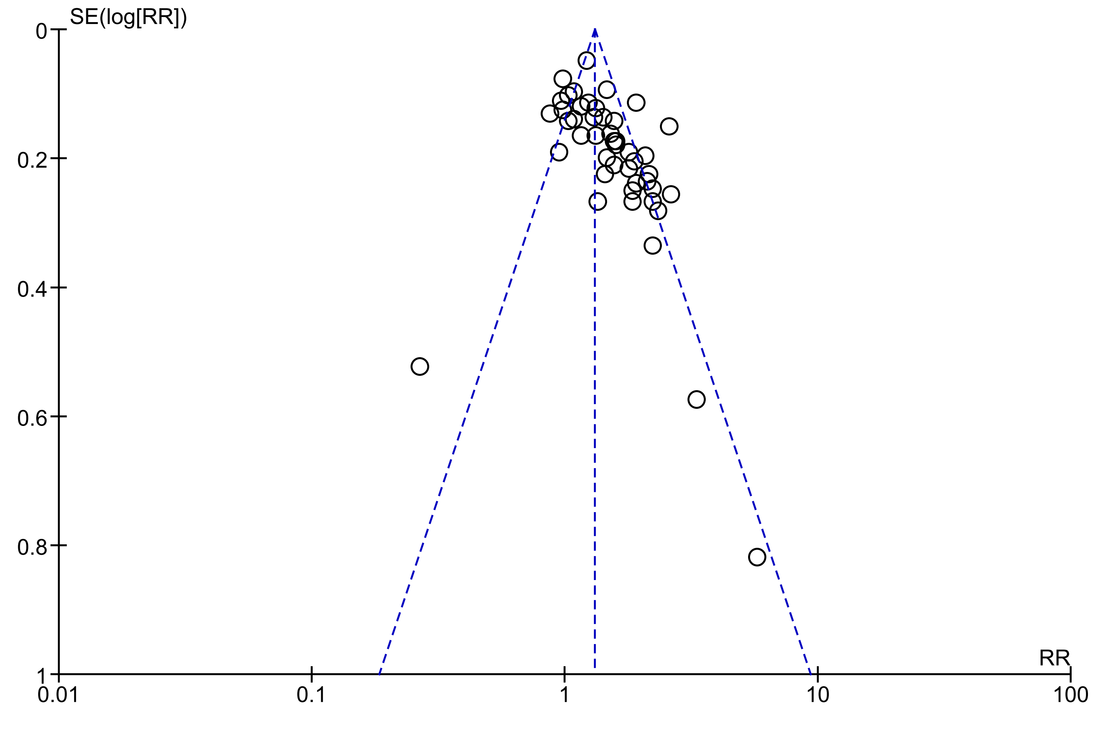

Keys: SD: standard deviation; BIA: bioelectrical impedance analysis; DXA: dual energy X-ray absorptiometry; CT: computed tomography.

Figure S4
Funnel plots of all-cause mortality in people with low lean mass by (a) BIA-, (b) DXA- and (c) CT-measurement.
- BIA
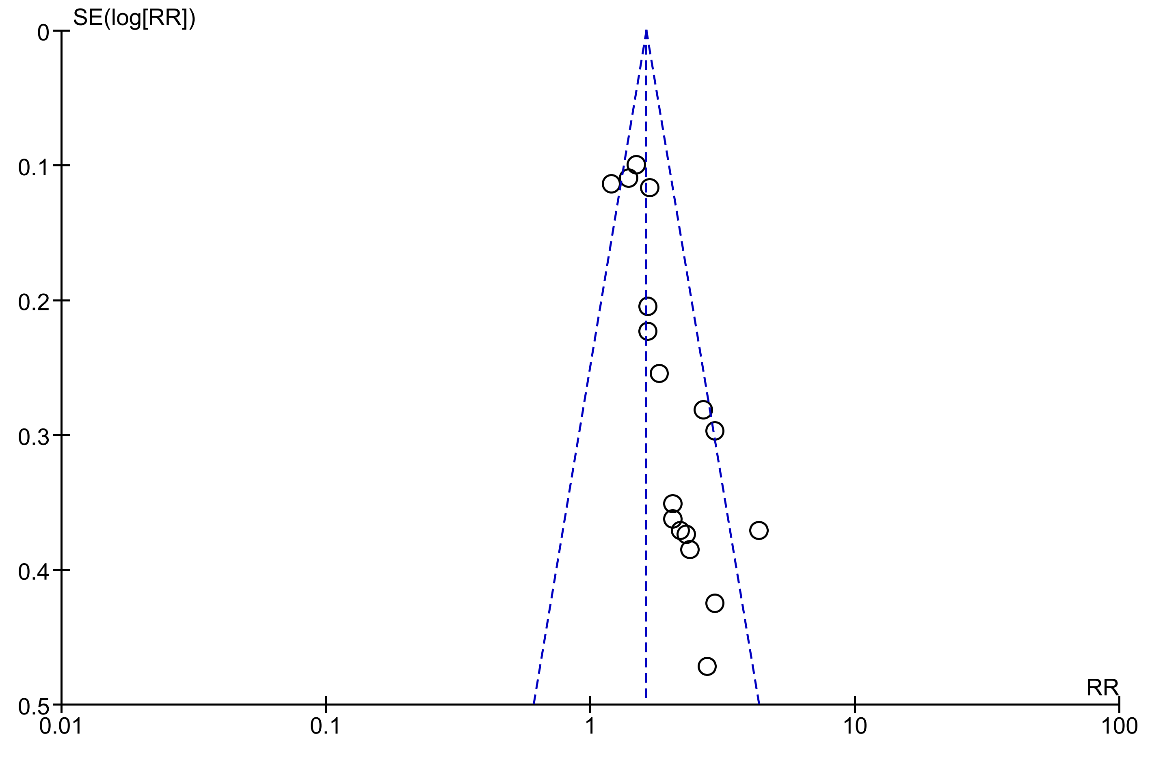
- DXA
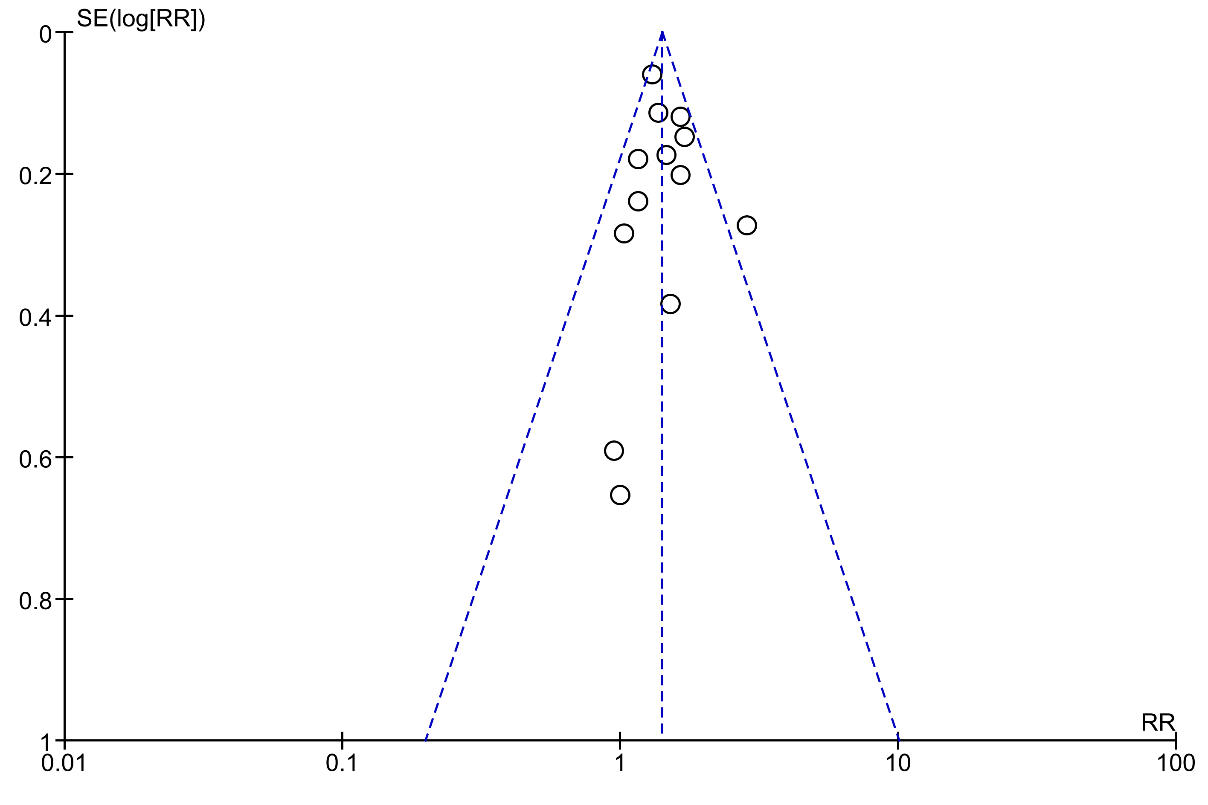
- CT
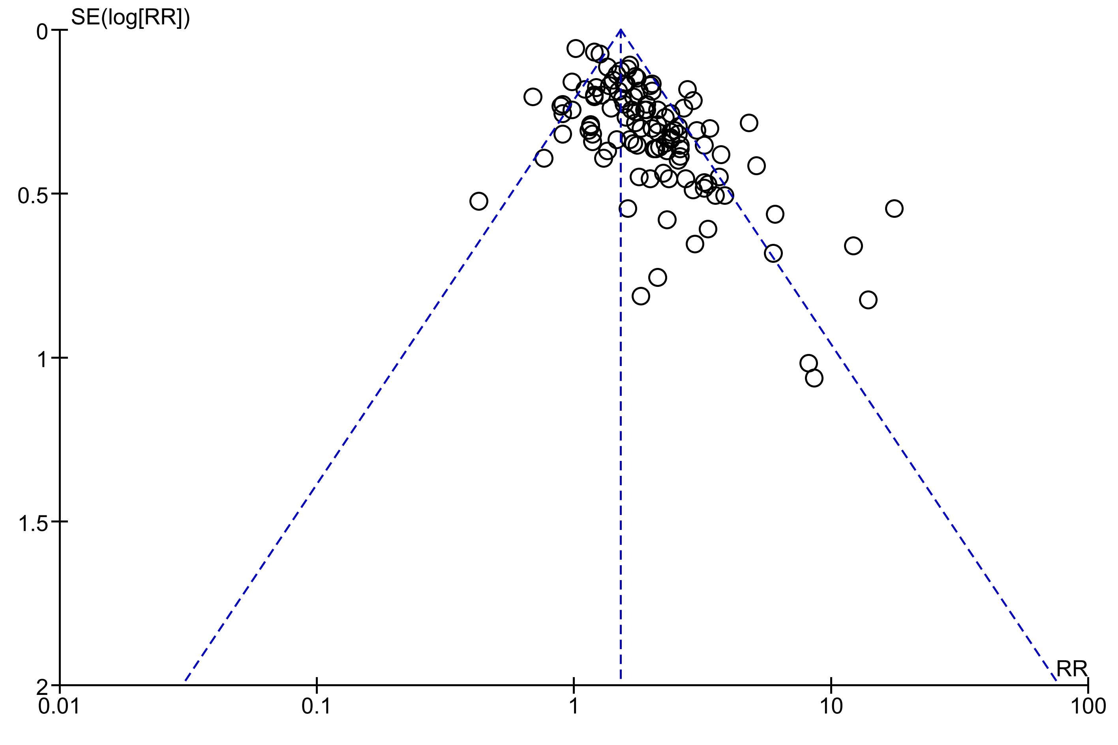

Keys: SD: standard deviation; BIA: bioelectrical impedance analysis; DXA: dual energy X-ray absorptiometry; CT: computed tomography.

