Supplementary materials to Kishimoto et al.
Efficacy and safety/tolerability of antipsychotics in the treatment of adult patients with major depressive disorder: A systematic review and meta-analysis.
Psychological Medicine

Table S1 Risk of bias summary 2
(“low”: low risk of bias; “?”: unclear risk of bias; “high“: high risk of bias) 3
Table S2 Characteristics of included studies 4
Table S3 Key findings 11
Table S4 Results of meta-analysis for secondary outcomes 13
Table S5 Meta-regression analyses for co-primary outcomes 22
Figure S1 Flow-diagram describing the search process 24
Figure S2 Meta-regression analysis in monotherapy 25
(A) Association between treatment response and mean age 25
(B) Association between treatment response and % Caucasian 26
(C) Association between treatment response and number of depressive episodes in past year 27
Figure S3 Meta-regression analysis in adjunctive therapy 28
(A) Association between treatment response and mean age 28
(B) Association between treatment response and number of lifetime depressive episodes 29
(C) Association between discontinuation due to adverse event and sample size 30
(D) Association between discontinuation due to adverse event and DDD ratio 31
Figure S4 Publication bias assessed by funnel plots, fail-safe estimates and Egger’s tests for the co-primary outcomes 32
(A) Treatment response, monotherapy; all RCTs 32
(B) Treatment response, monotherapy; RCTs of QUE 33
(C) Discontinuation due to adverse event, monotherapy; all RCTs 34
(D) Discontinuation due to adverse event, monotherapy; RCTs of QUE 35
(E) Treatment response, adjunctive therapy; all RCTs 36
(F) Treatment response, adjunctive therapy; RCTs of ARI 37
(G) Treatment response, adjunctive therapy; RCTs of BRE 38
(H) Treatment response, adjunctive therapy; RCTs of QUE 39
(I) Discontinuation due to adverse event, adjunctive therapy; all RCTs 40
(J) Discontinuation due to adverse event, adjunctive therapy; RCTs of ARI 41
(K) Discontinuation due to adverse event, adjunctive therapy; RCTs of BRE 42
(L) Discontinuation due to adverse event, adjunctive therapy; RCTs of QUE 43
References 44

Table S1 Risk of bias summary

 | Random sequence generation | Allocation concealment | Blinding of participants and personnel | Blinding of outcome assessment | Incomplete outcome data addressed | Selective reporting | Other sources of bias
Monotherapy
Bortnick 2011 | ? | ? | low | low | low | low | low
Boyer 1999 | ? | ? | low | low | low | low | low
Chaput 2008 | ? | low | low | low | high | low | ?
Cutler 2009 | low | low | low | low | low | low | low
Frolund 1974 | ? | ? | low | low | low | ? | low
Katila 2013 | low | ? | low | low | low | low | low
Kennedy 2014 | ? | ? | low | low | high | ? | low
Lecrubier 1997 | ? | ? | low | low | high | low | low
Liebowitz 2010 | ? | ? | low | low | high | low | low
Papakostas 2012 | ? | ? | low | low | low | low | high
Rüther 1999 | ? | ? | low | low | low | low | low
Wang 2014 | low | low | low | low | low | low | low
Weisler 2009 | low | low | low | low | low | low | low
Adjunctive therapy
Bauer 2009 | ? | ? | low | low | low | low | low
Berman 2007 | low | low | low | low | low | low | low
Berman 2009 | ? | ? | low | low | low | low | low
Dunner 2007 | ? | ? | high | high | high | low | low
Durgam 2016 | low | low | low | low | low | low | low
El-Khalili 2010 | low | ? | low | low | low | low | low
Fava 2012 | ? | ? | low | low | low | low | high
Flint 2019 | low | ? | low | low | low | low | low
Garakani 2008 | ? | ? | low | low | ? | low | low
Hobart 2018a | low | low | low | low | low | low | low
Hobart 2018b | low | low | low | low | low | low | low
Ionesc 2016 | ? | ? | low | low | high | low | high
Kamijima 2013 | ? | ? | low | low | low | low | low
Kamijima 2018 | ? | ? | low | low | low | low | low
Keitner 2009 | ? | ? | low | low | ? | high | low
Lenze 2015 | low | ? | low | low | low | low | low
Li 2016 | ? | ? | low | low | high | low | high
Lin 2011 | ? | ? | low | low | high | low | low
Mahmoud 2007 | low | low | low | low | low | low | low
Marcus 2008 | ? | ? | low | low | low | low | low
McIntyre 2007 | ? | ? | low | low | high | high | low
Papakostas 2015 | low | low | low | low | low | low | low
Parker 2005 | ? | ? | low | high | ? | high | high
Quante 2013 | ? | ? | low | low | ? | low | low
Reeves 2008 | ? | ? | low | low | ? | low | low
Sim 1978 | ? | ? | low | low | ? | low | low
Stabl 1995 | ? | ? | low | low | ? | low | low
Thase 2015a | low | low | low | low | low | low | low
Thase 2015b | low | low | low | low | low | low | low
Wade 2011 | low | low | low | low | low | low | low
NCT00797966 | ? | ? | low | low | low | ? | low
NCT01052077 | ? | ? | low | low | low | ? | low

Risk of bias summary: review authors' judgements about each risk of bias item for each included study

(“low”: low risk of bias; “?”: unclear risk of bias; “high“: high risk of bias)

Table S2 Characteristics of included studies

Study/  Country/  Blinding status | Total no. of patients | Duration (weeks) | Patient characteristics  Diagnosis  Age |  | Continuation  treatment(s) | Treatment arms (n) |  | Mean age (years) | % Male | % White | Mean dose (mg/day)
Monotherapy
Bortnick 2011 (1)  US  DB | 310 | 8 | Diagnosis: MDD (DSM-IV),  Age: 18-65 years,  Severity: HAM-D-17 ≥ 22 and a HAM-D Item 1 (depressed mood) score ≥ 2 |  | None | QUE (154)  PBO (156) |  | 43.3  42.6 | 35.4  35.5 | 68.7  65.8 | 162.2
Boyer 1999 (2)  France  DB | 323 | 12 | Diagnosis: Primary dysthymia (DSM-III-R)  Age: ≥ 18 years  Severity: MADRS < 21 |  | None | AMI (104)  [AMIN (111)]  PBO (108) |  | 48  48  48 | 29.8  21.6  24.1 | 99.0  98.2  99.1 | AMI 50 and AMIN 200 fixed dose
Chaput 2008 (3)  Canada  DB | 22 | 12 | Diagnosis: MDD (DSM-IV)  Age: 23-66 years  Severity: HAM-D-21 ≥ 18, CGI-S score ≥ 4, treatment refractory depression |  | None | QUE (11)  PBO (11) |  | 41.6  44.9 | 27.3  27.3 | NR | 147.7
Cutler 2009 (4)  US  DB | 612 | 6 | Diagnosis: MDD (DSM-IV)  Age: 18-65 years,  Severity: HAM-D-17 ≥ 22 and HAM-D Item 1 score ≥ 2 |  | None | QUE 150 (152)  QUE 300 (152)  [Duloxetine 60 (151)]  PBO (157) |  | 40.9  41.6  40.2  42.3 | 36.7  49.0  37.6  35.5 | 75.5  74.8  75.9  69.1 | QUE: 150 and 300 fixed dose  Duloxetine: 60 fixed dose
Frolund 1974 (5)  Denmark  DB | 231 | 2 | Diagnosis: Depression (clinical diagnosis)  Age: 20-70 years  Severity: NR |  | None | FLU (120)  PBO (111) |  | NR | 15  20 | NR | 0.5 – 1.5
Katila 2013 (6)  Multi  DB | 338 | 9 | Diagnosis: MDD (DSM-IV)  Age: ≥ 66 years  Severity: HAM-D-17 ≥ 22 and HAM-D Item 1 score ≥ 2 |  | None | QUE (166)  PBO (172) |  | 71.3  71.2 | 29.9  29.8 | 98.8  98.2 | 158.7
Kennedy 2014 (7)  Canada  DB | 53 | 1 | Diagnosis: MDD (DSM-IV)  Age: 18-65 years  Severity: HAM-D-17 > 14 |  | None | HAL (26)  PBO (27) |  | NR | NR | NR | 0.25
Lecrubier 1997 (8)  France  DB | 219 | 24 | Diagnosis: Primary dysthymia with major depression (DSM-III-R)  Age: NR  Severity: Mild or moderate severity or isolated chronic major depression in partial remission |  | None | AMI (73)  [IMI (73)]  PBO (73) |  | 41.8  44.0  42.9 | 43.8  52.1  39.7 | NR | AMI 50 and IMI 100 fixed dose
Liebowitz 2010 (9)  Multi  DB | 776 | 52 | Diagnosis: MDD (DSM-IV TR)  Age: 18-65 years  Severity: MADRS score ≤ 12 and CGI-S score ≤ 3 |  | None | QUE (391)  PBO (385) |  | 45.4  43.8 | 34.1  33.9 | NR | 177.1
Papakostas 2012 (10)  US  DB | 120 | 12 | Diagnosis: MDD (DSM-IV)  Age: 18-65 years  Severity: QIDS-SR ≥ 10 |  | None | ZIP-ZIP (29) ^{a)}  PBO-ZIP (47) ^{a)}  PBO-PBO (44) ^{a)} |  | 41.5  44.1  44.6 | 55.2  61.7  50.0 | NR | Phase I 81.4  Phase II 113.8
Rüther 1999 (11)  Germany and Austria  DB | 177 | 6 | Diagnosis: Depressive syndrome (ICD-10: F32.0, F32.1, F33.0, F33.1)  Age: 18-70 years  Severity: 27 ≥ HAM-D-21 ≥ 18 |  | None | SUL (87)  PBO (90) |  | 49.1  51.2 | 30.1  30.7 | NR | 181
Wang 2014 (12)  Multi  DB | 471 | 8 | Diagnosis: MDD (DSM-IV)  Age: 18-65 years  Severity: HAM-D-17 ≥ 22 and HAM-D Item 1 ≥ 2 |  | None | QUE (157)  [ESC (157)]  PBO (157) |  | 40.1  40.3  39.7 | 28.6  24.3  32.7 | 55.8  52.6  54.9 | QUE: 139.8  ESC: 10.7
Weisler 2009 (13)  US  DB | 723 | 6 | Diagnosis: MDD (DSM-IV)  Age: 18-65 years  Severity: HAM-D-17 ≥ 22 and HAM-D Item 1 ≥2 |  | None | QUE 50 (182)  QUE 150 (178)  QUE 300 (179)  PBO (184) |  | 40.6  41.5  40.7  40.3 | 46.6  38.1  41.5  36.5 | 73.6  73.8  69.9  76.4 | 50, 150 and 300 fixed dose
- Number of studies: 13 studies (13 reports)  - Number of patients: 4,375  [median=310 (range = 22−776)]  - Country:  US (studies=4, n=1,765)  Multinational (studies=4, n=1,762)  Canada (studies=2, n=75)  France (studies=2, n=542)  Denmark (study=1, n=231) |  |  |  | - Blinding status:  DB (studies=13, n=4,375)  - Mean duration: 12.2 weeks (range = 1 − 52)  - Antipsychotics:  AMI (studies=2, n=542), FLU (study=1, n=231),  HAL (study=1, n=53), QUE (studies=7, n=3,252),  SUL (study=1, n=177), ZIP (study=1, n=120) |  |  | - Age: 45.2±7.6 (range=39.7 – 71.3) years  - Gender (Male 35.4%)  - Race (White 76.7%)
Adjunctive therapy
Bauer 2009 (14)  Multi  DB | 493 | 6 | Diagnosis: MDD (DSM-IV)  Age: 18-65 years  Severity: HAM-D-17 ≥ 20, HAM-D Item 1 score ≥2, and history of an inadequate response during the current episode |  | AD | QUE 150 (167)  QUE 300 (163)  PBO (163) |  | 46.0  45.5  44.8 | 30.7  31.7  35.0 | 99.4  96.9  98.1 | 150 and 300 fixed dose
Berman 2007 (15)  US  DB | 362 | 6 | Diagnosis: MDD (DSM-IV),  Age: 18-65 years  Severity: HAM-D-17 ≥ 18, and inadequate response to AD treatment |  | AD | ARI (182)  PBO (176) |  | 46.5  44.2 | 38.5  35.8 | 87.4  92.6 | 11.8
Berman 2009 (16)  US  DB | 349 | 6 | Diagnosis: MDD (DSM-IV)  Age: 18-65 years  Severity: Inadequate response to AD |  | AD | ARI (177)  PBO (172) |  | 45.1  45.6 | 22.0  32.0 | 87.6  86.6 | 10.7
Dunner 2007 (17)  US  OL | 61 | 8 | Diagnosis: MDD (DSM-IV)  Age: 21-65 years  Severity: MADRS > 14, CGI-S ≥ 4, nonresponse to AD |  | Sertraline | ZIP 80 (22)  ZIP 160 (19)  PBO (20) |  | 43.1  42.6  46.3 | 45.5  52.6  45.0 | 90.9  94.7  80.0 | 80 and 160  Fixed dose
Durgam 2016 (18)  Multi  DB | 819 | 8 | Diagnosis: MDD (DSM-IV-TR) without psychotic features  Age: 18-65 years  Severity: Inadequate response to AD |  | AD | CAR1-2 (274)  CAR 2-4.5 (276)  PBO (269) |  | 45.5  45.1  46.4 | 31.5  26.4  28.6 | 85.7  88.6  86.5 | CAR 1 – 2: 1.4  CAR 2 – 4.5: 2.6
El-Khalili 2010 (19)  US  DB | 446 | 6 | Diagnosis: MDD (DSM-IV)  Age: 18-65 years  Severity: HAM-D-17 ≥ 20 and HAM-D Item 1 ≥ 2 |  | AD | QUE 150 (148)  QUE 300 (150)  PBO (148) |  | 45.9  44.3  46.2 | 23.8  27.4  31.5 | 89.5  91.1  89.5 | 150 and 300 fixed dose
Fava 2012 (20)  US  DB | 225 | 4.3 | Diagnosis: MDD (DSM, SAFER)  Age: 18–65 years  Severity: QIDS-SR > 15, HAM-D-17 ≥ 18, inadequate response to AD |  | AD | ARI-ARI (56) ^{b)}  PBO-ARI (84) ^{b)}  PBO-PBO (85) ^{b)} |  | 45.1 | ARI  33.93  PBO  36.09 | ARI  83.93  PBO  79.88 | 2 or 5
Flint 2019 (21)  US and Canada  DB | 126 | 36 | Diagnosis: MDD (DSM-IV-TR) with at least one associated delusion  Age: 18–85 years  Severity: Participants who met full-remission or near-remission criteria ^{c)} following treatment with sertraline plus olanzapine and who had a MMSE score ≥24 were eligible. |  | Sertraline | OLA (64)  PBO (62) |  | 55.0  55.7 | 42.2  33.9 | 84.4  79.0 | 5 – 20
Garakani 2008 (22)  US  DB | 114 | 8 | Diagnosis: MDD (DSM-IV)  Age: 18-65 years  Severity: MADRS > 15 |  | Fluoxetine | QUE (57)  PBO (57) |  | NR | NR | NR | 47.3
Hobart 2018a (23)  Multi  DB | 394 | 6 | Diagnosis: MDD (DSM-IV-TR)  Age: 18-65 years  Severity: HAM-D-17 ≥ 18, inadequate response to AD |  | AD | BRE (192)  PBO (202) |  | 43.0  42.7 | 23.4  28.7 | 85.4  84.7 | 2  fixed dose
Hobart 2018b (24)  Multi  DB | 503 | 6 | Diagnosis: MDD (DSM-IV-TR)  Age: 18-65 years  Severity: MADRS total score of ≥ 26, inadequate response to AD |  | AD | BRE (197)  QUE (100)  PBO (206) |  | 43.6  44.6  41.8 | 35.0  34.0  27.7 | 90.4  90.0  90.3 | BRE: 2 – 3  QUE: 150-300
Ionesc 2016 (25)  US  DB | 20 | 4 | Diagnosis: MDD (DSM-IV)  Age: NR  Severity: HAM-D ≥ 5, Anger/Hostility Scale of the Symptom Questionnaire ≥ 5, partial remission |  | AD | ILO (20) ^{d)}  PBO (20) ^{d)} |  | 46.1  46.1 | 30.0  30.0 | 84.6  84.6 | 1 – 8
Kamijima 2013 (26)  Japan  DB | 586 | 6 | Diagnosis: MDD (DSM-IV)  Age: 20-65 years  Severity: HAM-D-17 ≥ 18, inadequate response to AD |  | AD | ARI 3-15 (194)  ARI 3 (197)  PBO (195) |  | 38.1  39.2  38.7 | 52.1  62.9  59.0 | NR | ARI 3 – 15: 9.8, and 3 fixed dose
Kamijima 2018 (27)  Multi  DB | 412 | 6 | Diagnosis: MDD (DSM-5)  Age: 20–65 years  Severity: HAM-D-17 ≥ 18, inadequate response to AD |  | Sertraline | ARI (209)  PBO (203) |  | 38.3  39.5 | 62.0  64.5 | 1.0  2.0 | 6.3
Keitner 2009 (28)  US  DB | 97 | 4 | Diagnosis: MDD (DSM-IV)  Age: 18-65 years  Severity: MADRS ≥ 15, failed to respond or only partially responded to AD |  | AD | RIS (63)  PBO (34) |  | 45.5  44.6 | 42.2  45.5 | 93.7  84.8 | 1.6
Lenze 2015 (29)  US and Canada  DB | 181 | 12 | Diagnosis: MDD (DSM)  Age: ≥ 60 years  Severity: MADRS ≥ 15, not achieve remission with venlafaxine monotherapy |  | Venlafaxine | ARI (91)  PBO (90) |  | 66.0  65.7 | 43  43 | 88  88 | Median=7 in remitters; Median=10 in non-remitters
Li 2016 (30)  US  DB | 23 | 8 | Diagnosis: MDD (DSM-IV)  Age: 18-65 years  Severity: HAM-D-17 ≥ 18, HAM-A ≥ 18 |  | AD ^{e)} | QUE (11) ^{f)}  PBO (12) ^{f)} |  | 48.7  52.7 | 27.3  25.0 | 27.3  75.0 | 154
Lin 2011 (31)  Taiwan  DB | 41 | 10 | Diagnosis: MDD (DSM-IV)  Age: 18-65 years  Severity: HAM-D-17 ≥ 14, HAM-D Item 3 ≤ 3 |  | Sertraline | ARI (21)  PBO (20) |  | 35.9  35.1 | 19.1  20.0 | NR | 2.5
Mahmoud 2007 (32)  US  DB | 274 | 6 | Diagnosis: MDD (DSM-IV)  Age: 18-85 years  Severity: CGI-S score ≥ 4 |  | AD | RIS (141)  PBO (133) |  | 45.9  46.4 | 29.2  23.7 | 76.6  76.3 | 1 – 2
Marcus 2008 (33)  US  DB | 381 | 6 | Diagnosis: MDD (DSM-IV)  Age: 18-65 years  Severity: HAM-D-17 ≥ 18, inadequate response to AD |  | AD ^{g)} | ARI (191)  PBO (190) |  | 44.6  44.4 | 34.0  32.6 | 89.0  88.9 | 11.0
McIntyre 2007 (34)  Canada  DB | 58 | 8 | Diagnosis: MDD (DSM-IV)  Age: 18-65 years  Severity: HAM-D-17 ≥ 20, CGI-S ≥ 4, HAM-A ≥ 14 |  | SSRI or venlafaxine | QUE (29)  PBO (29) |  | 44  45 | 35  41 | NR | 182
Papakostas 2015 (35)  US  DB | 139 | 8 | Diagnosis: MDD (DSM-IV)  Age: 18–65 years  Severity: QIDS-SR ≥ 10 |  | Escitalopram | ZIP (71)  PBO (68) |  | 44.7  44.2 | 31.0  27.9 | NR | 98
Parker 2005 (36)  Australia  SB | 20 | 2 | Diagnosis: MDD (DSM-IV)  Age: NR  Severity: NR |  | AD | OLA (10)  PBO (10) |  | NR | 35.0 | NR | 2.5 – 5.0
Quante 2013 (37)  Germany  DB | 36 | 6 | Diagnosis: MDD (DSM-IV)  Age: 18-65 years  Severity: HAM-D item 13 ≥ 2 and HSCL/SCL-90 ≥ 1 SD higher than the mean value of healthy controls |  | Citalopram | QUE (19)  PBO (17) |  | 45.1  48.4 | NR | NR | 310
Reeves 2008 (38)  US  DB | 23 | 8 | Diagnosis: MDD (DSM-IV)  Age: 19-60 years  Severity: MADRS ≥ 25, MADRS suicidal subscore ≥ 4, with suicidal ideation despite treatment with AD |  | AD | RIS (12)  PBO (11) |  | 46.5  41.3 | 8.3  54.5 | NR | 1.17
Sim 1978 (39)  NR  DB | 66 | 6 | Diagnosis: Endogenous depression  Age: 18-70 years  Severity: HAM-D ≥ 20 |  | Imipramine | OXY 30 (16)  OXY 60 (18)  PBO (32) |  | 43  51  50 | 12.5  27.8  31.3 | NR | 30 and 60 fixed dose
Stabl 1995 (40)  Switzerland and Austria  DB | 78 | 4 | Diagnosis: MDD (DSM-III-R)  Age: 18-70 years  Severity: HAM-D-17 ≥ 20, depression is rated as marked or severe on the CGI, and refractory to at least two previous treatments |  | Moclobemide | THI (38)  PBO (40) |  | 51  53 | 47.4  40.0 | NR | 100  fixed dose
Thase 2015a (41)  Multi  DB | 379 | 6 | Diagnosis: MDD (DSM-IV-TR)  Age: 18-65 years  Severity: HAM-D-17 ≥ 18, inadequate response to AD |  | AD | BRE 2 (188)  PBO (191) |  | 44.1  45.2 | 30.9  28.3 | 86.7  86.9 | 2  fixed dose
Thase 2015b (42)  Multi  DB | 677 | 6 | Diagnosis: MDD (DSM-IV-TR)  Age: 18-65 years  Severity: HAM-D-17 ≥ 18, inadequate response to AD |  | AD | BRE 1 (226)  BRE 3 (230)  PBO (221) |  | 45.7  44.5  46.6 | 30.1  32.2  33.9 | 81.0  87.4  85.1 | 1 and 3  fixed dose
Wade 2011 (43)  UK  DB | 165 | 8 | Diagnosis: MDD (DSM-IV)  Age: NR  Severity: HAM-D-17 ≥ 18, CGI-S ≥ 4 |  | Citalopram | PIP (83)  PBO (82) |  | 40.1  39.7 | 15.7  24.4 | 98.8  100 | 10  fixed dose
NCT00797966 (44)  US  DB | 429 | 6 | Diagnosis: MDD (DSM-IV-TR)  Age: NR  Severity: HAM-D-17 ≥ 18, inadequate response to AD |  | AD | [BRE 0.15 (62)]  [BRE 0.5±0.25 (120)]  BRE 1.5±0.5 (121)  PBO (126) |  | 43.9  44.0  43.7  43.3 | 33.9  28.3  33.9  34.9 | NR | 0.15  fixed dose  0.5±0.25  1.5±0.5
NCT01052077 (45)  US  DB | 372 | 6 | Diagnosis: MDD (DSM-IV-TR)  Age: NR  Severity: HAM-D-17 ≥ 18, inadequate response to AD |  | AD | BRE (185)  PBO (187) |  | 44.7  42.7 | 32.0  33.5 | 75.5  67.5 | 1 – 3
- Number of studies: 32 studies (32 reports)  - Number of patients: 8,349  [median=203 (range = 20 − 819)]  - Country:  US (studies=15, n=3,315)  Multinational (studies=10, n=4,062)  Australia (study=1, n=20)  Canada (study=1, n=58)  Germany (study=1, n=36)  Japan (study=1, n=586)  NR (study=1, n=66)  Taiwan (study=1, n=41)  UK (study=1, n=165) |  |  |  | - Blinding status:  DB (studies=30, n=8,268), SB (study=1, n=20), OL (study=1, n=61)  - Mean duration: 7.4 (range =2 − 36)  - Antipsychotics:  ARI (studies=8, n=2,537), BRE (study=6, n=2,754),  CAR (study=1, n=819), ILO (study=1, n=20),  OLA (study=2, n=146), OXY (study=1, n=66),  PIP (study=1, n=165), QUE (studies=6, n=1,056),  RIS (studies=3, n=394), THI (study=1, n=78),  ZIP (study=2, n=200) |  |  | - Age: 45.4±5.2 (range=35.1 – 66) years  - Gender (Male 34.2%)  - Race (White 82.1%)

Notes:
[drug groups or numbers in squared brackets were not used in any analysis, neither the primary one nor in a sensitivity analysis]

Abbreviations:
AD=antidepressant, AMI=amisulpride, AMIN=amineptine, ARI=aripiprazole, BRE=brexpiprazole, CAR=cariprazine, CGI-S=Clinical Global Impressions－Severity of illness scale, DSM-IV-TR=Diagnostic and Statistical Manual of Mental Disorders, Fourth Edition. Text Revision, ECT=Electro Convulsive Therapy, ESC=escitalopram, FDA=Food and Drug Administration, FLU=flupenthixol, HAL=haloperidol, HAM-A= Hamilton Anxiety Rating Scale, HAM-D=Hamilton Rating Scale for Depression, HSCL/SCL-90=Hopkins Check List / Symptoms Check List 90, ILO=iloperidone, MADRS=Montgomery Åsberg Depression Rating Scale, MDD=Major Depressive Disorder, MMSE=Mini-Mental State Examination, OLA=olanzapine, OFC=olanzapine/fluoxetine combination, OXY=oxypertine, PBO=placebo, PIP=pipamperone, QIDS-SR=Quick Inventory of Depressive Symptomatology-Self-Rated, QUE=quetiapine, RIS=risperidone, SD=standard deviation, SNRI=Serotonin & Norepinephrine Reuptake Inhibitor, SSRI=Selective Serotonin Reuptake Inhibitor, SUL=sulpiride, THI=thioridazine, XR= extended release, ZIP=ziprasidone

- One hundred twenty outpatients were enrolled in a 12-week study that was divided into two 6-week periods according to the sequential parallel comparison design. Patients were randomized in a 2:3:3 fashion to receive ziprasidone for 12 weeks, placebo for 6 weeks followed by ziprasidone for 6 weeks, or placebo for 12 weeks.
- Two hundred twenty five MDD subjects were randomized to adjunctive treatment with aripiprazole 2 mg/day or placebo across two 30-day phases, with a 2: 3:3 randomization ratio to drug/drug (aripiprazole 2 mg/day in phase 1; 5 mg/day in phase 2), placebo/placebo (placebo in both phases), and placebo/drug (placebo in phase 1; aripiprazole 2 mg/day in phase 2).
- Remission was defined as the absence of delusions and hallucinations and a 17-item HAM-D score of 10 or less for 2 consecutive weeks. In addition, participants who met criteria for “near remission” following 12weeks of acute treatment were also eligible to enter the stabilization phase. Near remission was defined as the absence of delusions and hallucinations, an HAM-D score of 11 to 15 with 50% or more reduction in baseline HAM-D score, and being rated as “very much improved” or “much improved” on the Clinical Global Impression scale.
- Crossover study
- SSRI or SNRI
- Monotherapy or adjunctive therapy to antidepressant(s)
- Escitalopram, fluoxetine, paroxetine controlled-release, sertraline, or venlafaxine extended-release

Table S3 Key findings

- Nelson JC, Papakostas GI. Atypical antipsychotic augmentation in major depressive disorder: a meta-analysis of placebo-controlled randomized trials. The American journal of psychiatry. 2009;166(9):980-91.
- Spielmans GI, Berman MI, Linardatos E, Rosenlicht NZ, Perry A, Tsai AC. Adjunctive atypical antipsychotic treatment for major depressive disorder: a meta-analysis of depression, quality of life, and safety outcomes. PLoS medicine. 2013;10(3):e1001403.

Abbreviations:
AE=adverse event, AMI=amisulpride, AP=antipsychotic drug, ARI=aripiprazole, BRE=brexpiprazole, CAR=cariprazine, CI=confidence interval, FLU= flupenthixol, HAL=haloperidol, ILO=iloperidone, MDD=major depressive disorder, NR=not reported, OLA=olanzapine, OR=odds ratio, OXY=oxypertine, PIP=pipamperone, QUE=quetiapine, RIS=risperidone, RR=risk ratio, SUL=sulpiride, THI=thioridazine, ZIP=ziprasidone

Table S4 Results of meta-analysis for secondary outcomes

Category | Subcategory | Specific Outcomes | Medication | N | n | RR/  SMD | 95% CI |  | Results: P-value | Heterogeneity |  | NNH ^{a)}  (95% CI)
 |  |  |  |  |  |  | Lower limit | Upper limit | Results: P-value | P-value | I² | NNH ^{a)}  (95% CI)
Monotherapy
Efficacy | Anxiety symptom scale |  | QUE | 2 | 642 | -0.37 | -0.78 | 0.04 | 0.076 | 0.009 | 85.5 | −
Efficacy | CGI-I=1 or 2 (very much or much improved) |  | QUE | 5 | 2,087 | 1.35 | 1.12 | 1.62 | 0.002 | 0.002 | 75.8 | 7 (4, 19) ^{b)}
Efficacy | CGI-I=1 or 2 (very much or much improved) |  | SUL | 1 | 155 | 1.28 | 1.00 | 1.64 | 0.046 | − | − | 7 (4, 151) ^{b)}
Efficacy | CGI-S |  | QUE | 3 | 1,413 | -0.35 | -0.63 | -0.07 | 0.015 | 0.002 | 84.1 | −
Efficacy | CGI-S |  | ZIP | 2 | 166 | 0.16 | -0.21 | 0.54 | 0.389 | 0.281 | 14.1 | −
Efficacy | SDS |  | QUE | 1 | 771 | -0.17 | -0.31 | -0.03 | 0.018 | − | − | −
Efficacy | SDS Family life |  | QUE | 1 | 771 | -0.17 | -0.31 | -0.03 | 0.018 | − | − | −
Efficacy | SDS Social life |  | QUE | 1 | 771 | -0.17 | -0.31 | -0.03 | 0.018 | − | − | −
Efficacy | SDS Work/School |  | QUE | 1 | 771 | -0.09 | -0.23 | 0.05 | 0.202 | − | − | −
Safety | SAE |  | AMI | 1 | 145 | 0.49 | 0.09 | 2.61 | 0.406 | − | − | NA
Safety | SAE |  | QUE | 5 | 2481 | 1.28 | 0.66 | 2.48 | 0.459 | 0.562 | 0.0 | NA
Safety | SAE |  | SUL | 1 | 171 | 0.21 | 0.01 | 4.35 | 0.314 | − | − | NA
Safety | SAE |  | ZIP | 1 | 205 | 0.52 | 0.02 | 12.6 | 0.686 | − | − | NA
Safety | Anticholinergic AEs | Blurred vision | AMI | 1 | 145 | 2.63 | 0.73 | 9.52 | 0.141 | − | − | NA
Safety | Anticholinergic AEs | Blurred vision | QUE | 1 | 461 | 2.75 | 0.81 | 9.31 | 0.103 | − | − | 30 (15, 1894)
Safety | Anticholinergic AEs | Blurred vision | ZIP | 1 | 205 | 1.56 | 0.22 | 10.9 | 0.652 | − | − | NA
Safety | Anticholinergic AEs | Dry mouth | AMI | 1 | 145 | 0.99 | 0.52 | 1.87 | 0.966 | − | − | NA
Safety | Anticholinergic AEs | Dry mouth | QUE | 8 | 3271 | 3.21 | 2.40 | 4.29 | <0.001 | 0.103 | 41.3 | 7 (5, 11)
Safety | Anticholinergic AEs | Dry mouth | SUL | 1 | 171 | 0.71 | 0.12 | 4.12 | 0.700 | − | − | NA
Safety | Anticholinergic AEs | Dry mouth | ZIP | 1 | 205 | 1.56 | 0.52 | 4.68 | 0.425 | − | − | NA
Safety | Central nervous system | Anxiety | AMI | 1 | 212 | 0.52 | 0.10 | 2.77 | 0.443 | − | − | NA
Safety | Central nervous system | Anxiety | QUE | 1 | 312 | 2.96 | 0.98 | 8.98 | 0.055 | − | − | 20 (11, 466)
Safety | Central nervous system | Dizziness | AMI | 1 | 145 | 0.52 | 0.26 | 1.04 | 0.064 | − | − | NA
Safety | Central nervous system | Dizziness | QUE | 7 | 3249 | 1.62 | 1.32 | 1.99 | <0.001 | 0.489 | 0.0 | 19 (12, 35)
Safety | Central nervous system | Dizziness | SUL | 1 | 171 | 4.24 | 0.48 | 37.2 | 0.192 | − | − | NA
Safety | Central nervous system | Dizziness | ZIP | 1 | 205 | 1.56 | 0.22 | 10.9 | 0.652 | − | − | NA
Safety | Central nervous system | Fatigue | QUE | 7 | 3249 | 1.97 | 1.38 | 2.82 | <0.001 | 0.509 | 0.0 | 36 (19, 91)
Safety | Central nervous system | Fatigue | SUL | 1 | 171 | 2.65 | 0.53 | 13.3 | 0.236 | − | − | NA
Safety | Central nervous system | Headache | AMI | 1 | 212 | 1.04 | 0.35 | 3.12 | 0.946 | − | − | NA
Safety | Central nervous system | Headache | HAL | 1 | 53 | 0.85 | 0.42 | 1.71 | 0.647 | − | − | NA
Safety | Central nervous system | Headache | QUE | 8 | 3271 | 0.96 | 0.78 | 1.19 | 0.727 | 0.184 | 30.5 | NA
Safety | Central nervous system | Headache | SUL | 1 | 171 | 0.53 | 0.14 | 2.05 | 0.358 | − | − | NA
Safety | Central nervous system | Headache | ZIP | 1 | 205 | 2.34 | 0.40 | 13.7 | 0.345 | − | − | NA
Safety | Arousal-related AEs | Irritability | QUE | 4 | 2,266 | 0.82 | 0.44 | 1.54 | 0.542 | 0.164 | 41.2 | NA
Safety | Cardiovascular AEs | Palpitations | AMI | 2 | 357 | 0.93 | 0.47 | 1.83 | 0.828 | 0.876 | 0.0 | NA
Safety | Cardiovascular AEs | Palpitations | QUE | 1 | 312 | 0.99 | 0.33 | 2.99 | 0.982 | − | − | NA
Safety | Gastrointestinal AEs | Constipation | AMI | 1 | 145 | 0.78 | 0.43 | 1.41 | 0.409 | − | − | NA
Safety | Gastrointestinal AEs | Constipation | QUE | 7 | 3249 | 2.30 | 1.56 | 3.41 | <0.001 | 0.404 | 2.8 | 32 (18, 75)
Safety | Gastrointestinal AEs | Constipation | SUL | 1 | 171 | 0.21 | 0.01 | 4.35 | 0.314 | − | − | NA
Safety | Gastrointestinal AEs | Constipation | ZIP | 1 | 205 | 1.56 | 0.32 | 7.55 | 0.579 | − | − | NA
Safety | Gastrointestinal AEs | Diarrhea | QUE | 6 | 2934 | 0.82 | 0.60 | 1.11 | 0.196 | 0.324 | 14.0 | NA
Safety | Gastrointestinal AEs | Diarrhea | SUL | 1 | 171 | 0.21 | 0.01 | 4.35 | 0.314 | − | − | NA
Safety | Gastrointestinal AEs | Dyspepsia | QUE | 3 | 1490 | 1.34 | 0.79 | 2.29 | 0.282 | 0.984 | 0.0 | NA
Safety | Gastrointestinal AEs | Nausea | AMI | 1 | 212 | 0.69 | 0.12 | 4.06 | 0.684 | − | − | NA
Safety | Gastrointestinal AEs | Nausea | QUE | 8 | 3,271 | 0.89 | 0.63 | 1.26 | 0.521 | 0.090 | 43.3 | NA
Safety | Gastrointestinal AEs | Nausea | SUL | 1 | 171 | 0.35 | 0.01 | 8.55 | 0.522 | − | − | NA
Safety | Gastrointestinal AEs | Nausea | ZIP | 1 | 205 | 0.78 | 0.07 | 8.48 | 0.839 | − | − | NA
Safety | Other AEs | Nasopharyngitis | QUE | 3 | 1,395 | 0.53 | 0.19 | 1.48 | 0.226 | 0.048 | 67.0 | NA
Adjunctive therapy
Efficacy | Anxiety symptom scale |  | BRE | 2 | 769 | -0.19 | -0.33 | -0.05 | 0.010 | 0.998 | 0.0 | −
Efficacy | Anxiety symptom scale |  | QUE | 2 | 80 | -0.70 | -1.18 | -0.22 | 0.005 | 0.295 | 8.7 | −
Efficacy | Anxiety symptom scale |  | ZIP | 2 | 193 | -0.29 | -0.58 | -0.01 | 0.046 | 0.466 | 0.0 | −
Efficacy | CGI-I=1 or 2 (very much or much improved) |  | ARI | 4 | 1693 | 1.41 | 1.26 | 1.57 | <0.001 | 0.973 | 0.0 | 7 (5, 10) ^{b)}
Efficacy | CGI-I=1 or 2 (very much or much improved) |  | BRE | 3 | 1002 | 1.17 | 1.03 | 1.34 | 0.016 | 0.795 | 0.0 | 14 (7, 75) ^{b)}
Efficacy | CGI-I=1 or 2 (very much or much improved) |  | QUE | 2 | 919 | 1.22 | 1.08 | 1.39 | 0.002 | 0.859 | 0.0 | 9 (6, 27) ^{b)}
Efficacy | CGI-I=1 or 2 (very much or much improved) |  | THI | 1 | 78 | 1.05 | 0.81 | 1.37 | 0.699 | − | − | NA
Efficacy | CGI-S |  | ARI | 8 | 2404 | -0.26 | -0.37 | -0.16 | <0.001 | 0.164 | 33.0 | −
Efficacy | CGI-S |  | BRE | 6 | 2167 | -0.20 | -0.29 | -0.10 | <0.001 | 0.256 | 23.7 | −
Efficacy | CGI-S |  | CAR | 1 | 808 | -0.09 | -0.24 | 0.06 | 0.223 | − | − | −
Efficacy | CGI-S |  | QUE | 2 | 340 | 0.01 | -0.22 | 0.23 | 0.942 | 0.843 | 0.0 | −
Efficacy | CGI-S |  | RIS | 3 | 376 | -1.06 | -1.80 | -0.32 | 0.005 | 0.001 | 85.4 | −
Efficacy | CGI-S |  | ZIP | 2 | 199 | -0.37 | -0.65 | -0.08 | 0.012 | 0.757 | 0.0 | −
Efficacy | SDS |  | ARI | 3 | 1253 | -0.27 | -0.38 | -0.15 | <0.001 | 0.419 | 0.0 | −
Efficacy | SDS |  | BRE | 5 | 1744 | -0.20 | -0.29 | -0.11 | <0.001 | 0.774 | 0.0 | −
Efficacy | SDS |  | CAR | 1 | 808 | -0.15 | -0.30 | -0.01 | 0.043 | − | − | −
Efficacy | SDS |  | QUE | 2 | 326 | 0.23 | 0.00 | 0.46 | 0.051 | 0.629 | 0.0 | −
Efficacy | SDS |  | RIS | 1 | 223 | -0.57 | -0.84 | -0.30 | <0.001 | − | − | −
Efficacy | SDS Family life |  | ARI | 3 | 1256 | -0.34 | -0.46 | -0.23 | <0.001 | 0.379 | 0.0 | −
Efficacy | SDS Family life |  | BRE | 3 | 1165 | -0.23 | -0.35 | -0.12 | <0.001 | 0.967 | 0.0 | −
Efficacy | SDS Family life |  | QUE | 1 | 304 | 0.25 | 0.01 | 0.49 | 0.044 | − | − | −
Efficacy | SDS Family life |  | RIS | 1 | 223 | -0.39 | -0.66 | -0.13 | 0.004 | − | − | −
Efficacy | SDS Social life |  | ARI | 3 | 1,256 | -0.31 | -0.43 | -0.20 | <0.001 | 0.398 | 0.0 | −
Efficacy | SDS Social life |  | BRE | 3 | 1,165 | -0.21 | -0.33 | -0.10 | <0.001 | 0.996 | 0.0 | −
Efficacy | SDS Social life |  | QUE | 1 | 304 | 0.25 | 0.01 | 0.49 | 0.044 | − | − | −
Efficacy | SDS Social life |  | RIS | 1 | 223 | -0.55 | -0.81 | -0.28 | <0.001 | − | − | −
Efficacy | SDS Work/School |  | ARI | 3 | 1,104 | -0.17 | -0.42 | 0.08 | 0.176 | 0.020 | 74.5 | −
Efficacy | SDS Work/School |  | BRE | 3 | 1,030 | -0.04 | -0.17 | 0.08 | 0.482 | 0.678 | 0.0 | −
Efficacy | SDS Work/School |  | QUE | 1 | 203 | 0.24 | -0.05 | 0.53 | 0.111 | − | − | −
Safety | SAE |  | ARI | 6 | 2,264 | 0.96 | 0.43 | 2.17 | 0.924 | 0.775 | 0.0 | NA
Safety | SAE |  | BRE | 4 | 1,447 | 1.02 | 0.30 | 3.54 | 0.971 | 0.488 | 0.0 | NA
Safety | SAE |  | CAR | 1 | 812 | 0.97 | 0.09 | 10.7 | 0.983 | − | − | NA
Safety | SAE |  | ILO | 1 | 26 | 1.00 | 0.16 | 6.07 | 1.000 | − | − | NA
Safety | SAE |  | OLA | 1 | 126 | 0.97 | 0.47 | 1.99 | 0.931 | − | − | NA
Safety | SAE |  | PIP | 1 | 163 | 0.32 | 0.01 | 7.78 | 0.485 | − | − | NA
Safety | SAE |  | QUE | 2 | 936 | 0.73 | 0.21 | 2.59 | 0.631 | 0.757 | 0.0 | NA
Safety | SAE |  | RIS | 1 | 268 | 0.19 | 0.01 | 3.95 | 0.284 | − | − | NA
Safety | SAE |  | ZIP | 1 | 139 | 0.96 | 0.14 | 6.61 | 0.965 | − | − | NA
Safety | EPS | Dystonia | ARI | 1 | 586 | 10.5 | 0.62 | 178 | 0.104 | − | − | 40 (24, 124)
Safety | EPS | Dystonia | QUE | 1 | 58 | 3.00 | 0.33 | 27.2 | 0.329 | − | − | NA
Safety | EPS | Dystonia | RIS | 1 | 268 | 0.32 | 0.01 | 7.76 | 0.483 | − | − | NA
Safety | Anticholinergic AEs | Blurred vision | ARI | 2 | 706 | 4.05 | 1.68 | 9.75 | 0.002 | 0.920 | 0.0 | 19 (7, 86)
Safety | Anticholinergic AEs | Blurred vision | QUE | 1 | 23 | 3.25 | 0.15 | 72.4 | 0.457 | − | − | NA
Safety | Anticholinergic AEs | Dry mouth | ARI | 2 | 944 | 1.38 | 0.20 | 9.58 | 0.747 | 0.012 | 84.3 | NA
Safety | Anticholinergic AEs | Dry mouth | BRE | 1 | 403 | 2.09 | 0.19 | 22.9 | 0.546 | − | − | NA
Safety | Anticholinergic AEs | Dry mouth | CAR | 1 | 812 | 1.67 | 0.73 | 3.83 | 0.225 | − | − | NA
Safety | Anticholinergic AEs | Dry mouth | ILO | 1 | 26 | 6.00 | 0.83 | 43.1 | 0.075 | − | − | 3 (2, 13)
Safety | Anticholinergic AEs | Dry mouth | OLA | 1 | 126 | 0.32 | 0.01 | 7.78 | 0.486 | − | − | NA
Safety | Anticholinergic AEs | Dry mouth | PIP | 1 | 163 | 1.93 | 0.76 | 4.89 | 0.167 | − | − | NA
Safety | Anticholinergic AEs | Dry mouth | QUE | 6 | 1437 | 3.87 | 2.70 | 5.54 | <0.001 | 0.383 | 5.3 | 7 (4, 11)
Safety | Anticholinergic AEs | Dry mouth | RIS | 3 | 388 | 6.76 | 1.87 | 24.41 | 0.004 | 0.821 | 0.0 | 16  (4, 101)
Safety | Anticholinergic AEs | Dry mouth | THI | 1 | 78 | 7.36 | 0.39 | 138 | 0.182 | − | − | NA
Safety | Anticholinergic AEs | Dry mouth | ZIP | 2 | 200 | 1.34 | 0.15 | 11.9 | 0.794 | 0.118 | 59.2 | NA
Safety | Central nervous system | Anxiety | BRE | 4 | 1625 | 2.33 | 0.97 | 5.63 | 0.060 | 0.518 | 0.0 | NA
Safety | Central nervous system | Anxiety | QUE | 4 | 501 | 0.58 | 0.20 | 1.72 | 0.329 | 0.355 | 3.4 | NA
Safety | Central nervous system | Anxiety | ZIP | 1 | 139 | 8.62 | 0.47 | 157 | 0.146 | − | − | NA
Safety | Central nervous system | Dizziness | ARI | 4 | 1387 | 0.96 | 0.55 | 1.68 | 0.885 | 0.470 | 0.0 | NA
Safety | Central nervous system | Dizziness | CAR | 1 | 812 | 2.34 | 0.90 | 6.06 | 0.080 | − | − | NA
Safety | Central nervous system | Dizziness | ILO | 1 | 26 | 5.00 | 0.26 | 95.0 | 0.284 | − | − | NA
Safety | Central nervous system | Dizziness | OLA | 1 | 126 | 2.42 | 0.49 | 12.0 | 0.279 | − | − | NA
Safety | Central nervous system | Dizziness | PIP | 1 | 163 | 1.29 | 0.47 | 3.54 | 0.627 | − | − | NA
Safety | Central nervous system | Dizziness | QUE | 4 | 1017 | 1.43 | 0.88 | 2.31 | 0.144 | 0.309 | 16.5 | NA
Safety | Central nervous system | Dizziness | RIS | 2 | 291 | 1.66 | 0.50 | 5.48 | 0.408 | 0.918 | 0.0 | NA
Safety | Central nervous system | Dizziness | ZIP | 2 | 200 | 2.32 | 0.59 | 9.12 | 0.227 | 0.295 | 8.8 | NA
Safety | Central nervous system | Fatigue | ARI | 4 | 1126 | 2.07 | 1.28 | 3.36 | 0.003 | 0.870 | 0.0 | 23 (11, 87)
Safety | Central nervous system | Fatigue | BRE | 5 | 1997 | 2.10 | 1.17 | 3.77 | 0.013 | 0.642 | 0.0 | 58 (23, 376)
Safety | Central nervous system | Fatigue | CAR | 1 | 812 | 1.95 | 1.02 | 3.71 | 0.042 | − | − | 26 (14, 163)
Safety | Central nervous system | Fatigue | OLA | 1 | 126 | 1.94 | 0.18 | 20.8 | 0.585 | − | − | NA
Safety | Central nervous system | Fatigue | PIP | 1 | 163 | 1.08 | 0.44 | 2.67 | 0.860 | − | − | NA
Safety | Central nervous system | Fatigue | QUE | 5 ^{c)} | 1,379 | 2.65 | 1.60 | 4.38 | <0.001 | 0.430 | 0.0 | 13 (7, 35)
Safety | Central nervous system | Fatigue | RIS | 2 | 365 | 1.07 | 0.01 | 98.2 | 0.976 | 0.030 | 78.7 | NA
Safety | Central nervous system | Headache | ARI | 6 | 2429 | 0.69 | 0.51 | 0.95 | 0.021 | 0.538 | 0.0 | -45 ^{d)} (-261, -28)
Safety | Central nervous system | Headache | BRE | 5 | 1,865 | 0.69 | 0.48 | 0.99 | 0.042 | 0.601 | 0.0 | -43 ^{d)} (-1007, -26)
Safety | Central nervous system | Headache | ILO | 1 | 26 | 2.00 | 0.21 | 19.4 | 0.550 | − | − | NA
Safety | Central nervous system | Headache | OLA | 1 | 126 | 2.91 | 0.31 | 27.2 | 0.350 | − | − | NA
Safety | Central nervous system | Headache | PIP | 1 | 163 | 1.07 | 0.62 | 1.83 | 0.818 | − | − | NA
Safety | Central nervous system | Headache | QUE | 6 | 1437 | 0.73 | 0.50 | 1.07 | 0.109 | 0.353 | 9.8 | NA
Safety | Central nervous system | Headache | RIS | 3 | 388 | 0.46 | 0.24 | 0.89 | 0.020 | 0.227 | 32.5 | -10 ^{d)} (-44, -7)
Safety | Central nervous system | Headache | ZIP | 2 | 200 | 1.09 | 0.19 | 6.43 | 0.923 | 0.110 | 60.9 | NA
Safety | CNS | Irritability | ILO | 1 | 26 | 3.00 | 0.13 | 67.5 | 0.489 | − | − | NA
Safety | CNS | Irritability | QUE | 2 | 468 | 0.85 | 0.39 | 1.87 | 0.686 | 0.381 | 0.0 | NA
Safety | CNS | Irritability | ZIP | 1 | 139 | 6.70 | 0.85 | 53.1 | 0.071 | − | − | 12 (7, 113)
Safety | Cardiovascular AEs | Palpitations | ARI | 1 | 41 | 0.32 | 0.01 | 7.38 | 0.475 | − | − | NA
Safety | Cardiovascular AEs | Palpitations | ILO | 1 | 26 | 5.00 | 0.26 | 95.0 | 0.284 | − | − | NA
Safety | Gastrointestinal AEs | Constipation | ARI | 5 | 2071 | 2.19 | 1.33 | 3.61 | 0.002 | 0.536 | 0.0 | 38 (18, 138)
Safety | Gastrointestinal AEs | Constipation | BRE | 1 | 372 | 2.78 | 0.90 | 8.57 | 0.075 | − | − | NA
Safety | Gastrointestinal AEs | Constipation | CAR | 1 | 812 | 1.95 | 0.74 | 5.14 | 0.177 | − | − | NA
Safety | Gastrointestinal AEs | Constipation | OLA | 1 | 126 | 0.32 | 0.01 | 7.78 | 0.486 | − | − | NA
Safety | Gastrointestinal AEs | Constipation | QUE | 3 | 994 | 2.42 | 1.30 | 4.51 | 0.005 | 0.582 | 0.0 | 22 (9, 104)
Safety | Gastrointestinal AEs | Constipation | RIS | 2 | 365 | 1.47 | 0.57 | 3.76 | 0.423 | 0.878 | 0.0 | NA
Safety | Gastrointestinal AEs | Constipation | ZIP | 1 | 61 | 4.50 | 0.25 | 79.7 | 0.305 | − | − | NA
Safety | Gastrointestinal AEs | Diarrhea | ARI | 5 | 2050 | 0.71 | 0.46 | 1.08 | 0.112 | 0.751 | 0.0 | NA
Safety | Gastrointestinal AEs | Diarrhea | BRE | 3 | 998 | 1.02 | 0.49 | 2.16 | 0.950 | 0.176 | 42.4 | NA
Safety | Gastrointestinal AEs | Diarrhea | ILO | 1 | 26 | 3.00 | 0.13 | 67.5 | 0.489 | − | − | NA
Safety | Gastrointestinal AEs | Diarrhea | OLA | 1 | 126 | 3.88 | 0.45 | 33.7 | 0.220 | − | − | NA
Safety | Gastrointestinal AEs | Diarrhea | PIP | 1 | 163 | 0.74 | 0.34 | 1.59 | 0.443 | − | − | NA
Safety | Gastrointestinal AEs | Diarrhea | QUE | 1 | 445 | 1.00 | 0.48 | 2.07 | 0.993 | − | − | NA
Safety | Gastrointestinal AEs | Diarrhea | RIS | 2 | 291 | 0.59 | 0.21 | 1.70 | 0.327 | 0.954 | 0.0 | NA
Safety | Gastrointestinal AEs | Diarrhea | ZIP | 1 | 139 | 0.55 | 0.17 | 1.79 | 0.318 | − | − | NA
Safety | Gastrointestinal AEs | Dyspepsia | RIS | 1 | 268 | 0.72 | 0.16 | 3.14 | 0.659 | − | − | NA
Safety | Gastrointestinal AEs | Nausea | ARI | 7 | 2470 | 0.87 | 0.62 | 1.22 | 0.432 | 0.738 | 0.0 | NA
Safety | Gastrointestinal AEs | Nausea | BRE | 1 | 247 | 0.69 | 0.12 | 4.08 | 0.686 | − | − | NA
Safety | Gastrointestinal AEs | Nausea | CAR | 1 | 812 | 2.02 | 1.12 | 3.64 | 0.019 | − | − | 20 (12, 72)
Safety | Gastrointestinal AEs | Nausea | ILO | 1 | 26 | 2.00 | 0.21 | 19.4 | 0.550 | − | − | NA
Safety | Gastrointestinal AEs | Nausea | OLA | 1 | 126 | 0.48 | 0.09 | 2.55 | 0.392 | − | − | NA
Safety | Gastrointestinal AEs | Nausea | PIP | 1 | 163 | 0.70 | 0.42 | 1.17 | 0.174 | − | − | NA
Safety | Gastrointestinal AEs | Nausea | QUE | 3 | 994 | 0.98 | 0.61 | 1.58 | 0.928 | 0.530 | 0.0 | NA
Safety | Gastrointestinal AEs | Nausea | RIS | 2 | 291 | 0.44 | 0.14 | 1.35 | 0.152 | 0.570 | 0.0 | NA
Safety | Gastrointestinal AEs | Nausea | ZIP | 2 | 200 | 0.98 | 0.06 | 15.1 | 0.991 | 0.073 | 68.8 | NA
Safety | Other AEs | Nasopharyngitis | ARI | 2 | 998 | 1.12 | 0.81 | 1.55 | 0.481 | 0.802 | 0.0 | NA
Safety | Other AEs | Nasopharyngitis | BRE | 4 | 1,462 | 1.57 | 0.91 | 2.72 | 0.108 | 0.502 | 0.0 | NA
Safety | Other AEs | Nasopharyngitis | PIP | 1 | 163 | 0.69 | 0.23 | 2.08 | 0.508 | − | − | NA
Safety | Other AEs | Nasopharyngitis | QUE | 1 | 491 | 0.49 | 0.21 | 1.15 | 0.100 | − | − | NA

Notes:
Significant (P<.05) results are in bold. Continuous data (SMD) in italics.
RR values >1 indicate superiority of antipsychotics compared to placebo for positive outcomes, while RR values >1 indicate inferiority of antipsychotics compared to placebo for negative outcomes.
SMDs <0 indicate superiority of antipsychotics compared to placebo in symptom scale score. SMDs >0 indicate that antipsychotics had higher laboratory values than placebo.

- NNHs for individual adverse event were calculated.
- NNTs were calculated for positive outcome.
- Includes a study (Hobart 2018) with an incidence risk of 0% in both antipsychotic and placebo arms.
- Negative NNH indicates that the placebo was more harmful than the antipsychotics.
- RR was not calculable as an incidence risk was 0% in both antipsychotic and placebo arms (Alexopoulos 2008).

Abbreviations:
AMI=amisulpride, ARI=aripiprazole, BRE=brexpiprazole, CAR=cariprazine, CGI-S= Clinical Global Impressions - severity of illness, CI=confidence interval, EPS=extrapyramidal symptoms, ILO=iloperidone, LUR=lurasidone, N=the number of studies, n=the number of patients, NA=not applicable, NNH=number needed to harm, OLA=olanzapine, PER=perphenazine, PIP=pipamperone, QUE=quetiapine, RIS=risperidone, RR=risk ratio, SAE=serious adverse event, SDS= the Sheehan Disability Scale, SMD=standardized mean difference, SUL=sulpiride, THI=thioridazine, ZIP=ziprasidone

Table S5 Meta-regression analyses for co-primary outcomes

Administration | Outcomes | Covariant | N | n | Coefficient | 95% CI |  | P-value
 |  |  |  |  |  | Lower limit | Upper limit | P-value
Monotherapy | Treatment response | Mean age | 10 | 2,733 | 0.015 | 0.005 | 0.024 | 0.002
Monotherapy | Treatment response | % Male | 10 | 2,733 | -0.007 | -0.025 | 0.011 | 0.464
Monotherapy | Treatment response | % Caucasian | 6 | 2,293 | 0.013 | 0.006 | 0.019 | <0.001
Monotherapy | Treatment response | Publication year | 10 | 2,733 | -0.018 | -0.039 | 0.003 | 0.096
Monotherapy | Treatment response | Sample size | 10 | 2,733 | 0.000 | -0.001 | 0.001 | 0.814
Monotherapy | Treatment response | Trial duration | 10 | 2,733 | 0.027 | -0.001 | 0.055 | 0.058
Monotherapy | Treatment response | Illness duration | 4 | 1147 | 0.009 | -0.075 | 0.093 | .84
Monotherapy | Treatment response | # of lifetime DEP | 2 ^{a)} | NA
Monotherapy | Treatment response | # of DEP  in past year | 4 | 1780 | -0.203 | -0.375 | -0.030 | .02
Monotherapy | Treatment response | DDD ratio | 13 | 3,241 | -0.250 | -0.657 | 0.157 | 0.228
Monotherapy | Discontinuation due to adverse event | Mean age | 11 | 3,640 | -0.003 | -0.037 | 0.031 | 0.867
Monotherapy | Discontinuation due to adverse event | % Male | 11 | 3,640 | -0.002 | -0.055 | 0.051 | 0.940
Monotherapy | Discontinuation due to adverse event | % Caucasian | 6 | 2,358 | -0.005 | -0.031 | 0.022 | 0.725
Monotherapy | Discontinuation due to adverse event | Publication year | 12 | 3,693 | -0.004 | -0.084 | 0.077 | 0.932
Monotherapy | Discontinuation due to adverse event | Sample size | 12 | 3,693 | -0.001 | -0.002 | 0.001 | 0.197
Monotherapy | Discontinuation due to adverse event | Trial duration | 12 | 3,693 | -0.013 | -0.029 | 0.003 | 0.119
Monotherapy | Discontinuation due to adverse event | Illness duration | 5 | 1950 | -0.088 | -0.281 | 0.106 | .37
Monotherapy | Discontinuation due to adverse event | # of lifetime DEP | 2 ^{a)} | NA
Monotherapy | Discontinuation due to adverse event | # of DEP  in past year | 4 | 1832 | 0.090 | -0.763 | 0.943 | .84
Monotherapy | Discontinuation due to adverse event | DDD ratio | 15 | 4,218 | -0.361 | -1.713 | 0.990 | 0.600
Adjunctive therapy | Treatment response | Mean age | 28 | 7,366 | -0.025 | -0.047 | -0.003 | 0.027
Adjunctive therapy | Treatment response | % Male | 27 | 7,330 | 0.000 | -0.007 | 0.008 | 0.908
Adjunctive therapy | Treatment response | % Caucasian | 20 | 6,196 | -0.001 | -0.005 | 0.002 | 0.413
Adjunctive therapy | Treatment response | Publication year | 28 | 7,366 | 0.008 | -0.005 | 0.021 | 0.211
Adjunctive therapy | Treatment response | Sample size | 28 | 7,366 | 0.000 | -0.001 | 0.000 | 0.729
Adjunctive therapy | Treatment response | Trial duration | 28 | 7,366 | 0.034 | -0.037 | 0.105 | 0.349
Adjunctive therapy | Treatment response | Illness duration | 2 ^{a)} | NA
Adjunctive therapy | Treatment response | # of lifetime DEP | 9 | 2,705 | 0.109 | 0.007 | 0.211 | 0.036
Adjunctive therapy | Treatment response | # of DEP  in past year | 2 ^{a)} | NA
Adjunctive therapy | Treatment response | DDD ratio | 25 | 6,474 | 0.239 | -0.039 | 0.516 | 0.092
Adjunctive therapy | Discontinuation due to adverse event | Mean age | 26 | 7,553 | -0.021 | -0.084 | 0.043 | 0.527
Adjunctive therapy | Discontinuation due to adverse event | % Male | 26 | 7,553 | -0.012 | -0.043 | 197.0 | 0.471
Adjunctive therapy | Discontinuation due to adverse event | % Caucasian | 20 | 6,404 | -0.002 | -0.019 | 0.015 | 0.807
Adjunctive therapy | Discontinuation due to adverse event | Publication year | 26 | 7,553 | 0.052 | -0.017 | 0.120 | 0.142
Adjunctive therapy | Discontinuation due to adverse event | Sample size | 26 | 7,553 | 0.001 | 0.000 | 0.003 | 0.017
Adjunctive therapy | Discontinuation due to adverse event | Trial duration | 26 | 7,553 | 0.065 | -0.117 | 0.248 | 0.482
Adjunctive therapy | Discontinuation due to adverse event | Illness duration | 3 ^{a)} | NA
Adjunctive therapy | Discontinuation due to adverse event | # of lifetime DEP | 8 | 2,760 | 0.175 | -0.326 | 0.676 | .49
Adjunctive therapy | Discontinuation due to adverse event | # of DEP  in past year | 2 ^{a)} | NA
Adjunctive therapy | Discontinuation due to adverse event | DDD ratio | 25 | 6,772 | 1.757 | 0.813 | 2.700 | <0.001

Notes:
Significant (P<0.05) results are in bold.
- not enough studies for meta-regression analysis

Abbreviations:
CI=confidence interval, DDD=daily defined dose, DEP=depressive episodes, N=number of studies, n=number of patients, NA=not applicable

Figure S1 Flow-diagram describing the search process
4,377 records identified
through database searching
2,188 records excluded because they were clearly not relevant or duplicates
2,189 records screened
5 full-text articles excluded with reasons of no original data
43 full-text articles assessed for eligibility
Included
Eligibility
Screening
Identification
2,146 records excluded:

Not major depressive disorder: N=971
Review article: N=967
Not clinical trial: N=121
No antipsychotics: N=44
No available data or other reason: N=29
No placebo arm: N=11
Not human data: N=3
45 studies (45 articles) included in qualitative synthesis (meta-analysis)
Additional studies identified through other sources: N=7

Figure S2 Meta-regression analysis in monotherapy
- Association between treatment response and mean age
Coefficient=0.0145, 95% CI=0.0052 − 0.0238, p=0.0022

(B) Association between treatment response and % Caucasian
Coefficient=0.0126, 95% CI=0.0064 – 0.0189, p=0.0001

(C) Association between treatment response and number of depressive episodes in past year

Coefficient=-0.2025, 95% CI=-0.3749 – -0.0302, p=0.0213

Abbreviations:
AP=antipsychotic drug, PBO=placebo

Figure S3 Meta-regression analysis in adjunctive therapy

(A) Association between treatment response and mean age
Coefficient=-0.0249, 95% CI=-0.0468 – -0.0029, p=0.0265

(B) Association between treatment response and number of lifetime depressive episodes

Coefficient=0.1090, 95% CI=0.0070 – 0.2110, p=0.0363

(C) Association between discontinuation due to adverse event and sample size
Coefficient=0.0014, 95% CI=0.0002 – 0.0025, p=0.0170

(D) Association between discontinuation due to adverse event and DDD ratio

Coefficient=1.7567, 95% CI=0.8129 – 2.7004, p=0.0003

Abbreviations:
AE=adverse event, AP=antipsychotic drug, DDD=daily defined dose, PBO=placebo

Figure S4 Publication bias assessed by funnel plots, fail-safe estimates and Egger’s tests for the co-primary outcomes

Note that comparisons with less than three published studies could not be assessed by these methods.

- Treatment response, monotherapy; all RCTs

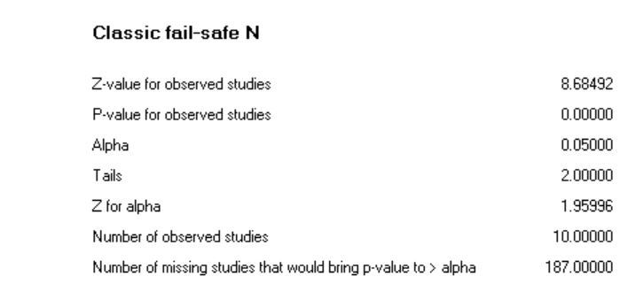
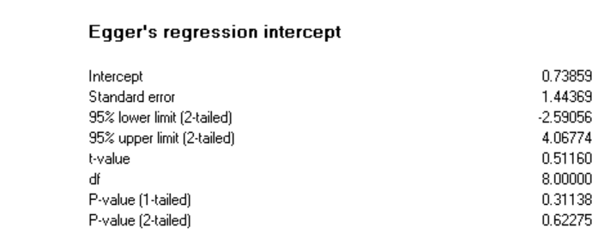
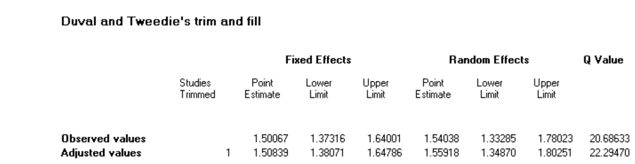
- Treatment response, monotherapy; RCTs of QUE

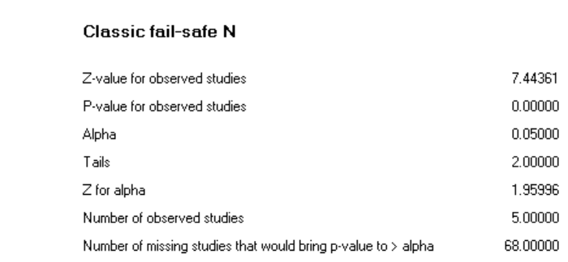
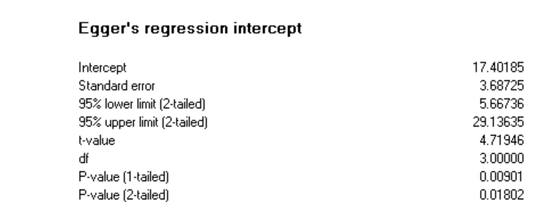

- Discontinuation due to adverse event, monotherapy; all RCTs

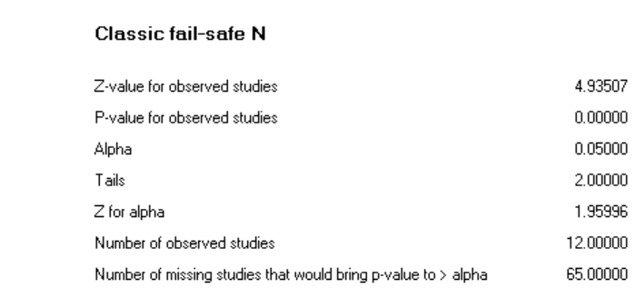
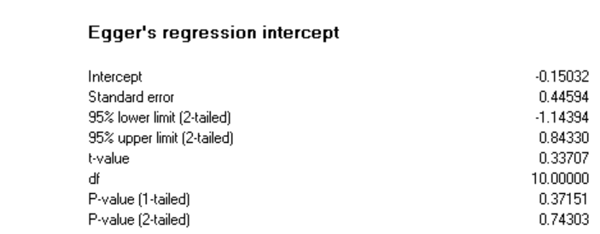

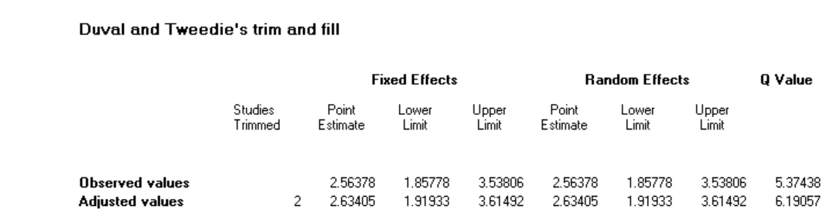

- Discontinuation due to adverse event, monotherapy; RCTs of QUE

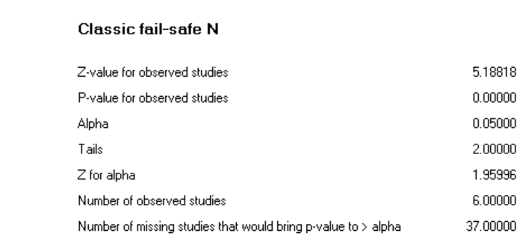
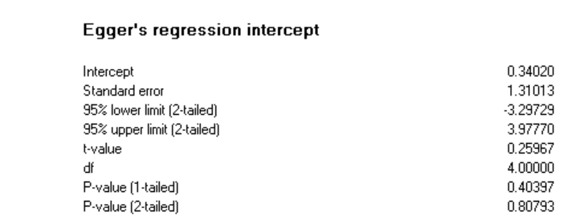

- Treatment response, adjunctive therapy; all RCTs

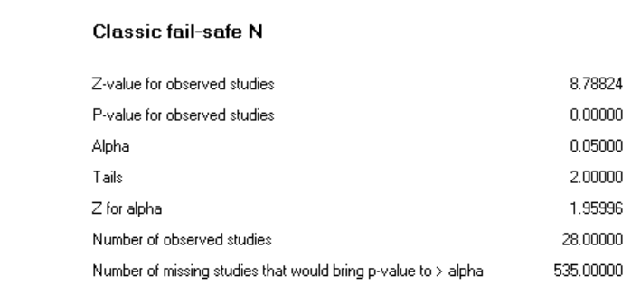
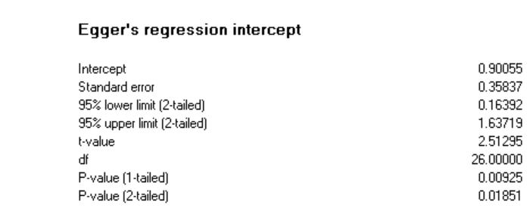
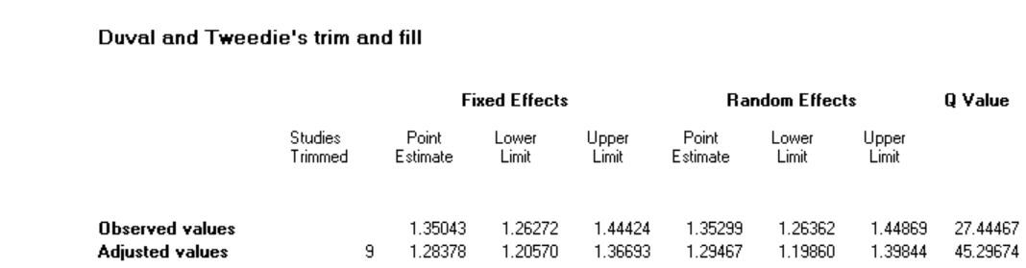

- Treatment response, adjunctive therapy; RCTs of ARI

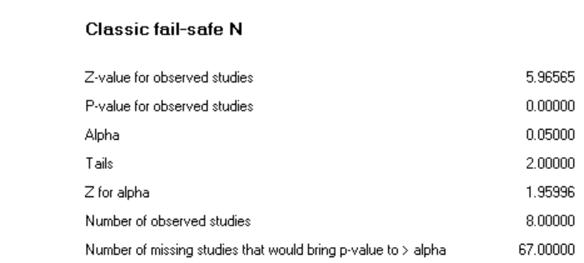
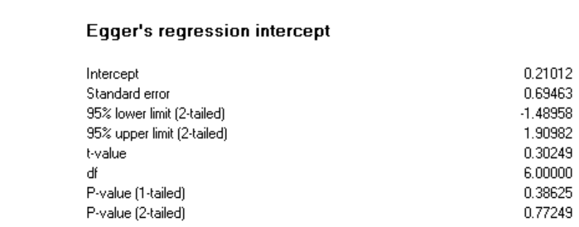
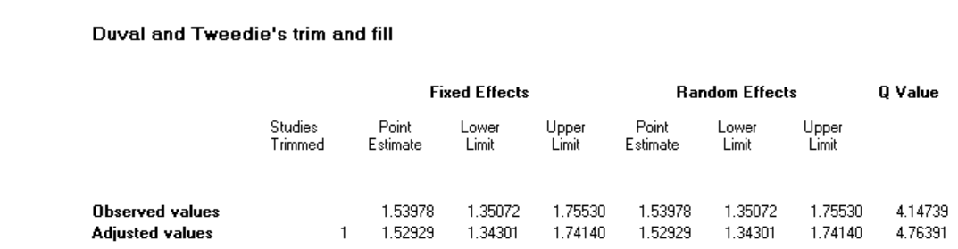

- Treatment response, adjunctive therapy; RCTs of BRE

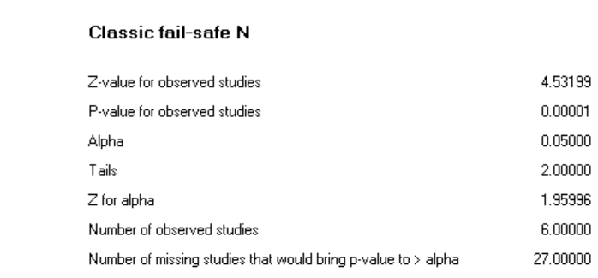
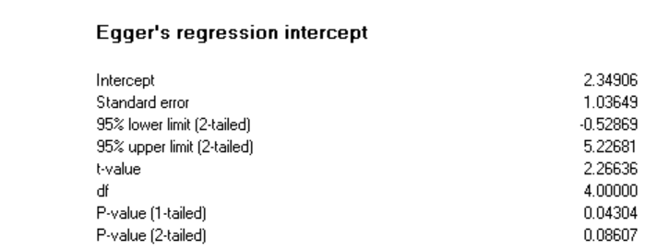
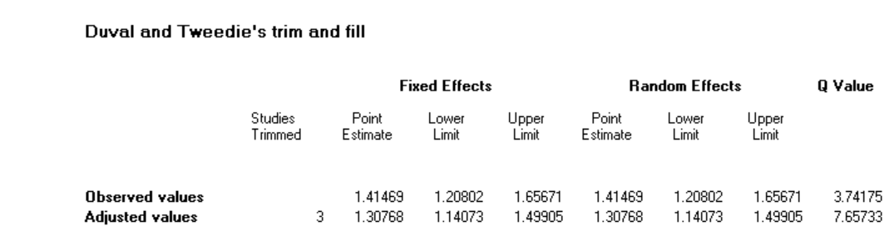

- Treatment response, adjunctive therapy; RCTs of QUE

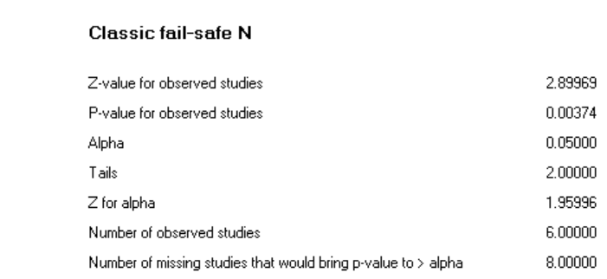
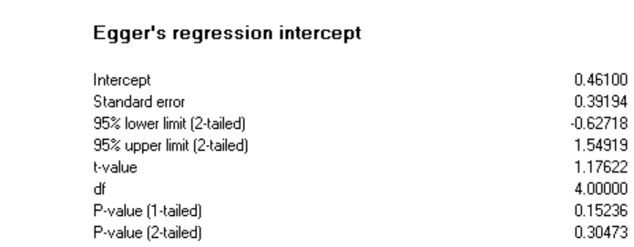

- Discontinuation due to adverse event, adjunctive therapy; all RCTs

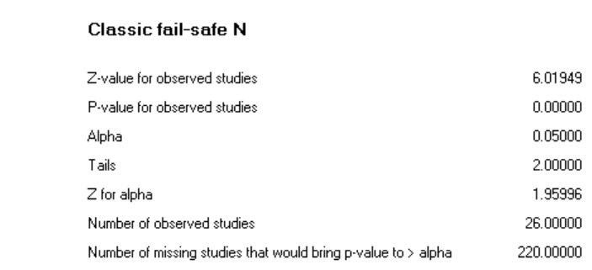
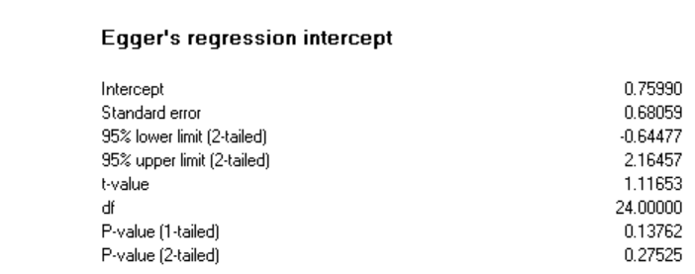
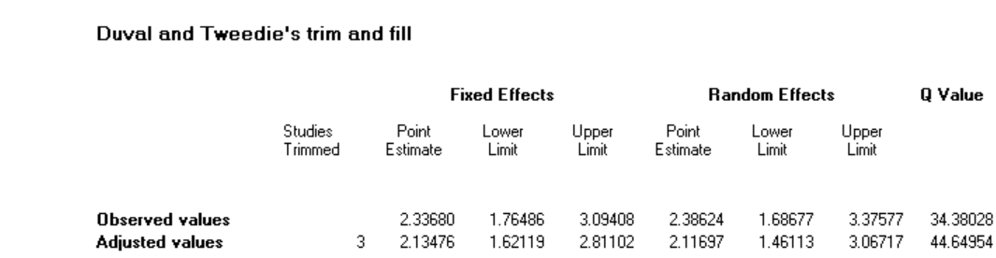

- Discontinuation due to adverse event, adjunctive therapy; RCTs of ARI

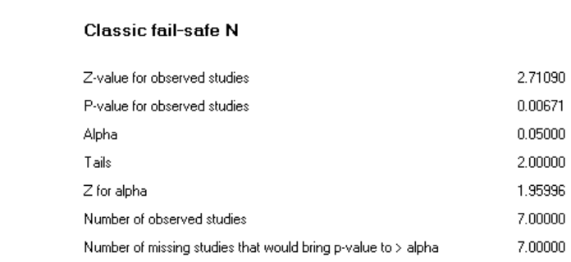
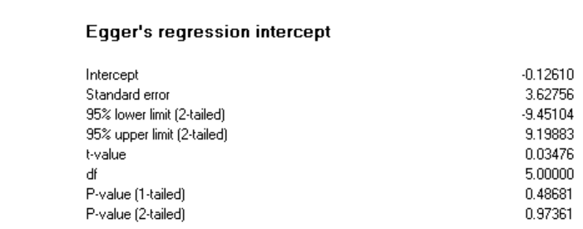

- Discontinuation due to adverse event, adjunctive therapy; RCTs of BRE

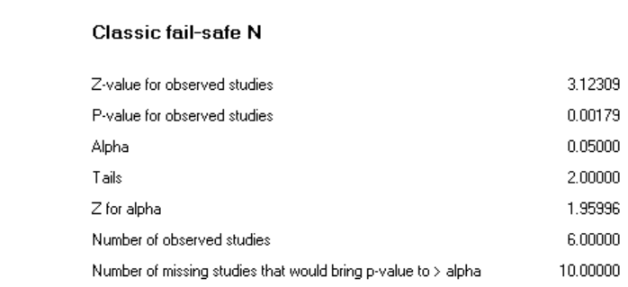
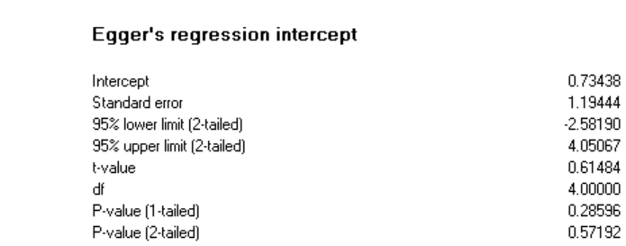
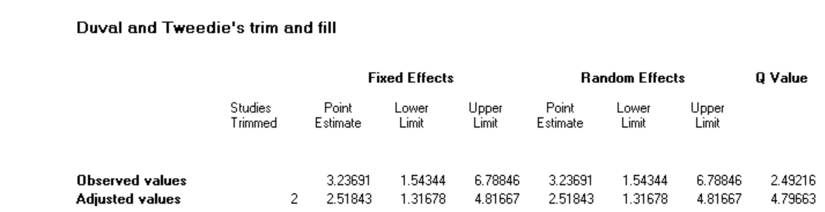

- Discontinuation due to adverse event, adjunctive therapy; RCTs of QUE

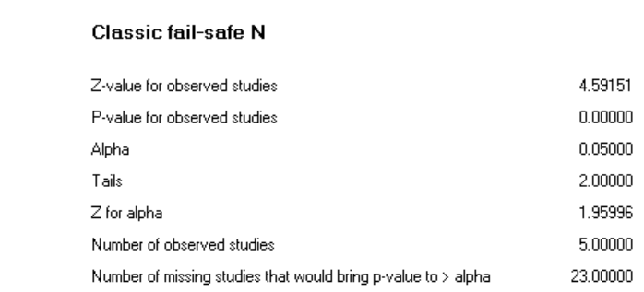
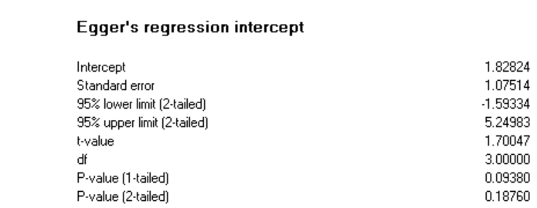

References

1. Bortnick B, El-Khalili N, Banov M, Adson D, Datto C, Raines S, et al. Efficacy and tolerability of extended release quetiapine fumarate (quetiapine XR) monotherapy in major depressive disorder: a placebo-controlled, randomized study. Journal of affective disorders. 2011;128(1-2):83-94.
2. Boyer P, Lecrubier Y, Stalla-Bourdillon A, Fleurot O. Amisulpride versus amineptine and placebo for the treatment of dysthymia. Neuropsychobiology. 1999;39(1):25-32.
3. Chaput Y, Magnan A, Gendron A. The co-administration of quetiapine or placebo to cognitive-behavior therapy in treatment refractory depression: a preliminary trial. BMC psychiatry. 2008;8:73.
4. Cutler AJ, Montgomery SA, Feifel D, Lazarus A, Astrom M, Brecher M. Extended release quetiapine fumarate monotherapy in major depressive disorder: a placebo- and duloxetine-controlled study. The Journal of clinical psychiatry. 2009;70(4):526-39.
5. Frolund F. Treatment of depression in general parctice: a controlled trial of flupenthixol ('Fluanxol'). Current medical research and opinion. 1974;2(2):78-89.
6. Katila H, Mezhebovsky I, Mulroy A, Berggren L, Eriksson H, Earley W, et al. Randomized, double-blind study of the efficacy and tolerability of extended release quetiapine fumarate (quetiapine XR) monotherapy in elderly patients with major depressive disorder. The American journal of geriatric psychiatry : official journal of the American Association for Geriatric Psychiatry. 2013;21(8):769-84.
7. Kennedy SH, Giacobbe P, Placenza F, Hudson CJ, Seeman P, Seeman MV. Depression treatment by withdrawal of short-term low-dose antipsychotic, a proof-of-concept randomized double-blind study. Journal of affective disorders. 2014;166:139-43.
8. Lecrubier Y, Boyer P, Turjanski S, Rein W. Amisulpride versus imipramine and placebo in dysthymia and major depression. Amisulpride Study Group. Journal of affective disorders. 1997;43(2):95-103.
9. Liebowitz M, Lam RW, Lepola U, Datto C, Sweitzer D, Eriksson H. Efficacy and tolerability of extended release quetiapine fumarate monotherapy as maintenance treatment of major depressive disorder: a randomized, placebo-controlled trial. Depression and anxiety. 2010;27(10):964-76.
10. Papakostas GI, Vitolo OV, Ishak WW, Rapaport MH, Zajecka JM, Kinrys G, et al. A 12-week, randomized, double-blind, placebo-controlled, sequential parallel comparison trial of ziprasidone as monotherapy for major depressive disorder. The Journal of clinical psychiatry. 2012;73(12):1541-7.
11. Ruther E, Degner D, Munzel U, Brunner E, Lenhard G, Biehl J, et al. Antidepressant action of sulpiride. Results of a placebo-controlled double-blind trial. Pharmacopsychiatry. 1999;32(4):127-35.
12. Wang G, McIntyre A, Earley WR, Raines SR, Eriksson H. A randomized, double-blind study of the efficacy and tolerability of extended-release quetiapine fumarate (quetiapine XR) monotherapy in patients with major depressive disorder. Neuropsychiatric disease and treatment. 2014;10:201-16.
13. Weisler R, Joyce M, McGill L, Lazarus A, Szamosi J, Eriksson H. Extended release quetiapine fumarate monotherapy for major depressive disorder: results of a double-blind, randomized, placebo-controlled study. CNS spectrums. 2009;14(6):299-313.
14. Bauer M, Pretorius HW, Constant EL, Earley WR, Szamosi J, Brecher M. Extended-release quetiapine as adjunct to an antidepressant in patients with major depressive disorder: results of a randomized, placebo-controlled, double-blind study. The Journal of clinical psychiatry. 2009;70(4):540-9.
15. Berman RM, Marcus RN, Swanink R, McQuade RD, Carson WH, Corey-Lisle PK, et al. The efficacy and safety of aripiprazole as adjunctive therapy in major depressive disorder: a multicenter, randomized, double-blind, placebo-controlled study. The Journal of clinical psychiatry. 2007;68(6):843-53.
16. Berman RM, Fava M, Thase ME, Trivedi MH, Swanink R, McQuade RD, et al. Aripiprazole augmentation in major depressive disorder: a double-blind, placebo-controlled study in patients with inadequate response to antidepressants. CNS spectrums. 2009;14(4):197-206.
17. Dunner DL, Amsterdam JD, Shelton RC, Loebel A, Romano SJ. Efficacy and tolerability of adjunctive ziprasidone in treatment-resistant depression: a randomized, open-label, pilot study. The Journal of clinical psychiatry. 2007;68(7):1071-7.
18. Durgam S, Earley W, Guo H, Li D, Nemeth G, Laszlovszky I, et al. Efficacy and safety of adjunctive cariprazine in inadequate responders to antidepressants: a randomized, double-blind, placebo-controlled study in adult patients with major depressive disorder. The Journal of clinical psychiatry. 2016;77(3):371-8.
19. El-Khalili N, Joyce M, Atkinson S, Buynak RJ, Datto C, Lindgren P, et al. Extended-release quetiapine fumarate (quetiapine XR) as adjunctive therapy in major depressive disorder (MDD) in patients with an inadequate response to ongoing antidepressant treatment: a multicentre, randomized, double-blind, placebo-controlled study. The international journal of neuropsychopharmacology. 2010;13(7):917-32.
20. Fava M, Mischoulon D, Iosifescu D, Witte J, Pencina M, Flynn M, et al. A double-blind, placebo-controlled study of aripiprazole adjunctive to antidepressant therapy among depressed outpatients with inadequate response to prior antidepressant therapy (ADAPT-A Study). Psychotherapy and psychosomatics. 2012;81(2):87-97.
21. Flint AJ, Meyers BS, Rothschild AJ, Whyte EM, Alexopoulos GS, Rudorfer MV, et al. Effect of Continuing Olanzapine vs Placebo on Relapse Among Patients With Psychotic Depression in Remission: The STOP-PD II Randomized Clinical Trial. Jama. 2019;322(7):622-31.
22. Garakani A, Martinez JM, Marcus S, Weaver J, Rickels K, Fava M, et al. A randomized, double-blind, and placebo-controlled trial of quetiapine augmentation of fluoxetine in major depressive disorder. International clinical psychopharmacology. 2008;23(5):269-75.
23. Hobart M, Skuban A, Zhang P, Augustine C, Brewer C, Hefting N, et al. A Randomized, Placebo-Controlled Study of the Efficacy and Safety of Fixed-Dose Brexpiprazole 2 mg/d as Adjunctive Treatment of Adults With Major Depressive Disorder. The Journal of clinical psychiatry. 2018;79(4).
24. Hobart M, Skuban A, Zhang P, Josiassen MK, Hefting N, Augustine C, et al. Efficacy and safety of flexibly dosed brexpiprazole for the adjunctive treatment of major depressive disorder: a randomized, active-referenced, placebo-controlled study. Current medical research and opinion. 2018;34(4):633-42.
25. Ionescu DF, Fava M, Kim DJ, Baer L, Shelton RC, Cusin C. A placebo-controlled crossover study of iloperidone augmentation for residual anger and irritability in major depressive disorder. Therapeutic advances in psychopharmacology. 2016;6(1):4-12.
26. Kamijima K, Higuchi T, Ishigooka J, Ohmori T, Ozaki N, Kanba S, et al. Aripiprazole augmentation to antidepressant therapy in Japanese patients with major depressive disorder: a randomized, double-blind, placebo-controlled study (ADMIRE study). Journal of affective disorders. 2013;151(3):899-905.
27. Kamijima K, Kimura M, Kuwahara K, Kitayama Y, Tadori Y. Randomized, double-blind comparison of aripiprazole/sertraline combination and placebo/sertraline combination in patients with major depressive disorder. Psychiatry and clinical neurosciences. 2018;72(8):591-601.
28. Keitner GI, Garlow SJ, Ryan CE, Ninan PT, Solomon DA, Nemeroff CB, et al. A randomized, placebo-controlled trial of risperidone augmentation for patients with difficult-to-treat unipolar, non-psychotic major depression. Journal of psychiatric research. 2009;43(3):205-14.
29. Lenze EJ, Mulsant BH, Blumberger DM, Karp JF, Newcomer JW, Anderson SJ, et al. Efficacy, safety, and tolerability of augmentation pharmacotherapy with aripiprazole for treatment-resistant depression in late life: a randomised, double-blind, placebo-controlled trial. Lancet (London, England). 2015;386(10011):2404-12.
30. Li R, Wu R, Chen J, Kemp DE, Ren M, Conroy C, et al. A Randomized, Placebo-Controlled Pilot Study of Quetiapine-XR Monotherapy or Adjunctive Therapy to Antidepressant in Acute Major Depressive Disorder with Current Generalized Anxiety Disorder. Psychopharmacology bulletin. 2016;46(1):8-23.
31. Lin CH, Lin SH, Jang FL. Adjunctive low-dose aripiprazole with standard-dose sertraline in treating fresh major depressive disorder: a randomized, double-blind, controlled study. Journal of clinical psychopharmacology. 2011;31(5):563-8.
32. Mahmoud RA, Pandina GJ, Turkoz I, Kosik-Gonzalez C, Canuso CM, Kujawa MJ, et al. Risperidone for treatment-refractory major depressive disorder: a randomized trial. Annals of internal medicine. 2007;147(9):593-602.
33. Marcus RN, McQuade RD, Carson WH, Hennicken D, Fava M, Simon JS, et al. The efficacy and safety of aripiprazole as adjunctive therapy in major depressive disorder: a second multicenter, randomized, double-blind, placebo-controlled study. Journal of clinical psychopharmacology. 2008;28(2):156-65.
34. McIntyre A, Gendron A, McIntyre A. Quetiapine adjunct to selective serotonin reuptake inhibitors or venlafaxine in patients with major depression, comorbid anxiety, and residual depressive symptoms: a randomized, placebo-controlled pilot study. Depression and anxiety. 2007;24(7):487-94.
35. Papakostas GI, Fava M, Baer L, Swee MB, Jaeger A, Bobo WV, et al. Ziprasidone Augmentation of Escitalopram for Major Depressive Disorder: Efficacy Results From a Randomized, Double-Blind, Placebo-Controlled Study. The American journal of psychiatry. 2015;172(12):1251-8.
36. Parker G, Brotchie H, Parker K. Is combination olanzapine and antidepressant medication associated with a more rapid response trajectory than antidepressant alone? The American journal of psychiatry. 2005;162(4):796-8.
37. Quante A, Regen F, Schindler F, Volkmer K, Severus E, Urbanek C, et al. Quetiapine as combination treatment with citalopram in unipolar depression with prominent somatic symptoms: a randomised, double-blind, placebo-controlled pilot study. Psychiatria Danubina. 2013;25(3):214-20.
38. Reeves H, Batra S, May RS, Zhang R, Dahl DC, Li X. Efficacy of risperidone augmentation to antidepressants in the management of suicidality in major depressive disorder: a randomized, double-blind, placebo-controlled pilot study. The Journal of clinical psychiatry. 2008;69(8):1228-36.
39. Sim M, Gordon EB, Nicol CG. Oxypertine in combination with imipramine: a controlled trial. The Journal of international medical research. 1978;6(1):4-10.
40. Stabl M, Kasas A, Blajev B, Bajetta G, Zochling R, Holsboer-Trachsler E, et al. A double-blind comparison of moclobemide and thioridazine versus moclobemide and placebo in the treatment of refractory, severe depression. Journal of clinical psychopharmacology. 1995;15(4 Suppl 2):41s-5s.
41. Thase ME, Youakim JM, Skuban A, Hobart M, Augustine C, Zhang P, et al. Efficacy and safety of adjunctive brexpiprazole 2 mg in major depressive disorder: a phase 3, randomized, placebo-controlled study in patients with inadequate response to antidepressants. The Journal of clinical psychiatry. 2015;76(9):1224-31.
42. Thase ME, Youakim JM, Skuban A, Hobart M, Zhang P, McQuade RD, et al. Adjunctive brexpiprazole 1 and 3 mg for patients with major depressive disorder following inadequate response to antidepressants: a phase 3, randomized, double-blind study. The Journal of clinical psychiatry. 2015;76(9):1232-40.
43. Wade AG, Crawford GM, Nemeroff CB, Schatzberg AF, Schlaepfer T, McConnachie A, et al. Citalopram plus low-dose pipamperone versus citalopram plus placebo in patients with major depressive disorder: an 8-week, double-blind, randomized study on magnitude and timing of clinical response. Psychological medicine. 2011;41(10):2089-97.
44. Study of the Safety and Efficacy of OPC-34712 as Adjunctive Therapy in the Treatment of Patients With Major Depressive Disorder [Available from: https://clinicaltrials.gov/ct2/show/NCT00797966.
45. Study of the Safety and Efficacy of OPC-34712 as Adjunctive Therapy in the Treatment of Adults With Major Depressive Disorder (STEP-D222) [Available from: https://clinicaltrials.gov/ct2/show/NCT01052077.

