Additional file 8. Forest plots for meta-analysis and post-hoc sensitivity analysis concerning cervicogenic headache versus migraine comparison. Studies were excluded from post-hoc sensitivity analysis due to moderate/high risk of bias (Quality Index <75%)

- Cervical ROM.
A.1. Meta-analysis and pos-hoc sensitivity analysis
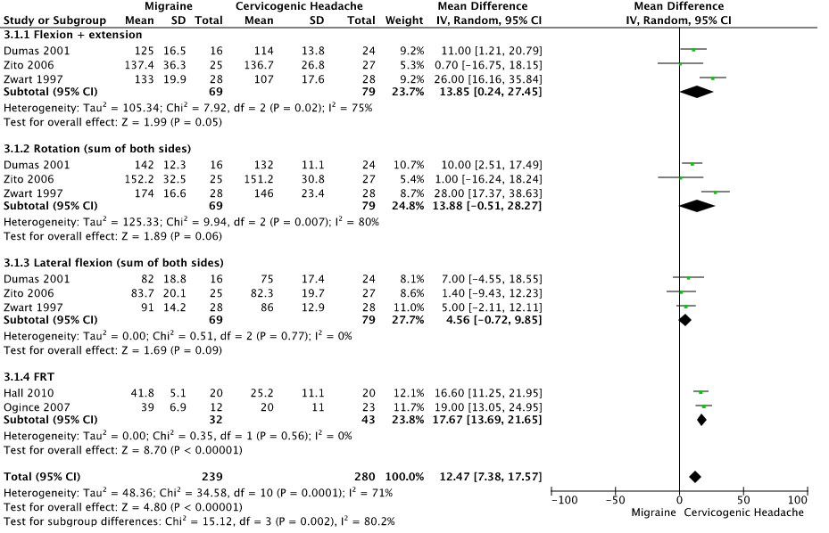

A.2. Pos-hoc sensitivity analysis
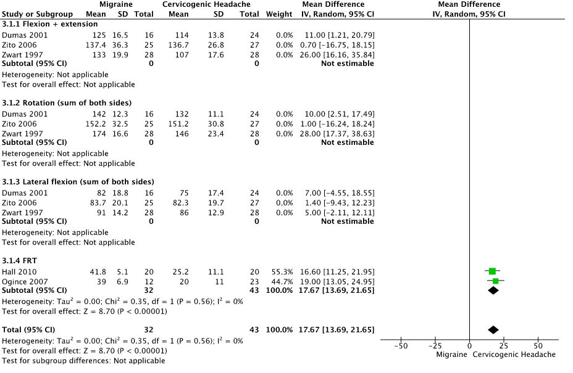

- Neck strength.

B.1. Meta-analysis


