Additional file 9. Forest plots for meta-analysis and post-hoc sensitivity analysis concerning migraine and asymptomatic individuals comparison. Studies were excluded from post-hoc sensitivity analysis due to moderate/high risk of bias (Quality Index <75%)

- Cervical ROM
A.1. Meta-analysis
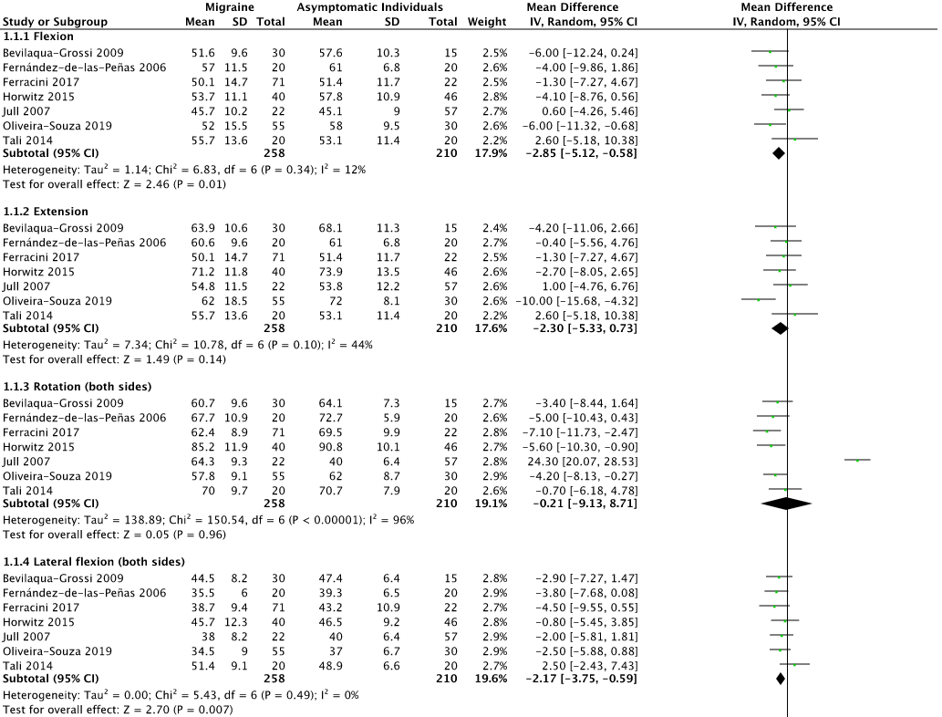
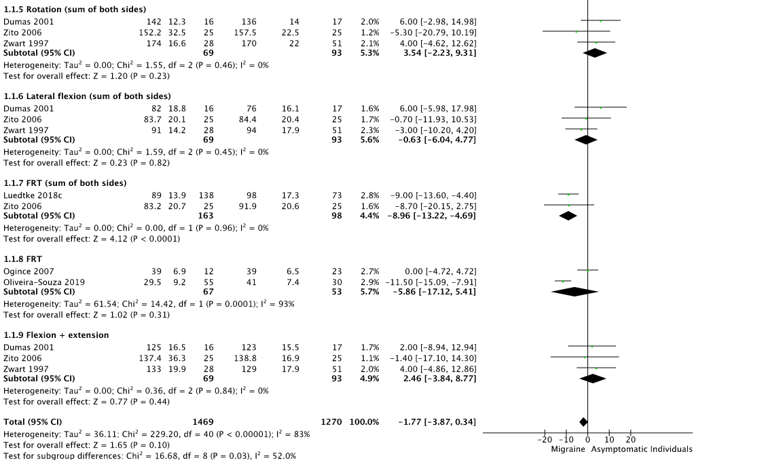

A.2. Pos-hoc sensitivity analysis
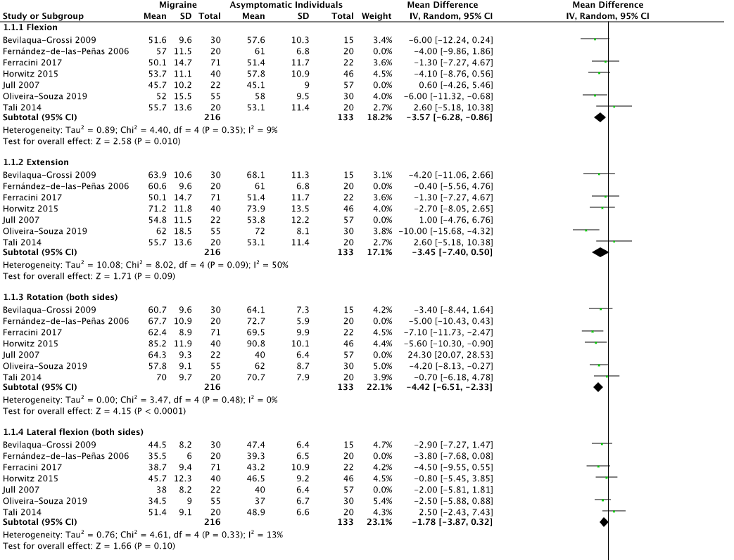
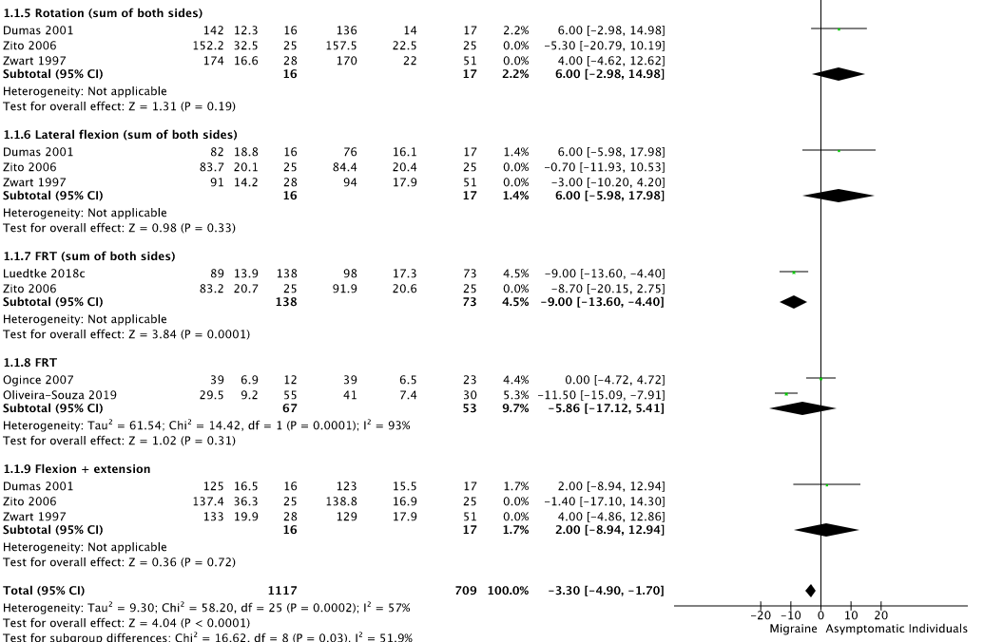

- Posture CLA.
B.1. Meta-analysis and post-hoc sensitivity analysis
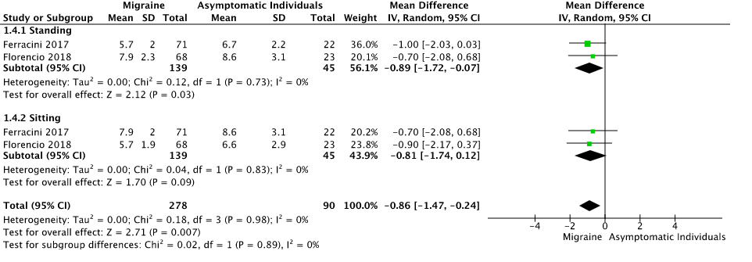

- Pressure Pain Threshold
C.1. Meta-analysis
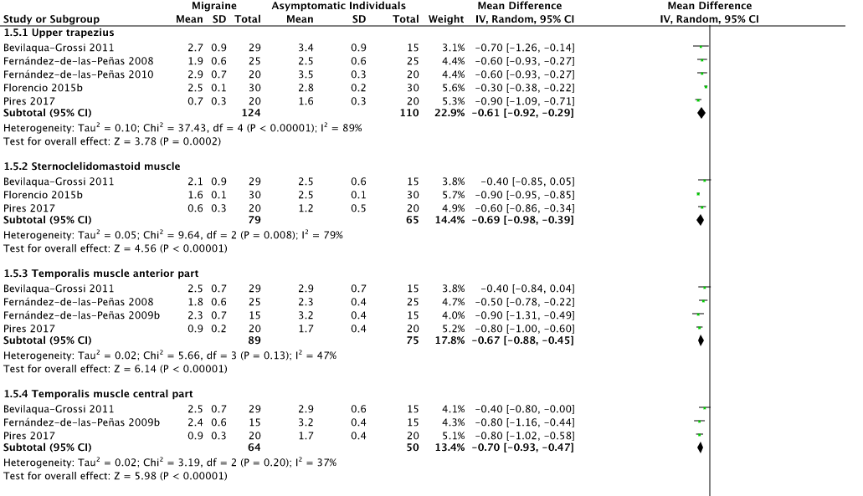
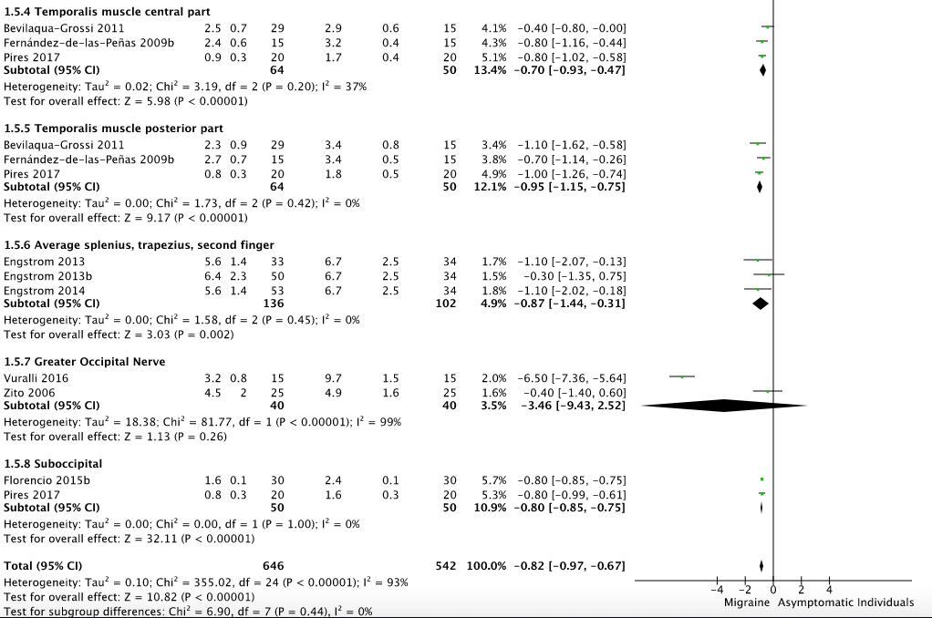

C.2. Post-hoc sensitivity analysis
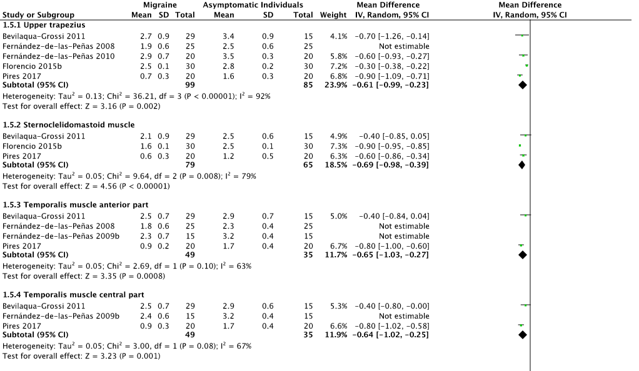
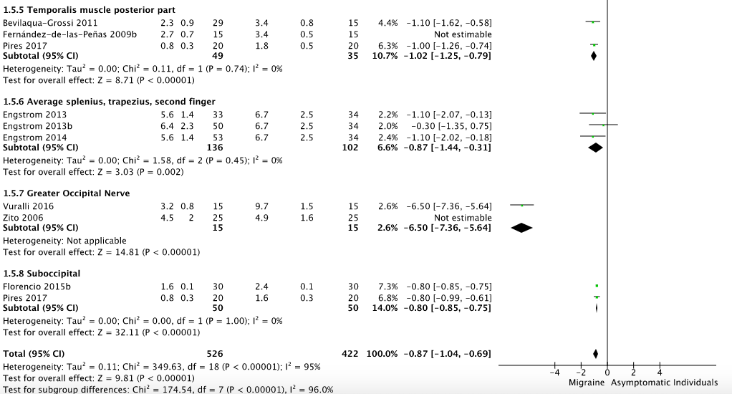

- Strength
D.1. Meta-analysis
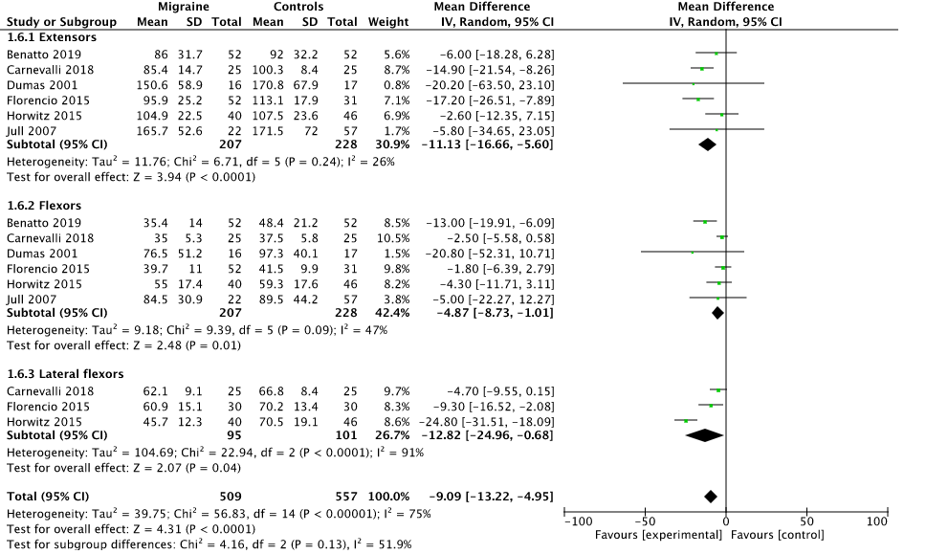

D.2. Post-hoc sensitivity analysis
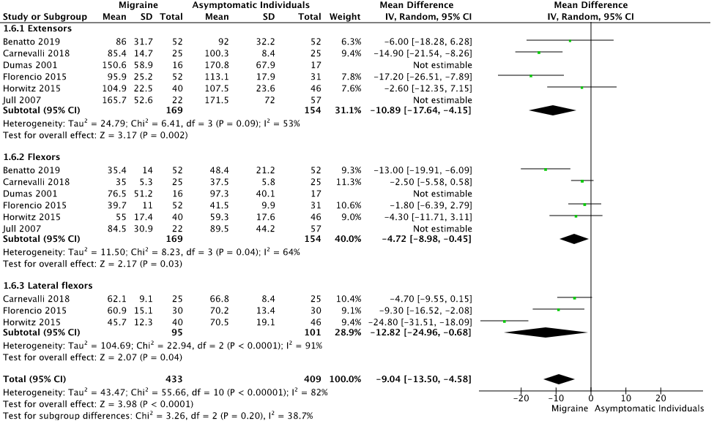

- CCFT performance at 22 mmHg Rheacer
E.1. Meta-analysis and post-hoc sensivity analysis
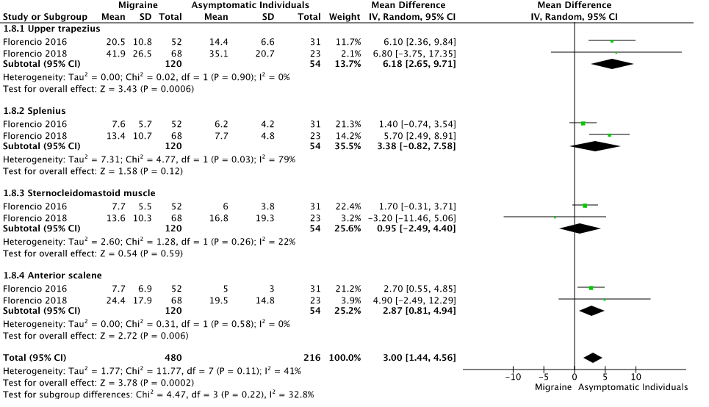

- CCFT performance at 30 mmHg
F.1. Meta-analysis and post-hoc sensitivity analysis


