Search Strategies
Searches were run in December 2019 and rerun in February 2021

Database: Ovid MEDLINE(R) ALL <1946 to December 02, 2019>
Search Strategy:
--------------------------------------------------------------------------------
1 exp Clinical Trials, Phase I as Topic/ (5199)
2 phase 1 clinical trial*.tw. (813)
3 Clinical trial, phase 1.pt. (0)
4 ((investigation or experimental) adj (therap* or trial*)).tw. (6075)
5 phase 1 study*.tw. (1343)
6 ((early phase or phase 1 or phase one) adj (trial or study or research or analysis)).tw. (2218)
7 ((early phase or phase 1 or phase one) adj (investigation* or experiment*)).tw. (34)
8 or/1-7 (14072)
9 exp Neoplasms/ (3242801)
10 cancer.tw. (1607605)
11 (carcin* or neoplas* or tumour* or tumor* or growth* or malig* or leukaemia* or lymphoma* or leukemia* or adenocarcin* or lesion* or oncolog*).tw. (4285190)
12 or/9-11 (5701081)
13 8 and 12 (6473)
14 (view* or viewpoint* or attitude* or experience* or opinion* or expression* or thought* or perspective* or understand* or satisfaction* or qualitative* or perceive* or perception*).tw. (5169433)
15 13 and 14 (1754)
16 limit 15 to (english language and humans) (1438)

Database: Ovid MEDLINE(R) <1946 to February Week 1 2021>
Search Strategy:
--------------------------------------------------------------------------------
1 exp Clinical Trials, Phase I as Topic/ (5465)
2 phase 1 clinical trial*.tw. (769)
3 Clinical trial, phase 1.pt. (0)
4 ((investigation or experimental) adj (therap* or trial*)).tw. (5670)
5 phase 1 study*.tw. (1282)
6 ((early phase or phase 1 or phase one) adj (trial or study or research or analysis)).tw. (2107)
7 ((early phase or phase 1 or phase one) adj (investigation* or experiment*)).tw. (36)
8 or/1-7 (13765)
9 exp Neoplasms/ (3413352)
10 cancer.tw. (1491495)
11 (carcin* or neoplas* or tumour* or tumor* or growth* or malig* or leukaemia* or lymphoma* or leukemia* or adenocarcin* or lesion* or oncolog*).tw. (3983328)
12 or/9-11 (5381722)
13 8 and 12 (6441)
14 (view* or viewpoint* or attitude* or experience* or opinion* or expression* or thought* or perspective* or understand* or satisfaction* or qualitative* or perceive* or perception*).tw. (4770602)
15 13 and 14 (1736)
16 limit 15 to (english language and humans) (1572)
17 limit 16 to yr="2019 - 2021" (154)

Database: EMBASE <1947-Present>
Search Strategy:
--------------------------------------------------------------------------------
1 (phase 1 clinical trial* or phase one trial* or phase 1 study*).tw. (6013)
2 ((investigation or experimental) adj (therap* or trial*)).tw. (17813)
3 ((early phase or phase 1 or phase one) adj (trial or study or research or analysis)).tw. (6231)
4 ((early phase or phase 1 or phase one) adj (investigation* or experiment*)).tw. (45)
5 1 or 2 or 3 or 4 (25789)
6 malignant neoplasm/ (41483)
7 (cancer* or carcin* or neoplas* or tumour* or tumor* or growth* or malig* or leukaemia* or lymphoma* or leukemia* or adenocarcin* or oncolog* or lesion*).tw. (6828629)
8 6 or 7 (6833784)
9 (view* or viewpoint* or attitude* or experience* or opinion* or expression* or thought* or perspective* or understand* or satisfaction* or qualitative* or perceive* or perception*).tw. (6833711)
10 5 and 8 and 9 (3881)
11 limit 10 to (english language and humans) (3051)
12 conference.pt. (4402491)
13 11 not 12 (1650)
14 from 13 keep 1-1650 (1650)

Database: Embase <1996 to 2021 February 15>
Search Strategy:
--------------------------------------------------------------------------------
1 (phase 1 clinical trial* or phase one trial* or phase 1 study*).tw. (6767)
2 ((investigation or experimental) adj (therap* or trial*)).tw. (17196)
3 ((early phase or phase 1 or phase one) adj (trial or study or research or analysis)).tw. (7057)
4 ((early phase or phase 1 or phase one) adj (investigation* or experiment*)).tw. (52)
5 1 or 2 or 3 or 4 (26168)
6 malignant neoplasm/ (59230)
7 (cancer* orcarcin* or neoplas* or tumour* or tumor* or growth* or malig* or leukaemia* or lymphoma* or leukemia* or adenocarcin* or oncolog* or lesion*).tw. (4594842)
8 6 or 7 (4624901)
9 (view* or viewpoint* or attitude* or experience* or opinion* or expression* or thought* or perspective* or understand* or satisfaction* or qualitative* or perceive* or perception*).tw. (6523175)
10 5 and 8 and 9 (3643)
11 limit 10 to (english language and humans) (2909)
12 conference.pt. (4549504)
13 11 not 12 (1402)
14 limit 13 to yr="2019 - 2021" (189)

Database: PsycINFO <1806 to November Week 4 2019>
Search Strategy:
--------------------------------------------------------------------------------
1 ((investigation or experimental) adj (therap* or trial*)).tw. (1230)
2 phase 1 study*.tw. (45)
3 ((early phase or phase 1 or phase one) adj (trial or study or research or analysis)).tw. (108)
4 ((early phase or phase 1 or phase one) adj (investigation* or experiment*)).tw. (11)
5 1 or 2 or 3 or 4 (1348)
6 exp Neoplasms/ (50066)
7 cancer.tw. (59512)
8 (carcin* or neoplas* or tumour* or tumor* or growth* or malig* or leukaemia* or lymphoma* or leukemia* or adenocarcin* or lesion* or oncolog*).tw. (182446)
9 6 or 7 or 8 (227719)
10 (view* or viewpoint* or attitude* or experience* or opinion* or expression* or thought* or perspective* or understand* or satisfaction* or qualitative* or perceive* or perception*).tw. (2022475)
11 5 and 9 and 10 (67)
12 limit 11 to english language (65)

Database: APA PsycInfo <2002 to February Week 2 2021>
Search Strategy:
--------------------------------------------------------------------------------
1 (phase 1 clinical trial* or phase one trial* or phase 1 study*).tw. (84)
2 ((investigation or experimental) adj (therap* or trial*)).tw. (1008)
3 ((early phase or phase 1 or phase one) adj (trial or study or research or analysis)).tw. (113)
4 ((early phase or phase 1 or phase one) adj (investigation* or experiment*)).tw. (10)
5 1 or 2 or 3 or 4 (1159)
6 exp Neoplasms/ (44114)
7 (carcin* or neoplas* or tumour* or tumor* or growth* or malig* or leukaemia* or lymphoma* or leukemia* or adenocarcin* or oncolog* or lesion*).tw. (132973)
8 cancer.tw. (53142)
9 6 or 7 or 8 (171951)
10 (view* or viewpoint* or attitude* or experience* or opinion* or expression* or thought* or perspective* or understand* or satisfaction* or qualitative* or perceive* or perception*).tw. (1480716)
11 5 and 9 and 10 (68)
12 limit 11 to (english language and humans) [Limit not valid in APA PsycInfo; records were retained] (64)
13 limit 12 to yr="2019 - 2021" (3)

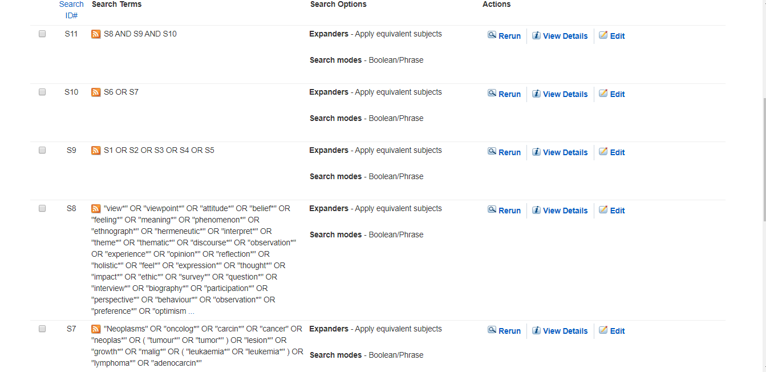
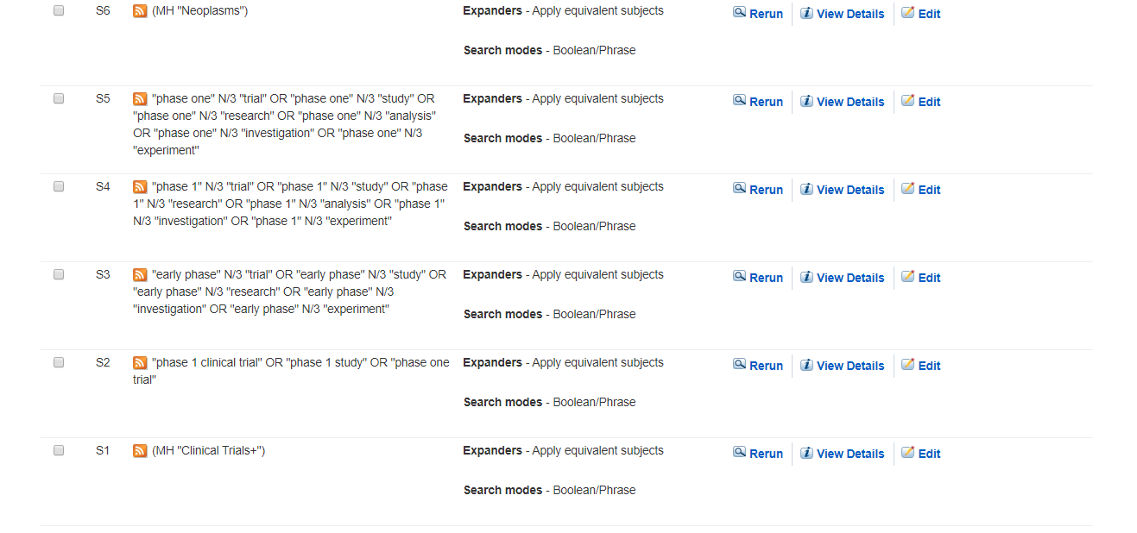
Ebsco CINAHL

Search Name: cochrane trails 10
Date Run: 10/12/2019 11:46:13
Comment:

ID Search Hits
#1 MeSH descriptor: [Clinical Trials, Phase I as Topic] explode all trees 59
#2 (Neoplasms OR oncolog* OR carcin* OR cancer OR neoplas* OR tumour* OR tumor* OR lesion* OR growth* OR malig* OR leukaemia* OR leukemia* OR lymphoma* OR adenocarcin*):ti,ab,kw 279772
#3 (view* or viewpoint* or attitude* or experience* or opinion* or expression* or thought* or perspective* or understand* or satisfaction* or qualitative* or perceive* or perception*) 288026
#4 #1 AND #2 AND #3 10

SCOPUS:
( ( ( TITLE-ABS ( "phase 1 clinical trial" OR "phase one trial" OR "phase 1 study" ) ) OR ( TITLE-ABS ( "early phase" W/1 "trial" OR "study" OR "research" OR "analysis" OR "investigation" OR "experiment" ) ) OR ( TITLE-ABS ( "phase 1" W/1 "trial" OR "study" OR "research" OR "analysis" OR "investigation" OR "experiment" ) ) OR ( TITLE-ABS ( "phase one" W/1 "trial" OR "study" OR "research" OR "analysis" OR "investigation" OR "experiment" ) ) ) AND ( TITLE-ABS ( "Neoplasms" OR "cancer" OR "carcin*" OR "neoplas*" OR "tumour*" OR "tumor*" OR "growth*" OR "malig*" OR "leukaemia*" OR "lymphoma*" OR "leukemia*" OR "adenocarcin*" OR "lesion*" OR "oncolog*" ) ) ) AND ( ( TITLE-ABS ( "theme*" OR "thematic*" OR "discourse*" OR "observation*" OR "experience*" OR "opinion*" OR "reflection*" OR "holistic*" ) ) OR ( TITLE-ABS-KEY ( "view*" OR "viewpoint*" OR "focus group*" OR "attitude*" OR "belief*" OR "feeling*" OR "meaning*" OR "phenomenon*" OR "ethnograph*" OR "hermeneutic*" OR "interpret*" ) ) OR ( TITLE-ABS ( "feel*" OR "expression*" OR "thought*" OR "impact*" OR "ethic*" OR "survey*" OR "question*" OR "interview*" OR "biography*" ) ) OR ( TITLE-ABS ( "participation*" OR "perspective*" OR "behaviour*" OR "observation*" OR "preference*" OR "optimism*" OR "pessimism*" OR "understanding*" OR "communication*" OR "satisfaction*" ) ) OR ( TITLE-ABS ( "psychology*" OR "attitude*" OR "recount*" OR "understanding*" OR "narrative*" OR "qualitative*" OR "perceive*" OR "perception*" OR "questionnaire*" OR "focus group*" ) ) ) AND ( LIMIT-TO ( LANGUAGE , "English" ) ) AND ( LIMIT-TO ( DOCTYPE , "ar" ) ) AND ( LIMIT-TO ( SUBJAREA , "MEDI" ) ) 707

