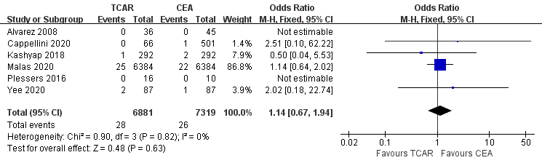
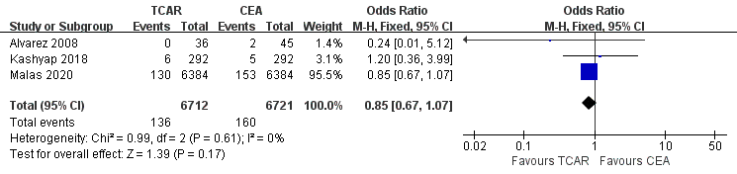
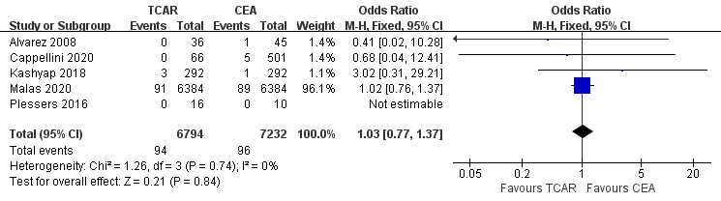
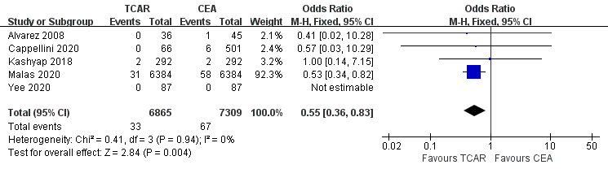
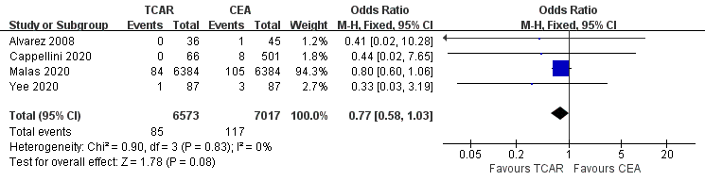
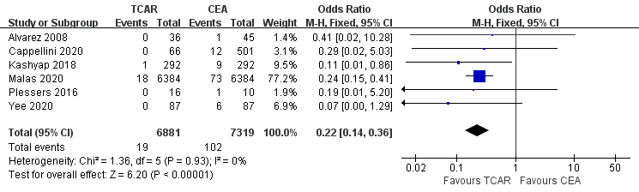

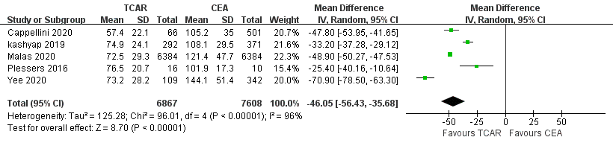

Supplemental Figure 1. Comparative efficacy between the two approaches on carotid stenosis. Forest plots of perioperative outcomes containing (A) stroke/death/MI, (B) death, (C) stroke, (D) MI, (E) hemorrhage, (F) CNI and (G) procedure time for patients with carotid stenosis treated by TCAR versus CEA among overall cohort.
MI: myocardial infarction, CNI: cranial nerve injury, CI: confidence interval
M-H: Mantel-Haenszel, IV: Inverse Variance.
TCAR: transcarotid artery revascularization, CEA: carotid endarterectomy

