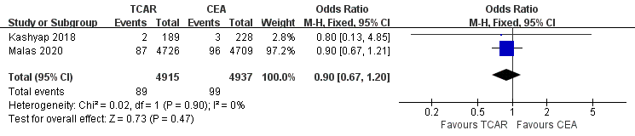
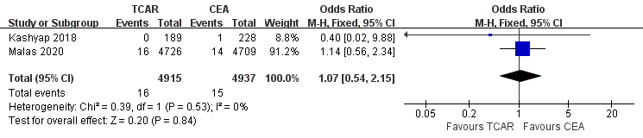
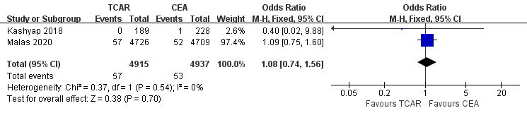
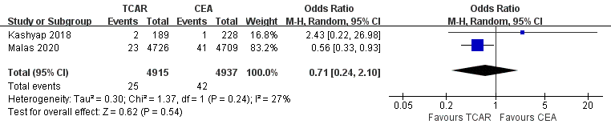
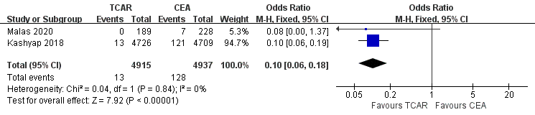

Supplemental figure 3. Comparative efficacy between the two approaches on carotid stenosis within asymptomatic cohort. Forest plots of perioperative outcomes containing (A) stroke/death/MI, (B) death, (C) stroke, (D) MI, (E) CNI for patients with carotid stenosis treated by transcarotid artery revascularization (TCAR) versus carotid endarterectomy (CEA) among asymptomatic cohort.
MI: myocardial infarction, CNI: cranial nerve injury, CI: confidence interval
M-H: Mantel-Haenszel.

