Appendix 1 Searching strategy

Databases: PubMed, Scopus, Medline (Proquest), Embase and Cochrane Central Register of Controlled Trials [CENTRAL]
SCI related
- Spinal cord injury
- SCI
- Spinal cord ischemia
- Spinal cord vascular diseases
- Spinal cord neoplasm
- Spinal cord disease
- Spinal cord compression
- Spinal cord laceration
- Myelopathy
- Spinal tumor
- Spinal damage
- Spinal trauma
- Spinal fracture
Cycling related
- Cycling
- Passive movement
- Movement Therapy
- Continuous Passive
Spasticity related
- Spasticity
- Hypertone
- Spasm
- Clonus
- 1 or 2 or 3 or 4 or 5 or 6 or 7 or 8 or 9 or 10 or 11 or 12 or 13
- 14 or 15 or 16 or 17
- 18 or 19 or 20 or 21
- 22 or 23 or 24 or 25
- 22 and 23 and 24 and 25

Appendix 2 Funnel plot of MAS standard error by difference in means and Egger’s test.

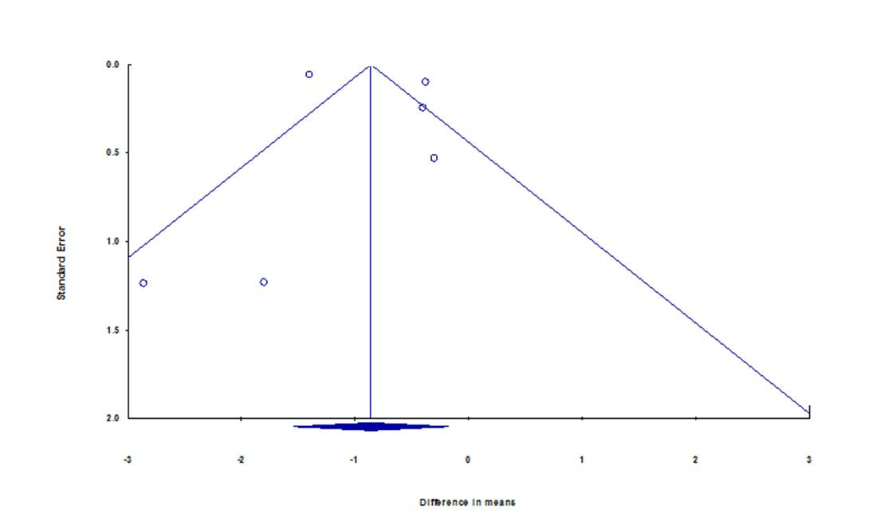

Egger’s regression intercept

Intercept | 1.47997
Standard error | 2.60956
95% lower limit (2-tailed) | -5.76533
95% upper limit (2-tailed) | 8.72526
t-value | 0.56713
df | 4.00000
P-value (2-tailed) | 0.60094

Appendix 3 Forest plot of subgroup analysis for spasticity. Subgroups were complete (ASIA A) and incomplete (ASIA B, C, D) two groups.



