Appendix
Table S1. Search strategy

EMBAS via Ovid
- 'sacubitril plus valsartan'/exp
- Entresto
- 'lcz 696'
- 'sacubitril valsartan'
- neprilysin AND inhibito*
- 'enkephalinase inhibitor'/exp
- Omapatrilat
- or/1-7
- 'randomized controlled trial'/exp
- 'randomized controlled trial'
- 'clinical trial'/exp
- 'double blind procedure'/exp
- 'single blind procedure'/exp
- 'random allocation'
- random$: ab, ti OR placebo$:ab, ti
- or/9-15
- 'heart failure'/exp
- heart* NEAR/2 decomp*
- (heart* OR cardiac* OR myocard*) NEAR/2 (fail* OR insuff*)
- or/17-19
- 8 AND 16 AND 20

MEDLINE via Ovid
- Entresto.mp.
- LCZ 696.mp.
- sacubitril valsartan.mp.
- neprilysin inhibito*.mp.
- omapatrilat.mp.
- or/1-5
- exp Heart Failure/
- ((heart* or cardiac* or myocard*) adj2 (fail* or insuff*)).tw.
- (heart* adj2 decomp*).tw.
- or/7-9
- exp Controlled Clinical Trial/
- exp Randomized Controlled Trials as Topic/
- exp Random Allocation/
- exp Double-Blind Method/
- exp Single-Blind Method/
- Clinical Trial.tw.
- Placebo.tw.
- (clinic$3 adj trial$2). ab, ti.
- (clin$ adj25 trial$).mp.
- or/11-19
- 6 and 10 and 20

Cochrane library
- entresto
- lcz 696
3 neprilysin inhibit*
4 sacubitril valsartan
5 or/1-4
6 MeSH descriptor: [Heart Failure] explode all trees
7 (heart* or cardiac* or myocard*) near2 (fail* or insuff*)
8 heart* near2 decomp*
9 or/6-8
10 5 and 9

Table S2. The definitions of worsening renal function (WRF) in each trial
Trial | The definitions of worsening renal function
2012 PARAMOUNT | An serum creatinine increase of >0.3mg/dL and/or >25% between two time-points
2014 PARADIGM | Reaching end-stage renal disease or a decrease in the eGFR of at least 50% or a decrease of more than 30 ml/min/1.73 m² from randomization to less than 60 ml/min/1.73 m²
2018 UK HARP-III | Decline of ≥25% in eGFR
2018 PIONEER | An increase in the serum creatinine concentration of ≥0.5 mg/dL [≥44 μmol/L] and a decrease in the eGFR of ≥25%
2019 EVALUATE | Decrease in eGFR of ≥35% or increase in serum creatinine of ≥ 0.5 mg/dL from baseline and decrease in eGFR of ≥25% from baseline.
2019 PARAGON | Decrease in the eGFR of ≥50%, development of end-stage renal disease, or death due to renal failure
2019 PRIME | Acute renal failure or serum creatinine ≥2.5 mg/dL
2020 PARALLAX | Acute kidney injury or renal failure or renal impairment or renal injury
2021 PARALLEL | Serum creatinine ≥2.0 mg/dL
2021 Post-STEMI | An increase in the serum creatinine concentration of ≥ 0.5 mg/dL [≥ 44 μmol/L] and/or a decrease in the eGFR of ≥ 25%

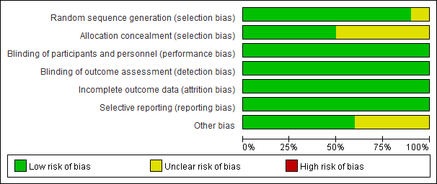
Supplementary Figure 1. Risk of bias graph: review authors' judgements about each risk of bias item presented as percentages across all included studies.

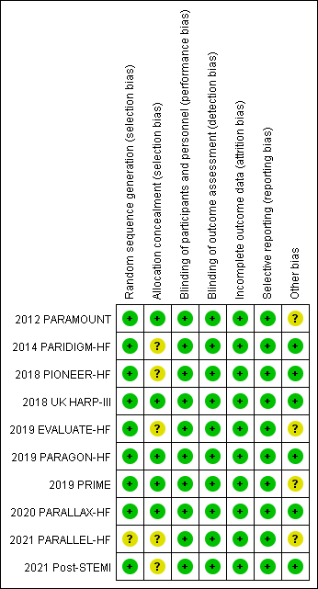
Supplementary Figure 2. Risk of bias summary: review authors' judgements about each risk of bias item for each included study.

