Supporting Information

Table S1. General characteristics of literature screening
characteristics | Details
Inclusion criteria | ① The diagnostic criteria of DN were in accordance with 2007 National Kidney Foundation Kidney of Disease Outcomes Quality Initiative (NKF-K/DOQI)  ② The intervention in the treatment group: TG were used on the basis of the control group; the control group: basic treatment  ③ The research literature reported at least one of the following outcomes: 24h-UTP, blood creatinine, adverse reactions  ④ The research type was randomized controlled trail (RCT)  ⑤ The treatment lasted for 3 or 6 months
Exclusion criteria | ① Patients with no diabetic nephropathy in studies  ② The interventions in the treatment group or control group did not accord with the inclusion criteria  ③ Not reported outcomes mentioned of the inclusion criteria  ④ Non-RCT  ⑤ repetitive study

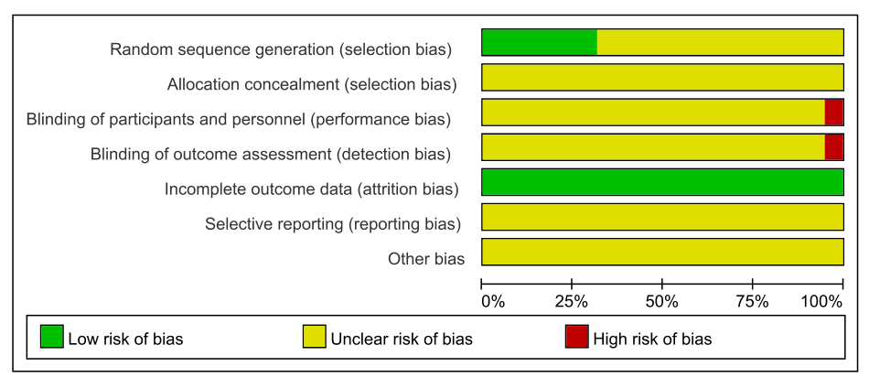

Figure S1. Risk of bias across studies after 3 months.
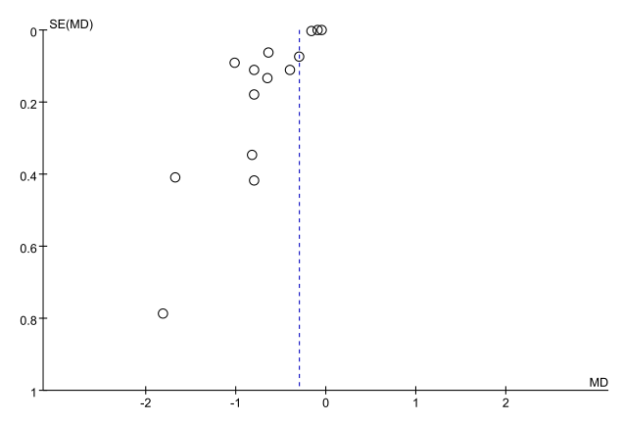

Figure S2. 24h-UTP: funnel plot of 3 months.
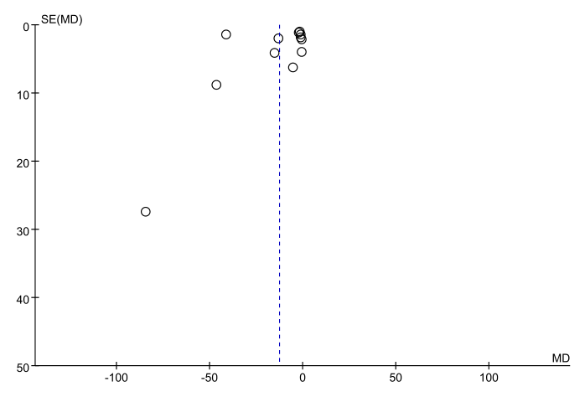

Figure S3. Blood creatinine: funnel plot of 3 months.

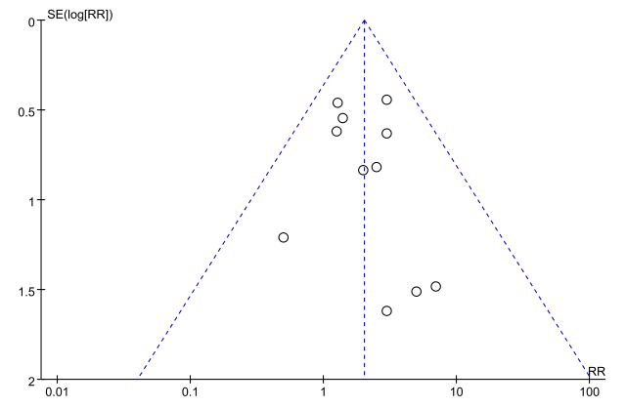

Figure S4. Adverse reaction: funnel plot of 3 months.
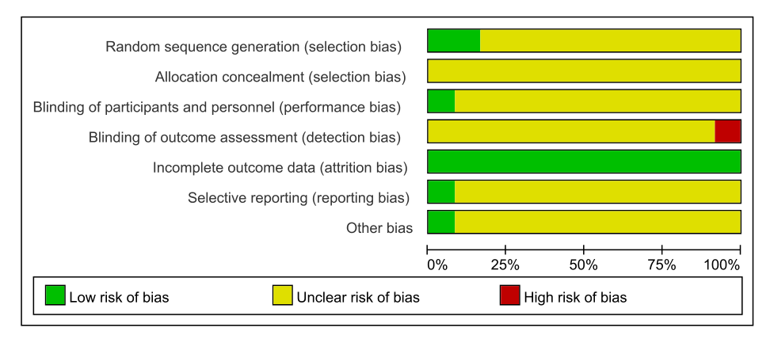

Figure S5. Risk of bias across studies after 6 months.
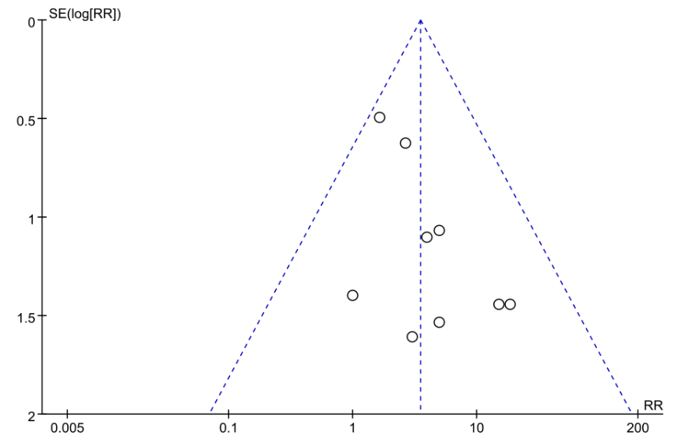

Figure S6. Funnel plot of adverse reaction events after 6 months.

