Supplemental Figure S1. the search strategy of WOS
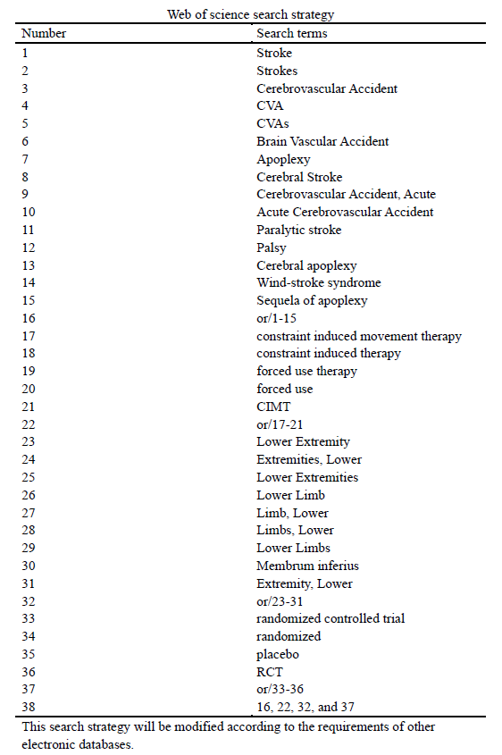

Supplemental Figure S2. Risk of bias in the involved studies, assessed by using the Cochrane Collaboration’s risk of bias tool: high risk of bias (+); unclear risk of bias (?); low risk of bias (-).
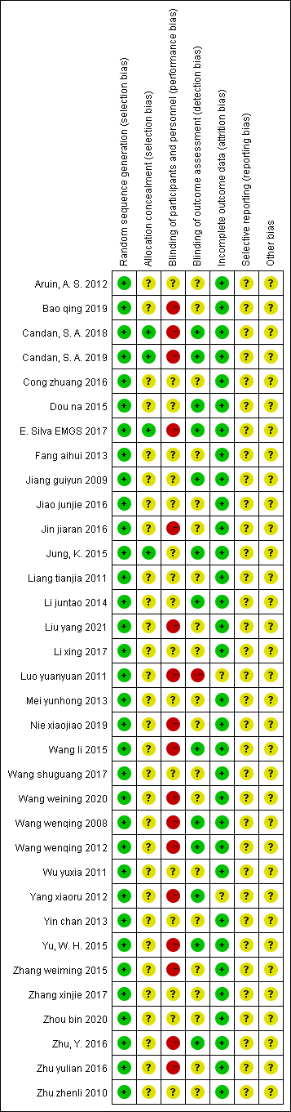
Supplemental Figure S3. Graph of the risk of bias: percentage of all studies included.
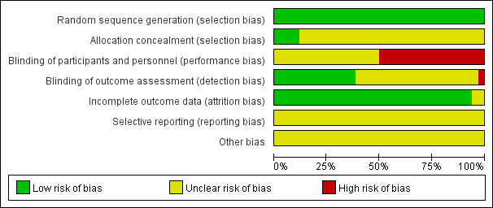

Supplemental Figure S4. Funnel plot. CIMT vs Conventional Physiotherapy on the Berg balance scale.
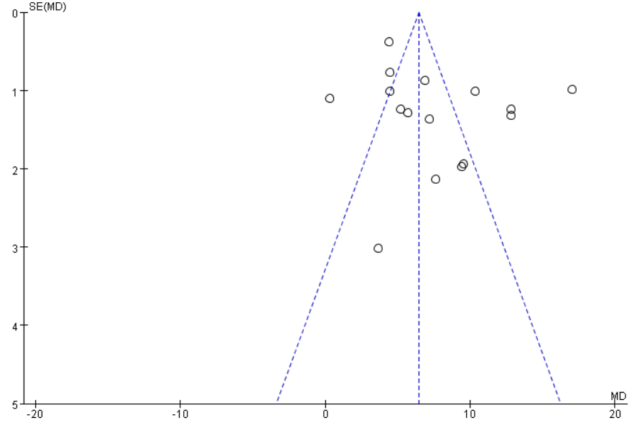

Supplemental Figure S5. Egger’s test. CIMT vs Conventional Physiotherapy on the Berg balance scale.
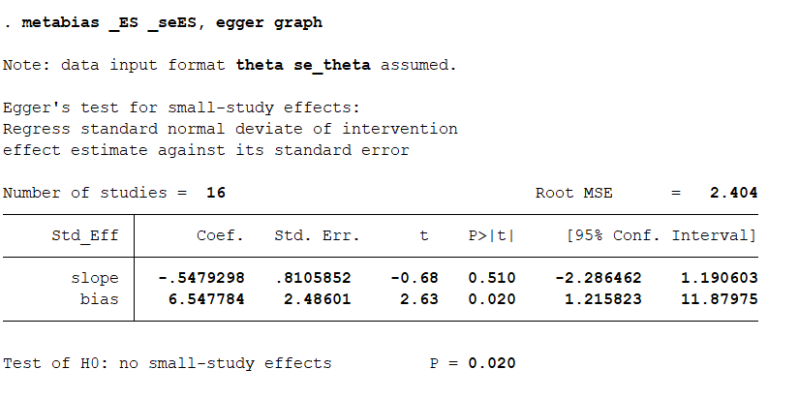

Supplemental Figure S6. Funnel plot. CIMT vs Conventional Physiotherapy on the 10-meter walk test.
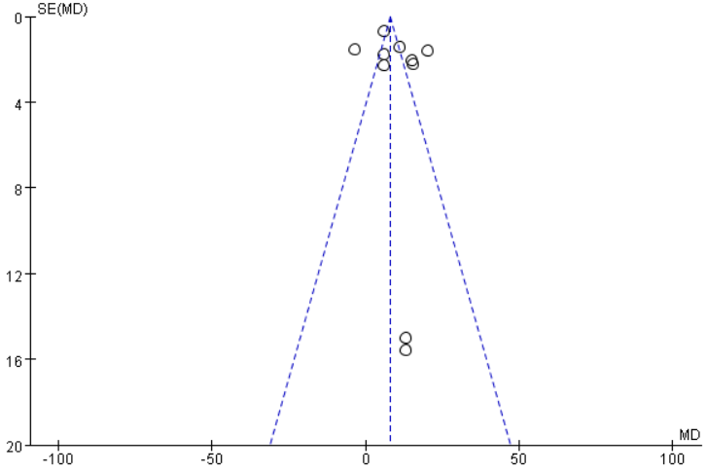

Supplemental Figure S7. Egger’s test. CIMT vs Conventional Physiotherapy on the 10-meter walk test.


