Supplementary material
Supplementary Table 1: Search strategy
Supplementary Table 2: Quality assessment of included randomised-controlled trials using the JBI Critical Appraisal tool
Supplementary Figure 1: Sensitivity analysis of SMD of the effect of TACS on cognition compared to placebo in psychiatric patients using TMT-B scores for Kim 2021 and Haller 2020
Supplementary Figure 2: Sensitivity analysis of SMD of the effect of TACS on cognition compared to placebo in psychiatric patients using Rey Auditory Visual Learning Test delayed recall for Benussi 2021

Supplementary Table 1: Search strategy
Database | Search terms | Results
CENTRAL | (“non-invasive brain stimulation” or “tacs” or “transcranial alternating current stimulation” or “transcranial alternate current stimulation”)  AND  (“memory” or “cogni*” or “depress*” or “anxie*” or “psychi*”)  Search conducted: 20 March 2022 | 32
MedLine via PubMed | (“non-invasive brain stimulation” or “tacs” or “transcranial alternating current stimulation” or “transcranial alternate current stimulation”)  AND  (“memory” or “cogni*” or “depress*” or “anxie*” or “psychi*”)  Search conducted: 20 March 2022 | 1,584
EMBASE | (“non-invasive brain stimulation” OR “tacs” OR “transcranial alternating current stimulation”/exp OR “transcranial alternating current stimulation” OR “transcranial alternate current stimulation”)  AND (“memory”/exp OR “memory” OR “cogni*” OR “depress*” OR “anxie*” OR “psychi*”)  NOT [medline]/lim  Search conducted: 20 March 2022 | 1,428
PsycINFO | (“non-invasive brain stimulation” or “tacs” or “transcranial alternating current stimulation” or “transcranial alternate current stimulation”)  AND  (“memory” or “cognitive” or “cognition” or “depressive” or “depression” or “anxiety” or “psychiatric” or “psychiatry”)  Search conducted: 20 March 2022 | 3,601

Supplementary Table 2: Quality assessment of included randomised-controlled trials using the JBI Critical Appraisal tool
Study | 1 | 2 | 3 | 4 | 5 | 6 | 7 | 8 | 9 | 10 | 11 | 12 | 13 | Overall
Benussi et al. | Y | Y | Y | Y | Y | Y | Y | Y | Y | Y | Y | Y | Y | Include
Kim et al. | Y | Y | Y | Y | Y | Y | Y | Y | Y | Y | Y | Y | Y | Include
Haller et al. | Y | Y | Y | Y | U | Y | Y | Y | Y | Y | Y | Y | Y | Include
Alexander et al. | Y | Y | Y | Y | Y | Y | Y | Y | Y | Y | Y | Y | Y | Include
Palm et al. | Y | Y | Y | Y | U | Y | Y | Y | Y | Y | Y | Y | Y | Include
Hoy et al. 2016 | Y | Y | Y | Y | U | Y | Y | Y | Y | Y | Y | Y | Y | Include
Mellin et al. | Y | Y | Y | Y | U | Y | Y | Y | Y | Y | Y | Y | Y | Include
Chang et al. | Y | Y | Y | Y | Y | Y | Y | Y | Y | Y | Y | Y | Y | Include
Pahor et al. | Y | Y | Y | Y | N | N | Y | Y | Y | Y | U | Y | Y | Include
Hoy et al. 2015 | Y | Y | Y | Y | U | Y | Y | Y | Y | Y | Y | Y | Y | Include
Krebs et al. | Y | Y | Y | Y | Y | Y | Y | Y | Y | Y | Y | Y | Y | Include

Checklist
1. Was true randomisation used for assignment of participants to treatment groups?
2. Was allocation to treatment groups concealed?
3. Were treatment groups similar at the baseline?
4. Were participants blind to treatment assignment?
5. Were those delivering treatment blind to treatment assignment?
6. Were outcomes assessors blind to treatment assignment?
7. Were treatment groups treated identically other than the intervention of interest?
8. Was follow-up complete and if not, were differences between groups in terms of their follow-up adequately described and analysed?
9. Were participants analysed in the groups to which they were randomised?
10. Were outcomes measured in the same way for treatment groups?
11. Were outcomes measured in a reliable way?
12. Was appropriate statistical analysis used?
13. Was the trial design appropriate, and any deviations from the standard RCT design (individual randomisation, parallel groups) accounted for in the conduct and analysis of the trial?

Legend:
Y – Yes, N – No, U – Unclear, NA – Not applicable
Supplementary Figure 1: Sensitivity analysis of SMD of the effect of TACS on cognition compared to placebo in psychiatric patients using TMT-B scores for Kim 2021 and Haller 2020

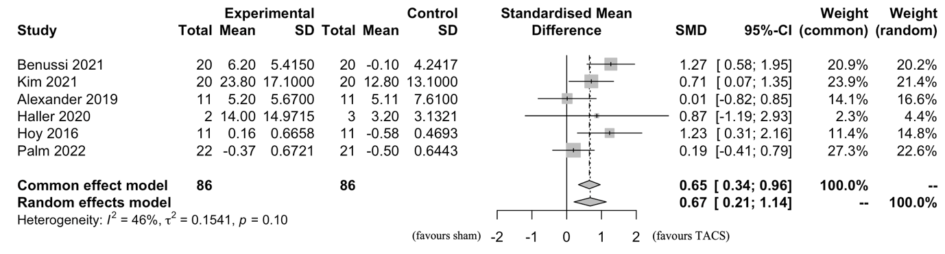

Supplementary Figure 2: Sensitivity analysis of SMD of the effect of TACS on cognition compared to placebo in psychiatric patients using Rey Auditory Visual Learning Test delayed recall for Benussi 2021


