Supplementary Figure 2: Leave out analysis
Figure 2a: Leave out analysis sorted by effect size
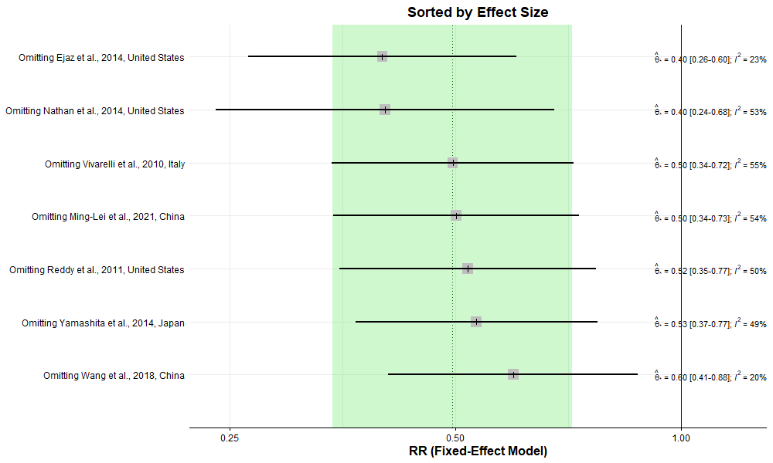

Figure 2b: Leave out analysis sorted by heterogeneity (I²)


