Supplementary Figure 3a: Trial sequential analysis for post-operative VTE
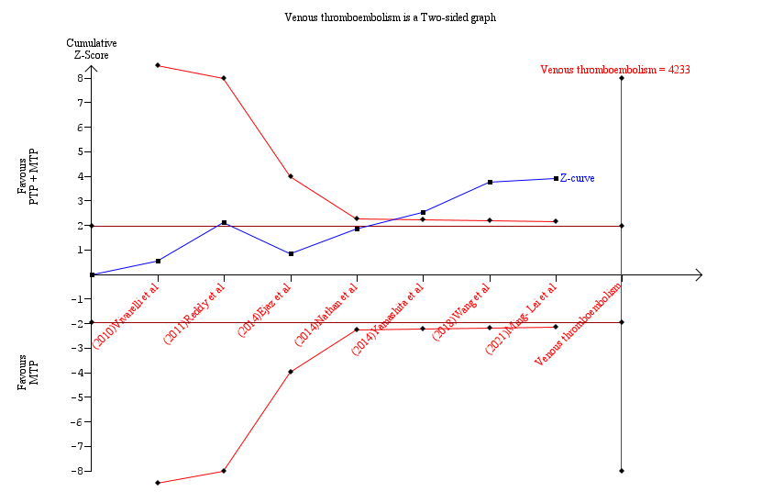
Supplementary Figure 3b: Trial sequential analysis for post-operative VTE- Penalized Z curve

