Table S1. The preferred reporting items for systematic reviews and meta-analyses: the PRISMA checklist
 | Section/topic |  | # | Checklist item |  | Reported on page #
 | Title
 | Title |  | 1 | Identify the report as a systematic review, meta-analysis, or both. |  | 1
 | Abstract
 | Structured summary |  | 2 | Provide a structured summary including, as applicable: background; objectives; data sources; study eligibility criteria, participants, and interventions; study appraisal and synthesis methods; results; limitations; conclusions and implications of key findings; systematic review registration number. |  | 2
 | Introduction
 | Rationale |  | 3 | Describe the rationale for the review in the context of what is already known. |  | 3, 4
 | Objectives |  | 4 | Provide an explicit statement of questions being addressed with reference to participants, interventions, comparisons, outcomes, and study design (PICOS). |  | 4
 | Methods
 | Protocol and registration |  | 5 | Indicate if a review protocol exists, if and where it can be accessed (e.g., Web address), and, if available, provide registration information including registration number. |  | 5
 | Eligibility criteria |  | 6 | Specify study characteristics (e.g., PICOS, length of follow-up) and report characteristics (e.g., years considered, language, publication status) used as criteria for eligibility, giving rationale. |  | 5, 6
 | Information sources |  | 7 | Describe all information sources (e.g., databases with dates of coverage, contact with study authors to identify additional studies) in the search and date last searched. |  | 5, 7
 | Search |  | 8 | Present full electronic search strategy for at least one database, including any limits used, such that it could be repeated. |  | Table S2
 | Study selection |  | 9 | State the process for selecting studies (i.e., screening, eligibility, included in systematic review, and, if applicable, included in the meta-analysis). |  | 5, 6, 7, Fig. 1.
 | Data collection process |  | 10 | Describe method of data extraction from reports (e.g., piloted forms, independently, in duplicate) and any processes for obtaining and confirming data from investigators. |  | 7
 | Data items |  | 11 | List and define all variables for which data were sought (e.g., PICOS, funding sources) and any assumptions and simplifications made. |  | 6, 7, 8
 | Risk of bias in individual studies |  | 12 | Describe methods used for assessing risk of bias of individual studies (including specification of whether this was done at the study or outcome level), and how this information is to be used in any data synthesis. |  | 6, 7
 | Summary measures |  | 13 | State the principal summary measures (e.g., risk ratio, difference in means). |  | 8
 | Synthesis of results |  | 14 | Describe the methods of handling data and combining results of studies, if done, including measures of consistency (e.g., I²) for each meta-analysis. |  | 8, 9
 | Risk of bias across studies |  | 15 | Specify any assessment of risk of bias that may affect the cumulative evidence (e.g., publication bias, selective reporting within studies). |  | 10
 | Additional analyses |  | 16 | Describe methods of additional analyses (e.g., sensitivity or subgroup analyses, meta-regression), if done, indicating which were pre-specified. |  | 9
Results
Study selection |  | 17 |  |  | Give numbers of studies screened, assessed for eligibility, and included in the review, with reasons for exclusions at each stage, ideally with a flow diagram. | 10, Fig. 1.
Study characteristics |  | 18 |  |  | For each study, present characteristics for which data were extracted (e.g., study size, PICOS, follow-up period) and provide the citations. | 10, 11, Table 1, S3.
Risk of bias within studies |  | 19 |  |  | Present data on risk of bias of each study and, if available, any outcome level assessment (see item 12). | 10, Fig. S1, Fig. S2.
Results of individual studies |  | 20 |  |  | For all outcomes considered (benefits or harms), present, for each study: (a) simple summary data for each intervention group (b) effect estimates and confidence intervals, ideally with a forest plot. | 16, Table 2, 5
Synthesis of results |  | 21 |  |  | Present the main results of the review. If meta-analyses are done, include for each, confidence intervals and measures of consistency. | 11-15, Tables 3, 4, Figures 2-4, and S3-S10
Risk of bias across studies |  | 22 |  |  | Present results of any assessment of risk of bias across studies (see Item 15). | 10
Additional analysis |  | 23 |  |  | Give results of additional analyses, if done (e.g., sensitivity or subgroup analyses, meta-regression [see Item 16]). | 15-16, Tables S4-S7, Figures 2, 4, S9, and S10
Discussion
Summary of evidence |  | 24 |  |  | Summarize the main findings including the strength of evidence for each main outcome; consider their relevance to key groups (e.g., healthcare providers, users, and policy makers). | 17-21, Table 6
Limitations |  | 25 |  |  | Discuss limitations at study and outcome level (e.g., risk of bias), and at review-level (e.g., incomplete retrieval of identified research, reporting bias). | 22
Conclusions |  | 26 |  |  | Provide a general interpretation of the results in the context of other evidence, and implications for future research. | 23
Funding
Funding |  | 27 |  |  | Describe sources of funding for the systematic review and other support (e.g., supply of data); role of funders for the systematic review. | 24

Table S2. The detailed search strategy for investigated databases
Database | Search strategy |  | No. of results
Database | #Search No. | Query | No. of results
PubMed ª | #1 | ((((((((covid-19) OR ("severe acute respiratory syndrome coronavirus 2")) OR ("Wuhan coronavirus")) OR ("2019-nCoV")) OR ("SARS-CoV-2")) OR ("2019 novel coronavirus")) OR ("COVID19")) OR ("COVID-19 pandemic")) OR ("coronavirus disease 2019") | 75661
PubMed ª | #2 | (((((((((((Remdesivir) OR ("l-alanine, N-((S)-hydroxyphenoxyphosphinyl)-, 2-ethylbutyl ester, 6-ester with 2-C-(4-aminopyrrolo(2,1-f)(1,2,4)triazin-7-yl)-2,5-anhydro-d-altrononitrile")) OR ("2-ethylbutyl (2S)-2-(((2R, 3S, 4R, 5R)-5-(4-aminopyrrolo(2,1-f) (1,2,4)triazin-7-yl)-5-cyano-3,4-dihydroxytetrahydrofuran-2-yl) methoxy)(phenoxy) phosphoryl) amino) propanoate")) OR (Veklury)) OR (GS-5734)) OR ("RNA replicase")) OR ("RNA-Directed RNA Polymerase")) OR ("RNA Polymerase, RNA-Directed")) OR ("RNA Directed RNA Polymerase")) OR ("RNA-Dependent RNA Polymerase")) OR ("RNA Dependent RNA Polymerase")) OR ("RNA Polymerase, RNA-Dependent") | 23457
PubMed ª | #3 | #1 and #2 | 815
Web of Science | #1 | ALL FIELDS: (COVID-19) OR ALL FIELDS: ("Wuhan coronavirus") OR ALL FIELDS: ("COVID-19 pandemic") OR ALL FIELDS: ("coronavirus disease 2019") OR ALL FIELDS: ("severe acute respiratory syndrome coronavirus 2") OR ALL FIELDS: (2019-nCoV) OR ALL FIELDS: (SARS-CoV-2) OR ALL FIELDS: ("2019 novel coronavirus") OR ALL FIELDS: (COVID19)  Refined by: [excluding] DOCUMENT TYPES: ( NEWS ITEM OR ART EXHIBIT REVIEW OR EDITORIAL MATERIAL OR MEETING ABSTRACT OR RETRACTION OR DANCE PERFORMANCE REVIEW OR LETTER OR CORRECTION OR BIOGRAPHICAL ITEM OR POETRY OR RETRACTED PUBLICATION OR REVIEW OR BOOK REVIEW )  Timespan: All years. Indexes: SCI-EXPANDED, SSCI, A&HCI, ESCI. | 33304
Web of Science | #2 | ALL FIELDS: (remdesivir) OR ALL FIELDS: (GS-5734) OR ALL FIELDS: ("RNA replicase") OR ALL FIELDS: ("RNA-Directed RNA Polymerase") OR ALL FIELDS: ("RNA Directed RNA Polymerase") OR ALL FIELDS: ("RNA-Dependent RNA Polymerase") OR ALL FIELDS: ("RNA Dependent RNA Polymerase") OR ALL FIELDS: ("RNA Polymerase, RNA-Dependent") OR ALL FIELDS: (veklury) OR ALL FIELDS: ("2-ethylbutyl (2S)-2-(((2R, 3S, 4R, 5R)-5-(4-aminopyrrolo(2,1-f) (1,2,4)triazin-7-yl)-5-cyano-3,4-dihydroxytetrahydrofuran-2-yl) methoxy)(phenoxy) phosphoryl) amino) propanoate") OR ALL FIELDS: ("l-alanine, N-((S)-hydroxyphenoxyphosphinyl)-, 2-ethylbutyl ester, 6-ester with 2-C-(4-aminopyrrolo(2,1-f)(1,2,4)triazin-7-yl)-2,5-anhydro-d-altrononitrile") OR ALL FIELDS: ("RNA Polymerase, RNA-Directed")  Refined by: [excluding] DOCUMENT TYPES: ( EDITORIAL MATERIAL OR BOOK CHAPTER OR CORRECTION ADDITION OR REVIEW OR LETTER OR CORRECTION OR RETRACTED PUBLICATION OR NEWS ITEM OR RETRACTION OR MEETING ABSTRACT )  Timespan: All years. Indexes: SCI-EXPANDED, SSCI, A&HCI, ESCI. | 4522
Web of Science | #3 | #1 and #2 | 378
Scopus | #1 | ( TITLE-ABS-KEY ( covid-19 ) OR TITLE-ABS-KEY ( "Wuhan coronavirus" ) OR TITLE-ABS-KEY ( covid19 ) OR TITLE-ABS-KEY ( "COVID-19 pandemic" ) OR TITLE-ABS-KEY ( "coronavirus disease 2019" ) OR TITLE-ABS-KEY ( "severe acute respiratory syndrome coronavirus 2" ) OR TITLE-ABS-KEY ( 2019-ncov ) OR TITLE-ABS-KEY ( sars-cov-2 ) OR TITLE-ABS-KEY ( "2019 novel coronavirus" ) ) AND ( EXCLUDE ( DOCTYPE , "le" ) OR EXCLUDE ( DOCTYPE , "re" ) OR EXCLUDE ( DOCTYPE , "ed" ) OR EXCLUDE ( DOCTYPE , "cp" ) OR EXCLUDE ( DOCTYPE , "ch" ) OR EXCLUDE ( DOCTYPE , "cr" ) OR EXCLUDE ( DOCTYPE , "bk" ) OR EXCLUDE ( DOCTYPE , "tb" ) ) | 58302
Scopus | #2 | ( TITLE-ABS-KEY ( remdesivir ) OR TITLE-ABS-KEY ( gs-5734 ) OR TITLE-ABS-KEY ( "RNA Polymerase, RNA-Dependent" ) OR TITLE-ABS-KEY ( "RNA-Directed RNA Polymerase" ) OR TITLE-ABS-KEY ( "RNA Directed RNA Polymerase" ) OR TITLE-ABS-KEY ( "RNA Polymerase, RNA-Directed" ) OR TITLE-ABS-KEY ( "RNA-Dependent RNA Polymerase" ) OR TITLE-ABS-KEY ( "RNA replicase" ) OR TITLE-ABS-KEY ( "RNA Dependent RNA Polymerase" ) OR TITLE-ABS-KEY ( veklury ) OR TITLE-ABS-KEY ( "2-ethylbutyl (2S)-2-(((2R, 3S, 4R, 5R)-5-(4-aminopyrrolo(2,1-f) (1,2,4)triazin-7-yl)-5-cyano-3,4-dihydroxytetrahydrofuran-2-yl) methoxy)(phenoxy) phosphoryl) amino) propanoate" ) OR TITLE-ABS-KEY ( "l-alanine, N-((S)-hydroxyphenoxyphosphinyl)-, 2-ethylbutyl ester, 6-ester with 2-C-(4-aminopyrrolo(2,1-f)(1,2,4)triazin-7-yl)-2,5-anhydro-d-altrononitrile" ) ) AND ( EXCLUDE ( DOCTYPE , "re" ) OR EXCLUDE ( DOCTYPE , "le" ) OR EXCLUDE ( DOCTYPE , "ed" ) OR EXCLUDE ( DOCTYPE , "ch" ) OR EXCLUDE ( DOCTYPE , "cp" ) OR EXCLUDE ( DOCTYPE , "bk" ) OR EXCLUDE ( DOCTYPE , "tb" ) ) | 8354
Scopus | #3 | #1 and #2 | 1177
Science Direct ^{b} | #1 | ((COVID-19 OR 2019-nCoV OR SARS-CoV-2 OR "2019 novel coronavirus" OR COVID19)) | 20221
Science Direct ^{b} | #2 | ((remdesivir OR GS-5734 OR "RNA replicase" OR "RNA Dependent RNA Polymerase")) | 7500
Science Direct ^{b} | #3 | #1 AND #2 | 1231
Wiley online library ^{c} | #1 | "COVID-19 OR COVID19 OR "COVID-19 pandemic" OR "coronavirus disease 2019" OR "severe acute respiratory syndrome coronavirus 2" OR 2019-nCoV OR "Wuhan coronavirus" OR SARS-CoV-2 OR "2019 novel coronavirus" anywhere | 24312
Wiley online library ^{c} | #2 | "Remdesivir OR "l-alanine, N-((S)-hydroxyphenoxyphosphinyl)-, 2-ethylbutyl ester, 6-ester with 2-C-(4-aminopyrrolo(2,1-f)(1,2,4)triazin-7-yl)-2,5-anhydro-d-altrononitrile" OR "2-ethylbutyl (2S)-2-(((2R, 3S, 4R, 5R)-5-(4-aminopyrrolo(2,1-f) (1,2,4)triazin-7-yl)-5-cyano-3,4-dihydroxytetrahydrofuran-2-yl) methoxy)(phenoxy) phosphoryl) amino) propanoate" OR GS-5734 OR "RNA replicase" OR "RNA-Directed RNA Polymerase" OR "RNA Directed RNA Polymerase" OR "RNA Polymerase, RNA-Directed" OR "RNA-Dependent RNA Polymerase" OR "RNA Dependent RNA Polymerase" OR "RNA Polymerase, RNA-Dependent" OR veklury" anywhere | 4105
Wiley online library ^{c} | #3 | #1 and #2 | 943
medRxiv and bioRxiv |  | "(COVID-19 OR 2019-nCoV OR SARS-CoV-2 OR "novel coronavirus") AND (remdesivir OR GS-5734 OR "RNA-Dependent RNA Polymerase")" | 1018
ª "Systematic Review", "Review", and "Meta-Analysis" article types were excluded from the search results.
^{b} Irrelevant article types (e.g., review articles, mini reviews, and editorials) were excluded from the search results.
^{c} The search results were limited to "Journals" publication type.

Table S3. The definition of the evaluated outputs according to the associated studies
Clinical improvement
- Spinner et al. and Goldman et al.: decrease of at least two points on the seven-category ordinal scale (his scale has been recommended by WHO R&D blueprint group).
- Wang et al., Olender et al., and Grein et al.: alive discharge or a decrease of two points or more on the modified seven-category ordinal scale.
- Beigel et al.: Improvement of two categories on the eight-category ordinal scale.
- Antinori et al.: Improvement in patient's hospitalization status, which was evaluated using the seven-category ordinal scale.
Serious adverse drug reactions
- Beigel et al.: Cardiac disorders (cardiac arrest and atrial fibrillation), general disorders and administration site conditions (multiple organ dysfunction syndrome), infections and infestations (septic shock and COVID-19), investigations (glomerular filtration rate decreased), renal and urinary disorders (acute kidney injury and renal failure), respiratory, thoracic and mediastinal disorders (respiratory failure, acute respiratory failure, respiratory distress, acute respiratory distress syndrome, pneumothorax, pulmonary embolism, hypoxia, and pneumonia aspiration), and vascular disorders (hypotension and shock)
- Wang et al.: Respiratory failure or acute respiratory distress syndrome, cardiopulmonary failure, pulmonary embolism, recurrence of COVID-19, cardiac arrest, acute coronary syndrome, tachycardia, septic shock Lung abscess, sepsis, bronchitis, thrombocytopenia, increased D-dimer, hemorrhage of lower digestive tract, ileus, deep vein thrombosis, acute kidney injury, diabetic ketoacidosis, and multiple organ dysfunction syndrome
- Goldman et al.: Acute respiratory failure, respiratory failure, septic shock, acute respiratory distress syndrome, hypoxia, respiratory distress, dyspnea, pneumothorax, viral pneumonia, aminotransferase levels increased
- Grein et al.: Multiple-organ-dysfunction syndrome, septic shock, acute kidney injury, and hypotension
- Antinori et al.: The severity of the adverse drug reactions was classified using the national cancer institute common terminology criteria for adverse events, version 4.0.
- Spinner et al.: Serious adverse drug reactions were not clarified in this study.
Recovery
- Beigel et al.: Alive discharge or hospitalization only for infection-control purposes.
- Olender et al.: According to the seven-category ordinal scale which severity allocation of the scores was descending, recovery was defined as having a score of 5–7 points for patients with a baseline score of 2–4, a score of 6–7 for patients with a baseline score of 5, or a score of 7 for patients with a baseline score of 6.
- Spinner et al.: a) Recovery: An improvement from a baseline score of 2-5 to a score of 6 or 7, or from a baseline score of 6 to a score of 7. b) Modified recovery: same as Olender et al.'s definition.

Table S4. The sensitivity analysis results for risk ratio meta-analysis of the RCT studies
No. of studies | No. of cases |  | Risk ratio (95% CI) | P-value | Heterogeneity
No. of studies | Remdesivir | No-remdesivir | Risk ratio (95% CI) | P-value | Heterogeneity
Alive discharge (14)
Two (total); Wang et al., Spinner et al. | 539 | 278 | 1.13 (1.02-1.26) | 0.03 | Tau²=0; Q-value=0.03; df=1 (P=0.88); I²=0%
One; Spinner et al. | 384 | 200 | 1.14 (1.01-1.07) | 0.03
One; Wang et al. | 155 | 78 | 1.09 (0.67-1.78) | 0.73
Alive discharge (28)
Two (total); Wang et al., Spinner et al. | 539 | 278 | 1.08 (1.0-1.15) | 0.04 | Tau²=0; Q-value=0.15; df=1 (P=0.70); I²=0%
One; Spinner et al. | 384 | 200 | 1.08 (1.01-1.16) | 0.04
One; Wang et al. | 155 | 78 | 1.03 (0.82-1.30) | 0.81
Clinical improvement (14)
Two (total)-Wang et al., Spinner et al. | 539 | 278 | 1.14 (1.02-1.27) | 0.02 | Tau²=0; Q-value=0.02; df=1 (P=0.89); I²=0%
One; Spinner et al. | 384 | 200 | 1.13 (1.02-1.27) | 0.03
One; Wang et al. | 155 | 78 | 1.17 (0.73-1.90) | 0.51
Clinical improvement (28)
Two (total); Wang et al., Spinner et al. | 539 | 278 | 1.90 (1.02-1.17) | 0.01 | Tau²=0; Q-value=0.28; df=1 (P=0.60); I²=0%
One; Spinner et al. | 384 | 200 | 1.08 (1.01-1.16) | 0.03
One; Wang et al. | 155 | 78 | 1.15 (0.92-1.44) | 0.21
Death (14)
Four (total); Beigel et al., Spinner et al., Wang et al., Pan et al. | 3813 | 3503 | 0.78 (0.51-1.21) | 0.27 | Tau²=0.11; Q-value=8.63; df=3 (P=0.04); I²=65.22%
Three; Spinner et al., Wang et al., Pan et al. | 3282 | 2986 | 1.0 (0.85-1.17) | 0.98 | Tau²=0; Q-value=1.57; df=2 (P=0.46); I²=0%
Three; Beigel et al., Spinner et al., Wang et al., | 1070 | 795 | 0.61 (0.43-0.87) | 0.01 | Tau²=002; Q-value=2.24; df=2 (P=0.33); I²=10.67%
Three; Beigel et al., Wang et al., Pan et al. | 3429 | 3303 | 0.83 (0.53-1.29) | 0.40 | Tau²=0.11; Q-value=7.33; df=2 (P=0.03); I²=72.73%
Three; Beigel et al., Spinner et al., Pan et al. | 3658 | 3425 | 0.72 (0.42-1.23) | 0.23 | Tau²=0.15; Q-value=8.49; df=2 (P=0.01); I²=76.45%
Death (28)
Four (total); Beigel et al., Spinner et al., Wang et al., Pan et al. | 3813 | 3503 | 0.94 (0.82-1.07) | 0.32 | Tau²=0; Q-value=2.86; df=3 (P=0.41); I²=0%
Three; Spinner et al., Wang et al., Pan et al. | 3282 | 2986 | 0.98 (0.85-1.14) | 0.80 | Tau²=0; Q-value=0.50; df=2 (P=0.78); I²=0%
Three; Beigel et al., Wang et al., Pan et al. | 3429 | 3303 | 0.94 (0.82-1.07) | 0.35 | Tau²=0.01; Q-value=2.56; df=2 (P=0.28); I²=21.94%
Three; Beigel et al., Spinner et al., Wang et al., | 1070 | 795 | 0.79 (0.60-1.05) | 0.10 | Tau²=0; Q-value=1.11; df=2 (P=0.57); I²=0%
Three; Beigel et al., Spinner et al., Pan et al. | 3658 | 3425 | 0.93 (0.81-1.06) | 0.29 | Tau²=0.01; Q-value=2.63; df=2 (P=0.27); I²=23.85%
Recovery (28)
Two (total); Beigel et al., Spinner et al. | 915 | 717 | 1.09 (1.04-1.15) | 0.001 | Tau²=0; Q-value=0.16; df=1 (P=0.70); I²=0%
One; Beigel et al. | 531 | 517 | 1.10 (1.02-1.19) | 0.01
One; Spinner et al. | 384 | 200 | 1.08 (1.01-1.16) | 0.02
Serious ADR
Three (total); Beigel et al, Spinner et al., Wang et al. | 1070 | 795 | 0.75 (0.63-0.90) | 0.001 | Tau²=0; Q-value=1.20; df=2 (P=0.55); I²=0%
Two; Beigel et al, Spinner et al. | 915 | 717 | 0.76 (0.63-0.91) | 0.004 | Tau²=0.01; Q-value=1.13; df=1 (P=0.29); I²=11.29%
Two; Beigel et al, Wang et al. | 686 | 595 | 0.77 (0.64-0.93) | 0.01 | Tau²=0; Q-value=0.14; df=1 (P=0.70); I²=0%
Two; Spinner et al., Wang et al. | 539 | 278 | 0.64 (0.43-0.95) | 0.03 | Tau²=0; Q-value=0.37; df=1 (P=0.54); I²=0%
CI, confidence interval; df, degree of freedom
Table S5. The sensitivity analysis for assessment of the respiratory support improvement in RCT studies; remdesivir groups
No. of studies | No. of cases | Risk ratio (95% CI) | P-value | Heterogeneity
High flow oxygen or NIMV; day one vs. day 14
Four (total); Wang et al., Spinner et al., Goldman et al., Beigel et al. | 1467 | 2.88 (1.69-4.91) | ˂0.001 | Tau²=0.18; Q-value=8.80; df=3 (P=0.03); I²=68.89%
Three; Spinner et al., Goldman et al., Beigel et al. | 1312 | 3.34 (1.83-6.08) | ˂0.001 | Tau²=0.16; Q-value=5.38; df=2 (P=0.7); I²=62.84%
Three; Wang et al., Goldman et al., Beigel et al. | 1083 | 3.38 (2.15-5.31) | <0.001 | Tau²=0.09; Q-value=4.81; df=2 (P=0.09); I²=58.37%
Three; Wang et al., Spinner et al., Goldman et al. | 936 | 2.34 (0.96-5.66) | 0.06 | Tau²=0.43; Q-value=8.53; df=2 (P=0.01); I²=76.55%
Three; Wang et al., Spinner et al., Beigel et al. | 1070 | 2.24 (1.12-4.52) | 0.02 | Tau²=0.23; Q-value=5.58; df=2 (P=0.06); I²=64.18%
IMV or ECMO; day one vs. day 14
Four (total); Wang et al., Spinner et al., Goldman et al., Beigel et al. | 1467 | 0.48 (0.13-1.85) | 0.23 | Tau²=1.22; Q-value=27.09; df=3 (P<0.001); I²=88.93%
Three; Spinner et al., Goldman et al., Beigel et al. | 1312 | 0.61 (0.14-2.55) | 0.49 | Tau²=1.20; Q-value=24.71; df=2 (P<0.001); I²=91.91%
Three; Wang et al., Goldman et al., Beigel et al. | 1083 | 0.50 (0.12-2.18) | 0.36 | Tau²=1.29; Q-value=26.54; df=2 (P<0.001); I²=92.46%
Three; Wang et al., Spinner et al., Goldman et al. | 936 | 0.28 (0.16-0.50) | <0.001 | Tau²=0.0; Q-value=0.39; df=2 (P=0.82); I²=0.0%
Three; Wang et al., Spinner et al., Beigel et al. | 1070 | 0.67 (0.14-3.30) | 0.62 | Tau²=1.05; Q-value=3.72; df=2 (P=0.16); I²=46.26%
Low flow oxygen; day one vs. day 14
Four (total); Wang et al., Spinner et al., Goldman et al., Beigel et al. | 1467 | 2.88 (1.80-4.60) | <0.001 | Tau²=0.19; Q-value=21.74; df=3 (P<0.001); I²=86.20%
Three; Spinner et al., Goldman et al., Beigel et al. | 1312 | 3.37 (2.73-4.16) | <0.001 | Tau²=0.0; Q-value=1.85; df=2 (P=0.40); I²=0.0%
Three; Wang et al., Goldman et al., Beigel et al. | 1083 | 2.52 (1.54-4.12) | <0.001 | Tau²=0.17; Q-value=17.07; df=2 (P<0.001); I²=88.28%
Three; Wang et al., Spinner et al., Goldman et al. | 936 | 2.76 (1.48-5.14) | 0.001 | Tau²=0.25; Q-value=14.88; df=2 (P=0.001); I²=86.56%
Three; Wang et al., Spinner et al., Beigel et al. | 1070 | 2.88 (1.51-5.47) | 0.001 | Tau²=0.28; Q-value=20.28; df=2 (P<0.001); I²=90.14%
High flow oxygen or NIMV; day one vs. day 28
Three (total); Wang et al., Spinner et al., Beigel et al. | 1070 | 8.90 (6.67-11.87) | <0.001 | Tau²=0.0; Q-value=1.83; df=2 (P=0.40); I²=0.0%
Two; Spinner et al., Beigel et al. | 915 | 10.46 (7.15-15.31) | <0.001 | Tau²=0.0; Q-value=0.21; df=1 (P=0.65); I²=0.0%
Two; Wang et al., Beigel et al. | 686 | 8.60 (6.37-11.62) | <0.001 | Tau²=0.01; Q-value=1.24; df=1 (P=0.27); I²=19.18%
Two; Wang et al., Spinner et al. | 539 | 7.89 (5.27-11.80) | <0.001 | Tau²=0.02; Q-value=1.13; df=1 (P=0.29); I²=11.34%
IMV or ECMO; day one vs. day 28
Three (total); Wang et al., Spinner et al., Beigel et al. | 1070 | 9.81 (1.89-50.96) | 0.01 | Tau²=1.56; Q-value=7.97; df=2 (P=0.02); I²=79.90%
Two; Spinner et al., Beigel et al. | 915 | 7.47 (0.38-147.67) | 0.19 | Tau²=4.07; Q-value=7.96; df=1 (P=0.01); I²=87.44%
Two; Wang et al., Beigel et al. | 686 | 22.96 (9.43-55.88) | <0.001 | Tau²=0.0; Q-value=0.77; df=1 (P=0.38); I²=0.0%
Two; Wang et al., Spinner et al. | 539 | 4.91 (0.55-43.61) | 0.15 | Tau²=1.82; Q-value=3.69; df=1 (P=0.06); I²=72.92%
Low flow oxygen; day one vs. day 28
Three (total); Wang et al., Spinner et al., Beigel et al. | 1070 | 1.02 (0.10-9.97) | 0.99 | Tau²=2.76; Q-value=6.29; df=2 (P=0.04); I²=68.18%
Two; Spinner et al., Beigel et al. | 915 | 2.01 (0.20-20.33) | 0.56 | Tau²=1.96; Q-value=2.45; df=1 (P=0.12); I²=59.22%
Two; Wang et al., Beigel et al. | 686 | 1.37 (0.07-25.57) | 0.83 | Tau²=3.54; Q-value=3.92; df=1 (P=0.05); I²=74.50%
Two; Wang et al., Spinner et al. | 539 | 0.26 (0.03-2.30) | 0.22 | Tau²=0.0; Q-value=0.05; df=1 (P=0.82); I²=0.0%
High flow oxygen or NIMV; day 14 vs. day 28
Three (total); Wang et al., Spinner et al., Beigel et al. | 1070 | 2.75 (1.99-3.79) | <0.001 | Tau²=0.0; Q-value=1.39; df=2 (P=0.50); I²=0.0%
Two; Spinner et al., Beigel et al. | 915 | 2.30 (1.48-3.56) | <0.001 | Tau²=0.0; Q-value=0.0; df=1 (P=0.97); I²=0.0%
Two; Wang et al., Beigel et al. | 686 | 2.79 (1.10-3.91) | <0.001 | Tau²=0.02; Q-value=1.27; df=1 (P=0.26); I²=20.93%
Two; Wang et al., Spinner et al. | 539 | 3.20 (2.06-4.97) | <0.001 | Tau²=0.0; Q-value=0.40; df=1 (P=0.53); I²=0.0%
IMV or ECMO; day 14 vs. day 28
Three (total); Wang et al., Spinner et al., Beigel et al. | 1070 | 5.34 (2.37-12.05) | <0.001 | Tau²=0.0; Q-value=1.71; df=2 (P=0.42); I²=0.0%
Two; Spinner et al., Beigel et al. | 915 | 4.90 (1.84-13.01) | 0.001 | Tau²=0.34; Q-value=1.62; df=1 (P=0.20); I²=38.09%
Two; Wang et al., Beigel et al. | 686 | 7.18 (2.84-18.17) | <0.001 | Tau²=0.0; Q-value=0.03; df=1 (P=0.87); I²=0.0%
Two; Wang et al., Spinner et al. | 539 | 3.91 (1.29-11.87) | 0.02 | Tau²=0.04; Q-value=1.06; df=1 (P=0.30); I²=5.79%
Low flow oxygen; day 14 vs. day 28
Three (total); Wang et al., Spinner et al., Beigel et al. | 1070 | 2.67 (1.81-3.92) | <0.001 | Tau²=0.0; Q-value=0.63; df=2 (P=0.73); I²=0.0%
Two; Spinner et al., Beigel et al. | 915 | 2.71 (1.82-4.03) | <0.001 | Tau²=0.0; Q-value=0.51; df=1 (P=0.48); I²=0.0%
Two; Wang et al., Beigel et al. | 686 | 2.72 (1.84-4.01) | <0.001 | Tau²=0.0; Q-value=0.14; df=1 (P=0.71); I²=0.0%
Two; Wang et al., Spinner et al. | 539 | 1.66 (0.39-6.99) | 0.49 | Tau²=0.0; Q-value=0.18; df=1 (P=0.68); I²=0.0%
CI, confidence interval; df, degree of freedom; NIMV, non-invasive mechanical ventilation; IMV, invasive mechanical ventilation; ECMO, extracorporeal membrane oxygenation
Table S6. The sensitivity analysis for assessment of the respiratory support improvement in RCT studies; no- remdesivir groups
No. of studies | No. of cases | Risk ratio (95% CI) | P-value | Heterogeneity
High flow oxygen or NIMV; day one vs. day 14
Three (total); Wang et al., Spinner et al., Beigel et al. | 795 | 3.12 (2.18-4.48) | <0.001 | Tau²=0.06; Q-value=5.28; df=2 (P=0.07); I²=62.10%
Two; Spinner et al., Beigel et al. | 717 | 3.66 (2.85-4.71) | <0.001 | Tau²=0.0; Q-value=0.34; df=1 (P=0.56); I²=0.0%
Two; Wang et al., Beigel et al. | 595 | 2.90 (1.91-4.41) | <0.001 | Tau²=0.07; Q-value=4.16; df=1 (P=0.04); I²=75.95%
Two; Wang et al., Spinner et al. | 278 | 2.96 (1.58-5.53) | 0.001 | Tau²=0.14; Q-value=2.60; df=1 (P=0.11); I²=61.60%
IMV or ECMO; day one vs. day 14
Three (total); Wang et al., Spinner et al., Beigel et al. | 795 | 1.61 (0.44-5.81) | 0.47 | Tau²=1.01; Q-value=11.92; df=2 (P=0.003); I²=83.21%
Two; Spinner et al., Beigel et al. | 717 | 1.75 (0.21-14.57) | 0.61 | Tau²=1.10; Q-value=6.04; df=1 (P=0.01); I²=83.45%
Two; Wang et al., Beigel et al. | 595 | 2.37 (0.62-9.09) | 0.21 | Tau²=0.82; Q-value=7.22; df=1 (P=0.01); I²=86.15%
Two; Wang et al., Spinner et al. | 278 | 0.94 (0.43-2.08) | 0.88 | Tau²=0.0; Q-value=0.69; df=1 (P=0.41); I²=0.0%
Low flow oxygen; day one vs. day 14
Three (total); Wang et al., Spinner et al., Beigel et al. | 795 | 0.36 (0.05-2.56) | 0.31 | Tau²=2.13; Q-value=7.70; df=2 (P=0.2); I²=74.02%
Two; Spinner et al., Beigel et al. | 717 | 0.52 (0.04-6.45) | 0.61 | Tau²=2.53; Q-value=3.31; df=1 (P=0.07); I²=69.83%
Two; Wang et al., Beigel et al. | 595 | 0.56 (0.07-4.76) | 0.60 | Tau²=1.94; Q-value=4.44; df=1 (P=0.04); I²=77.47%
Two; Wang et al., Spinner et al. | 278 | 0.12 (0.02-0.66) | 0.02 | Tau²=0.0; Q-value=0.06; df=1 (P=0.80); I²=0.0%
High flow oxygen or NIMV; day one vs. day 28
Three (total); Wang et al., Spinner et al., Beigel et al. | 795 | 7.18 (5.29-9.74) | <0.001 | Tau²=0.06; Q-value=3.32; df=2 (P=0.19); I²=39.71%
Two; Spinner et al., Beigel et al. | 717 | 8.83 (6.02-12.96) | <0.001 | Tau²=0.0; Q-value=0.23; df=1 (P=0.63); I²=0.0%
Two; Wang et al., Beigel et al. | 595 | 6.91 (3.79-12.58) | <0.001 | Tau²=0.13; Q-value=3.32; df=1 (P=0.07); I²=69.85%
Two; Wang et al., Spinner et al. | 278 | 5.45 (3.50-8.48) | <0.001 | Tau²=0.0; Q-value=0.47; df=1 (P=0.49); I²=0.0%
IMV or ECMO; day one vs. day 28
Three (total); Wang et al., Spinner et al., Beigel et al. | 795 | 8.52 (4.79-15.18) | <0.001 | Tau²=0.0; Q-value=0.10; df=2 (P=0.61); I²=0.0%
Two; Spinner et al., Beigel et al. | 717 | 9.52 (5.10-17.80) | <0.001 | Tau²=0.0; Q-value=0.18; df=1 (P=0.67); I²=0.0%
Two; Wang et al., Beigel et al. | 595 | 8.70 (4.83-15.65) | <0.001 | Tau²=0.0; Q-value=0.88; df=1 (P=0.35); I²=0.0%
Two; Wang et al., Spinner et al. | 278 | 4.59 (1.20-17.62) | 0.03 | Tau²=0.0; Q-value=0.0; df=1 (P=0.95); I²=0.0%
Low flow oxygen; day one vs. day 28
Three (total); Wang et al., Spinner et al., Beigel et al. | 795 | 0.70 (0.07-6.71) | 0.76 | Tau²=3.02; Q-value=9.19; df=2 (P=0.01); I²=78.24%
Two; Spinner et al., Beigel et al. | 717 | 0.85 (0.03-23.01) | 0.92 | Tau²=4.76; Q-value=5.25; df=1 (P=0.2); I²=80.96%
Two; Wang et al., Beigel et al. | 595 | 1.41 (0.15-12.92) | 0.76 | Tau²=2.05; Q-value=4.07; df=1 (P=0.04); I²=75.43%
Two; Wang et al., Spinner et al. | 278 | 0.22 (0.04-1.31) | 0.10 | Tau²=0.0; Q-value=0.34; df=1 (P=0.56); I²=0.0%
High flow oxygen or NIMV; day 14 vs. day 28
Three (total); Wang et al., Spinner et al., Beigel et al. | 795 | 2.63 (1.38-5.02) | 0.003 | Tau²=0.0; Q-value=1.20; df=2 (P=0.55); I²=0.0%
Two; Spinner et al., Beigel et al. | 717 | 2.40 (1.17-4.90) | 0.02 | Tau²=0.0; Q-value=0.84; df=1 (P=0.36); I²=0.0%
Two; Wang et al., Beigel et al. | 595 | 2.47 (1.27-4.79) | 0.01 | Tau²=0.0; Q-value=0.48; df=1 (P=0.49); I²=0.0%
Two; Wang et al., Spinner et al. | 278 | 4.76 (1.24-18.27) | 0.02 | Tau²=0.0; Q-value=0.23; df=1 (P=0.63); I²=0.0%
IMV or ECMO; day 14 vs. day 28
Three (total); Wang et al., Spinner et al., Beigel et al. | 795 | 2.45 (1.80-3.32) | <0.001 | Tau²=0.0; Q-value=1.10; df=2 (P=0.58); I²=0.0%
Two; Spinner et al., Beigel et al. | 717 | 2.45 (1.79-3.35) | <0.001 | Tau²=0.02; Q-value=1.10; df=1 (P=0.30); I²=8.67%
Two; Wang et al., Beigel et al. | 595 | 2.54 (1.86-3.48) | <0.001 | Tau²=0.0; Q-value=0.02; df=1 (P=0.90); I²=0.0%
Two; Wang et al., Spinner et al. | 278 | 1.70 (0.68-4.29) | 0.26 | Tau²=0.0; Q-value=0.44; df=1 (P=0.51); I²=0.0%
Low flow oxygen; day 14 vs. day 28
Three (total); Wang et al., Spinner et al., Beigel et al. | 795 | 2.31 (1.63-3.27) | <0.001 | Tau²=0.0; Q-value=0.71; df=2 (P=0.70); I²=0.0%
Two; Spinner et al., Beigel et al. | 717 | 2.40 (1.55-3.72) | <0.001 | Tau²=0.0; Q-value=0.62; df=1 (P=0.43); I²=0.0%
Two; Wang et al., Beigel et al. | 595 | 2.40 (1.66-3.47) | <0.001 | Tau²=0.0; Q-value=0.23; df=1 (P=0.63); I²=0.0%
Two; Wang et al., Spinner et al. | 278 | 2.02 (1.21-3.37) | 0.01 | Tau²=0.0; Q-value=0.22; df=1 (P=0.64); I²=0.0%
CI, confidence interval; df, degree of freedom; NIMV, non-invasive mechanical ventilation; IMV, invasive mechanical ventilation; ECMO, extracorporeal membrane oxygenation
Table S7. The sensitivity analysis for the pooled median and IQR value estimation meta-analysis
No. of studies | No. of cases |  | Group differences (95% CI) | P-value | Heterogeneity
No. of studies | Remdesivir | No-remdesivir | Group differences (95% CI) | P-value | Heterogeneity
The median time to recovery
Two (total); Beigel et al., Spinner et al. | 734 | 721 | Pooled median difference:  2.56 (-2.34 to 7.46) | 0.31 | Tau²=12.15; Q-value=36.03; df=1 (P˂0.0001); I²=97.22%
One; Beigel et al. | 541 | 521 | Rate ratio:  1.29 (1.12 to 1.49) | ˂0.001
One; Spinner et al. | 193 | 200 | Hazard ratio:  1.10 (0.90 to 1.36) | 0.379
The median time to clinical improvement
Two (total); Beigel et al., Wang et al. | 696 | 599 | Pooled median difference:  2.99 (2.71 to 3.28) | ˂0.001 | Tau²=0; Q-value=0.32; df=1 (P=0.57); I²=0%
One; Beigel et al. | 541 | 521 | Rate ratio:  1.29 (1.12 to 1.48) | ˂0.001
One; Wang et al. | 155 | 78 | Hazard ratio:  1.23 (0.87 to 1.75) | 0.688
IQR, interquartile range; CI, confidence interval; df, degree of freedom

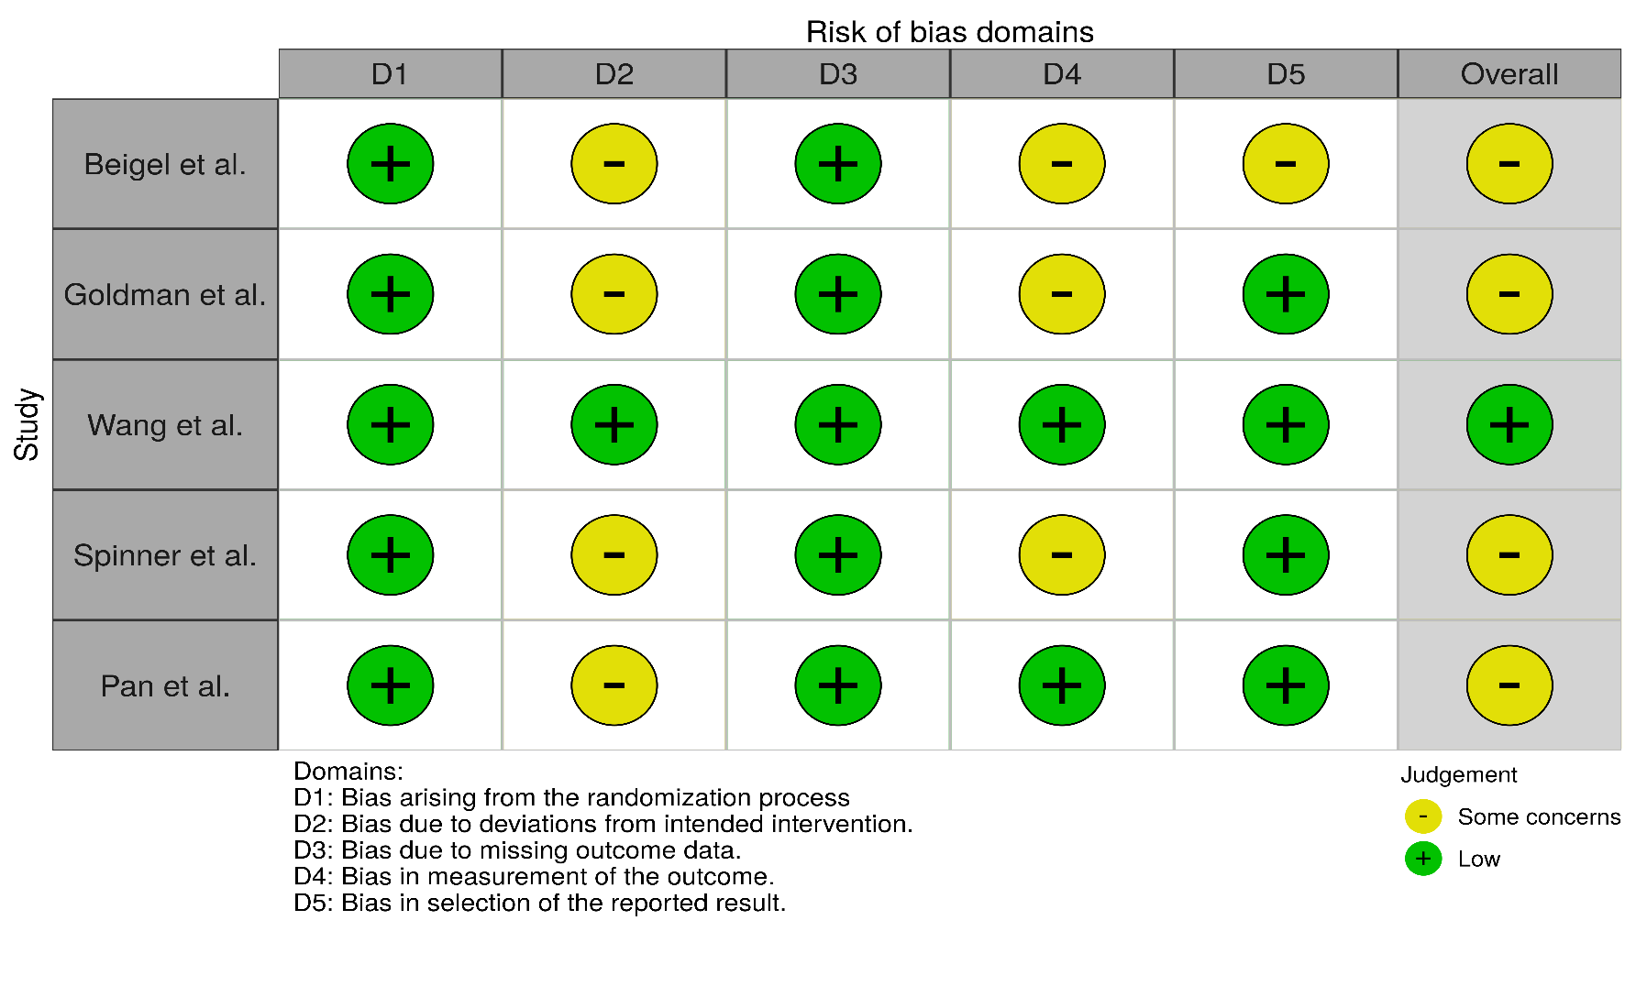
Fig. S1. Risk of bias assessment results for randomized controlled trials according to a revised tool for risk of bias in randomized trials (RoB 2.0) tool

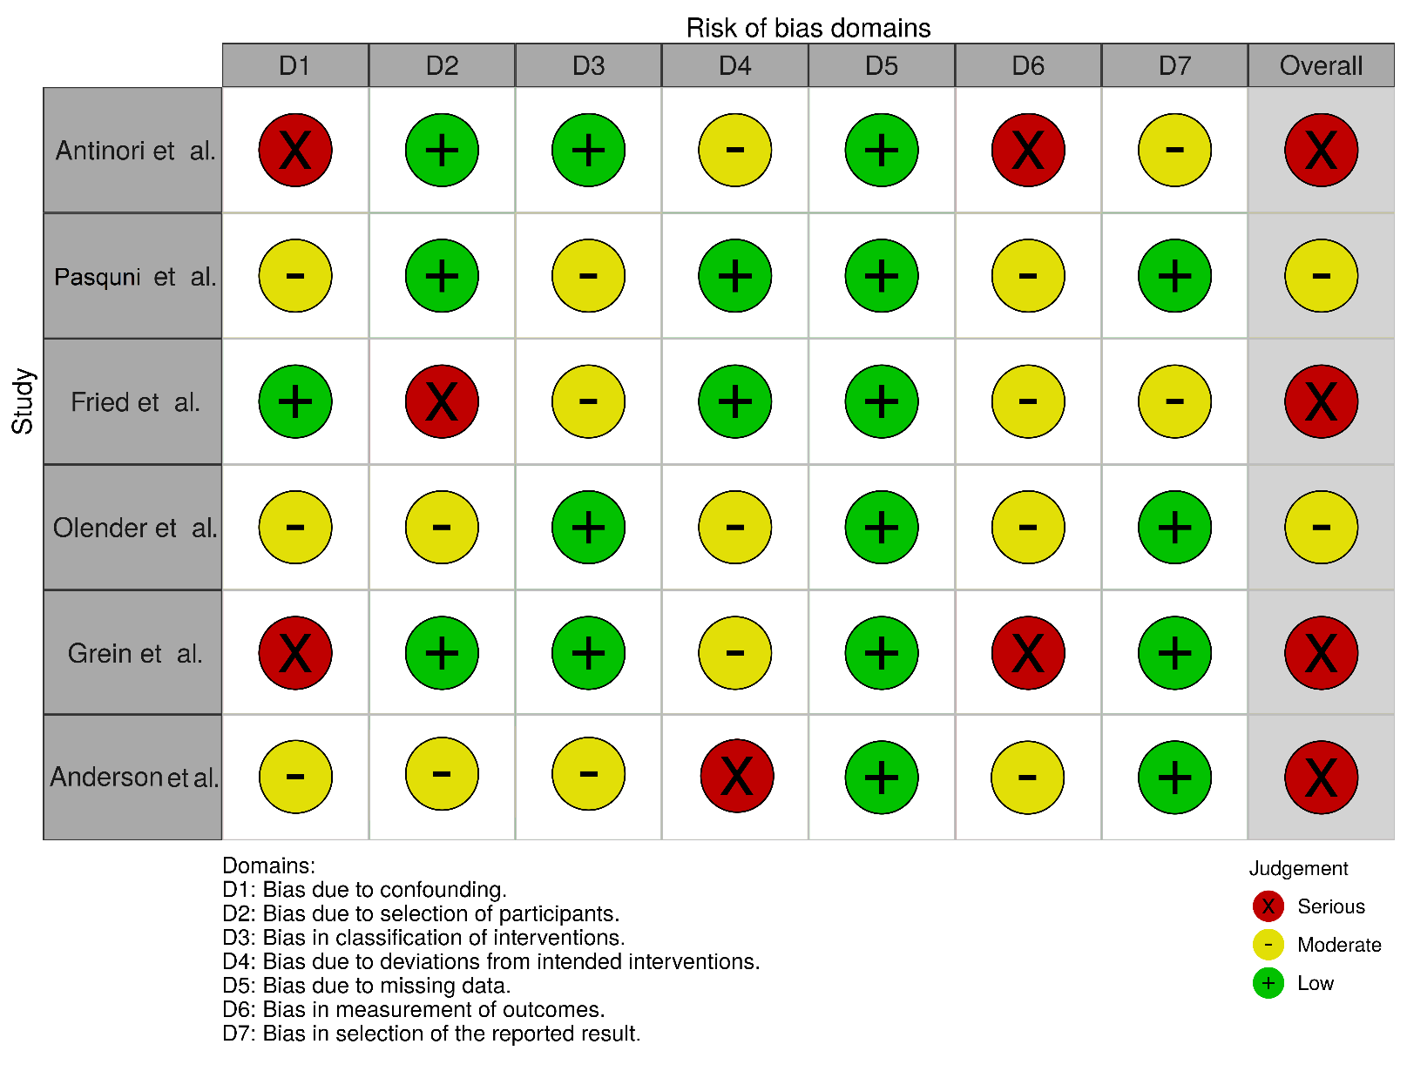
Fig. S2. Risk of bias assessment results for non-randomized studies according to the risk of bias in non-randomized studies of interventions (ROBINS-I) tool
The pooled event rates of the remdesivir groups
RCT studies: Clinical improvement on follow-ups of 14 and 28 days occurred in 55% (n=936, 95% CI, 29.8%-77.9%) and 80.7% (n=539, 95% CI, 48.2%-94.9%) of participants, respectively. The pooled rates of death on follow-ups of 14 and 28 days were 7.2% (n=4210, 95% CI, 5%-10.4%) and 8.7% (n=3813, 95% CI, 5.6%-13.3%), respectively. The viral load reduction over time occurred in 71% (n=131, 95% CI, 62.7%-78.1%) of participants. Overall, 16.8% (n=1467, 95% CI, 9.5%-28.2%) experienced serious ADRs. The pooled alive discharge rate was 52.7% (n=936, 95% CI, 27.5%-76.5%) and 78.2% (n=539, 95% CI, 37.4%-95.6%) on follow-up of 14 and 28 days, respectively. Finally, 69.5% (n=1312, 95% CI, 58.2%-78.9%) and 85.3% (n=915, 95% CI, 60.9%-95.6%) of patients were recovered on 14-day and 28-day follow-ups, respectively.
The random-effects approach was utilized for all the evaluated outputs. The detailed results are shown in the forest plot for pooling event rates of remdesivir groups in RCT studies (Fig. S3).

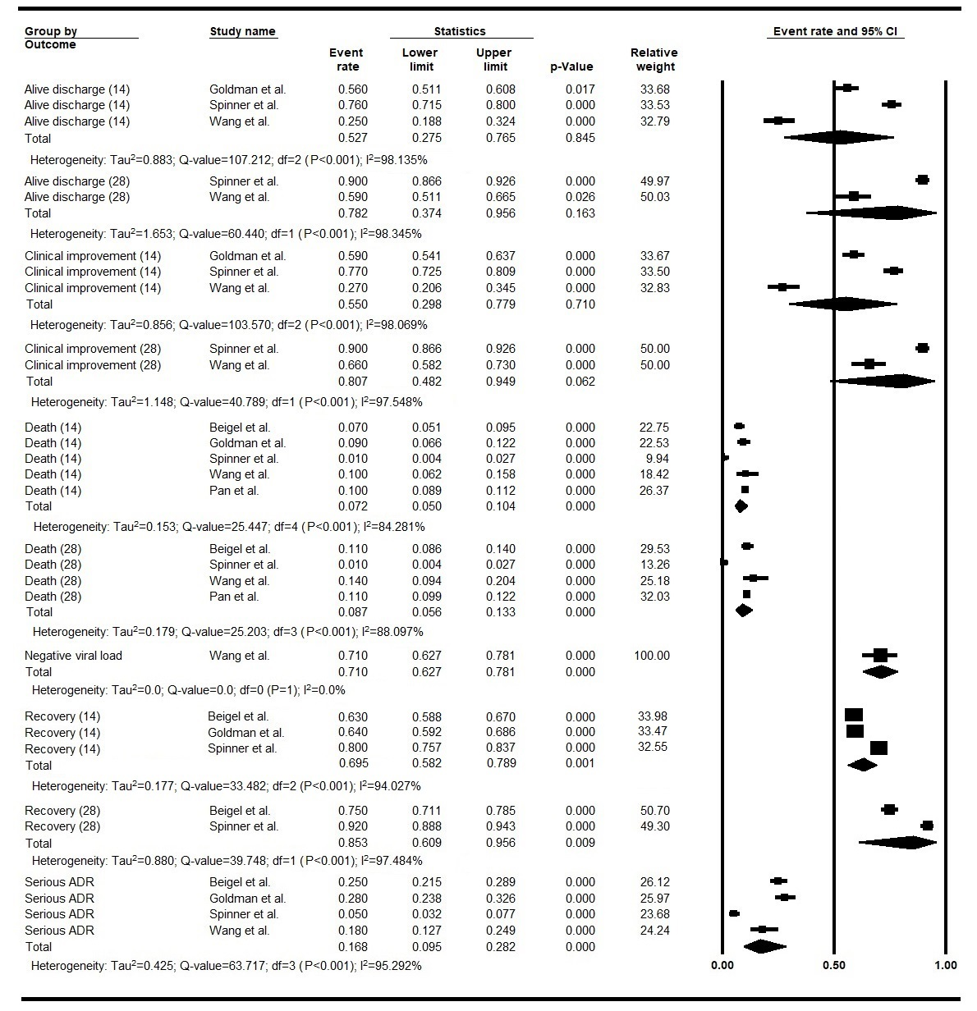
Fig. S3. Forest plot for pooling event rates of remdesivir groups in RCT studies.
ADR, adverse drug reaction; (14), 14-day follow-up; (28), 28-day follow-up; CI, confidence interval; df, degree of freedom

NRSIs: The rate of clinical improvement on 14-day follow-up was 35.8% (n=88, 95% CI, 26.5%-46.4%) and on 28-day follow-up was 69.4% (n=88, 95% CI, 58.9%-78.2%). Serious ADRs were experienced in 29.3% (n=88, 95% CI, 17.6%-44.5%) of patients. Death on follow-ups of 14 and 28 days occurred in 8.4% (n=400, 95% CI, 6.1%-11.6%) and 22.1% (n=161, 95% CI, 8.5%-46.4%) of participants, respectively. The viral load reduced over time in 97.7% (n=21, 95% CI, 72.3%-99.9%) of participants. The pooled 14-day recovery rate was 74% (n=312, 95% CI, 68.8%-78.6%). The 14-day and 28-day follow-ups showed 10% (n=88, 95% CI, 1.4%-46.8%) and 68.8% (n=136, 95% CI, 88.6%-89.1%) alive discharge rates, respectively.
The random-effects approach was used to calculate the pooled event rates of all the evaluated outputs except for the 14-day and 28-day clinical improvement. The detailed results are shown in the forest plot for pooling event rates of remdesivir groups in NRSIs (Fig. S4).
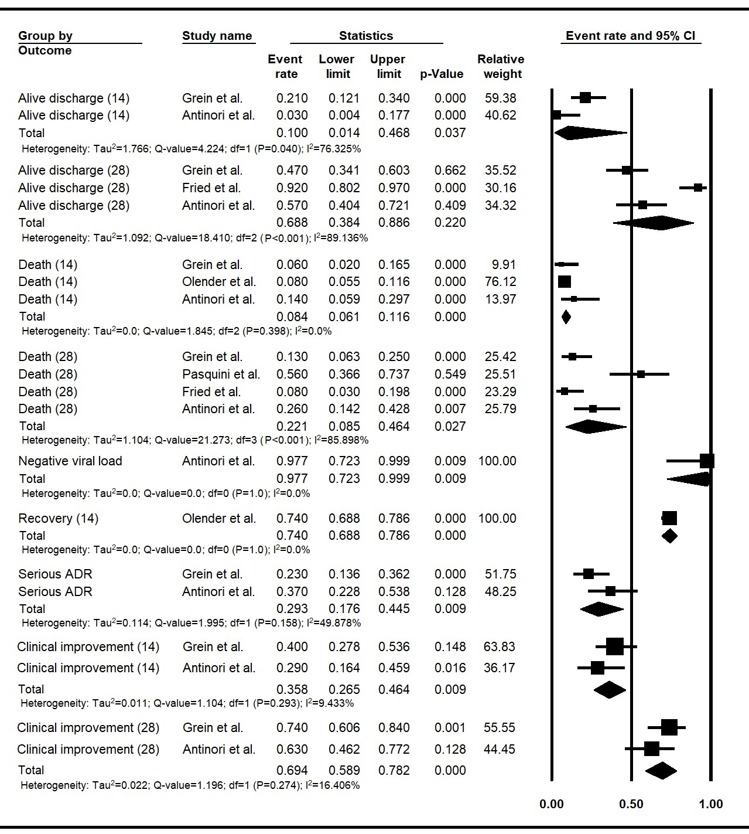
Fig. S4. Forest plot for pooling event rates of remdesivir groups in NRSIs.
ADR, adverse drug reaction; (14), 14-day follow-up; (28), 28-day follow-up; CI, confidence interval; df, degree of freedom

The pooled event rates of the no-remdesivir groups
The pooled event rates were calculated for four RCTs and three NRSIs that were enrolled in no-remdesivir groups.
RCT studies: The pooled rates of clinical improvement on follow-ups of 14 and 28 days were 44.7% (n=278, 95% CI, 10.6%-84.7%) and 72.3% (n=278, 95% CI, 43.1%-90%), respectively. Serious ADRs observed in 20.5% (n=795, 95% CI, 9.3%-39.5%) of participants. Mortality on 14-day and 28-day follow-ups were 8.8% (n=3503, 95% CI, 6.1%-12.5%) and 10.3% (n=3503, 95% CI, 6.9%-15.1%), respectively. The pooled rates of alive discharge on follow-ups of 14 and 28 days were 44.1% (n=278, 95% CI, 10.8%-83.8%) and 72.3% (n=278, 95% CI, 43.1%-90%), respectively. The pooled recovery rates were 63.4% (n=717, 95% CI, 42.3%-80.3%) and 77.4% (n=717, 95% CI, 56.7%-89.9%) on follow-ups of 14 and 28 days, respectively. Finally, the viral load reduction over time occurred in 75% (n=65, 95% CI, 63.1%-84%) of participants.
The random-effects model was used to calculate the pooled event rates of all evaluated outputs. The detailed results are shown in the forest plot for pooling event rates of no-remdesivir groups in RCT studies (Fig. S5).

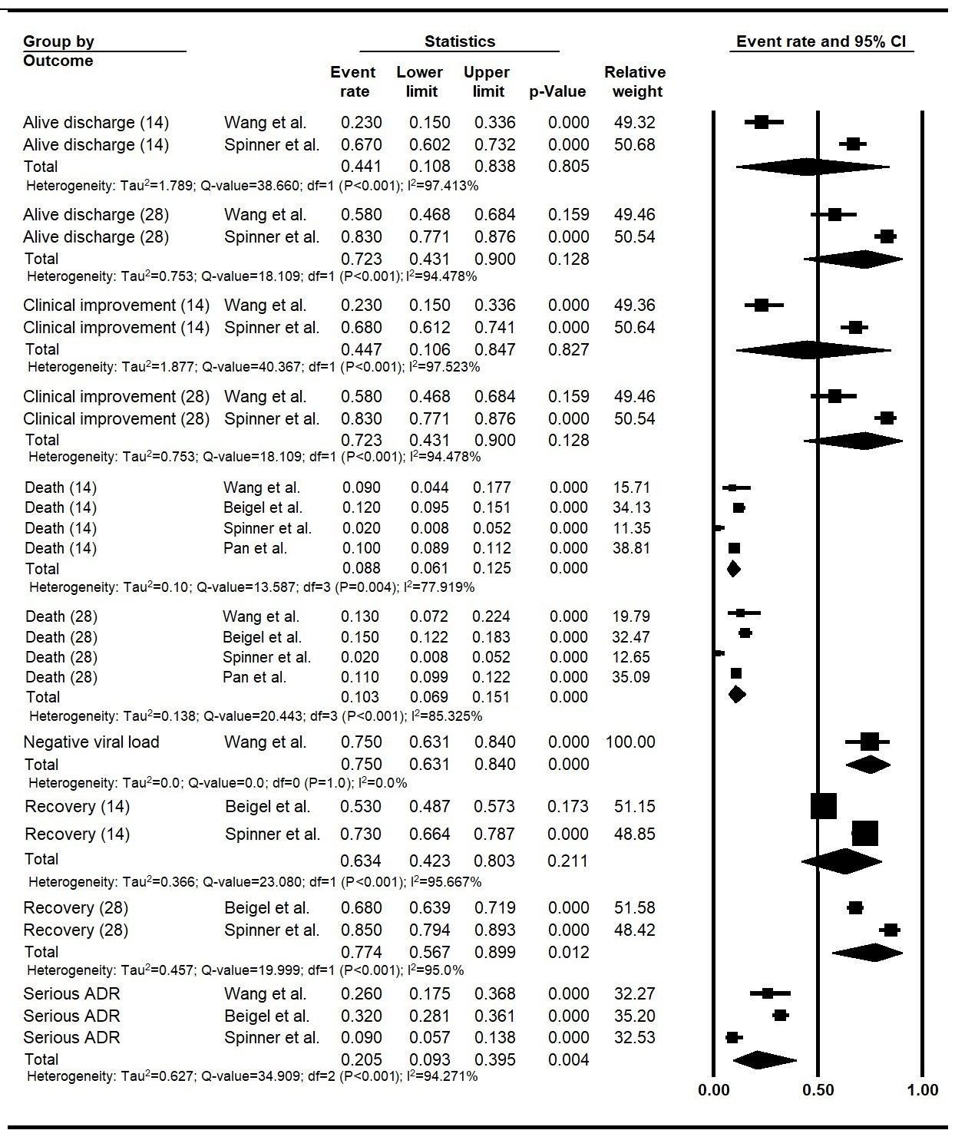
Fig. S5. Forest plot for pooling event rates of no-remdesivir groups in RCT studies.
ADR, adverse drug reaction; (14), 14-day follow-up; (28), 28-day follow-up; CI, confidence interval; df, degree of freedom
NRSIs: Death on follow-ups of 14 and 28 days happened in 13% (n=818, 95% CI, 10.9%-15.5%) and 64.5% (n=4258, 95% CI, 5.4%-98.3%) of participants, respectively. The pooled event rate for recovery on follow-up of 14 days was 59% (n=818, 95% CI, 55.6%-62.3%). The pooled 28-day alive discharge rate was 72% (n=4232, 95% CI, 70.6%-73.3%).
The random-effects model was used for all the evaluated outputs. The detailed results are shown in the forest plot for pooling event rates of no-remdesivir groups in NRSIs (Fig. S6).

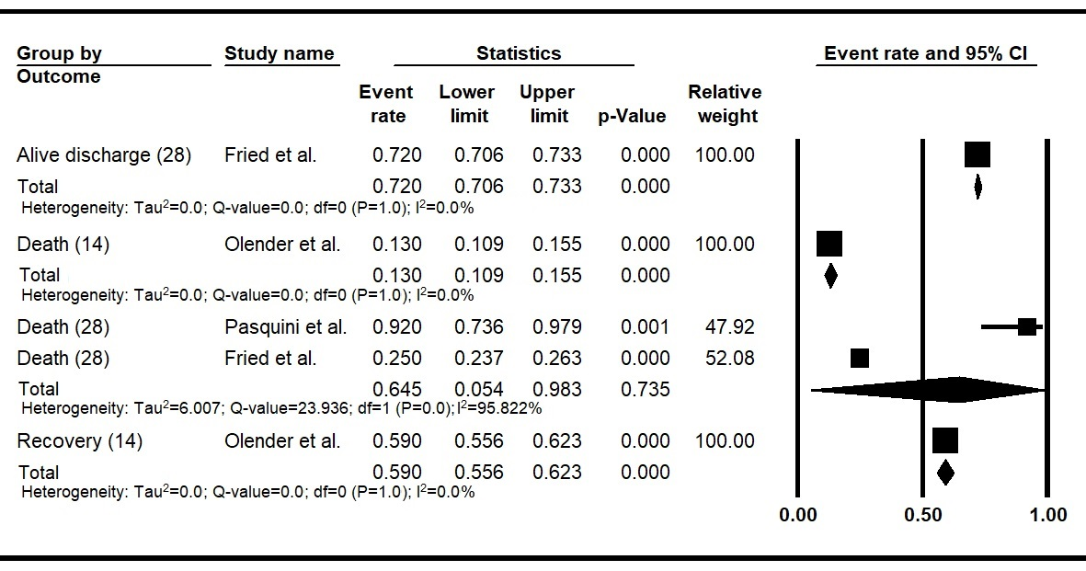Fig. S6. Forest plot for pooling event rates of no-remdesivir groups in NRSIs.
(28), 28-day follow-up; (14), 14-day follow-up; CI, confidence interval; df, degree of freedom

Fig. S7. Forrest plots for improvement asssessment of the respiratory support levels in remdesivir group over-time; RCT studies
O2, oxygen; NIMV, non-invasive mechanical ventilation; IMV, invasive mechanical ventilation; ECMO, Extracorporeal membrane oxygenation; df, degree of freedom; CI, confidence interval
Fig. S8. Forrest plots for improvement assessment of the respiratory support levels in no-remdesivir group over-time; RCT studies
O2, oxygen; NIMV, non-invasive mechanical ventilation; IMV, invasive mechanical ventilation; ECMO, Extracorporeal membrane oxygenation; df, degree of freedom; CI, confidence interval
Fig. S9. Forrest plots for improvement assessment of the respiratory support levels in remdesivir group over-time; NRSIs
O2, oxygen; NIMV, non-invasive mechanical ventilation; IMV, invasive mechanical ventilation; ECMO, Extracorporeal membrane oxygenation; df, degree of freedom; CI, confidence interval
Fig. S10. Forrest plots for improvement assessment of the respiratory support levels in 5-day and 10-day remdesivir courses over-time
O2, oxygen; NIMV, non-invasive mechanical ventilation; IMV, invasive mechanical ventilation; ECMO, Extracorporeal membrane oxygenation; df, degree of freedom; CI, confidence interval

